ASSIGNMENT 2

Customer
Customer_Id | Customer_Name
1 | John
2 | Smith
3 | Ricky
4 | Walsh
5 | Stefen
6 | Fleming
7 | Thomson
8 | David

Product
Product_Id | Product_Name | Product_Price
1 | Television | 19000
2 | DVD | 3600
3 | Washing Machine | 7600
4 | Computer | 35900
5 | Ipod | 3210
6 | Panasonic Phone | 2100
7 | Chair | 360
8 | Table | 490
9 | Sound System | 12050
10 | Home Theatre | 19350

Order
Order_Id | Customer_Id | Ordered_Date
1 | 4 | 10-Jan-05
2 | 2 | 10-Feb-06
3 | 3 | 20-Mar-05
4 | 3 | 10-Mar-06
5 | 1 | 5-Apr-07
6 | 7 | 13-Dec-06
7 | 6 | 13-Mar-08
8 | 6 | 29-Nov-04
9 | 5 | 13-Jan-05
10 | 1 | 12-Dep-2007

Order_Details
Order_Detail_Id | Order_Id | Product_Id | Quantity
1 | 1 | 3 | 1
2 | 1 | 2 | 3
3 | 2 | 10 | 2
4 | 3 | 7 | 10
5 | 3 | 4 | 2
6 | 3 | 5 | 4
7 | 4 | 3 | 1
8 | 5 | 1 | 2
9 | 5 | 2 | 1
10 | 6 | 5 | 1
11 | 7 | 6 | 1
12 | 8 | 10 | 2
13 | 8 | 3 | 1
14 | 9 | 10 | 3
15 | 10 | 1 | 1

- Fetch all the Customer Details along with the product names that the customer has ordered.

- Fetch Order_Id, Ordered_Date, Total Price of the order (product price*qty).

- Fetch the Customer Name, who has not placed any order

- Fetch the Product Details without any order(purchase)

- Fetch the Customer name along with the total Purchase Amount

- Fetch the Customer details, who has placed the first and last order

- Fetch the customer details , who has placed more number of orders

- Fetch the customer details, who has placed multiple orders in the same year

- Fetch the name of the month, in which more number of orders has been placed

- Fetch the maximum priced Ordered Product

-- 1. Fetch all the Customer Details along with the product names that the customer has
-- ordered.

SELECT c.*,p.product_name
FROM orders o
JOIN customer c USING(customer_id)
JOIN order_details od USING (order_id)
JOIN product p USING(product_id)
ORDER BY customer_id;

OUTPUT:
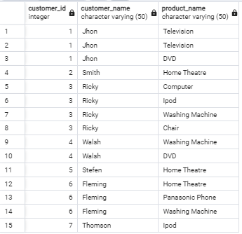

--2. Fetch Order_Id, Ordered_Date, Total Price of the order (product price*qty).

SELECT o.order_id,o.ordered_date,(p.product_price * od.quantity) AS total_salary
FROM orders o
JOIN order_details od USING(order_id)
JOIN product p USING(product_id)

OUTPUT:

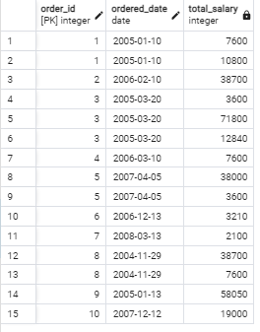
-- 3.Fetch the Customer Name, who has not placed any order

SELECT c.*
FROM customer c
LEFT JOIN orders o USING(customer_id)
WHERE o.order_id IS NULL

OUTPUT:
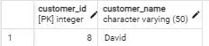

-- 4) Fetch the Product Details without any order(purchase)

SELECT p.*
FROM product p
LEFT JOIN order_details od USING(product_id)
WHERE od.order_id IS NULL
ORDER BY p.product_id

OUTPUT:

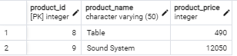

-- 5) Fetch the Customer name along with the total Purchase Amount

SELECT c.customer_name,SUM(p.product_price) AS total_price
FROM orders o
JOIN customer c USING(customer_id)
JOIN order_details od USING (order_id)
JOIN product p USING(product_id)
GROUP BY c.customer_name;

OUTPUT:

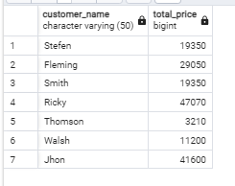

-- 6) Fetch the Customer details, who has placed the first and last order

SELECT c.*,MIN(o.ordered_date) AS first_order,MAX(ordered_date) AS last_order
FROM customer c
JOIN orders o USING (customer_id)
GROUP BY c.customer_id
ORDER BY last_order DESC
LIMIT 1

OUTPUT:

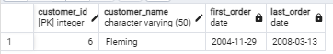

-- 7) Fetch the customer details , who has placed more number of orders

SELECT c.*, COUNT(*) AS total_orders
FROM orders o
LEFT JOIN customer c USING(customer_id)
GROUP BY c.customer_id
ORDER BY total_orders DESC
LIMIT 3

OUTPUT:

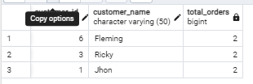

-- 8) Fetch the customer details, who has placed multiple orders in the same year

SELECT c.*,EXTRACT(YEAR FROM o.ordered_date)
FROM orders o
JOIN customer c USING(customer_id)
ORDER BY c.customer_id
LIMIT 2

OUTPUT:
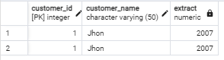

-- 9) Fetch the name of the month, in which more number of orders has been placed

SELECT COUNT(*) AS no_of_orders,to_char(o.ordered_date,'Month') AS month_h
FROM orders o
GROUP BY month_h
ORDER BY no_of_orders DESC
LIMIT 1

OUTPUT:



-- 10) Fetch the maximum priced Ordered Product

SELECT p.product_name,p.product_price
FROM customer c
LEFT JOIN orders o USING(customer_id)
JOIN order_details od USING (order_id)
JOIN product p USING(product_id)
ORDER BY p.product_price DESC
LIMIT 1

OUTPUT:
