Automated Network Penetrator

Abstract:
Technology is the basic unit as well as advance unit of this modern era. There are a lot of servers holding human data and credentials. They are being hacked through the one way or the other. This is being done because of vulnerabilities present in the services running on those servers. There are many ways through which those services can be access and their vulnerabilities are exploited. These services are accessed through network and different scans are done in order to find vulnerabilities and than are exploited. Our task in this project is to scan the network and find the vulnerable services running on the end host on the network. We have written some scripts which will scan the network and will show the vulnerabilities present in the system. The system is scanned through its IP address and the messages or banners are returned from the open ports. The banners returned may be vulnerable and can cause a threat to the system. The banners are matched with online data bases to check whether the service/banner running on the system is vulnerable or not.

Introduction:
We are making an automated network Penetrator which will do penetration of a network and show the vulnerabilities of the network. Those vulnerabilities are the vulnerabilities of the services running on that network. Those vulnerabilities than result in the threats. There are some manual techniques which do the penetration and find the vulnerabilities present in the network but we want to automate the process. For that purpose we will write scripts. Those script will do get interacted to the network and find the vulnerabilities.

Problem Statement

We are going to make an Automated Network Penetrator.

Background:

The global village means the world is all because of the network which makes one able to communicate to the other. When two or more computer linked with each other in order to share resources, exchange files etc form a network. There are several form of models that a network follow to make end machines communicate to each other like server-client of peer to peer models. These end machines have some services running on them. The network established have many routers and switches which make sure the passage of data from one side to the other.

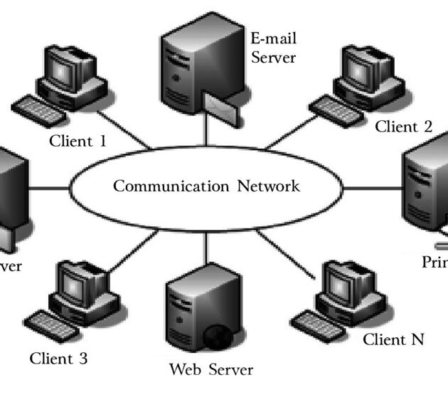

In the above diagram whenever the message is send from one computer to the other over a network, it has to pass through different routers and switches in order to reach the destination.
Now there is a possibility that the message send by a computer is read by a person sitting in between the sending computer and destination. The person sitting in between has number of ways through which he/she can read the message. He can either attack on the switches or routers through one way or the other to get packets of message sent one person and read the private data. This can be done if routers or switches are not perfectly configured. He can also get access to the end host to see the data. This can be done if there are some vulnerable services running on the host. These services can be any application on the host. These vulnerable services let the attacker to get into the system by exploiting such vulnerabilities of services in the system.

Scope:
Keeping in my the vulnerable path of the network, we restricted our final year project to the services. We are going to scan the system to check the vulnerable services running on it. The services being vulnerable gives access to the root privileges of the system. We are going to scan and penetrate in to the system through manual processes and than will try to make the processes of penetration automatic.

Methodology:

What we have done so far in our project is described below:

1.Set up the Environment.
2.Vulnerable application.
3.Attack the Machine.
4.Checked the vulnerabilities of application and exploited them manually.
5. Checked the vulnerabilities of application exploited them automatically.

1.Set up the Environment:

Work Environment:
The process of penetration was to be done on a local network as it is illegal and dangerous to run those processes on a running network. For doing penetration we had to use virtual machines so that if system in virtual machine crashes we don’t have any crash on the underlying operating system. The operating systems and machines we were given at initial are as follows.

Initial Environment:

System no | Memory | Hard disk | Processor | Operating system | Virtual OS
1 | 6 GB | 500 HDD | 2.93 GHz | Parrot Home Edition | Windows Starter Edition 32 Bit
2 | 4 GB | 500 HDD | 2.93 GHz | Parrot Home Edition | None

We had to use two computer systems as the system specifications were not meeting our requirements. One system was here to attack the machine and the other was being attacked.

Computer system 1:
The Operating system installed in this system was Parrot Home Edition which required about 2.5GB of memory. The system having 6 Giga Bytes of RAM was enough to run a virtual machine. So, at that system we installed a virtual box and installed a windows 7 starter edition. The minimal versions of Windows were used in order to get better performance and get maximum resources of the system.
Windows used in this case was taking about 1 to 1.5 GB’s of memory.

Computer system 2:
This system had 4 GB’s of memory. So, it was difficult to run a separate virtual machine on this system. Although we tried to use Some minimal operating systems like Trisquel and Slacks etc, but there were many issues which we faced during installation of packages and they were old and have some stability issues in those operating system. This system had Parrot Home Edition installed on it. This was the system at which the scripting was done. The scripts written here were executed and showed effects on the windows installed on the virtual box of other computer.

Final Environment:
After some time, we informed about the problem of our PCs that they are not capable enough for our project. Then they told us that there is a spare PC available. Then we were given new computer system. The specifications of that system are as follows:

System no | Memory | Hard disk | Processor | Operating system | Virtual OS
1 | 8 GB | 1000 HDD | 3.00 GHz | Parrot Home Edition | Windows Starter Edition

After getting this system, we were now able to run virtual machines in single system. We installed Windows Starter Edition in virtual box.

Here a vulnserver application is run at windows in virtual machine and the scripts are written on the the Parrot OS running on which virtual machine is running.

2.Vulnerable application:
For scanning and then checking vulnerabilities in the services we needed to run a service which is already vulnerable and its vulnerabilities are known. We run a service/application(Vulnserver) having known vulnerabilities in Windows.

3. Vulnserver:
Vulnserver is a Windows based threaded TCP server application that is made to be exploited. This application have known vulnerabilities. Those vulnerabilities can be detected and then exploited through some tools. This is the service we ran on windows operating system. The purpose of running this application on windows was to get access to the root privileges of the windows operating system. This service/application which automatically run on port number 9999 on Windows. First of all, we checked its vulnerabilities manually by using a tool such as net-cat. After checking it manually then we checked it automatically by writing our own scrips such as boofuz, spike etc.

3.Attack the Machine:
The attack machine which was used for penetrating into windows was parrot operating system, which is a[Linux distribution. This is the OS at which we used tools to get access to the windows and than wrote scripts on it. In order to let the linux communicate to the windows, the windows network used was bridge. In virtual box we have a possibility to use a bridge network which assigns the same ip address to the OS running in virtual box as the underlying OS with little change in last digits. This allows the underlying OS to communicate to the OS in virtual box.
We pinged to the OS of virtual box through underlying OS to check whether both are communicating to each other or not.

