**AMAN NEWS WEBISTE**



**Session (Spring 2020-Fall 2023)**

Bachelor of Studies in Computer Science

**Submitted By**

Abdul Wahid 58016-S020

Shah Khalid 58059-S020

Zain Ul Abideen 58067-020[1]

**Supervised By**

Mr. Ghulam Mustafa Asad

Lecturer, Department of CS & IT

**Hazara University, Mansehra**

Hazara University Mansehra

CS & IT Department

FYP Student Visit Performa

**Session: Spring-2020 – Fall-2023**

**Title of FYP: AMAN NEWS**

**Supervisor Name: Ghulam Mustafa Asad Designation:**

|  |  |  |
| --- | --- | --- |
| Date | Assigned Task | Task Progress i.e. Task completed/incomplete/Suggestions from supervisor |
|  |  |  |
|  |  |  |
|  |  |  |
|  |  |  |
|  |  |  |
|  |  |  |
|  |  |  |

FYP Member/Members:

R.No Name Student Signature

1. 58016-S020 Abdul Wahid

2. 58059-S020 Shah Khalid

3. 58067-020 Zain Ul Abideen

Supervisor Remarks: _____________________________________________________________________

Supervisor Signature

**Declaration**

It is hereby declared that this project, neither as a whole nor as a part has been copied out from any source. It is further declared that I developed this software and this report entirely on the basis of my personal efforts made under the sincere guidance of my project Supervisor. If any part of this software is proved to be copied or found to be a report of some other, I standby the consequences. No portion of the work presented in this report has been submitted in support of any application from any other degree of qualification of any other university or institute of learning. I further declare that this software and all associated documents, reports and records are submitted as partial requirement for the degree of BSCS (Bachelor of Studies in Computer Science). I therefore understand and transfer copyrights for these materials to Hazara University Mansehra.

**Abdul Wahid**

**Shah Khalid**

**Zain Ul Abideen**

**Acknowledgements**

All praise and thanks be to Allah who has given us a portion of His infinite knowledge. In addition, special thanks to our supervisor “Mr. Ghulam Mustafa Asad”. It was his monitoring, important analysis, encouragement, and guidance as we successfully completed our work. We would also like to thank our teachers who passed on their knowledge to us and our parents for their support and encouragement.

**Abdul Wahid**

**Shah Khalid**

**Zain Ul Abideen**

**Project in Brief**

**Project Title:** AMAN NEWS (website)

**Developed By:** Abdul Wahid

Shah Khalid

Zain Ul Abideen

**Supervised By:** Mr. Ghulam Mustafa Asad

**Tools Used:**  VS code, Xampp

**Languages Used:** HTML, CSS, JavaScript, Bootstrap, PHP, MySQL

**System Used:** HP Probook 440 G5.

**Operating System:** Microsoft Windows 11

**Starting Date:** 05-October -2023

**Completion Date:** 16- January-2024

**CHAPTER 1**

**INTRODUCTION**

**1.1 Introduction of the Project and its background**

In this project we made a dynamic news website title as “AMAN NEWS” which aims to deliver timely, accurate, and unbiased news to its audience. In the ever-evolving landscape of information dissemination, the “AMAN NEWS” Website emerges as a dynamic platform designed to cater to the diverse and discerning needs of its audience. This website sets out to be a reliable source of information in an era were staying well-informed is crucial. This website has a user-friendly interface which ensures that visitors can easily access the information they seek without unnecessary complexities. In this website the admin can easily upload posts such as images, videos, and text to enhance the overall understanding of news stories.

**1.2 SCOPE OF AMAN NEWS in SWAT**

1. AMAN NEWS will extensively cover national news, providing in-depth coverage of political developments, economic trends, social issues, and cultural events across the SWAT district of Pakistan.
2. Recognizing the diversity within district Swat, AMAN NEWS will prioritize localized reporting, ensuring that news from various regions, and cities in Swat is adequately represented.
3. AMAN NEWS will spotlight the social and cultural fabric of district Swat, celebrating its diversity and heritage.
4. AMAN NEWS will prioritize reporting on healthcare and education, two critical sectors that significantly impact the well-being and future of district Swat.

**1.3 Feasibility of the Project**

The Aman News project aims to establish a comprehensive news platform that focuses on delivering reliable, unbiased, and timely news content to its audience. This feasibility study assesses the viability of the project, considering various aspects such as market analysis, technical requirements, financial projections, and potential risks.

**1.3.1 Market Analysis:**

We have identified the specific demographic and psychographic characteristics of the target.

We have analyzed existing news platforms, identifying strengths, weaknesses, and opportunities.

**1.3.2. Technical Requirements:**

We have implemented a user-friendly CMS for easy content creation, editing, and management.

We ensure that the CMS supports multimedia content, including text, images, and videos.

We developed a responsive website design to ensure a seamless user experience across various devices (desktops, tablets, and smartphones).

We have integrated a powerful search engine to enable users to quickly find relevant articles and news topics.

**1.3.3. CONCLUSION:**

The feasibility study indicates that the Aman News project is viable and has the potential to be a successful venture. With careful planning, effective implementation, and continuous adaptation to market dynamics, Aman News can establish itself as a reputable and influential news platform. It is essential to regularly review and update the feasibility study as the project progresses to ensure its ongoing success.

Introduction of the Tool used in the Project V. Introduction of Report (All chapters introduced in a single paragraph)

**1.4 Introduction of the Tools used in the Project:**

**1.4.1 Visual Studio Code:**

Visual Studio Code (VS Code) is a lightweight, open-source code editor developed by Microsoft. It is widely used by developers for various programming languages and supports a rich set of features. Here are some key aspects of Visual Studio Code:

**ii. Cross-Platform Support:**

VS Code is available for Windows, macOS, and Linux, making it a versatile choice for developers using different operating systems.

**iii. Extensions:**

VS Code has a robust extension system that allows developers to enhance the functionality of the editor. There are extensions available for a wide range of programming languages, frameworks, and tools.

**iv. Integrated Terminal:**

VS Code includes an integrated terminal that allows developers to run shell commands, scripts, and other terminal-based tasks without leaving the editor.

**v. Source Control Integration:**

Git integration is built directly into the editor, providing features like version control, branch management, and easy access to Git commands.

**vi. IntelliSense:**

VS Code provides intelligent code completion (IntelliSense) for various programming languages, offering suggestions for variables, methods, and more as you type.

**vii. Debugger:**

The editor comes with built-in support for debugging various languages, allowing developers to set breakpoints, inspect variables, and step through code.

**viii. Language Support:**

Visual Studio Code supports a wide range of programming languages out of the box, and additional language support can be added through extensions.

**ix. Themes and Customization:**

VS Code supports various themes and customization options, allowing developers to personalize the editor's appearance and behavior.

**1.4.2 XAMPP SERVER:**

XAMPP is a free and open-source cross-platform web server solution stack package developed by Apache Friends. It's widely used for local development and testing of web applications. Here are some characteristics of XAMPP:

**i. Cross-Platform Compatibility:**

XAMPP is compatible with multiple operating systems, including Windows, macOS, and Linux, making it versatile for developers using different environments.

**ii. Integrated Software Stack:**

XAMPP bundles together several key components of the web development environment, including Apache HTTP Server, MySQL database, PHP, and Perl. This integration simplifies the setup process.

**iii. Ease of Installation:**

Installing XAMPP is relatively straightforward. It provides an installer that packages all the necessary components into one installation process.

**iv. Local Development Environment:**

XAMPP is designed primarily for local development, allowing developers to set up a web server on their own machines for testing and debugging before deploying applications to a live server.

**v. Apache Web Server:**

XAMPP includes the Apache HTTP Server, a widely used web server. Apache is configurable and supports features like virtual hosts, URL rewriting, and SSL.

**vi. MySQL Database:**

XAMPP includes a MySQL database server, which is a popular relational database management system (RDBMS). It provides an easy-to-use interface for managing databases.

**vii. PHP:**

XAMPP comes with PHP, a server-side scripting language commonly used for web development, and Perl, a general-purpose programming language.

**viii. phpMyAdmin:**

XAMPP includes phpMyAdmin, a web-based tool for managing MySQL databases. It provides a graphical interface for tasks such as database creation, modification, and querying.

**ix. Quick Deployment:**

XAMPP allows for rapid deployment of web applications, making it a popular choice for developers who need a quick and easy setup for testing and development.

**1.5 Languages used in the development of the “Aman News”**

**HTML:**

HTML stands for HyperText Markup Language, is the standard markup language used to create and design documents on the World Wide Web. It forms the backbone of web content and provides a structure for presenting information on websites.

**CSS:**

CSS stands for Cascading Style Sheets, is a stylesheet language used for describing the presentation and formatting of a document written in HTML or XML. CSS plays a crucial role in web development by allowing developers to control the layout, appearance, and styling of web pages. CSS works by selecting HTML elements and applying style rules to them. Selectors target specific elements, and declarations define how those elements should be styled.

**Bootstrap:**

Bootstrap is an open-source CSS library for creation of responsive Web pages.

We have used bootstrap framework of the CSS in our project to responsively run the website on different screen sizes like Laptop, Tablets, and Mobile Phones.

**JavaScript:**

JavaScript is a high-level, dynamic, and versatile programming language primarily used for client-side web development. It enables the creation of interactive and dynamic user interfaces on web pages.

**PHP:**  
PHP stands for Hypertext Preprocessor, is a server-side scripting language widely used for web development. It is embedded within HTML code and executed on the server, generating dynamic content that is then sent to the client's browser.

PHP code is typically embedded directly within HTML files, allowing developers to mix dynamic PHP-generated content with static HTML content.

PHP syntax is like C-style languages, making it relatively easy for developers with experience in languages like C, C++, or Java to learn.

**MySQL:**

MySQL is an open-source relational database management system (RDBMS) that is widely used for managing and organizing large sets of data. It is a popular choice for web applications due to its reliability, scalability, and ease of use.

* MySQL is an RDBMS, which means it organizes data into tables with rows and columns, following the principles of relational databases.
* MySQL is open-source software, which means it is freely available for use, modification, and distribution.
* MySQL uses SQL (Structured Query Language) for defining and manipulating the data stored in its databases. SQL is a standard language for interacting with relational databases.

**1.6 Introduction of Report:**

In Chapter 1, we delve into the foundation of our platform, providing a thorough introduction that sets the stage for the exciting journey ahead. Chapter 2 meticulously navigates through the intricate world of requirement specification, outlining the essential elements that underpin the functionality and purpose of Aman News. As we progress to Chapter 3, the spotlight shifts to the design of our proposed system, unraveling the innovative architecture and user-centric principles driving our platform's development. In chapter 4 we test our project which pass all the test cases. We developed our project title as “AMAN NEWS” which aims to deliver the news, articles, and storied to the audience timely and accurately.

**Chapter 2:**

**Requirement Specification**

2.1 **Existing system**

The existing system of a news website, commonly known as a print newspaper, involves a well-established process that has evolved over decades. Newspapers play a vital role in community-building by reporting local news, events, and fostering a sense of shared identity. Here are the key components of the existing system for a traditional paper news publication:

i. Journalist and Reporters gather news through research, interviews, and on-the-ground reporting.

ii. Journalists draft articles, which undergo editing for accuracy, style, and adherence to editorial guidelines.

iii. The newspaper is printed using offset printing presses, and multiple copies are produced for distribution.

iv. Distribution teams deliver newspapers to various locations, including newsstands, vendors, and subscribers.

v. Advertising teams sell ad spaces, design campaigns, and ensure timely placement in the newspaper.

**2.2. Limitations of existing System**

**i. Lack of Timeliness:**

Printed newspapers have fixed publication schedules, typically offering news on a daily or weekly basis. This lack of real-time updates can result in outdated information, especially for fast-evolving events.

**ii. Limited Interactivity:**

Unlike digital platforms, paper news lacks interactive features. Readers cannot engage with content beyond reading, as there are no hyperlinks, multimedia elements, or opportunities for real-time discussions.

**iii. Space Constraints:**

The physical constraints of print newspapers limit the amount of content that can be included.

**iv. Distribution Challenges:**

Printed newspapers require physical distribution networks, which can be logistically challenging and costly. Distribution delays may impact the timely delivery of newspapers to readers.

**v. Single-Use Nature:**

Physical newspapers are typically discarded after use, contributing to paper waste. In contrast, digital news consumption eliminates the need for physical production and disposal.

**2.3. Proposed System:**

The proposed system aims to position AMAN NEWS as a dynamic and forward-thinking news platform, leveraging technology and user-centric design to deliver a modern and engaging news consumption experience.

In envisioning the future of AMAN NEWS, several key enhancements and innovations are proposed to elevate the news website's functionality, user experience, and overall impact. The proposed system encompasses a series of strategic upgrades across various facets of the project which are following:

**i. Real-time News Updates:**

Implement a robust content management system that supports real-time updates, ensuring that breaking news and developing stories are promptly published to keep the audience informed with the latest information.

**ii. Dynamic User Interface:**

Redesign the user interface with a focus on user experience, employing modern design principles, intuitive navigation, and responsive elements to enhance accessibility across various devices, including mobile phones and tablets.

**iii. Multimedia Integration:**

Expand multimedia integration by incorporating high-quality videos, infographics, and interactive features, providing users with a more engaging and visually appealing news consumption experience.

**iv. Enhanced Search and Archives:**

Upgrade the search functionality to provide users with efficient and accurate results. Additionally, optimize the archives system to facilitate easy retrieval of past articles and editions, enhancing the platform's historical reference value.

**2.4. Functional Requirements of AMAN**

**i. User Registration and Authentication:**

The admin can add the user to the Aman news, the admin will add its role when adding him to the system. The role may be admin or moderator. The admin will see post of the every user/reporter and can edit or delete it while the moderator only can see his own post and edit it or delete it. When the admin add a user then the admin will provide the username and password to the user to login to the system.

**ii. Real-time News Updates:**

The system enables journalists and editors to publish news articles in real-time.

Users should receive timely updates on breaking news.

**iii. Multimedia Integration:**

The platform support the integration of multimedia elements, including images, videos, and infographics.

Users should be able to access and engage with diverse content formats.

**iv. Dynamic User Interface:**

The user interface is dynamic, responsive, and user-friendly.

Intuitive navigation should facilitate seamless browsing across devices.

**vi. Add/ Update/ Delete News:**

The user can easily add, update, or delete news without any difficulty if his role is “admin”.

**vii. Add/Update/Delete User:**

The user can easily add, update, or delete news without any difficulty if his role is “admin”.

.

**USE CASE DIAGRAM**

The following is the use case diagram of our project.

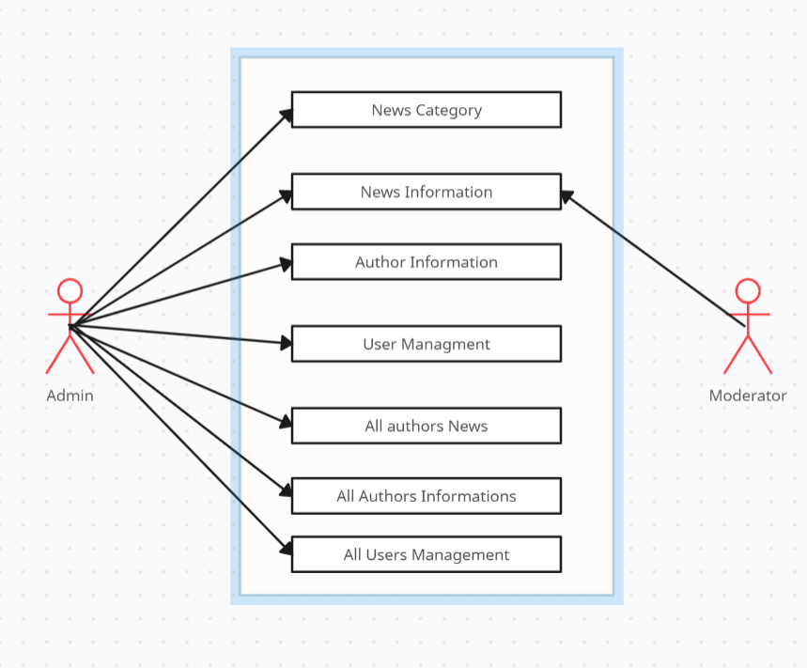

Figure 2.1 Usecase diagram

**DATAFLOW DIAGRAM:**

The following is the data flow diagram of our project.

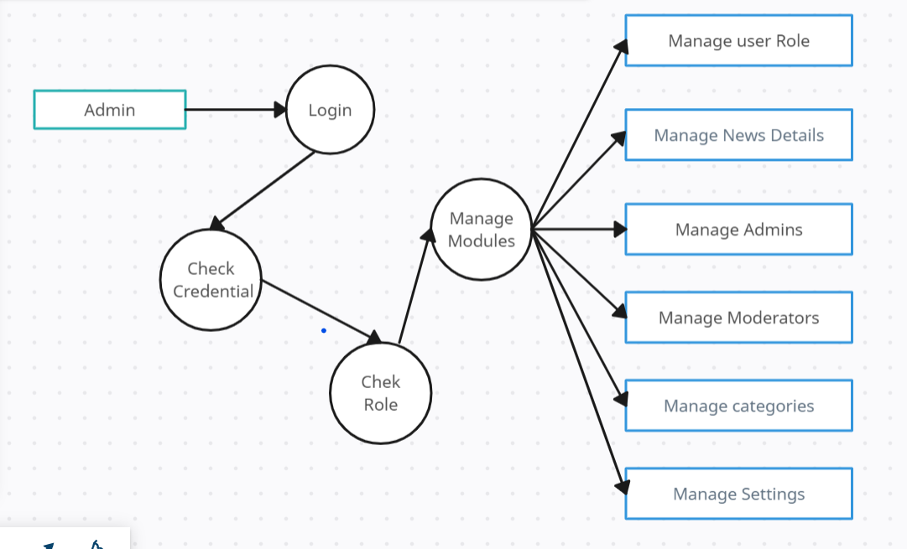

Figure 2.2 Data flow diagram

**2.5. Non-Functional requirements:**

**i. Security:**

User data is encrypted in this website during transmission (using HTTPS) and stored securely.

The website implemented measures to prevent common web vulnerabilities (e.g., SQL injection, cross-site scripting).

**ii. Usability:**

The website is compatible with major browsers (Chrome, Firefox, Safari, Edge) and different devices (desktops, tablets, smartphones).

The user interface is intuitive, with clear navigation and a consistent design.

**iii. Performance:**

The website response time is less than 3 seconds for 95% of user interactions.

The website supports a minimum of 10,000 concurrent users without degradation in performance.

Page load times are optimized for both mobile and desktop devices.

**iv. Availability:**

The website will be accessible 24/7, with scheduled maintenance communicated to users in advance.

**v. Scalability:**

The website is scalable to handle a 20% increase in traffic within a 6-month period.

**Chapter 3:**

**Design of the Proposed System**

**3.1 System Architecture:**

**Context Diagram**

Below is the context diagram of our website.

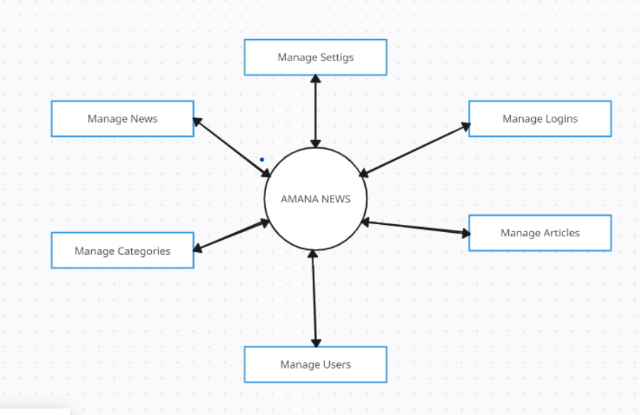

**Figure 3.1 Context Diagram**

**3.2. Design Constraints:**

Design constraints of our website can be categorized into various aspects, including functionality, user experience, aesthetics, and technical considerations. Design constraints of our website are following.

**i. Responsive Design:**

The website is accessible and usable across various devices, including desktops, tablets, and mobile phones responsively.

**ii. Cross-Browser Compatibility:**

The design is compatible with popular web browsers such as Chrome, Firefox, Safari, and Edge, ensuring a consistent user experience.

**iii. Page Load Speed:**

The website is loading quickly to provide a seamless experience for users, with consideration for users with slower internet connections.

**iv. Content Management:**

The design is accommodating easy content updates and management to keep the news information current.

**v. Search Functionality:**

We have Implemented a robust search feature to allow users to quickly find relevant news articles.

**vi. Navigation:**

Intuitive navigation is crucial. We include a clear and user-friendly menu structure in our website to help users easily find the information they are looking for.

**vii. Security:**

We have implemented security measures to protect user data, prevent hacking, and ensure the overall safety of the website.

**viii. Multimedia Support:**

Support for various multimedia elements such as images, and videos to enhance the presentation of news content.

**3.3 Low Level Design**

The following is the low-level design of our website.

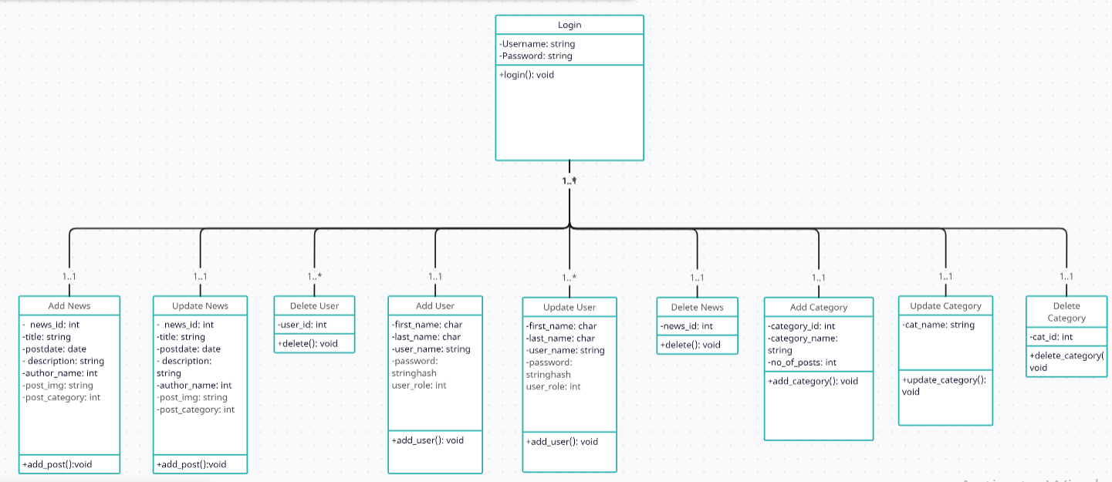

Figure 3.2 Low Level Design.

**3.4 Optimized Database Design**

Database design is the organization of data according to a database model. The designer determines what data must be stored and how the data elements interrelate. With this information, they can begin to fit the data to the database model. Database design involves classifying data and identifying interrelationships. This theoretical representation of the data is called an ontology. The ontology is the theory behind the database’s design.

The following is database design of our website.

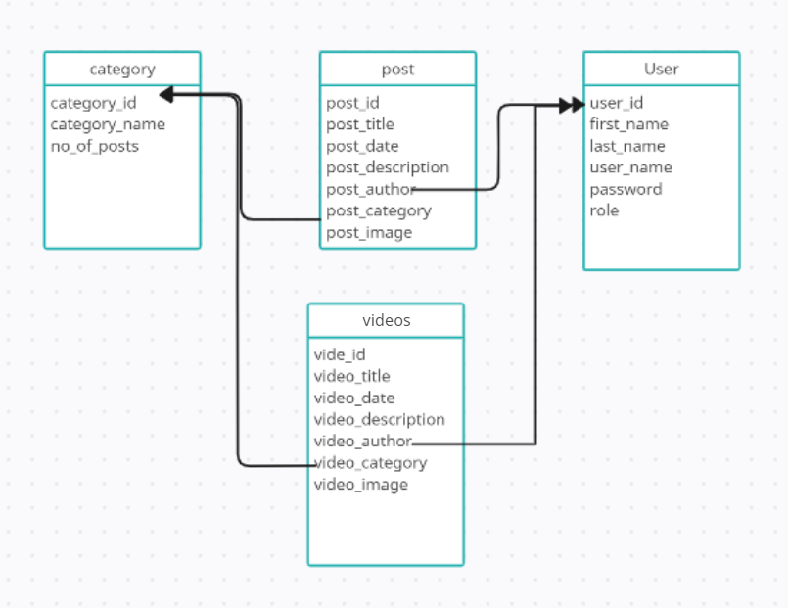

Figure 3.3 Database design.

**3.4.1. Normalization (for SQL Database):**Database normalization is a process used to organize a relational database to reduce data redundancy and improve data integrity. In the context of our website, we have four entities User, Post, Videos, and Category.

(i) **User** (user_Id, first_name, last_name, user_username, password)

(ii) **Article** (post_Id, post_title, post_date, post_description, post_author, post_date, post_img)

(iii) **Category** (category_Id, category_name, no_of_posts)

(iv) **Videos (**video_Id, video_title, video_date, Video_description, video_author, video_category, video_name)

a. The authors _Id is a foreign key referencing the user_Id of the user table to show the author of the post.

b. The post_Category is a foreign key which is reference to the category_Id of the category table to show the category of the post.

c. The user_Id and the category_Id are primary keys.

**3.4.2. Denormalization**

Denormalization is the process of adding precomputed redundant data to an otherwise normalized relational database to improve read performance of the database. Normalizing a database involves removing redundancy so only a single copy exists of each piece of information.

**3.5 Algorithm of the system**

1. Start

2. Sign in IF Sign in correct “Go to step 3”

3. Home

3.1- Add/Update/Delete News

3.2- Add/Update/Delete Users

3.3- Add/Update/Delete Category

4. Logout

5. Exit

**CHAPTER NO: 4**

**TESTING**

**4.1 Testing Introduction**

After the development of any Website, the major tasks are testing the website on the localhost to remove errors and deficiencies and then implementation of website with simple and easy user interface so that anyone can use it with ease.

**4.1.1 Purpose of Testing**

Testing is any activity aimed at evaluating a function or capability of a product and determining that it meets its required results. Testing is the process of executing a program or application with the intent of finding errors. The focus of our test strategy was primarily functional and end-to-end testing due to the limited development time frame. The benefits of testing include preventing bugs, reducing development costs, and improving performance.

**4.2 Admin Test Cases**

**i. Admin Test Case # 1**

Admin Login Activity

Precondition: the admin should have internet connection.

Step to be executed: Enter Username and password.

Expected result: system should display the message “successfully logged in”.

Result: Pass.

**ii. Admin Test Case # 2**

Admin Add News Activity

Step to be executed: Enter Title, description, category, and post images.

Expected result: the Post will be displayed on the top of the website and in recent post.

Result: Pass.

**iii. Admin Test Case # 3**

Admin Update News Activity

Step to be executed: Edit Title, description, category, or post images.

Expected result: the edited Post will be displayed on the top of the website.

Result: Pass.

**iv. Admin Test Case # 4**

Admin Delete News Activity

Step to be executed: Click on delete button to the corresponding post.

Expected result: The post data will be deleted from the database and the post image should be deleted from the upload folder.

Result: Pass.

**v. Admin Test Case # 5**

Admin Add User Activity

Steps to be executed: Enter first name, last name, username, password, and role of the user.

Expected result: the system will add the user and will show the message “user added successfully”.

Result: Pass.

**vi. Admin Test Case # 6**

Admin Update User Activity

Steps to be executed: Edit first name, last name, username, or role of the user.

Expected result: the system will update the user and will show the message “user updated successfully”.

Result: Pass.

**vii. Admin Test Case # 7**

Admin Delete users Activity.

Steps to be executed: Click on delete button to the corresponding user.

Expected result: the user data will be deleted from the database.

Result: Pass.

**viii. Admin Test Case # 8**

Admin Add Category Activity.

Steps to be executed: Enter Category name.

Expected result: the category should be added to category table in the database.

Result: Pass.

**ix. Admin Test Case # 9**

Admin Update users Activity.

Steps to be executed: Click on update button to the corresponding category.

Expected result: The category should be updated.

Result: Pass.

**x. Admin Test Case # 10**

Admin Delete Category Activity.

Steps to be executed: Click on delete button to the corresponding category.

Expected result: The category should be deleted from the database.

Result: Pass.

**4.3 User Test Case # 1**

**4.3.1 User Search Activity**

Precondition: the user should have internet connection.

Steps to be executed: Enter the title of the page to search.

Expected result: The searched data will be checked in the title column of the post in data base and the result will be showed to the user.

Result: Pass.

**4.4 White Box Testing**

A strategy in which software component is treated as a transparent box. Test designer can peek into the box and gain knowledge about the implementation. They can use this knowledge to build test cases cover different parts of the code and follow different execution paths. White box testing is a test case design method that uses the control structure of the procedure design to derive test cases.

**4.5 Black Box Testing**

A strategy in which a software component is treated like an opaque box. This tests designers’ focus on determining how well the component conforms to the published requirements for the component, instead of worrying about the implementation details. Black box testing focuses on the functional requirement of the software. This testing strategy enables us to derive sets of input conditions that will fully exercise all functional requirements for a program.

**4.6 Branch Testing**

Branch coverage is a testing method, which aims to ensure that each one of the possible branches from each decision point is executed at least once and thereby ensuring that all reachable code is executed. That is every branch taken each way, true and false. It helps in validating all the branches in the code making sure that no branch leads to abnormal behavior of the application.

**4.7 Boundary Testing**

Boundary testing is the process of testing between extreme ends or boundaries between partitions of the input values, so these extreme ends like Start- End, Lower- Upper, Maximum-Minimum, Just Inside-Just Outside values are called boundary values and the testing is called “boundary testing”.

**4.8 Unit Testing**

We test the whole branches of the project one by one. Where we find some kind of errors then we will fix these errors. Some of the errors we will solve during user testing module also.

**4.9 Conclusions**

I had to get to know the technologies chosen and it was time taking to familiarize ourselves with the features of tools use in our website. I learned how to break a project in different modules and how to integrate the individual work as a unit. Working as a single was a new experience and learnt how to collaborate with itself and how to merge different thoughts into a single product. I learned how to manage work and time.

**4.10 Project Summary**

Our website plays an important role in our modern era. In passed the news were reported from the reporter then it’s edited by the team editors and then its printed on the papers and distributed. The newspaper was read once and then it became useless. There were time issues the news were not provided to the audience on time. So, in this website the news will be provided to the audience on timely. We have created search functionality in our website so that the user can easily access the required information.

**CHAPTER 5:**

**SCREENSHOTS**

**USER/ADMIN MANUAL**

**5.1 Log In**

This is the first page of the website where the admin can login to the system and can add, update, and delete news articles, category or users.

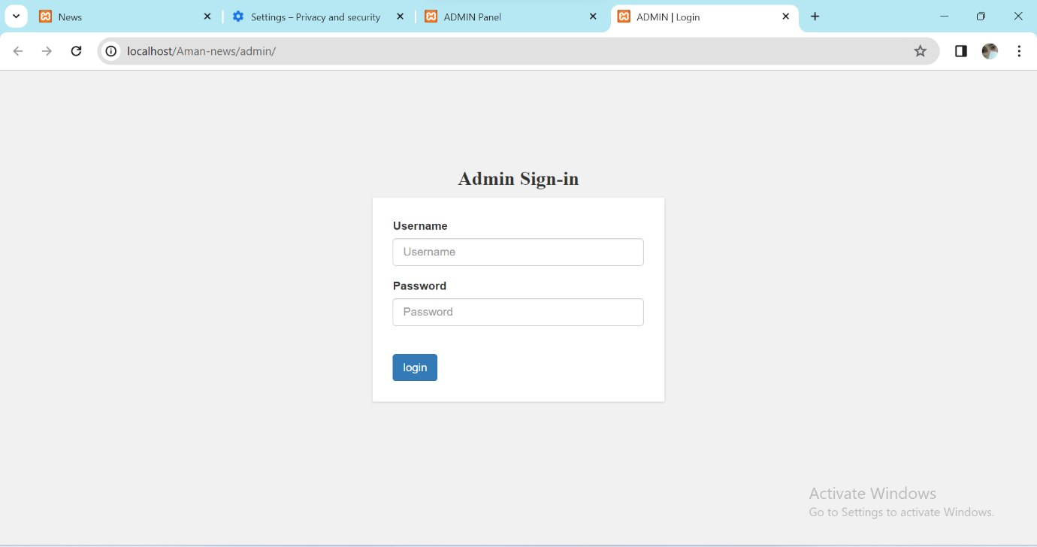

Screenshot 5.1 Log in Page

**5.2 Home Page**

This is a home page where the admin can add/update/delete post, category, and users.

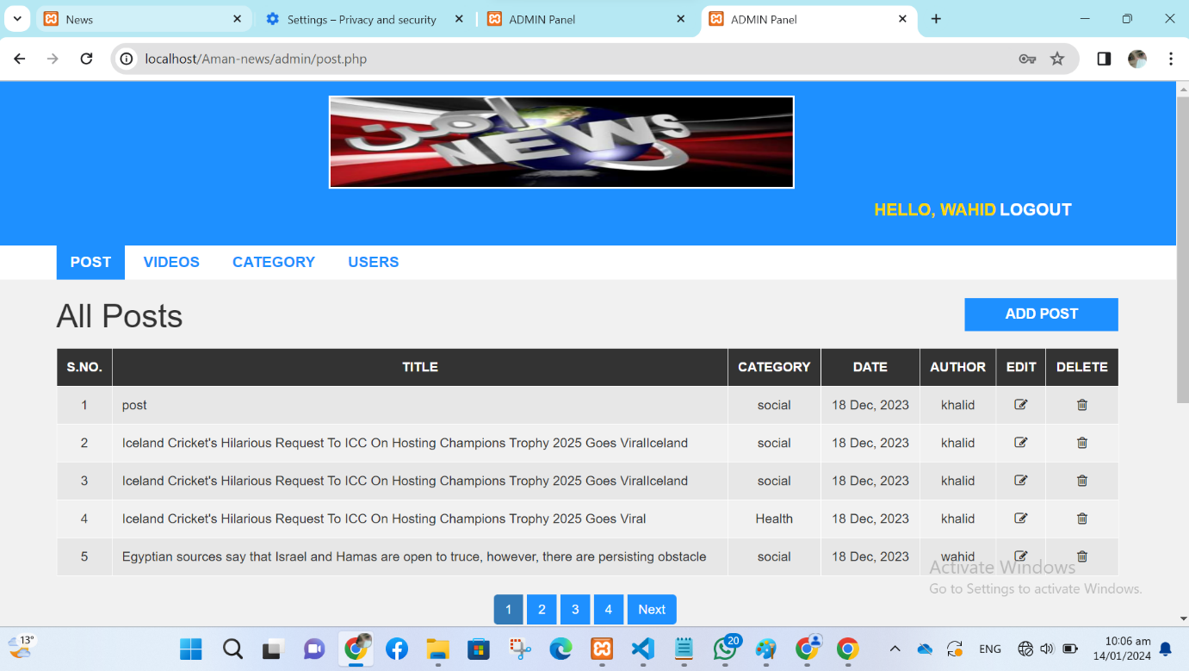

Screenshot 5.2 Admin Home Page

**5.3 Add User.**

When the admin click on the “add user” button then he will add these data (first name, last name, username, password, user role). The user role may be admin or normal user. Admin can see, edit, or delete news of all users and also can and category and add, update, or delete user as well. The normal user can see, add, update, or delete his own news only.

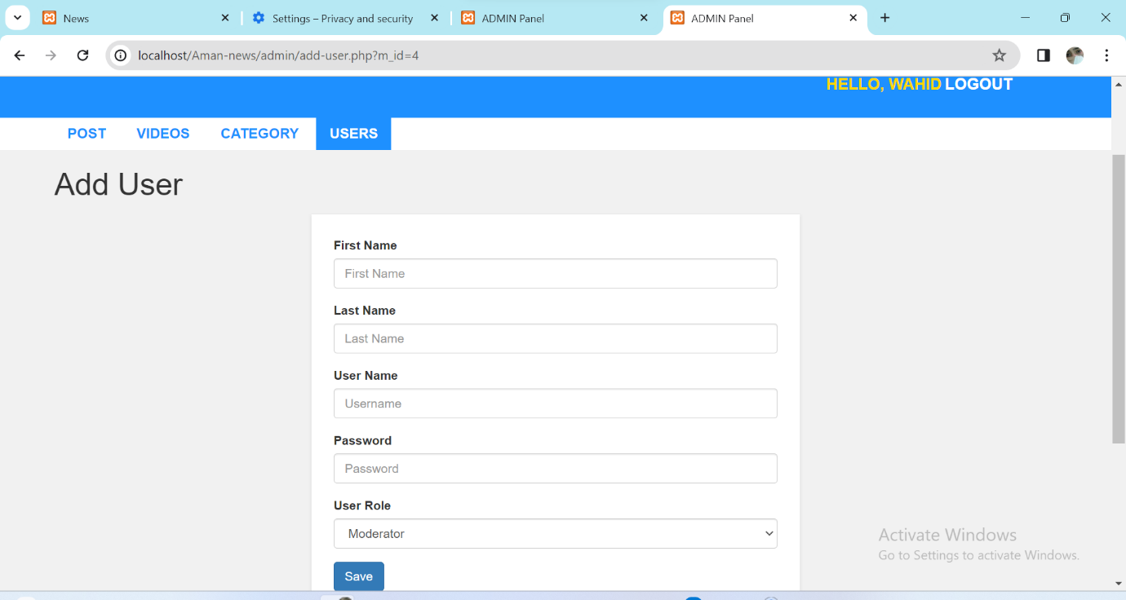

Screenshot 5.3 Add user

**5.4 Add category.**

The admin will enter the new category name here. If the category name is already exist then the system will show an error message that “category name is already exist”. If the category name is not exist then the category will be added and the system will show the message that “category is successfully added”. The category will be shown in the category table in the admin panel and in main page of the user side.

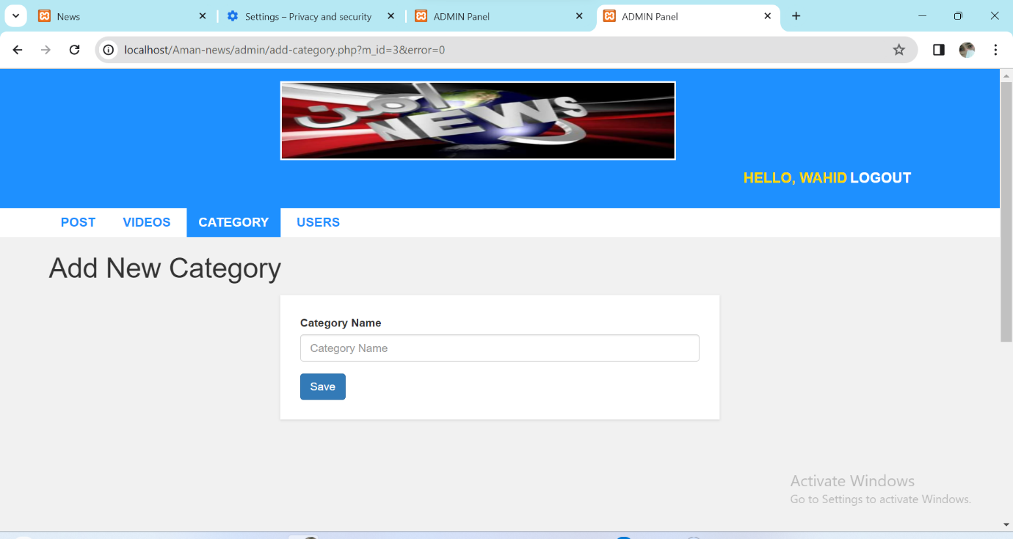

Screenshot 5.4 Add New Category

**5.5 Add post:**

When the admin/moderator click on add post then he will enter these information of the post (title, description, category, post image/images). The admin can add one image or multiple image.

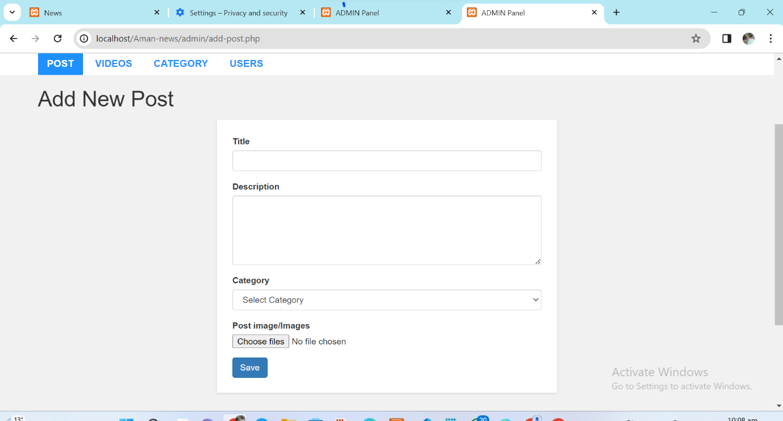

Screenshot 5.5 Add News

**5.6 Update post.**

When the user click on the “Update Post” button then the old data will be fetched to the form from the database. The admin can update any field of the news post. When the admin click on the “Update” button the post will be update and the update data will be saved in the database.

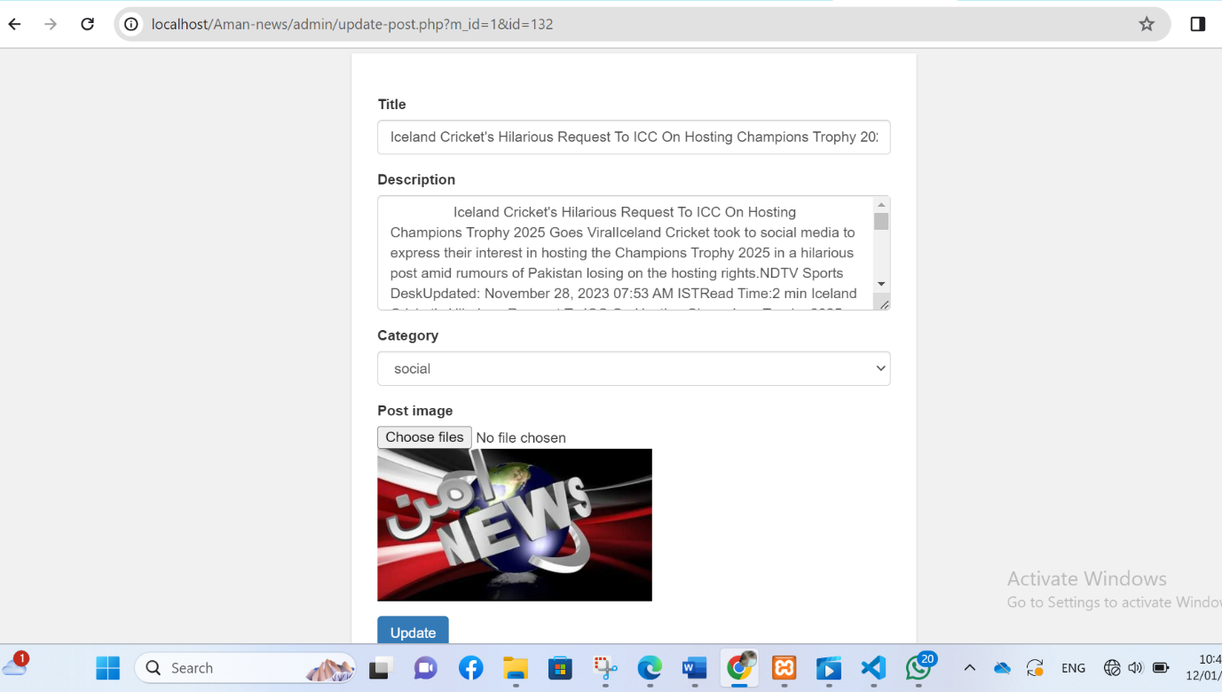

Screenshot 5.6 Update post

**5.7 User homepage**

This is the home page for the user where the audience will see the latest news.

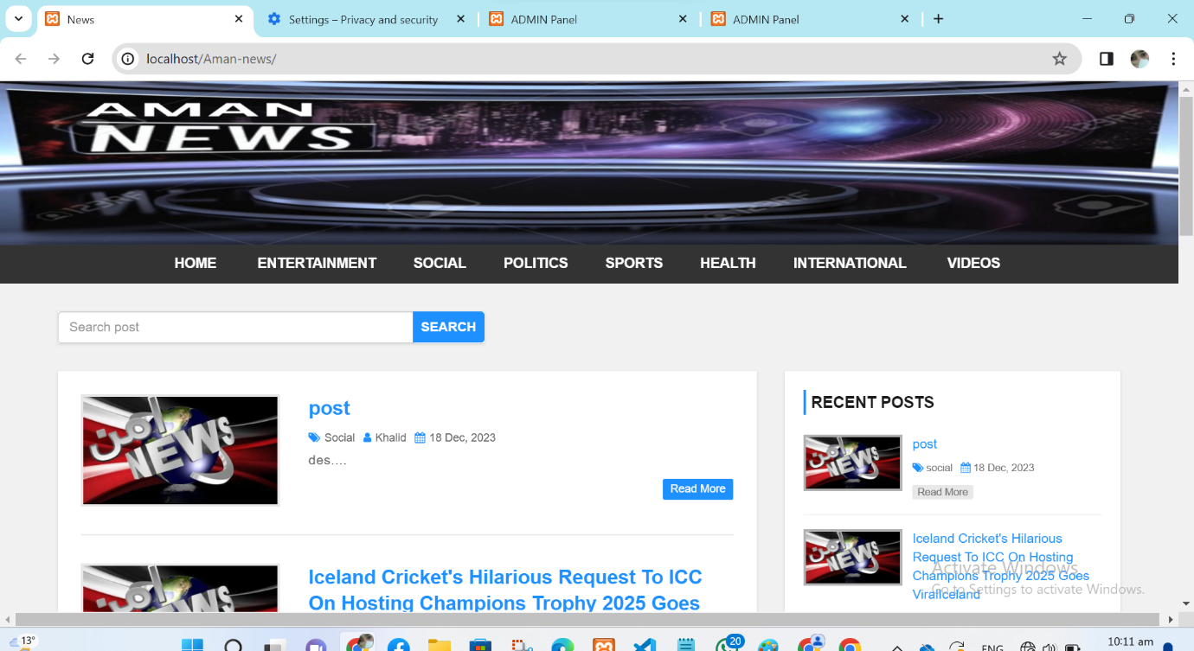

Screenshot 5.7 Audience home page

**5.8 User home page on mobile and tablet**

The home page on the tablet and small screens will look like the screenshot. When the user click on the 3 bars the navigation will be go dropdown and become visible.

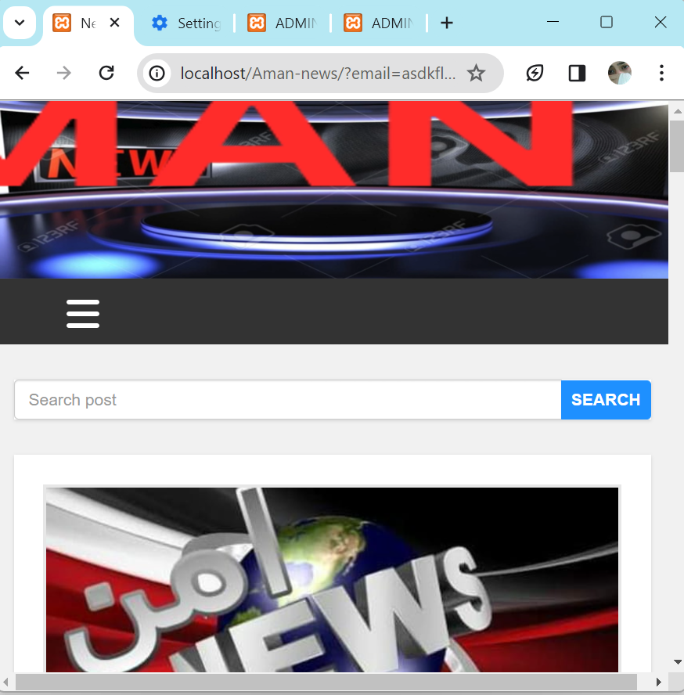

Screenshot 5.8 home page on small screens

**5.9 Searching**

When the user search the news, the searched term will be searched in title column of the database and if it get at least one record it will be shown.

Footer of the website.

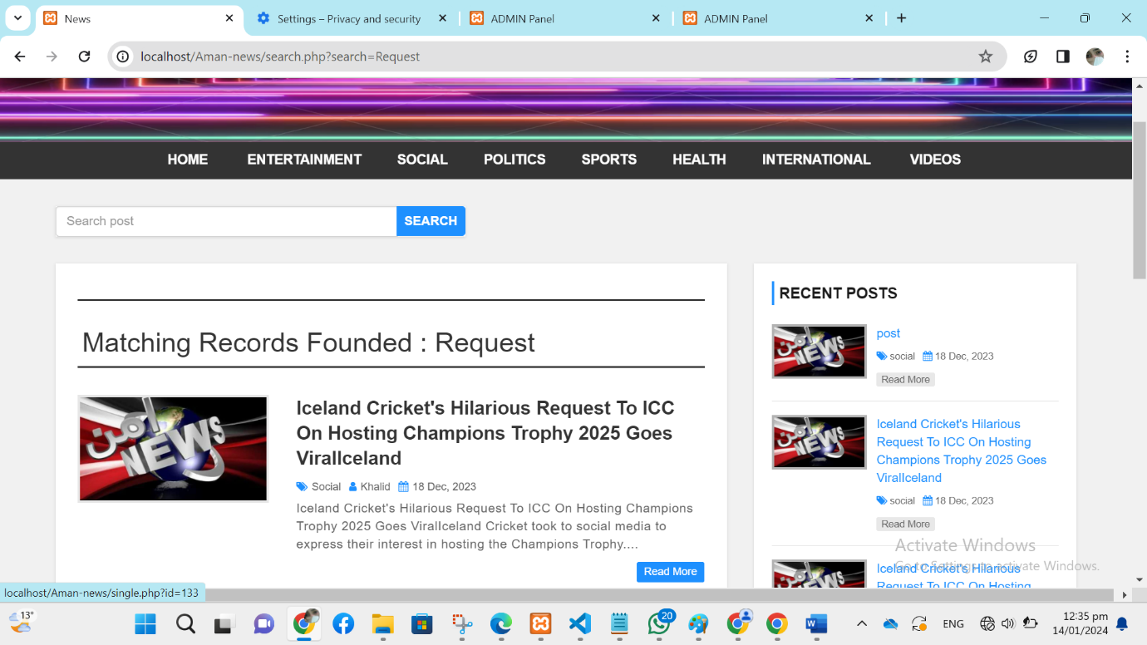

Screenshot 5.9 Searching

**5.10 Footer**

The footer of the website consist of social media links, contact links, about the Aman News, and a comment section. When the user click on social link the user will direct to the corresponding platform.

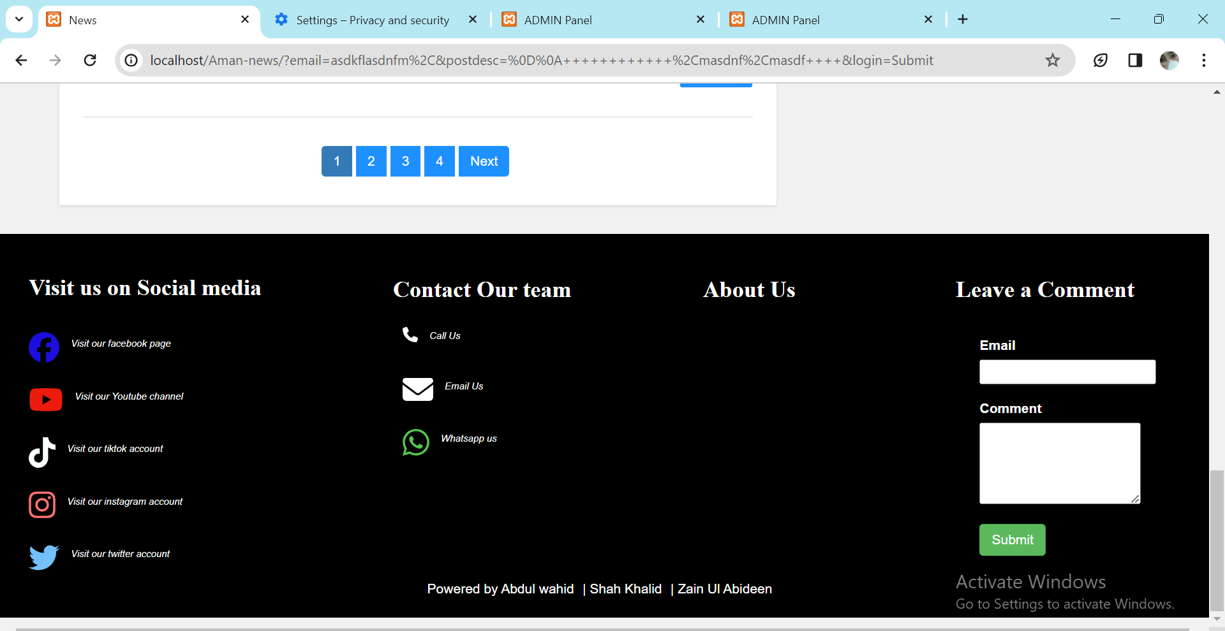

Screenshot 5.10 Footer

1.