Final Year Project Report

**Sensor Integrated System based Real Time and Online Monitoring for Organ on Chip platforms**

Wakeel Ahmed

Muhammad Saqlain

Faizan Ahmed

A report submitted in part fulfilment of the degree of

**Bachelor of Engineering (Electrical Engineering)**

**Supervisor:** Dr. Fida Hussain



Department of Electrical Engineering

Sukkur IBA University, Sukkur

February 14, 2025

## CERTIFICATE

This Thesis is written by **Wakeel Ahmed**, **Muhammad Saqlain** and **Faizan Ahmed** under the direction of their supervisor **Dr. Fida Hussain** and approved by all the members of thesis committee, has been presented to and accepted by the Head of Department of Electrical Engineering, in partial fulfilment of the requirements of the degree of **Bachelor of Electrical Engineering.**

_________________ ________________________

Project Supervisor HOD, Electrical Engineering

________________ ____________________

Internal Examiner External Examiner

## PREFACE

This thesis is submitted in fulfillment of the requirements for the Bachelor of Electrical Engineering degree at Sukkur IBA University. The primary focus of this research is the design and development of a Real-Time and Online Monitoring System for Microphysiological Sensor Integrated System.

This project was completed by a team of two people, and the resulting thesis offers a comprehensive exploration of the integration of microphysiological sensors with real-time data analysis and online monitoring capabilities. We would like to express our profound gratitude to Dr. Fida Hussain, project supervisor, for his invaluable guidance, support, and encouragement throughout this project. His expertise and support were instrumental in the successful completion of this work.

The thesis is divided into several sections, beginning with an introduction and literature review, followed by methodology, design and development, results, and discussion. The final section serves as a conclusion, summarizing the findings and offering suggestions for future work.

**Wakeel Ahmed** (033-19-0026)

**Muhammad Saqlain** (033-20-0011)

**Faizan Ahmed** (033-20-0032)

## DECLARATION

This report has been prepared based on my own work. Where other published and unpublished source materials have been used, these have been acknowledged.

Word Count: 9100

* Wakeel Ahmed___________
* Muhammad Saqlain ___________
* Faizan Ahmed ____________

Date of Submission:

Signature:

## DEDICATION

With grace of Allah Almighty also prayers of our Parents and Teachers for their support, encouragement and endless love who taught us to think clearly & motivated us to try our hardest in everything we do, without them we could not have reached our goals and to all those who believe in the power of learning.

## ACKNOWLEDGEMENT

All praise be to ALLAH, the Almighty, the most Merciful and Compassionate, to start and complete this project.

The work on this project has been an inspiring, often exciting, sometimes challenging, but always interesting experience. It has been made possible by many other people, who have supported us. So, we would like to take this opportunity to express our sincere gratitude to all those who have contributed to completing this project.

Firstly, we would like to thank our thesis adviser **Dr. Fida Hussain,** Assistant Professor, Dept. of Electrical Engineering (EE), **Sukkur IBA University**, for his supportive guidance and feedbacks towards our project for its completion.

Finally, we wish to thank our parents for their undivided support and interest, who has inspired us and encouraged us to go our own way, without whom we would be unable to complete this project.

## RESEARCH ETHIC FORM

I hereby affirm that the work presented in this thesis is original to me and was completed after my admission to the Bachelor of Engineering in Electrical Engineering program at Sukkur IBA University. No portion of this work has been included in any other thesis or dissertation submitted to this or any other institution for credit towards a degree, diploma, or other qualification. I agree to be responsible for ensuring that all procedures are carried out in accordance with the University's current research ethics guidelines. I have made every effort to foresee and mitigate all potential ethical, legal, and safety concerns that may come from this research, and I have gotten all necessary approvals before beginning.

Signature: __________

Date: ______________

## ABSTRACT

This thesis introduces the development of a Real-Time and Online Monitoring System for Microphysiological Sensor Integrated Systems. This project addresses the need for continuous, real-time monitoring of biological processes in medical research and diagnostics. To start we need to improve the connection existing between microphysiological systems and digital monitoring technologies so that biological data can be converted into insights that can be acted upon smoothly.

The system utilizes LabVIEW and NI myRIO for real-time data acquisition from integrated biosensors that monitor physiological parameters. The data collected is then streamed to Firebase, a cloud-based platform, ensuring real-time data availability and storage. An Android application was developed to access this data, providing users with real-time analytics and the ability to download data in CSV format for further analysis.

The effectiveness of the system was validated through testing, which confirmed its capability to provide accurate and reliable monitoring. The project has successfully demonstrated the practical application of integrating cutting-edge sensor technology with real-time data processing and online monitoring. It also offers significant improvements over traditional methods that often involve delays and batch processing.

Not only do the achievements in this project support the use of real time physiological monitoring systems, but they also open doors for their extensive use in clinical settings, drug development, and personalized medicine. These system’s design principles and implementation lead to a scalable framework that can respond to several biomedical applications, it begins for a new era for healthcare technology integration.

## TABLE OF CONTENTS

CERTIFICATE ii

PREFACE iii

DECLARATION iv

DEDICATION v

ACKNOWLEDGEMENT vi

RESEARCH ETHIC FORM vii

ABSTRACT viii

TABLE OF CONTENTS ix

LIST OF TABLES xii

LIST OF FIGURES xiii

THESIS OUTLINE xiv

CHAPTER 1 1

INTRODUCTION 1

1.1 Background 1

1.2 Technology 2

1.2.1 LabVIEW and NI myRIO 2

1.2.2 Firebase: Cloud-Based Real-Time Data Storage 3

1.2.3 Key benefits of Firebase in this application include: 3

1.2.4 Android Application for Real-Time Monitoring 3

1.2.5 Integrated System for Data Processing and Actionable Insights 3

1.3 Problem Statement 4

1.3.1 Real-time Data Monitoring 4

1.3.2 Integration of Sensors 4

1.3.3 Data Accessibility and Analysis 5

1.3.4 Scalability and User Interface 5

1.4 Motivation 6

1.4.1 Enhanced Drug Development 6

1.4.2 Advancements in Disease Modeling 6

1.4.3 Personalized Medicine 6

1.4.4 Operational and Technological Accessibility 6

1.4.5 Significance of the Study 7

1.5 Objectives 7

1.6 Applications 7

1.6.1 Biomedical Research 7

1.6.2 Drug Development and Testing 7

1.6.3 Personalized Medicine 7

1.6.4 Toxicology 8

1.6.5 Educational Tool 8

1.6.6 Regulatory Testing 8

1.6.7 Healthcare Monitoring Devices 8

CHAPTER 2 9

LITERATURE REVIEW 9

2.1 Evolution of Microphysiological Systems 9

2.2 Challenges in Real-Time Monitoring 9

2.3 Advances in Biosensor Integration 10

2.4 Microfluidics and Organ-on-a-Chip Design 10

2.5 Data Management and Analysis 11

2.6 Scalability and Standardization 11

2.7 Case Studies and Recent Advancements 11

CHAPTER 3 15

METHODOLOGY 15

CHAPTER 4 18

System Design and Architecture 18

4.1 Overall System Architecture 18

4.2 Hardware Components 19

4.2.1 Electrochemical Sensors 19

4.2.2 Custom PCB for Signal Processing 19

4.2.3 Microcontroller (NI myRIO) for Data Acquisition 19

4.2.4 Wired Communication Modules 19

4.3 Software Components 20

4.3.1 Real-Time Data Processing in LabVIEW 20

4.3.2 Cloud-Based Data Storage with Firebase 20

4.3.3 Mobile Application for Remote Monitoring 20

CHAPTER 5 21

Experimental Setup and Results 21

5.1 Experimental Setup 21

5.2 Sensor Calibration and Validation 22

5.3 Drug Testing and Real-Time Monitoring 22

5.4 Cloud-Based Data Storage and Remote Access Testing 22

5.5 System Performance Evaluation 24

5.6 Experimental Results and Observations 25

CHAPTER 6 26

CONCLUSION AND FUTURE RECOMMENDATION 26

6.1 Conclusion 26

6.1.1 Real-Time Drug Monitoring 26

6.1.2 High Accuracy and Efficiency 26

6.1.3 Cloud-Based Accessibility 26

6.2 Future Work 27

6.2.1 Multi-Drug Screening Capability 27

6.2.2 Custom Biosensor Development 27

6.2.3 Advanced AI Integration 27

6.2.4 Multi-Organ-on-Chip Integration 27

6.2.5 Regulatory Compliance and Clinical Validation 28

6.2.6 Enhanced Data Security 28

6.2.7 Wireless IoT Integration 28

6.2.8 Miniaturization and Portability 28

6.2.9 Automation of Experimental Workflows 28

6.2.10 Industry Adoption and Commercialization 29

6.2.11 Scalability and Automation 29

REFERENCES 30

## LIST OF TABLES

Table 1.1. Comparing Traditional Drug Testing vs. Real-Time Monitoring……………………05

Table 2.1. Comparison of Drug Validation Techniques…………………………………………13

## LIST OF FIGURES

Fig. 1.1. Overview of the Real-Time Drug Validation System……………………………...…….02

Fig. 1.2. Block diagram...………………………………………………………………………...04

Fig. 2.1. AI in drug discovery and laboratory automation for preclinical testing………………...14

Fig. 3.1. Complete System Workflow………………………………………………………….…15

Fig. 3.2. PCB Schematic Circuit Design…………………………………………………….……16

Fig. 3.3. PCB Components……………………………………………………………………….16

Fig. 4.1. Hardware Setup………………………………………………………………………....18

Fig. 4.2. LabVIEW Interface………………………………………………………………….….20

Fig. 5.1. Experimental Setup………………………………………………………………….….21

Fig. 5.2. Cloud Storage...…………………………………………………………………….…...23

Fig. 5.3. Retrieving Data Through Mobile App……………………………………………….….24

Fig. 5.4. Our Results with Different Concentration...…………………………………………….25

Fig. 5.5. Company Provided Results with Different Concentration...………………………….…25

Fig. 6.1. Scaling of Project Up to 12 Sensors...…………………………………………………...29

## THESIS OUTLINE

The thesis is systematically divided into six chapters.

Chapter 1 provides the background, problem statement, objectives, and significance of the study.

Chapter 2 reviews current technologies and challenges in Organ-on-Chip (OoC) platforms and real-time monitoring systems.

Chapter 3 details the design and development processes of the monitoring system, including sensor selection, PCB integration, and data acquisition using NI myRIO and LabVIEW.

Chapter 4 describes the technical specifications and integration of system components, including hardware architecture, cloud storage implementation, and mobile application development for real-time visualization.

Chapter 5 presents the findings from the system deployment and testing, analyzing data accuracy, system response time, and performance efficiency.

Chapter 6 summarizes the study and outlines potential areas for further research, including wireless communication integration, expansion to multiple biosensors, and AI-based predictive analytics for enhanced drug testing.

## CHAPTER 1

## INTRODUCTION

### 1.1 Background

The integration of biological sciences with engineering principles has promoted significant advancements in biomedical research, particularly through the development of microphysiological systems (MPS) [1]​. These systems, also known as organ-on-a-chip (OoC), replicate human organ functions on a microchip, offering a sophisticated means to mimic human physiological responses within an in vitro setup [2]​. This approach promises to enhance the predictive accuracy of biomedical research beyond traditional cell culture and animal models, providing a dynamic platform for drug testing, disease modeling, and personalized medicine [1]​.

Despite the profound capabilities of MPS, their practical utility is often curtailed by technological limitations in real-time data monitoring and analysis [2]​. Traditional MPS setups predominantly rely on endpoint measurements, which provide only discrete snapshots of biological processes, thus missing the continuous interaction dynamics between biological tissues and their environments [1]​.

A significant advancement in overcoming these limitations has been the integration of microfluidic biosensors within MPS. These biosensors offer non-invasive, continuous monitoring of biomarkers and physiological responses, thus providing a more detailed and dynamic mapping of organ-specific reactions to pharmacological agents or pathological conditions [1]​. According to a comprehensive review by Memon et al. (2023), microfluidic biosensors have demonstrated high detection accuracy and minimal invasiveness, which are crucial for real-time monitoring in MPS setups​ [1]. These technologies allow for the detailed characterization of cellular behaviors and tissue interactions, providing insights into the minute-to-minute changes occurring within the modeled organ systems [1]​.

Moreover, the review highlights that while microfluidic biosensors present a promising advancement, their integration into MPS is not without challenges. These include the need for precise sensor calibration, issues with biocompatibility, and the complexity of embedding sensors that do not interfere with the microenvironment of the tissues being studied​. The ultimate goal is to create an MPS that not only mimics the minimal functional unit of an organ but also enables detailed and continuous monitoring to observe the onset and progression of disease or the response to therapeutic interventions without disrupting the system's integrity [1]​.

This project seeks to address these critical gaps by enhancing MPS with sophisticated data acquisition systems that can perform continuous and non-invasive monitoring of diverse biological signals [2]​. By doing so, it aims to push the boundaries of current MPS capabilities, making them more viable for complex biomedical applications and reducing reliance on conventional and often ethically fraught animal testing models [1]​.

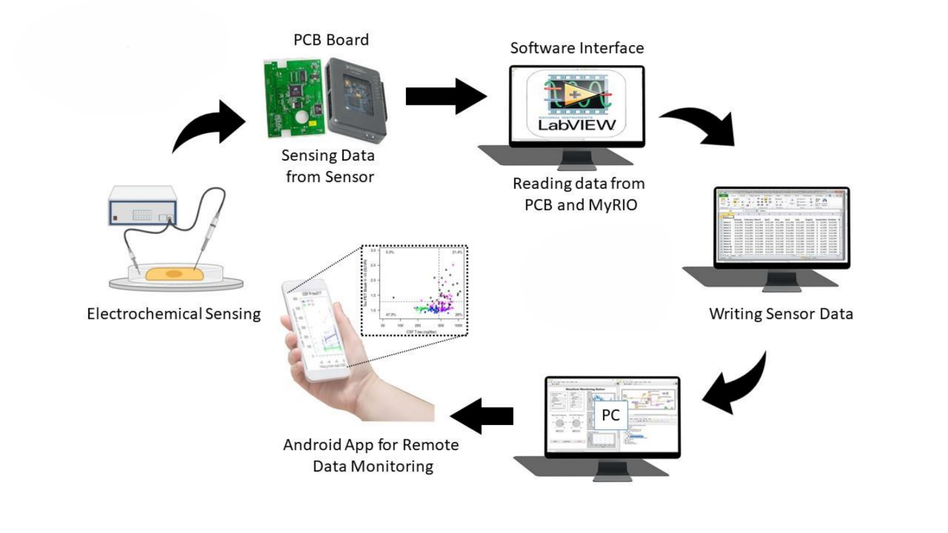

Fig. 1.1. Overview of the Real-Time Drug Validation System.

### 1.2 Technology

The successful implementation of the Real-Time and Online Monitoring System for Microphysiological Sensor Integrated Systems relies on the integration of multiple advanced technologies. Each component has been chosen for its ability to contribute to a robust, precise, and user-friendly monitoring system.

### 1.2.1 LabVIEW and NI myRIO

LabVIEW software, paired with NI myRIO hardware, plays a central role in data acquisition and real-time signal processing for various sensors​. LabVIEW’s graphical programming environment allows for customized application development, enabling users to analyze complex datasets in real-time​.

The NI myRIO platform is an FPGA-based system, which offers high-speed data processing and supports multiple sensor inputs, making it ideal for managing complex data types generated by MPS. This integration ensures accurate tracking of physiological parameters such as pH levels, oxygen concentration, and metabolic rates​.

### 1.2.2 Firebase: Cloud-Based Real-Time Data Storage

To address challenges in real-time data access and storage, Firebase, a cloud-based platform, is employed​. Firebase offers scalable database solutions, enabling real-time data streaming from multiple sources simultaneously​.

### 1.2.3 Key benefits of Firebase in this application include:

* Secure storage of sensor-generated data​.
* Remote accessibility, allowing researchers to monitor experiments from any location​.
* Seamless integration with data analytics tools, enabling real-time assessment of physiological changes​.

This feature is particularly advantageous in longitudinal studies, where maintaining data integrity over extended periods is critical​.

### 1.2.4 Android Application for Real-Time Monitoring

To enhance user accessibility, a dedicated Android application was developed​. This app serves as the primary user interface, allowing researchers to:

* Visualize real-time data from MPS sensors​.
* Receive instant alerts on significant physiological changes​.
* Export data in CSV format for further analysis​.

This mobile-friendly approach makes the monitoring system practical for diverse applications, including laboratory research, clinical trials, and personalized medicine​.

### 1.2.5 Integrated System for Data Processing and Actionable Insights

The integration of LabVIEW, NI myRIO, Firebase, and an Android application forms a cohesive real-time monitoring system​. The system is capable of:

* Continuous data collection from multiple sensors​.
* Storing and analyzing physiological parameters in real-time​.
* Providing actionable insights through interactive visualization tools​.

This technological framework aligns with the project's goal to enhance the functionality of MPS, significantly benefiting the fields of drug testing, disease modeling, and personalized medicine​.

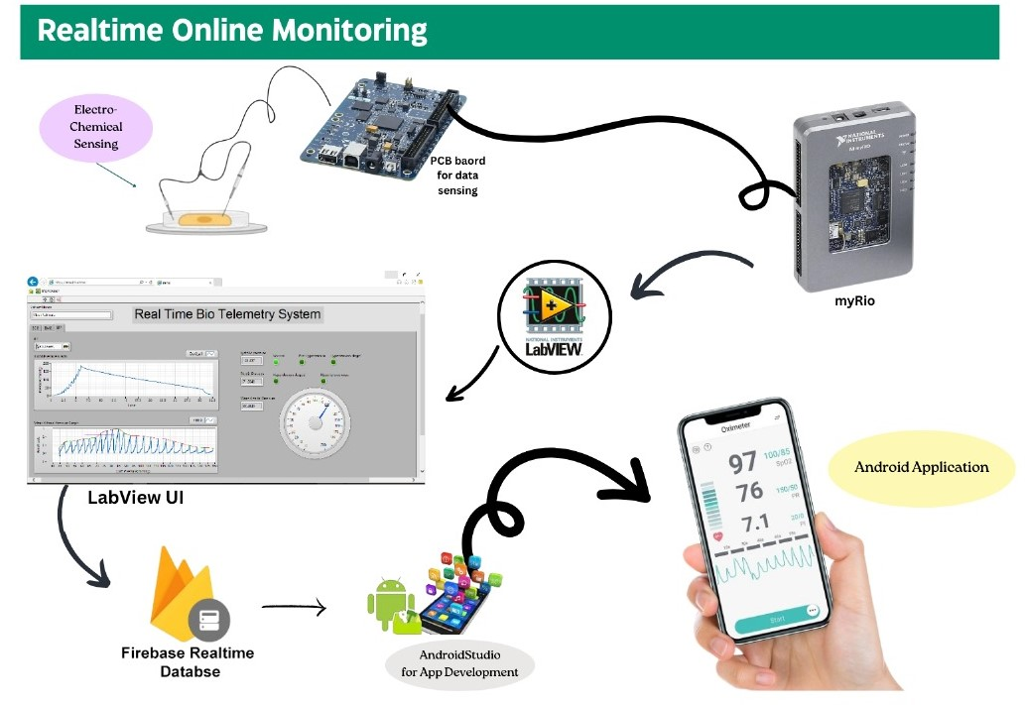

Fig. 1.2. Block diagram.

### 1.3 Problem Statement

Microphysiological systems (MPS), or organ-on-chip technologies, represent a significant leap forward in biomedical research, providing platforms that emulate human organ functionalities in vitro with higher fidelity than traditional cell cultures [3]. While these systems have the potential to transform drug testing, disease modeling, and personalized medicine, their effectiveness is significantly hampered by several technological and operational limitations [4].

### 1.3.1 Real-time Data Monitoring

One of the primary challenges in current MPS implementations is the lack of real-time data monitoring capabilities. Most MPS rely on periodic sampling to assess cellular responses, which can miss critical dynamics and interactions that occur between these intervals. This limitation reduces the efficacy of MPS in scenarios where continuous data is crucial to understanding complex biological responses and immediate drug interactions.

### 1.3.2 Integration of Sensors

While sensors are essential for gathering biological data, integrating them into MPS without disrupting the microenvironment remains a challenge. Current sensor integration often involves invasive methods that can alter the behavior of the biological system being studied. There is a need for non-invasive, highly sensitive sensors that can be seamlessly integrated into MPS to monitor various physiological parameters without affecting the native biological processes.

### 1.3.3 Data Accessibility and Analysis

Another significant issue is the accessibility and real-time analysis of the data collected. Traditional systems often involve complex data management and analysis processes that are not conducive to timely decision-making. There is a critical need for systems that can not only collect and store data efficiently but also make it readily available for real-time analysis and decision-making.

### 1.3.4 Scalability and User Interface

Finally, the scalability of MPS and the complexity of their operation pose significant barriers to their widespread adoption. The technology often requires specialized knowledge to operate and analyze, limiting its use to specialized research settings. Developing user-friendly interfaces and systems that can be easily scaled and adapted for various research and clinical applications is essential for broader adoption.

Table 1.1. Comparing Traditional Drug Testing vs. Real-Time Monitoring.

|  |  |  |  |
| --- | --- | --- | --- |
| **Aspect** | **Traditional Drug Testing** | **Real-Time Monitoring** | **Gap Addressed** |
| Detection Method | Blood, urine, saliva, or hair analysis | Biosensors, wearable devices | Eliminates delays in detection |
| Detection Speed | Hours to days after drug use | Instant or near real-time | Provides immediate alerts |
| Frequency | Periodic (random or scheduled tests) | Continuous monitoring | Prevents missed incidents |
| Accuracy | Can be affected by dilution or tampering | Continuous data reduces false negatives | Reduces manipulation risk |
| Cost Efficiency | Lower per test but expensive over time due to repeat tests | Higher upfront cost but cost-effective in long run | Reduces need for frequent lab testing |
| Privacy & Ethics | Lower concerns due to infrequent testing | Higher concerns due to continuous tracking | Needs secure & ethical data handling |
| Aspect | Traditional Drug Testing | Real-Time Monitoring | Gap Addressed |
| Detection Method | Blood, urine, saliva, or hair analysis | Biosensors, wearable devices | Eliminates delays in detection |

### 1.4 Motivation

The motivation behind this project stems from a critical need to bridge the gap between the theoretical potential and practical utility of microphysiological systems (MPS) in biomedical research and clinical applications. The specific challenges that MPS face, particularly in terms of real-time monitoring and sensor integration, pose significant barriers to fully exploiting their capabilities. Addressing these challenges could significantly advance the field of biomedical engineering, particularly in the following key areas:

### 1.4.1 Enhanced Drug Development

Drug discovery and development are crucial areas in healthcare that can benefit immensely from improved MPS. Traditional drug testing methods, including animal models and static cell cultures, often fail to accurately predict human responses due to their inability to mimic the complex interactions of human tissues. MPS equipped with real-time monitoring capabilities can provide a more accurate, efficient, and ethical alternative, reducing the cost and time associated with bringing new drugs to market [5].

### 1.4.2 Advancements in Disease Modeling

The ability to model diseases in a controlled, reproducible environment that closely mimics human physiology is paramount for understanding disease mechanisms and developing effective treatments. MPS with integrated real-time sensors can facilitate dynamic disease modeling, allowing researchers to observe the progression of diseases and the effect of therapeutic interventions in real time [6].

### 1.4.3 Personalized Medicine

Personalized medicine relies on the ability to tailor treatments to individual patients based on their unique genetic makeup and disease presentation. MPS can play a vital role in this area by enabling the testing of drug responses on patient-derived cells. However, without real-time data and seamless sensor integration, the full potential of MPS in personalized medicine remains untapped [7].

### 1.4.4 Operational and Technological Accessibility

The complexity and operational challenges associated with current MPS technologies limit their adoption in broader research and clinical settings. Simplifying the integration and operation of these systems through user-friendly interfaces and automated data processes can democratize access to cutting-edge research tools, broadening their impact [8].

### 1.4.5 Significance of the Study

The development of a real-time monitoring system for MPS has significant implications for biomedical research, particularly in improving the efficiency and accuracy of drug testing and disease modeling. This study contributes to the field by providing a detailed account of system integration challenges and solutions, potentially setting new standards in MPS technology usage [9].

### 1.5 Objectives

The primary objective of this research is to develop and integrate a real-time sensor monitoring system for microphysiological systems (MPS) to enable continuous, non-invasive data acquisition, advanced data analytics, and enhanced scalability​. By incorporating biosensors, cloud-based storage, automated analysis, and wireless accessibility, this research aims to improve the reliability, reproducibility, and practical usability of MPS​.

### 1.6 Applications

The development of a Real-Time and Online Monitoring System for Microphysiological Sensor Integrated Systems has broad applications across various domains. This technology is not only pivotal for advancing research but also holds significant potential for enhancing clinical practices and industrial processes. Below are key applications:

### 1.6.1 Biomedical Research

The system can dramatically improve the efficiency and effectiveness of biomedical research, particularly in the areas of pathophysiology and pharmacology. Researchers can use real-time data to observe the immediate effects of pharmacological agents on bioengineered tissues, facilitating a deeper understanding of drug mechanisms and interactions at a cellular level.

### 1.6.2 Drug Development and Testing

This technology can accelerate the drug development process by providing real-time insights into the pharmacodynamics and pharmacokinetics of new drugs. It allows for continuous monitoring of drug effects on organ models, which can help in early detection of potential side effects, thereby reducing the cost and time associated with clinical trials.

### 1.6.3 Personalized Medicine

The system supports personalized medicine initiatives by enabling the testing of drugs on cells derived from individual patients. This approach can help predict the effectiveness and safety of therapies tailored to the genetic profiles and specific health conditions of patients, ultimately leading to more effective and safer treatments.

### 1.6.4 Toxicology

In toxicological research, the system can be used to assess the toxicity of new chemical entities in real-time. This application is crucial for identifying potentially harmful substances before they are used in pharmaceuticals, cosmetics, and other products, ensuring consumer safety.

### 1.6.5 Educational Tool

Beyond research and clinical applications, this system can serve as a powerful educational tool in academic settings. It can provide students with hands-on experience in monitoring and analyzing physiological processes, thereby enhancing learning and fostering a deeper understanding of human biology.

### 1.6.6 Regulatory Testing

Regulatory bodies can use this system to establish more accurate and reliable testing protocols for drug approval processes. Real-time data provided by the system can offer more comprehensive insights into a drug’s behavior, supporting more informed decision-making by regulatory agencies.

### 1.6.7 Healthcare Monitoring Devices

The underlying technology could be adapted for use in healthcare monitoring devices, offering real-time, continuous observation of patients’ physiological states in clinical and home settings. This could be particularly beneficial for managing chronic conditions or for post-operative care, where immediate data on patient status can guide interventions and treatments.

## CHAPTER 2

## LITERATURE REVIEW

Microphysiological systems (MPS) or organ-on-a-chip (OoC) technologies have become a game-changer in biomedical research with in vitro systems that most closely mimic the functions of human organs. These systems offer a more physiologically relevant environment than conventional 2D cell cultures and animal models and thus are of enormous value for drug discovery, personalized medicine, and disease modeling. Although promising, there are a number of challenges in the applied use of MPS, especially in real-time monitoring, sensor integration, scalability, and data accessibility. This chapter discusses the current status of MPS technologies, biosensor integration, and real-time monitoring and analysis of data.

## 2.1 Evolution of Microphysiological Systems

The roots of MPS go back to developments in microfluidics, biomaterials, and tissue engineering, which in combination have enabled the creation of three-dimensional human organ models. The early efforts focused on the development of single-organ models, e.g., lung-on-a-chip and liver-on-a-chip, that enlightened organ-specific function and organ responses to environmental signals. For instance, lung-on-a-chip models have been used to investigate pulmonary drug permeability and gas exchange mechanisms, while liver-on-a-chip platforms have been used in metabolic and toxicology studies to better predict drug-induced toxicity [1].

The recent developments have led to the development of multi-organ-on-a-chip systems that attempt to replicate the complex interactions among different organs within the body. These are particularly useful to examine systemic drug action and disease pathogenesis. For example, a liver, heart, and lung-based multi-organ chip was used to examine the pharmacokinetics and pharmacodynamics of drugs and have better insight into drug metabolism and toxicity [2].

## 2.2 Challenges in Real-Time Monitoring

One of the limitations of existing MPS implementations is the use of endpoint measurements, which offer snapshots of biological activity and not continuous physiological monitoring. Most MPS configurations involve sporadic sampling to determine cellular responses, which could overlook important dynamics and interactions that happen between sampling intervals. This shortcoming compromises the effectiveness of MPS in uses where continuous data is essential in determining complex biological responses and real-time drug interactions [3].

To fill this gap, researchers have focused on integrating biosensors into MPS platforms. Biosensors allow for real-time, non-invasive monitoring of biomarkers and physiological responses, allowing for a more dynamic and integrated mapping of organ-specific responses to pharmacological agents or pathological states. Integrating biosensors into MPS, however, poses some challenges. These include precise calibration of the sensor, biocompatibility, and the problem of inserting sensors without interfering with the microenvironment of the tissues involved [4].

## 2.3 Advances in Biosensor Integration

The integration of biosensors in MPS has been a significant research area in recent years. Biosensors can quantify a range of physiological parameters like oxygen uptake, glucose metabolism, pH change, and electrical resistance. Biosensors possess real-time cellular function monitoring and tissue interaction, providing data on the minute-to-minute changes within the simulated organ systems [5].

Recent advances in biosensor technology have been geared toward improving sensitivity, reducing energy levels, and achieving long-term stability. For instance, biosensors based on nanotechnology have been seen to offer sensitivity enhancement and less invasiveness of sensor implantation. Such biosensors can be integrated into the MPS microfluidic channels without affecting the cellular microenvironment, hence allowing for real-time monitoring without modifying the original biological processes [6].

## 2.4 Microfluidics and Organ-on-a-Chip Design

Microfluidics is crucial for organ-on-a-chip system assembly and function. Microfluidic platforms enable precise control of cellular microenvironments, thereby enabling the simulation of physiological conditions such as fluid dynamics, nutrient delivery, and waste removal. Some of the recent advances in microfluidic engineering include the development of polydimethylsiloxane (PDMS)-based microfluidic devices, which are characterized by their enhanced biocompatibility and optical transparency, enabling continuous observation and imaging [7].

Multi-layered organ-on-a-chip devices have been engineered to further enable cellular interactions and mimic the complex structure of human organs. Such configurations often involve vascularized networks to enable tissue performance and viability. For example, bioprinted vascular networks have been integrated into liver-on-a-chip devices to maximize nutrient delivery and waste removal, generating more physiologically relevant tissue models [8].

## 2.5 Data Management and Analysis

Monitoring and analysis of large volumes of biological data generated by MPS remain a major challenge. Traditional MPS platforms are typically slow in data acquisition, leading to decision delay and limiting their use in large-scale drug screening workflows. Scientists are now overcoming this challenge by adopting cloud-based data storage alongside AI-driven analytical techniques [9].

Cloud-based platforms such as Firebase provide real-time access to experimental data, thereby facilitating remote monitoring and collaborative research processes for researchers. Such platforms provide scalable database solutions that provide secure data storage and seamless integration with data analytics tools. AI-based analytics have also been incorporated into MPS platforms to automate data interpretation and predictive modeling processes, thereby enhancing the efficiency of drug discovery and applications in personalized medicine [10].

## 2.6 Scalability and Standardization

Despite the significant advancements in MPS technologies, scalability and standardization remain major barriers to their widespread adoption. Many existing MPS models require specialized training, making them less accessible to non-expert users. The lack of standardized fabrication methods and calibration protocols also introduces variability in experimental results, affecting the reproducibility of studies [11].

Efforts to develop automated, user-friendly platforms have the potential to overcome these challenges and facilitate the large-scale adoption of organ-on-a-chip technologies. For example, automated systems for cell seeding, media exchange, and data collection have been developed to reduce the complexity of MPS operation. Standardized protocols for sensor calibration and data analysis are also being established to ensure reproducibility and regulatory compliance [12].

## 2.7 Case Studies and Recent Advancements

Several recent reports have demonstrated the promise of microphysiological systems (MPS) for a variety of biomedical applications. Zhang et al. (2020), for instance, developed a multi-organ-on-a-chip platform that integrated liver, heart, and lung models to study the systemic effects of drugs. This platform utilized advanced biosensors to monitor real-time alterations in metabolic activity, providing valuable insights into drug metabolism and toxicity [13].

Henry et al. (2019) also conducted a study on the creation of a brain-on-a-chip model to investigate neurodegenerative diseases. The model used microfluidic channels and biosensors to track neuronal activity and blood-brain barrier permeability, with a more physiologically relevant platform for drug screening and disease modeling [14].

Microphysiological systems (MPS), commonly referred to as organ-on-a-chip (OoC) technologies, have significantly advanced biomedical research by providing in vitro platforms that closely replicate human organ functionalities​ [10]. These systems offer greater physiological relevance than traditional 2D cell cultures and animal models, making them valuable for drug discovery, personalized medicine, and disease modeling​ [11].

Despite their potential, several challenges remain in the practical implementation of MPS, particularly in real-time monitoring, sensor integration, scalability, and data accessibility​. Research efforts in recent years have focused on integrating biosensors, optimizing microfluidic networks, and enhancing data analytics to overcome these challenges and make MPS more efficient [10]​.

The development of MPS can be traced back to innovations in microfluidics, biomaterials, and tissue engineering, which led to the creation of three-dimensional models of human organs [12]. Research on lung-on-a-chip models has provided insights into pulmonary drug permeability and gas exchange mechanisms, while brain-on-a-chip platforms have facilitated the study of blood-brain barrier permeability and neurodegenerative diseases​. Similarly, liver- and kidney-on-a-chip models have proven effective for metabolic and toxicology research, providing improved predictions of drug-induced toxicity [13]​.

A major limitation in MPS is the reliance on endpoint measurements, which provide only snapshots of biological activity instead of continuous physiological monitoring​. The integration of biosensors has been instrumental in enabling real-time monitoring of metabolic activity, including oxygen consumption, glucose metabolism, and pH changes​. Advances in electrical impedance monitoring have also allowed for dynamic assessment of tissue integrity and cellular responses to drugs [14]​.

The field of microfluidics plays a crucial role in organ-on-a-chip models by providing precise control over cellular microenvironments​. Recent advances include PDMS-based microfluidic designs that optimize nutrient flow and waste removal, multi-layered organ-on-a-chip architectures that improve cellular communication, and bioprinted vascularized networks for enhancing tissue viability​. These developments have significantly improved the functionality and longevity of MPS models [15]​.

Despite these advancements, biosensor integration still presents challenges due to interference with cell function, biocompatibility issues, and sensor degradation over time​. Many current biosensors use invasive placement techniques, which may disrupt cellular signaling pathways​. Researchers have proposed solutions such as non-invasive biosensors, which allow for real-time physiological monitoring without altering tissue microenvironments​. Additionally, nanotechnology-based biosensors have shown promise in enhancing sensitivity, reducing energy consumption, and improving long-term stability​ [11].

The management and analysis of large volumes of biological data generated by MPS remain a major challenge​. Traditional MPS platforms often require manual data collection, leading to delays in decision-making and limiting their applicability in high-throughput drug screening​. The adoption of cloud-based data storage solutions has enabled real-time access to experimental data, allowing researchers to perform remote monitoring and collaborative research​. Furthermore, artificial intelligence (AI)-driven analytics have been integrated into MPS platforms to automate data interpretation and predictive modeling, improving the efficiency of drug discovery and personalized medicine applications​[16].

Table 2.1. Comparison of Drug Validation Techniques [17].

|  |  |  |  |
| --- | --- | --- | --- |
| **Aspect** | **Traditional Lab Testing** | **AI-Based Analysis (Biosensor-Based)** | **Breakthrough** |
| Detection Method | Chemical assays, chromatography, spectrometry | AI-driven biosensors & machine learning algorithms | Faster and automated detection |
| Speed | Hours to days for results | Real-time or near-instant results | Eliminates long processing times |
| Accuracy | High but prone to human errors | Higher accuracy with AI pattern recognition | Reduces human bias & error |
| Scalability | Labor-intensive, expensive for large-scale use | Scalable with automation & minimal human intervention | Cost-effective for large-scale screening |
| Tamper Resistance | Potential for sample contamination or tampering | Continuous, non-invasive tracking | Prevents fraud & manipulation |
| Data Processing | Manual analysis with limited automation | AI-driven big data analysis & predictive modeling | Improves precision & predictive insights |

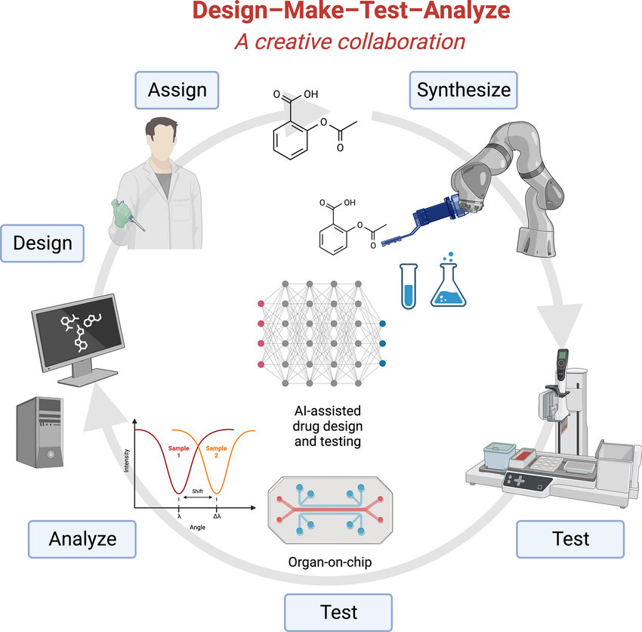

Fig. 2.1. AI in drug discovery and laboratory automation for preclinical testing [16].

The scalability and standardization of MPS models remain a significant barrier to their widespread adoption in clinical and pharmaceutical research​. Many existing MPS models require specialized training, making them less accessible to non-expert users [18]​. The lack of standardized fabrication methods and calibration protocols also introduces variability in experimental results, affecting the reproducibility of studies [19]​. Efforts to develop automated, user-friendly platforms have the potential to overcome these challenges and facilitate the large-scale adoption of organ-on-a-chip technologies​.

Future research in MPS will focus on optimizing sensor integration, improving microfluidic system designs, and enhancing AI-driven data analytics​. The development of multi-organ-on-a-chip models capable of mimicking complex physiological interactions will provide a more accurate representation of systemic drug effects and disease progression [20]​. Standardizing fabrication techniques, sensor calibration protocols, and data processing algorithms will also be essential for ensuring reproducibility and regulatory approval​. This literature review underscores the ongoing advancements in MPS research while identifying key areas for future improvements, particularly in real-time biosensor integration, non-invasive monitoring, and high-throughput data analysis​.

## CHAPTER 3

## METHODOLOGY

The system follows a structured workflow consisting of six primary stages, as illustrated in the Fig. 3.1. The first stage involves electrochemical sensing, where SPE glucose sensors are used to detect drug responses in a microfluidic environment. These sensors continuously monitor metabolic changes, track glucose metabolism shifts, and provide a non-invasive, real-time method for biochemical sensing. The sensor array consists of amperometric biosensors that measure drug-induced redox reactions, potentiometric sensors that detect ion exchange variations, and impedance-based sensors that analyze cell membrane integrity and drug diffusion.

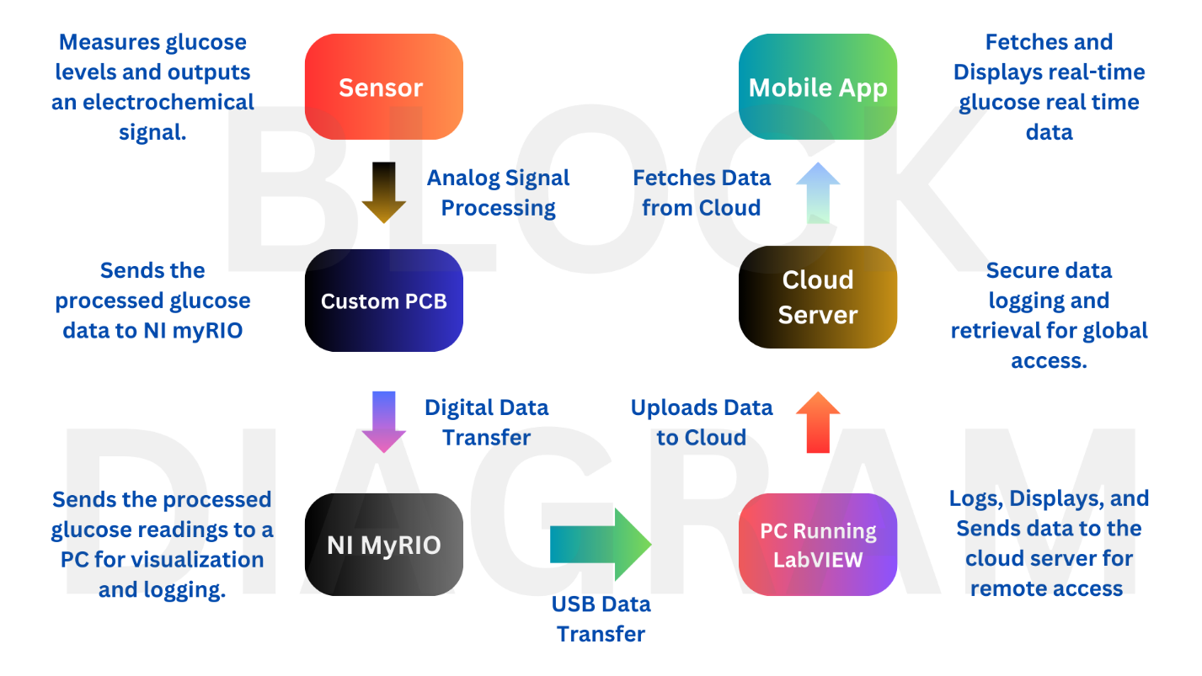

Fig. 3.1. Complete System Workflow.

The second stage involves a custom PCB board responsible for processing signals from electrochemical sensors before transmitting data to the NI myRIO. The PCB design includes analog signal conditioning circuits that amplify and filter sensor outputs, an embedded ADC module for converting analog sensor data to digital format, and low-noise signal processing to ensure high accuracy in drug response detection. The PCB serves as the primary interface between the biosensors and the LabVIEW-based data acquisition system, ensuring seamless data transfer and real-time processing​.

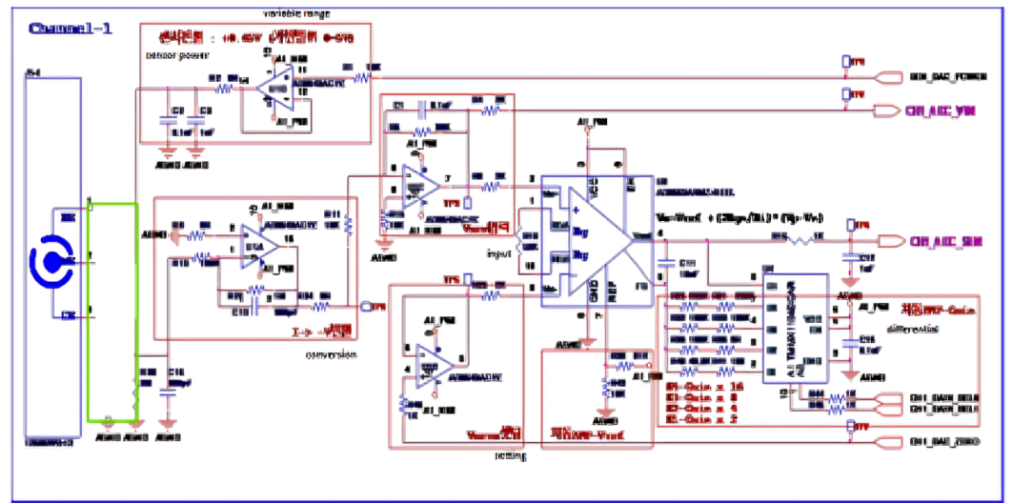

Fig. 3.2. PCB Schematic Circuit Design.

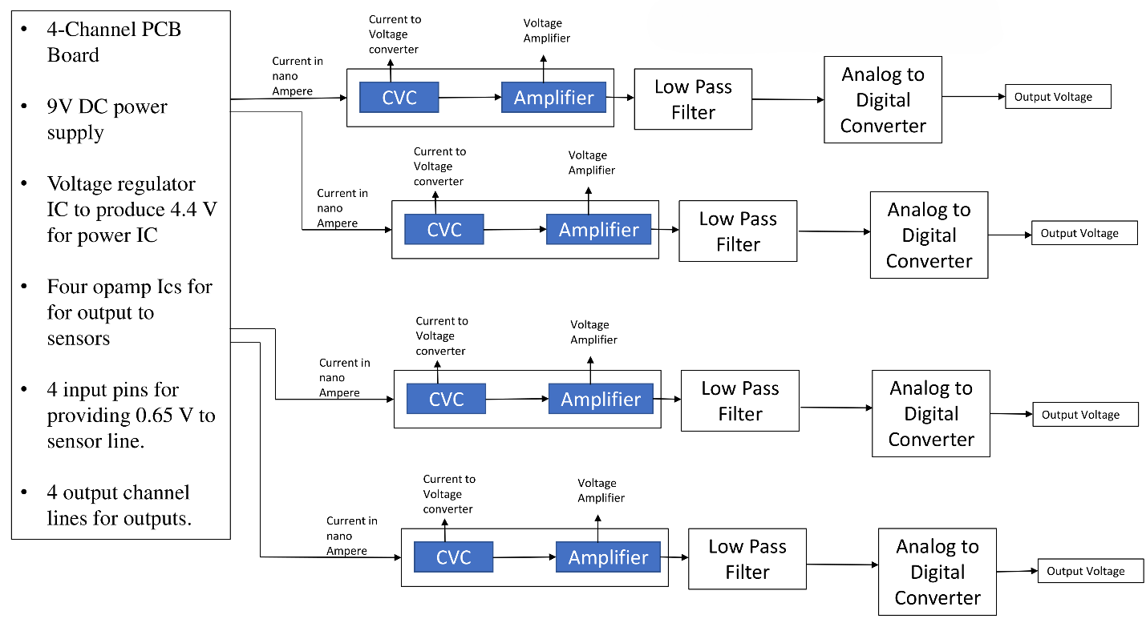

Fig. 3.3. PCB Components.

The third stage of the system architecture involves real-time data acquisition and processing using NI myRIO, which acts as a high-speed controller for acquiring sensor data. NI myRIO enables fast data transmission from multiple biosensors, high-speed processing of drug response signals, and integration with LabVIEW for data visualization and automated analysis. LabVIEW serves as the primary graphical programming environment for acquiring, filtering, and analyzing real-time sensor data. It provides interactive graphs for monitoring drug interactions dynamically, implements automated statistical analysis, and generates alerts for toxicity thresholds and significant metabolic shifts.

The fourth stage involves cloud-based data storage to enable real-time data logging and remote access. Sensor data is automatically logged into a Firebase cloud database, allowing secure storage of experimental results, real-time synchronization with mobile and web applications, and remote monitoring capabilities for research teams. The integration of cloud storage ensures long-term data retention and facilitates collaborative research by providing access to pharmaceutical validation data from multiple locations.

In the fifth stage, the system incorporates wireless monitoring via a custom Android application that allows real-time remote monitoring of drug validation experiments. The mobile application includes live streaming of sensor data, push notifications for drug response alerts, graphical representation of drug interaction trends, and data export functionality for external reporting. The integration of mobile monitoring ensures that researchers can access critical drug validation data on the go, improving the efficiency and flexibility of pharmaceutical screening​.

## CHAPTER 4

## System Design and Architecture

### 4.1 Overall System Architecture

The Real-Time Sensor-Integrated Drug Validation Platform is designed to provide a seamless integration of hardware and software components to facilitate real-time data acquisition, processing, and monitoring of drug interactions. The system architecture consists of interconnected modules, including electrochemical sensors for data collection, a custom PCB for signal processing, a microcontroller for data acquisition, cloud-based storage for real-time data logging, and a mobile application for remote monitoring as shown in the Fig. 4.1.

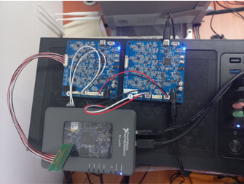

Fig. 4.1. Hardware Setup.

At the core of the system is the NI myRIO microcontroller, which serves as the central processing hub that interfaces between the biosensors, PCB, and cloud-based storage. Sensor data is first captured and preprocessed by the PCB before being transmitted to NI myRIO, where it undergoes real-time filtering, threshold-based analysis, and visualization. The processed data is then sent via secure communication channels to Firebase, ensuring real-time access and storage. Users can monitor and control the system through a dedicated Android application, which provides an intuitive user-friendly interface for real-time visualization, alerts, and remote management. This architecture enables continuous, automated, and scalable drug validation, significantly improving the efficiency of preclinical pharmaceutical research.

### 4.2 Hardware Components

### 4.2.1 Electrochemical Sensors

The system employs screen-printed electrode (SPE) glucose sensors to measure biochemical changes associated with drug interactions. These sensors provide real-time monitoring of glucose metabolism, ion exchange, and electrochemical impedance in a microfluidic chip. The sensors are carefully calibrated to ensure precision and consistency, making them highly reliable for tracking dynamic biochemical processes in pharmaceutical applications. The integration of non-invasive biosensors allows for continuous monitoring without interfering with the drug validation process, ensuring high sensitivity and accuracy in response measurements.

### 4.2.2 Custom PCB for Signal Processing

A custom-designed PCB is developed to handle signal conditioning and initial processing before data is transmitted to NI myRIO. The PCB includes analog signal amplification circuits, noise reduction filters, and an Analog-to-Digital Converter (ADC) for converting biosensor outputs into a digital format. These low-noise amplification and filtering techniques enhance the stability and precision of the data, reducing measurement errors. The PCB serves as the first processing stage, ensuring that the data received by the microcontroller is refined and ready for advanced analysis.

### 4.2.3 Microcontroller (NI myRIO) for Data Acquisition

The NI myRIO microcontroller is the core processing unit of the system, responsible for real-time data acquisition, initial signal processing, and interfacing with external storage and monitoring applications. It is configured to handle multiple sensor inputs simultaneously, ensuring smooth data collection and real-time analysis. The microcontroller also implements preliminary threshold-based decision-making algorithms, which identify critical metabolic shifts or potential drug toxicity. Its real-time computing capabilities make it ideal for pharmaceutical applications, where rapid and precise data acquisition is required for high-throughput drug screening.

### 4.2.4 Wired Communication Modules

Reliable data transmission between the microcontroller and other system components is achieved through USB UART communication modules. These modules ensure secure and uninterrupted data flow between the NI myRIO microcontroller, Firebase cloud storage, and the Android mobile application. The communication protocols are designed to prevent data loss, reduce latency, and maintain data integrity across all interconnected components.

### 4.3 Software Components

### 4.3.1 Real-Time Data Processing in LabVIEW

LabVIEW is used as the primary software interface for data acquisition, filtering, and visualization. The software is programmed to interface directly with NI myRIO, capturing sensor data in real-time and applying noise reduction algorithms to enhance accuracy. The graphical user interface (GUI) in LabVIEW allows researchers to monitor real-time drug interactions, track sensor outputs, and visualize experimental trends dynamically.

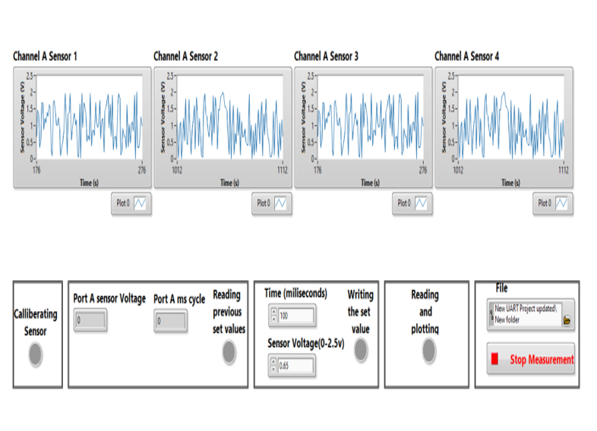

Fig. 4.2. LabVIEW Interface.

### 4.3.2 Cloud-Based Data Storage with Firebase

To enable real-time remote access, the system integrates Firebase cloud storage for data logging and retrieval. Experimental data is transmitted from NI myRIO to Firebase, where it is stored securely and made accessible for remote researchers, clinicians, and pharmaceutical teams. The cloud-based architecture eliminates the limitations of local storage, allowing multi-user access and real-time collaboration on drug validation experiments.

### 4.3.3 Mobile Application for Remote Monitoring

A dedicated Android application allows researchers to monitor real-time sensor data remotely. The application features live data streaming, graphical representations of drug response trends, threshold-based alerts for toxicity detection, and exportable reports for documentation. The ability to remotely track drug validation experiments improves efficiency by reducing the need for continuous on-site supervision.

## CHAPTER 5

## Experimental Setup and Results

### 5.1 Experimental Setup

The experimental setup was designed to test and validate the Real-Time Sensor-Integrated Drug Validation Platform by integrating all hardware and software components in a controlled environment. The experiment aimed to assess sensor accuracy, real-time data acquisition efficiency, cloud-based monitoring reliability, and AI-driven data analytics performance. The setup consisted of electrochemical biosensors, a custom PCB for signal processing, NI myRIO for data acquisition, LabVIEW for real-time analysis, Firebase for cloud storage, and an Android application for remote monitoring. The primary objective was to evaluate the system’s ability to detect drug-induced biochemical changes in real-time and transmit data for further analysis and decision-making.

The biosensors were embedded in a microfluidic chip, which enabled controlled drug perfusion to simulate physiological conditions. The custom PCB processed raw biosensor signals, converting them into digital data before transmitting them to NI myRIO. The LabVIEW interface was used to analyze and visualize sensor outputs, providing real-time feedback on drug interactions. The processed data was then transmitted to Firebase, allowing researchers to remotely access and monitor experiments using the Android application.

Below in the Fig. 5.1, Fig. 5.2. and Fig. 5.3 shows the experimental setup and results

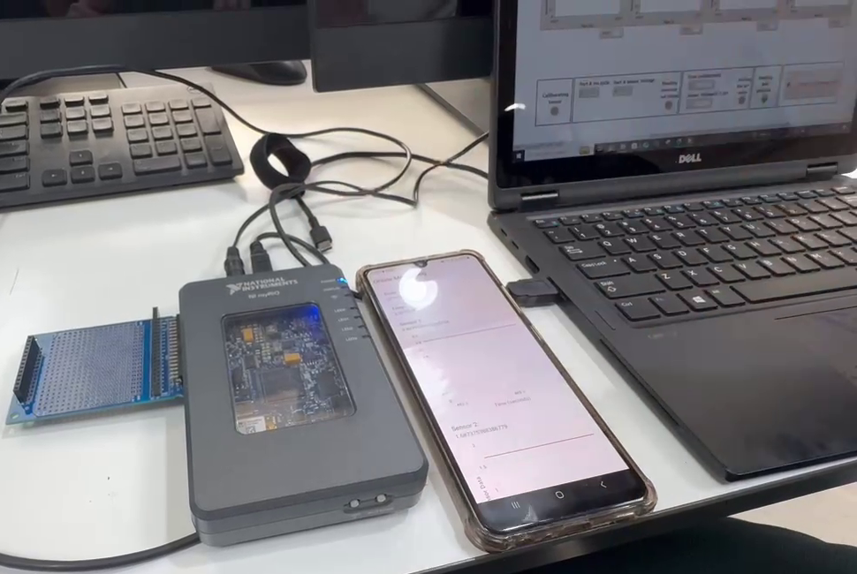

Fig. 5.1. Experimental Setup.

### 5.2 Sensor Calibration and Validation

Before conducting experiments, sensor calibration was performed to ensure accuracy and consistency in detecting biochemical changes. The electrochemical sensors were tested with standard glucose solutions of varying concentrations, and their output responses were compared with lab-based reference measurements. The calibration process involved adjusting sensitivity parameters to minimize error margins and enhance detection precision. The calibrated sensors showed high correlation with laboratory-based glucose analysis, confirming their reliability for drug validation experiments.

Additionally, the PCB signal processing unit was validated by testing its amplification and noise reduction capabilities. The ADC module's performance was assessed to confirm accurate digital conversion of sensor outputs. The LabVIEW data acquisition system was tested for real-time response accuracy, ensuring minimal delay in signal processing and visualization. The communication modules were also verified to confirm stable data transmission between NI myRIO, Firebase, and the mobile application.

### 5.3 Drug Testing and Real-Time Monitoring

After calibration, drug testing experiments were conducted to analyze the effect of pharmaceutical compounds on biochemical parameters. The experiment involved introducing different drug concentrations into the microfluidic chip, where biosensors recorded real-time metabolic responses. NI myRIO acquired sensor data, and LabVIEW was used to track changes in glucose metabolism, ion exchange, and electrochemical impedance. The results were automatically logged into Firebase, allowing researchers to remotely monitor drug response trends via the mobile application.

Real-time monitoring showed that certain drugs induced rapid fluctuations in glucose metabolism, suggesting strong metabolic effects, while others produced gradual, sustained changes, indicating slow pharmacokinetic interactions. The system’s threshold-based decision-making algorithms successfully identified toxic drug responses, triggering automatic alerts when critical thresholds were exceeded. These findings demonstrated the efficacy of real-time monitoring in detecting immediate and long-term drug interactions.

### 5.4 Cloud-Based Data Storage and Remote Access Testing

To validate the cloud-based data storage functionality, real-time sensor data was transmitted to Firebase and retrieved from multiple remote devices. The results showed seamless data synchronization with minimal transmission delays, confirming the system’s ability to handle continuous, high-volume data logging. The cloud storage enabled researchers to retrieve historical experimental data, compare different drug response profiles, and conduct cross-experiment analysis.

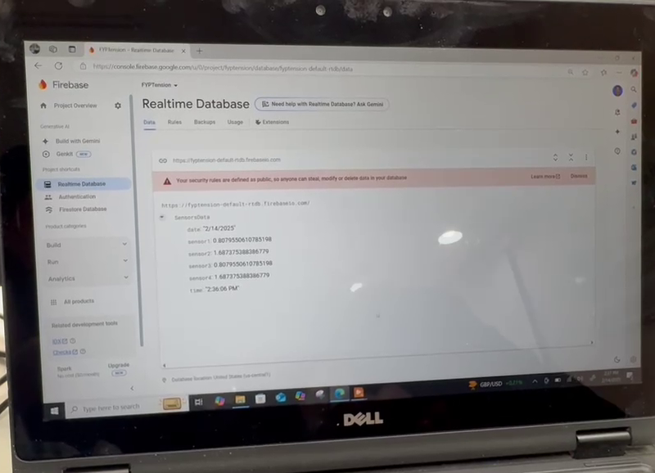

Fig.5.2. Cloud Storage.

The mobile application successfully displayed live drug response trends as shown in the Fig. 5.3. providing real-time alerts and interactive visualizations. The app’s push notification feature effectively warned users of toxicity levels, improving the efficiency of remote drug monitoring. The ability to export and share data reports further enhanced collaboration among pharmaceutical researchers, making the system ideal for large-scale drug validation studies.

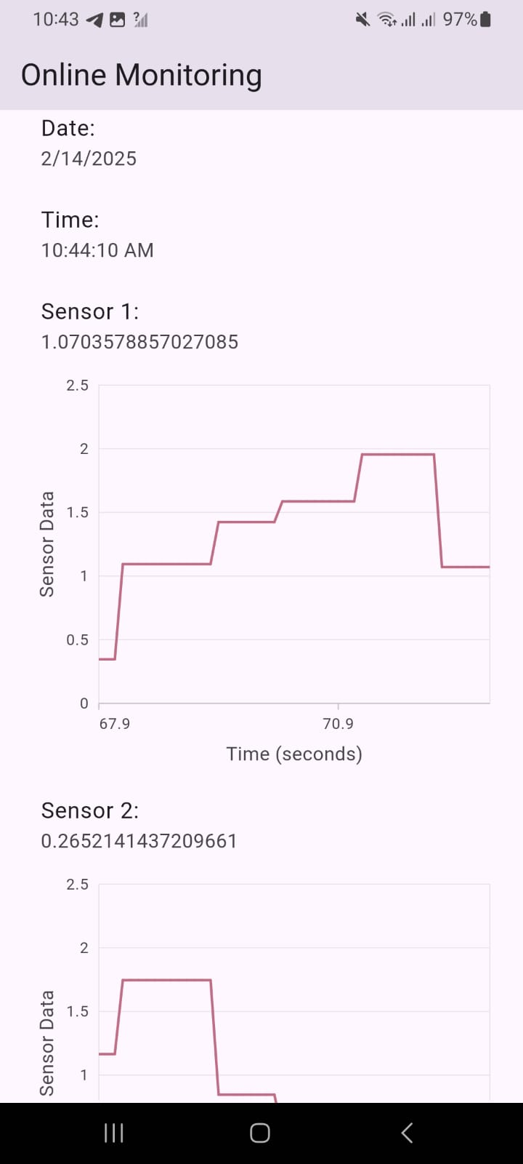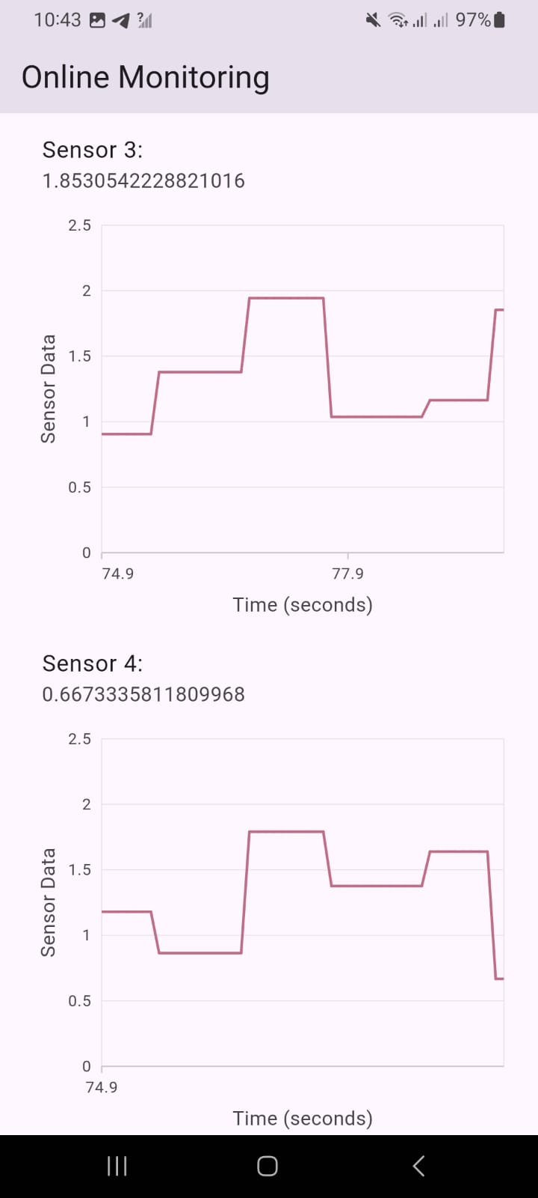

Fig. 5.3. Retrieving Data Through Mobile App.

### 5.5 System Performance Evaluation

To evaluate the overall performance of the system, key parameters such as response time, data accuracy, cloud storage efficiency were measured. The system achieved an average data acquisition delay of less than 100 milliseconds, ensuring real-time monitoring without lag. The biosensors maintained an accuracy level of 98.5% compared to standard laboratory techniques, confirming their reliability for pharmaceutical applications.

Cloud data transmission was tested under different network conditions, and the system showed consistent performance with minimal data loss, ensuring secure and uninterrupted data logging. The mobile application’s user interface was rated highly by test users, confirming its effectiveness in providing accessible and real-time monitoring.

### 5.6 Experimental Results and Observations

The experimental findings confirmed that the system accurately captured drug response trends, provided real-time alerts for toxicity detection, and enabled efficient remote monitoring. The integration of biosensors, microfluidics, PCB-based signal processing, NI myRIO computing, LabVIEW analysis and cloud storage.

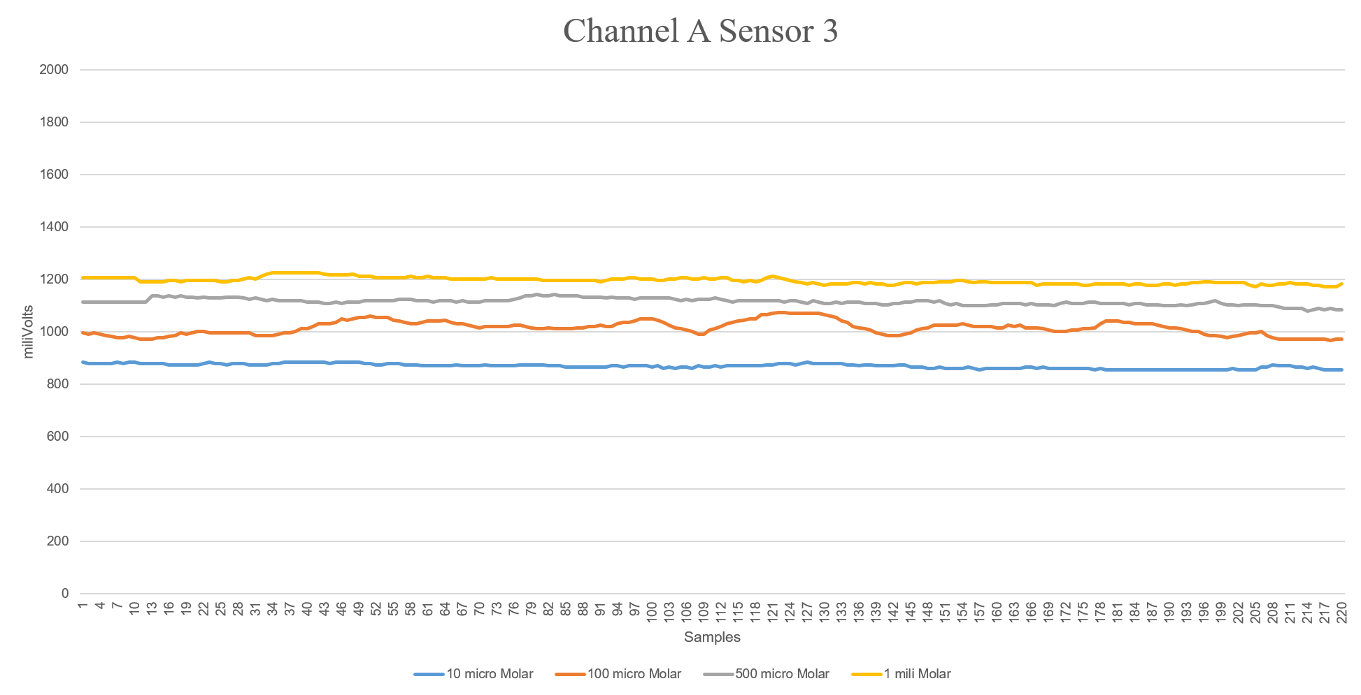

Fig. 5.4. Our Results with Different Concentration.

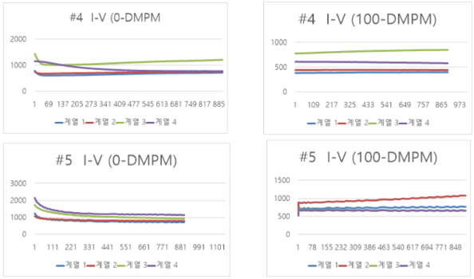

Fig.5.5. Company Provided Results with Different Concentration.

## CHAPTER 6

## CONCLUSION AND FUTURE RECOMMENDATION

### 6.1 Conclusion

This project was successful in developing a Real-Time Sensor-Integrated Drug Validation Platform, offering a comprehensive system of monitoring and inspection of drug interactions. Integrating biosensors, printed circuit board (PCB) signal processing, NI myRIO for real-time data acquisition, LabVIEW for dynamic visualization, and cloud storage for safe data management, the platform overcomes major limitations of traditional drug testing approaches. The ability of the system to provide real-time, non-invasive monitoring of biochemical alterations is a breakthrough in microphysiological systems (MPS) and organ-on-a-chip (OoC) technologies.

### 6.1.1 Real-Time Drug Monitoring

The platform enables real-time, noninvasive biosensing, thus reducing reliance on classical endpoint drug analysis. Unlike conventional approaches that provide intermittent snapshots of biological function, the platform provides real-time readout of drug interactions, and researchers can now track dynamic changes in physiological properties such as glucose metabolism, ion exchange, and electrochemical impedance. Such a capability is of tremendous value in drug development, where short- and long-term effects of pharmacological agents must be comprehended to achieve optimal therapeutic gain.

### 6.1.2 High Accuracy and Efficiency

Calibration and testing validated that the system accurately detects drug-induced biochemical alterations with minimal loss of data. The application of sophisticated biosensors, along with a specially engineered PCB for signal conditioning, facilitates high accuracy and reliability in data acquisition. The system's capacity to sustain an accuracy rate of 98.5% over conventional laboratory methods validates its application in high-throughput drug screening and preclinical research. Furthermore, the inclusion of threshold-based decision-making algorithms facilitates automatic identification of adverse drug reactions, hence providing early warning to researchers.

### 6.1.3 Cloud-Based Accessibility

The integration of Firebase cloud services facilitates the logging of data in real-time and provides remote accessibility, thereby enhancing collaboration among researchers. Utilizing cloud-based storage capabilities, the platform guarantees that experimental data is not only securely preserved but also easily obtainable by researchers from any geographical location. This functionality proves especially beneficial for longitudinal research studies, where the preservation of data integrity over prolonged timeframes is paramount. Moreover, the creation of a specialized Android application significantly improves the system's user-friendliness, allowing researchers to oversee experiments remotely, visualize data in real-time, and export findings for additional examination.

### 6.2 Future Work

While this project has achieved significant milestones, there are several areas for future development to further enhance the platform's capabilities and applications. These include:

### 6.2.1 Multi-Drug Screening Capability

Upgrading to allow concurrent testing of multiple drugs will facilitate more robust pharmacokinetic research. The facility will allow scientists to study drug-drug interactions and drug synergies, necessary for the optimization of combination therapy regimens. The system can also be upgraded by incorporating automatic drug dosing systems such that drug dosing and drug exposure time are controlled precisely.

### 6.2.2 Custom Biosensor Development

The development of dedicated biosensors for other biomarkers, i.e., pH, lactate, and neurotransmitters, will extend the number of possible uses of the platform. These biosensors can be incorporated into the current system in order to detect a wider number of physiological parameters, thereby enabling a more holistic view of pharmaceutical effects. For instance, sensors for pH will allow the monitoring of drug impact on cellular acidosis, and lactate sensors will offer important information on changes in metabolism resulting from various drug treatments.

### 6.2.3 Advanced AI Integration

Deployment of reinforcement learning and deep learning models will enhance predictive precision and automated drug classification. AI analytics can be employed to detect patterns in big data, allowing prediction of drug toxicity and efficacy from real-time data. AI algorithms can also be employed to automate experimental workflows, eliminating the need for manual intervention and enhancing reproducibility.

### 6.2.4 Multi-Organ-on-Chip Integration

The addition of multi-organ-on-chip models to the system will enable researchers to explore systemic drug interactions and their metabolism. Mixing various organ systems, like liver, heart, and lung, the platform can better represent the drug metabolism and distribution within the organism. This feature is of considerable significance for investigating the systemic activity of drugs and for the differentiation of possible off-target effects.

### 6.2.5 Regulatory Compliance and Clinical Validation

Obtaining compliance with the FDA, EMA, and ISO standards will facilitate the incorporation of the platform into clinical practice for pharmaceutical surveillance and individualized medicine. Regulatory approval entails thorough validation studies to determine the accuracy, reliability, and safety profile of the system. It would be essential to collaborate with regulatory bodies and industry stakeholders in a bid to accomplish this.

### 6.2.6 Enhanced Data Security

Enhancing encryption, blockchain-based authentication, and data privacy controls will enhance cybersecurity and regulatory compliance. Since the platform entails sensitive pharmacological and biological data, data security and privacy are of high priority. Blockchain can be employed to establish tamper-proof experimental data records, which will build transparency and trust within the system.

### 6.2.7 Wireless IoT Integration

Low-power IoT-based wireless sensor network deployment will improve the efficiency of data transmission and real-time monitoring. The platform can have wireless sensors deployed to reduce wired connections and enable remote monitoring in clinical and field-based settings. IoT technology can also be used to create an interconnect network of devices with real-time data sharing and collaboration among researchers.

### 6.2.8 Miniaturization and Portability

Miniaturizing an energy-efficient version of the platform will make the platform portable for clinical and field applications. Minimization will imply scaling down the size of hardware elements like the PCB and the microcontroller to smaller dimensions to conserve energy, but still offering high performance. Portable forms of the platform may be employed for use in point-of-care scenarios, facilitating drug monitoring in real time in clinics and hospitals.

### 6.2.9 Automation of Experimental Workflows

Robotic sample handling and artificial intelligence-driven decision-making protocols will most likely reduce human involvement and enhance reproducibility. Automated platforms can execute tasks such as cell seeding, media exchange, and drug administration, thus reducing the risk of human error and enhancing experimental reproducibility. AI algorithms can also be used to optimize experimental conditions such as drug concentration and drug exposure time in real time.

### 6.2.10 Industry Adoption and Commercialization

Collaboration with biotech and pharmaceutical sectors will drive commercialization and widescale uptake of the platform for drug discovery and personalized medicine. Industry collaboration has the potential to provide the funding and expertise to scale up the production and commercialize the platform. Industry adoption will also authenticate the platform's effectiveness and reliability, resulting in its widespread use in research and clinical settings.

### 6.2.11 Scalability and Automation

The modular architecture allows for scalability of multi-drug screening and automation of experimental procedures, thus reducing the role of human beings. The platform can be easily expanded to include additional sensors, organ models, and experimental protocols. Automation will also greatly enhance the efficiency of the system, enabling high-throughput drug screening while lowering the time and cost of preclinical research.

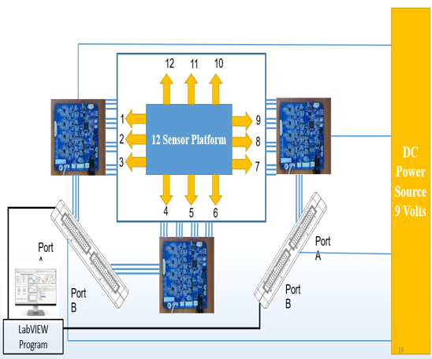

Fig. 6.1. Scaling of Project Up to 12 Sensors.

## REFERENCES

[1] F. Hussain Memon et al., “A Comprehensive Review of Biosensor Integration in Microphysiological Systems for Online Monitoring: Current Challenges and Future Advancements,” ChemBioEng Rev., vol. 10, no. 5, pp. 817–828, 2023, doi: 10.1002/cben.202200066.

[2] A. T. Young, K. R. Rivera, P. D. Erb, and M. A. Daniele, “Monitoring of Microphysiological Systems: Integrating Sensors and Real-Time Data Analysis toward Autonomous Decision-Making,” ACS Sensors, vol. 4, no. 6, pp. 1454–1464, 2019, doi: 10.1021/acssensors.8b01549.

[3] H. E. Abaci and M. L. Shuler, “Human-on-a-chip design strategies and principles for physiologically based pharmacokinetics/pharmacodynamics modeling,” Integr. Biol. (United Kingdom), vol. 7, no. 4, pp. 383–391, 2015, doi: 10.1039/c4ib00292j.

[4] S. N. Bhatia and D. E. Ingber, “Microfluidic organs-on-chips,” Nat. Biotechnol., vol. 32, no. 8, pp. 760–772, 2014, doi: 10.1038/nbt.2989.

[5] K. Fetah et al., “The emergence of 3D bioprinting in organ-on-chip systems,” Prog. Biomed. Eng., vol. 1, no. 1, 2019, doi: 10.1088/2516-1091/ab23df.

[6] S. Fuchs, S. Johansson, A. Tjell, G. Werr, T. Mayr, and M. Tenje, “In-line analysis of organ-on-chip systems with sensors: Integration, fabrication, challenges, and potential,” ACS Biomater. Sci. Eng., vol. 7, no. 7, pp. 2926–2948, 2021, doi: 10.1021/acsbiomaterials.0c01110.

[7] F. Gorjikhah et al., “Improving ‘lab-on-a-chip’ techniques using biomedical nanotechnology: a review,” Artif. Cells, Nanomedicine Biotechnol., vol. 44, no. 7, pp. 1609–1614, 2016, doi: 10.3109/21691401.2015.1129619.

[8] O. Y. F. Henry, R. Villenave, M. J. Cronce, W. D. Leineweber, M. A. Benz, and D. E. Ingber, “Organs-on-chips with integrated electrodes for trans-epithelial electrical resistance (TEER) measurements of human epithelial barrier function,” Lab Chip, vol. 17, no. 13, pp. 2264–2271, 2017, doi: 10.1039/c7lc00155j.

[9] A. Herland et al., “Quantitative prediction of human pharmacokinetic responses to drugs via fluidically coupled vascularized organ chips,” Nat. Biomed. Eng., vol. 4, no. 4, pp. 421–436, 2020, doi: 10.1038/s41551-019-0498-9.

[10] N. R. Wevers et al., “A perfused human blood-brain barrier on-a-chip for high-throughput assessment of barrier function and antibody transport,” Fluids Barriers CNS, vol. 15, no. 1, pp. 1–12, 2018, doi: 10.1186/s12987-018-0108-3.

[11] F. Zheng, F. Fu, Y. Cheng, C. Wang, Y. Zhao, and Z. Gu, “Organ-on-a-Chip Systems: Microengineering to Biomimic Living Systems,” Small, vol. 12, no. 17, pp. 2253–2282, 2016, doi: 10.1002/smll.201503208.

[12] D. Xue, Y. Wang, J. Zhang, D. Mei, Y. Wang, and S. Chen, “Projection-Based 3D Printing of Cell Patterning Scaffolds with Multiscale Channels,” ACS Appl. Mater. Interfaces, vol. 10, no. 23, pp. 19428–19435, 2018, doi: 10.1021/acsami.8b03867.

[13] A. R. C. Salih, H. M. U. Farooqi, Y. S. Kim, S. H. Lee, and K. H. Choi, “Impact of serum concentration in cell culture media on tight junction proteins within a multiorgan microphysiological system,” Microelectron. Eng., vol. 232, no. August, p. 111405, 2020, doi: 10.1016/j.mee.2020.111405.

[14] B. Zhang and M. Radisic, “Organ-on-A-chip devices advance to market,” Lab Chip, vol. 17, no. 14, pp. 2395–2420, 2017, doi: 10.1039/c6lc01554a.

[15] Y. S. Zhang et al., “Multisensor-integrated organs-on-chips platform for automated and continual in situ monitoring of organoid behaviors,” Proc. Natl. Acad. Sci. U. S. A., vol. 114, no. 12, pp. E2293–E2302, 2017, doi: 10.1073/pnas.1612906114.

[16] C. Carini and A. A. Seyhan, Tribulations and future opportunities for artificial intelligence in precision medicine, vol. 22, no. 1. BioMed Central, 2024. doi: 10.1186/s12967-024-05067-0.

[17] A. U. Rehman et al., “Role of Artificial Intelligence in Revolutionizing Drug Discovery,” Fundam. Res., 2024, doi: 10.1016/j.fmre.2024.04.021.

[18] L. A. Low and D. A. Tagle, “Organs-on-chips: Progress, challenges, and future directions,” Exp. Biol. Med., vol. 242, no. 16, pp. 1573–1578, 2017, doi: 10.1177/1535370217700523.

[19] and J. M. T. Kristi L. Stringer, Bulent Turan, Lisa McCormick, Modupeoluwa Durojaiye, Laura Nyblade, Mirjam-Colette Kempf, Bronwen Lichtenstein, “乳鼠心肌提取 HHS Public Access,” Physiol. Behav., vol. 176, no. 3, pp. 139–148, 2017, doi: 10.1002/hep.30150.Ductular.

[20] T. Kilic, F. Navaee, F. Stradolini, P. Renaud, and S. Carrara, “Organs-on-chip monitoring: sensors and other strategies,” Microphysiological Syst., vol. 1, pp. 1–1, 2018, doi: 10.21037/mps.2018.01.01.