CivicSure
Software Architecture & Design Document

Final Year Project | Department of Computer Science
Version 1.0 — April 2025

1. Executive Summary
CivicSure is a multi-tenant middleware platform designed to modernise emergency incident reporting in Pakistan. The system intercepts citizen reports submitted via Instagram Direct Messages and a public web form, applies natural language processing (NLP) to extract structured incident data, verifies reports with the submitting citizen via WhatsApp, and pushes verified incidents to a real-time dispatcher dashboard.
Pakistani emergency services currently suffer significant resource waste caused by unverified, duplicate, and prank reports. CivicSure targets a 70 % reduction in false dispatches by enforcing a structured, two-step verification workflow before any incident reaches a dispatcher.
The system is architected as a modular Spring Boot monolith paired with a React dashboard, PostgreSQL persistence, optional Redis caching, and Twilio WhatsApp integration. Multi-tenant isolation ensures that data from different emergency services organisations remains logically separated without requiring separate database instances.

2. Project Understanding

2.1 Problem Statement
Emergency dispatch centres in Pakistan receive a large volume of reports through informal channels — phone calls, social media posts, and walk-ins. Many reports are incomplete, duplicated across channels, or deliberately false. Dispatchers must manually triage each report, consuming time and resources that could be directed toward genuine emergencies. CivicSure addresses this gap by automating ingestion, structured extraction, citizen verification, and prioritisation before a human dispatcher ever sees the incident.

2.2 Core Objectives
- 70 % Reduction in False Dispatches: Two-step WhatsApp confirmation eliminates unverified reports from the dispatcher feed.
- Structured Extraction from Social Media: NLP pipeline converts free-text Instagram DMs into typed incident records (type, location, description).
- Real-Time Verified Feed: Dispatcher dashboard displays only VERIFIED or DISPATCHED incidents, refreshed via polling.
- Multi-Tenant Isolation: Each emergency service organisation operates as an independent tenant with full data segregation.
- Academic Feasibility: System is implementable by a four-person team within a single academic semester without microservices complexity.

2.3 Target Users
User Role | Responsibility
Citizen Reporter | Submits emergency reports via web form or Instagram DM.
Emergency Dispatcher | Reviews verified incidents, applies filters, marks DISPATCHED or REJECTED.
Response Unit | Receives incident assignments from the dispatcher.
System Admin | Manages tenants, user accounts, and platform configuration.
NGO Coordinator | Views verified incident feeds and analytics for coordination purposes.

3. Scope Definition

3.1 In-Scope (MVP)
- Public web form for incident submission (type, location, description, phone number).
- WhatsApp verification via Twilio Sandbox.
- Dispatcher dashboard with real-time polling at 5–10 second intervals.
- Incident status lifecycle: PENDING → VERIFIED → DISPATCHED (also REJECTED / EXPIRED / DUPLICATE).
- JWT-based authentication and role-based access control (ADMIN, DISPATCHER, VIEWER).
- Manual incident creation by dispatcher, bypassing WhatsApp verification.
- Duplicate detection: same incident type + similar location within a 15-minute window.
- Instagram DM ingestion via Meta webhooks (Phase 3 — optional for demo).
- NLP extraction using regex with Spring AI as fallback (Phase 3).
- Multi-tenant data isolation enforced at database query level.

3.2 Out of Scope
- SMS fallback for citizen verification.
- Real GPS coordinates or GPS spoofing prevention.
- Automatic dispatch without human confirmation.
- Native mobile application (iOS or Android).
- Training custom machine-learning models.
- Integration with TikTok, Twitter, or other social platforms.
- Replacing existing Computer-Aided Dispatch (CAD) software.

3.3 Scope Refinement Summary
Original Consideration | Narrowed Decision
Multiple social platforms | Instagram DMs + public web form only
Full dispatch system | Verified incident feed with human dispatcher decision
Real GPS verification | Manual address confirmation via WhatsApp reply
All emergency types | Fire, Medical, Accident
Production ML pipeline | Spring AI + regex fallback, manual review for unclassified

4. Functional Requirements

4.1 Citizen-Facing Requirements
- FR-C1: Submit an incident report via a public web form specifying type, location address, description, and phone number.
- FR-C2: Receive a WhatsApp template message immediately after submission requesting confirmation.
- FR-C3: Confirm the report by replying CONFIRM, optionally providing a location address.
- FR-C4: Receive a receipt identifier upon successful submission for future reference.

4.2 Dispatcher-Facing Requirements
- FR-D1: Log in to the dispatcher dashboard using email and password; system issues a signed JWT.
- FR-D2: View a live incident feed refreshed every 5–10 seconds without manual page reload.
- FR-D3: Filter incidents by status (PENDING, VERIFIED, DISPATCHED, REJECTED, EXPIRED) and by type (FIRE, MEDICAL, ACCIDENT).
- FR-D4: View full incident details: location, description, reporter source, and verification history.
- FR-D5: Mark a verified incident as DISPATCHED or REJECTED.
- FR-D6: Create a manual incident entry that bypasses the WhatsApp verification step and is immediately VERIFIED.
- FR-D7: Resend a WhatsApp verification template for any PENDING incident.

4.3 System-Level Requirements
- FR-S1: Receive and validate Instagram DM webhooks using HMAC-SHA256 signature verification.
- FR-S2: Receive and validate Twilio reply webhooks using the Twilio request signature header.
- FR-S3: Persist all incoming webhook payloads as raw events in webhook_events for idempotent reprocessing.
- FR-S4: Extract incident type, location, and description from free-text DMs using regex patterns with Spring AI as fallback.
- FR-S5: Cache partial Instagram conversation state in Redis with a 24-hour TTL.
- FR-S6: Send a Twilio WhatsApp template message for each new PENDING incident.
- FR-S7: Update incident status to VERIFIED upon receiving a valid citizen CONFIRM reply.
- FR-S8: Detect duplicate reports: same tenant, same incident type, overlapping location, created within 15 minutes.
- FR-S9: Transition PENDING incidents to EXPIRED if no confirmation is received within 30 minutes.
- FR-S10: Log every status transition with a timestamp and the actor identifier (user ID or system).
- FR-S11: Enforce tenant isolation: all database queries are scoped to the current tenant_id extracted from the JWT.

5. Non-Functional Requirements
Category | Requirement | Priority
Security | JWT Bearer token required on all protected endpoints. | HIGH
Security | Role-based access control enforced via Spring Security method annotations. | HIGH
Security | Tenant isolation: every query scoped to tenant_id from JWT claim. | HIGH
Security | HMAC-SHA256 signature validation for all incoming webhooks. | HIGH
Security | Citizen phone numbers encrypted at rest using AES-256. | HIGH
Security | No plaintext location data or phone numbers emitted in application logs. | HIGH
Reliability | Idempotent webhook processing via external_event_id uniqueness constraint. | HIGH
Reliability | Event worker retries failed event processing up to three times with back-off. | HIGH
Performance | Webhook endpoint acknowledges within 500 ms to prevent provider timeout. | HIGH
Performance | Dashboard incident list loads within 2 seconds for up to 1,000 records. | MEDIUM
Auditability | All incident status transitions persisted with timestamp and actor. | MEDIUM
Availability | System targets 99 % uptime during demo period on a single VM. | MEDIUM
Maintainability | Modular package structure; no cross-module direct calls outside defined service interfaces. | LOW

6. System Architecture

6.1 Architectural Pattern
CivicSure is structured as a modular monolith. All backend modules — Auth, Webhook Ingress, Event Worker, Incident Management, Verification, and NLP — run within a single Spring Boot process, organised into clearly bounded packages with no cross-cutting dependencies outside of shared domain objects and service interfaces.
This pattern was selected over a microservices architecture for the following reasons:
- Eliminates distributed-systems complexity (service discovery, network latency, distributed transactions) that is inappropriate for an FYP scope.
- Simplifies local development, testing, and Docker Compose deployment to a single container.
- Supports multi-tenancy through database-level scoping rather than per-tenant service instances.
- Allows the Event Worker module to be extracted into a separate service in future without architectural rework.

6.2 High-Level Component Diagram
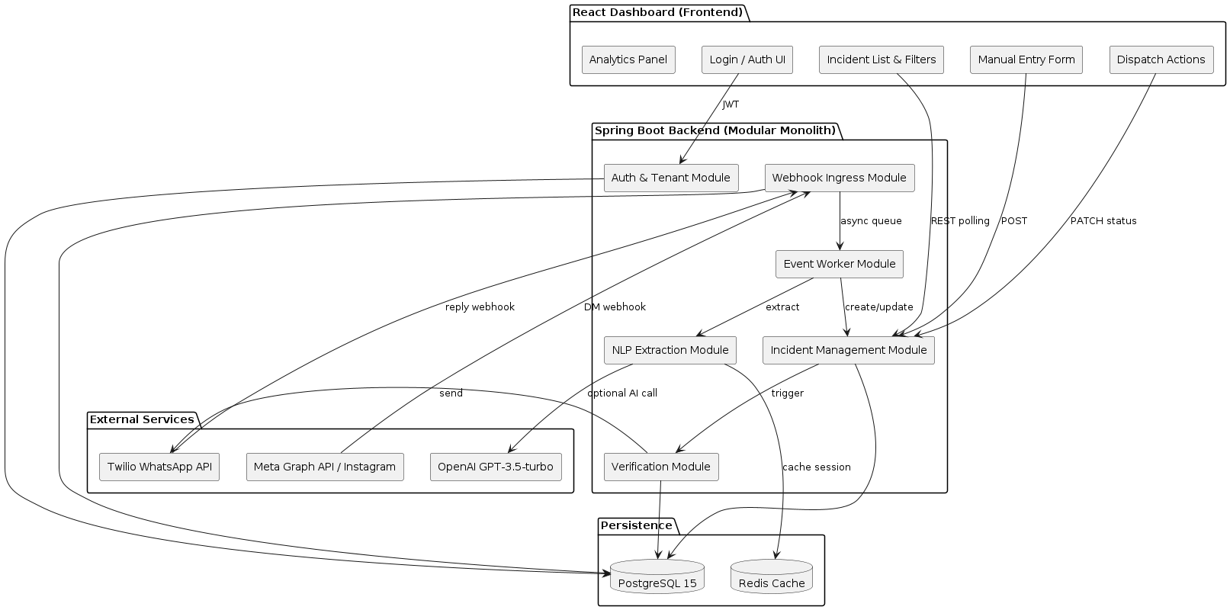
Figure: CivicSure — Component Architecture

6.3 Module Responsibilities
Module | Owner | Responsibilities
Auth & Tenant Module | Hamza | Issues and validates JWT tokens; loads tenant context per request; enforces RBAC annotations.
Webhook Ingress Module | Hamza | Validates provider signatures; persists raw webhook_events; returns 200 within 500 ms.
Event Worker Module | Wali | Polls webhook_events for unprocessed records; routes by source; retries on failure (max 3×).
Incident Management Module | Wali | Creates and updates incidents; enforces status state machine; duplicate detection; expiry scheduling.
Verification Module | Hamza | Sends Twilio WhatsApp templates; tracks verification_attempts; handles CONFIRM reply and EXPIRED timeout.
NLP Extraction Module | Wali | Regex extraction first; delegates to Spring AI (GPT-3.5) when regex confidence is insufficient; caches Instagram session state in Redis.
React Dashboard | Fatima | Login UI; polling-based incident list; status/type filters; manual entry form; dispatch/reject actions; analytics panel.

7. Data Flows

7.1 Web Form → WhatsApp Verification (Primary MVP Journey)
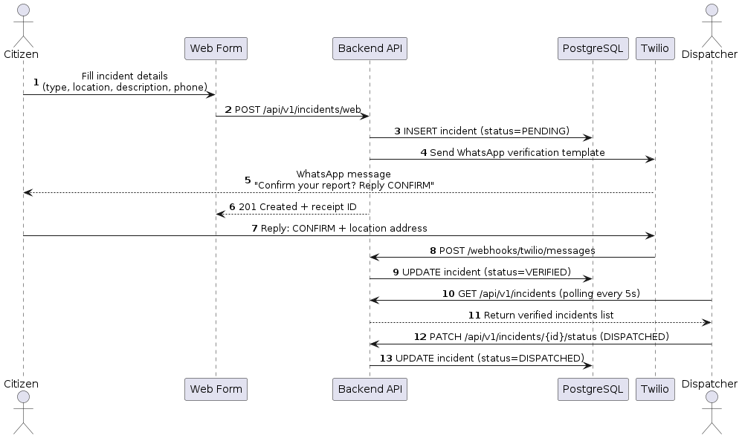
Figure: Sequence: Web Form Submission and WhatsApp Verification

- Step 1: Citizen fills the public web form and submits.
- Step 2: Backend validates input; creates an incident record with status PENDING.
- Step 3: Backend calls Twilio API to send a WhatsApp template message to the citizen's phone number.
- Step 4: Backend returns HTTP 201 with a receipt identifier.
- Step 5: Citizen receives WhatsApp message and replies CONFIRM (optionally with an address).
- Step 6: Twilio delivers the reply to the backend webhook endpoint.
- Step 7: Backend updates the incident status to VERIFIED.
- Step 8: Dispatcher dashboard polls and displays the newly verified incident.
- Step 9: Dispatcher marks the incident DISPATCHED or REJECTED.

7.2 Instagram DM → NLP → WhatsApp Verification
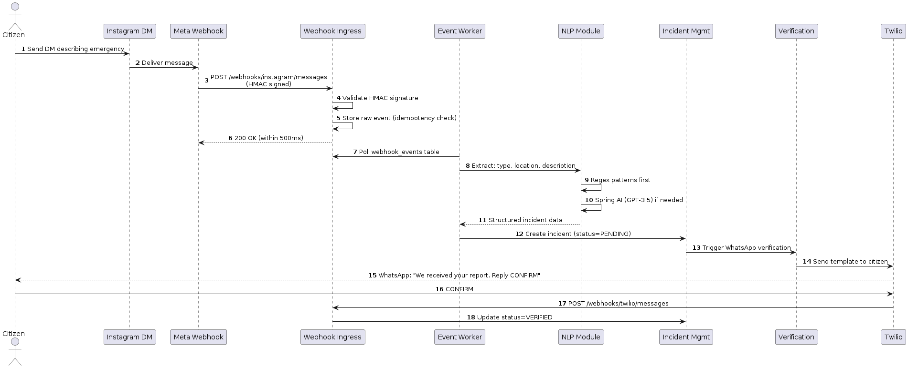
Figure: Sequence: Instagram DM with NLP Extraction

- Step 1: Citizen sends a DM to the tenant's Instagram Professional account describing an emergency.
- Step 2: Meta delivers the DM event to the registered webhook endpoint via HTTPS POST.
- Step 3: Webhook Ingress validates the HMAC-SHA256 signature and stores the raw payload in webhook_events.
- Step 4: Endpoint returns HTTP 200 within 500 ms (Meta ack requirement).
- Step 5: Event Worker detects an unprocessed webhook_event and routes it to the NLP module.
- Step 6: NLP module applies regex patterns; calls Spring AI if extraction confidence is low.
- Step 7: Structured incident data (type, location, description) returned to the Event Worker.
- Step 8: Event Worker calls Incident Management to create a PENDING incident.
- Step 9: Incident Management triggers the Verification module to send a WhatsApp template.
- Step 10: Citizen replies CONFIRM; Twilio webhook updates the status to VERIFIED.

7.3 Duplicate Detection
When a new incident is created, the system queries for existing incidents within the same tenant that share the same incident type and a similar location address, created within the preceding 15 minutes. If such a record exists, the new incident is marked DUPLICATE with a foreign-key reference (duplicate_of_id) to the original. No new WhatsApp verification is sent for duplicate incidents, preventing alert fatigue for the citizen.

7.4 Verification Timeout (No Response)
A Spring @Scheduled task runs at one-minute intervals and queries for PENDING incidents whose WhatsApp verification was sent more than 30 minutes ago with no CONFIRM response. Such incidents are automatically transitioned to EXPIRED and surfaced on the dashboard for manual dispatcher review.

8. Database Design

8.1 Entity-Relationship Diagram
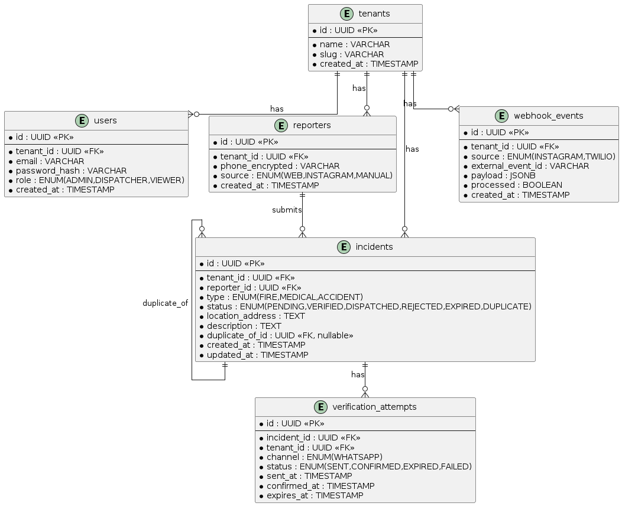
Figure: CivicSure Entity-Relationship Diagram

8.2 Table Descriptions
tenants: Root entity for multi-tenancy. Every other table references tenant_id as a foreign key, enabling logical data isolation without separate database schemas.
users: Dispatcher and admin accounts. The role ENUM (ADMIN, DISPATCHER, VIEWER) drives RBAC. Scoped to a single tenant.
reporters: De-duplicated citizen contact records. Phone number stored encrypted (AES-256). Source ENUM tracks the submission channel (WEB, INSTAGRAM, MANUAL).
incidents: Central entity of the domain model. Status ENUM enforces the lifecycle state machine. duplicate_of_id is a self-referential FK for DUPLICATE-flagged records.
verification_attempts: One record per WhatsApp message sent. Tracks sent_at, confirmed_at, and expires_at. Forms the audit trail for the verification workflow.
webhook_events: Raw inbound events from Meta and Twilio. JSONB payload stores the full provider body. external_event_id enforces idempotency. processed flag tracks Event Worker state.

8.3 Redis Cache
Redis caches partial Instagram conversation state while the Event Worker awaits a multi-turn DM thread to complete (e.g., the citizen has not yet supplied a location in the initial message). Key pattern:
ig:session:{tenant_id}:{conversation_id} (TTL: 24 hours)
Redis is optional for the MVP; the system falls back to PostgreSQL-only session tracking if Redis is unavailable.

9. API Design
Method | Path | Auth | Description
POST | /api/v1/auth/login | Public | Authenticates user; returns signed JWT.
GET | /api/v1/incidents | JWT (DISPATCHER+) | Returns paginated, filtered incident list for current tenant.
POST | /api/v1/incidents/web | Public | Creates incident from web form; triggers WhatsApp verification.
POST | /api/v1/incidents/manual | JWT (DISPATCHER) | Dispatcher manually creates a VERIFIED incident.
GET | /api/v1/incidents/{id} | JWT | Returns full detail of a single incident.
PATCH | /api/v1/incidents/{id}/status | JWT (DISPATCHER) | Transitions status to DISPATCHED or REJECTED.
POST | /api/v1/incidents/{id}/resend-verification | JWT (DISPATCHER) | Resends WhatsApp template for a PENDING incident.
POST | /webhooks/instagram/messages | HMAC-SHA256 | Receives Meta Instagram DM events.
GET | /webhooks/instagram/messages | Challenge token | Meta webhook verification handshake.
POST | /webhooks/twilio/messages | Twilio Signature | Receives Twilio WhatsApp reply events.
GET | /api/v1/admin/tenants | JWT (ADMIN) | Lists all tenants.
POST | /api/v1/admin/tenants | JWT (ADMIN) | Creates a new tenant.

10. Authentication & Authorisation

10.1 JWT Authentication
Protected API endpoints require a Bearer JWT in the Authorization header. Tokens are issued by POST /api/v1/auth/login, signed with HS256 using a server-side secret, and carry claims for user_id, tenant_id, and role. Token expiry is configurable (default: 8 hours). Spring Security processes the token on every request via a custom OncePerRequestFilter before the controller layer executes.

10.2 Role-Based Access Control
Role | Permitted Actions
ADMIN | Tenant and user management; full incident visibility; analytics dashboard; system configuration.
DISPATCHER | Incident list, filters, detail view, status updates (DISPATCHED/REJECTED), manual entry, resend verification.
VIEWER | Read-only access to incident list and detail view. No status mutations permitted.

10.3 Webhook Authentication
Webhook endpoints do not use JWT authentication. Provider-specific signatures are used:
- Instagram: HMAC-SHA256 of the raw request body using the Meta app secret, delivered in the X-Hub-Signature-256 header.
- Twilio: Twilio-Signature header computed using the account auth token and the fully-qualified request URL.
Requests failing signature validation are rejected with HTTP 403 before any data is processed or persisted.

10.4 Tenant Isolation
Every JPA repository method and native query includes WHERE tenant_id = :tenantId. The tenant_id is extracted from the JWT on each request and stored in a request-scoped TenantContext bean. Cross-tenant data access is structurally impossible through the API layer.

11. Technology Stack
Category | Technology | Rationale
Frontend Runtime | React 18 + TypeScript | Component-based UI; type safety; large ecosystem.
Frontend Build | Vite | Fast HMR; native ESM; small bundle output.
Frontend Styling | Tailwind CSS | Utility-first; consistent design tokens without CSS files.
Frontend Data | React Query (TanStack) | Polling, caching, and background refetch with minimal boilerplate.
Frontend Charts | Recharts | Declarative React chart components for the analytics panel.
Backend Runtime | Java 21 (LTS) | Virtual threads (Project Loom); modern language features; stable long-term support.
Backend Framework | Spring Boot 3.4.x | Auto-configuration; embedded Tomcat; mature security and JPA integration.
Backend Security | Spring Security + JWT (HS256) | Filter-based authentication; RBAC method annotations; proven production track record.
Backend ORM | Spring Data JPA (Hibernate 6) | Repository pattern; lazy loading; compatible with Flyway migrations.
Backend AI | Spring AI + OpenAI GPT-3.5-turbo | Structured extraction prompts; regex-first fallback keeps costs near zero for demo.
Backend Scheduling | Spring @Scheduled | Expiry worker and event poller; no external queue required for MVP.
Database | PostgreSQL 15+ | JSONB for webhook payloads; strong ACID guarantees; Flyway migration support.
Migrations | Flyway | Versioned SQL migrations applied on startup; repeatable scripts; CI-friendly.
Cache | Redis 7 (optional) | Instagram conversation session state; TTL-based expiry; in-memory fallback if unavailable.
Messaging | Twilio WhatsApp API | Sandbox for FYP demo; production upgrade path documented; template-based messaging.
Social Ingestion | Meta Graph API (Instagram) | DM webhooks via HTTPS; HMAC signature validation.
Containerisation | Docker + Docker Compose | Reproducible one-command local environment; environment variable injection via .env.
Tunnelling | ngrok | Exposes localhost:8080 to Meta and Twilio for webhook delivery during development.
Testing | JUnit 5 + Mockito + Testcontainers | Unit, service, and container-based database integration tests.

12. Deployment Architecture

12.1 Deployment Diagram
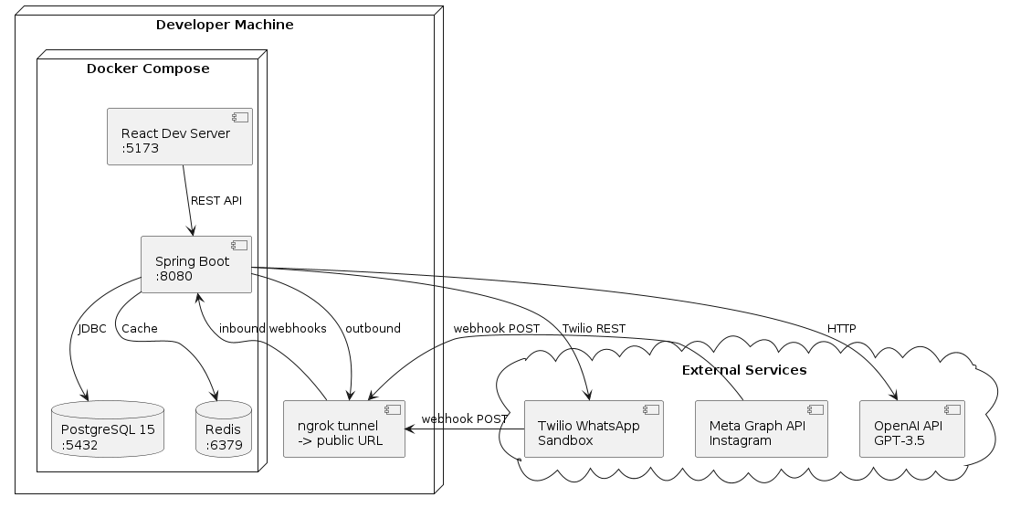
Figure: CivicSure Deployment Architecture

12.2 Local Development Environment
Service | Port / URL | Notes
React Dev Server | :5173 | Vite HMR; /api and /webhooks proxied to Spring Boot.
Spring Boot | :8080 | All backend modules; connects to PostgreSQL and Redis.
PostgreSQL 15 | :5432 | Persistent storage; Flyway migrations applied on startup.
Redis 7 | :6379 | Optional session cache; container included in Compose for convenience.
ngrok | public HTTPS URL | Tunnels webhook calls from Meta and Twilio to localhost:8080.

12.3 Production VM (Optional Cloud Deployment)
- Nginx reverse proxy: serves React static files from /dist; proxies /api and /webhooks to Spring Boot on port 8080.
- Spring Boot JAR: deployed as a systemd service or as a Docker container with restart policy.
- PostgreSQL: single-instance deployment; daily pg_dump backup to object storage.
- Redis: optional; omit if Instagram conversation caching is not required.
- SSL: Let's Encrypt certificate managed by Certbot with automatic renewal via Nginx.

13. Use Case Diagram
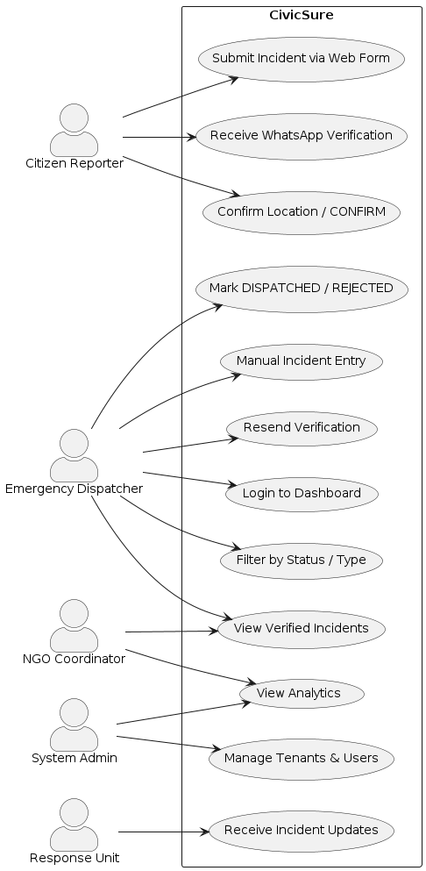
Figure: CivicSure — Use Case Diagram

14. Incident Lifecycle Activity Flow
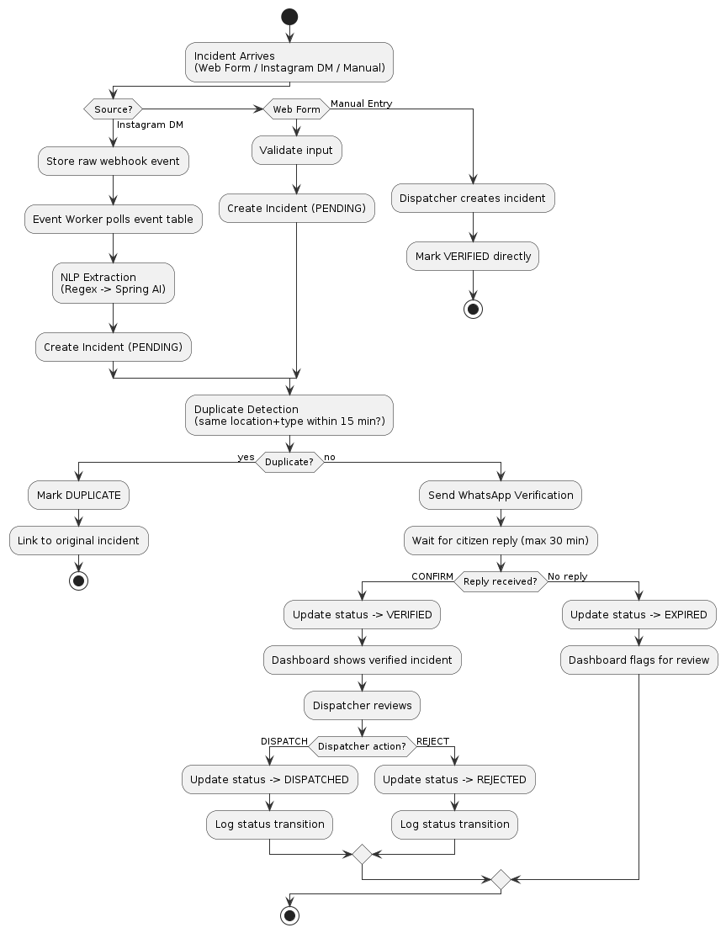
Figure: Incident Lifecycle — Activity Diagram

15. Risks & Tradeoffs

15.1 Technical Risks
Risk | Severity | Mitigation
Meta Webhook Delivery Delays / Duplicates | HIGH | webhook_events table with external_event_id uniqueness constraint; idempotent event worker processes each ID exactly once.
Twilio Sandbox Limitations | MEDIUM | Sandbox used for demo only; requires pre-approved recipient phone numbers. Production upgrade path documented. Not a blocking issue for FYP.
Spring AI / GPT Hallucination | MEDIUM | Regex extraction applied first; AI used only when regex confidence is insufficient. Unclassified incidents routed to manual dispatcher review.
ngrok Session Expiry During Demo | MEDIUM | Reserve a static ngrok domain ahead of the demo; pre-configure backup webhook URLs in Meta and Twilio dashboards.
Redis Unavailability | LOW | System falls back to PostgreSQL-only session persistence. Redis is optional for the MVP scope.

15.2 Architectural Tradeoffs
Polling vs. WebSockets: Dashboard polls at 5–10 s intervals rather than maintaining a persistent WebSocket connection. This is simpler to implement and sufficient for the dispatcher's operational tempo. WebSockets are the recommended production enhancement.
Modular Monolith vs. Microservices: A single deployable unit is simpler to develop, test, and demonstrate within the FYP timeline. The modular package structure preserves the option to extract individual services post-graduation.
Regex-First NLP vs. Pure AI: Regex is deterministic and free; AI adds latency and token cost. The hybrid approach maximises reliability while keeping operating costs near zero for an academic demo.
Manual Review Fallback: Incidents that cannot be automatically classified or verified are surfaced for dispatcher manual review rather than being auto-rejected, preventing missed genuine emergencies.
No SMS Fallback: WhatsApp is the sole verification channel. Citizens without WhatsApp cannot self-verify via the automated flow. Dispatchers can manually verify such reports after a phone-based confirmation.

16. Testing Strategy

16.1 Unit Tests
- Status transition logic: all valid and invalid state machine transitions.
- Duplicate detection: same location+type within window; boundary and edge conditions.
- Phone number normalisation: international format, leading zeros, country code handling.
- Webhook signature validation: valid HMAC; tampered body; missing header.
- Regex NLP extraction: FIRE/MEDICAL/ACCIDENT keywords; mixed case; partial matches; unrecognised input.

16.2 Integration Tests
- Web form submission → WhatsApp message sent (Twilio client mocked).
- Twilio reply webhook → incident status updated to VERIFIED.
- Meta Instagram webhook → NLP extraction → PENDING incident created → WhatsApp sent.
- Idempotency: same external_event_id submitted twice; only one incident created.
- Tenant isolation: dispatcher of Tenant A cannot retrieve incidents belonging to Tenant B.

16.3 API Tests (Postman / Newman)
- Auth: valid login; wrong password; expired token; request without token.
- Incidents: list with status/type filters; web form create; manual entry; PATCH status.
- Webhooks: valid Meta payload with correct HMAC; invalid signature (expect 403); valid Twilio reply.

16.4 UI Validation Tests (Manual)
- Login flow: valid credentials; invalid credentials; session expiry.
- Incident list: status filter; type filter; sort by date.
- Manual entry form: all required fields; submission success message.
- Dispatch action: mark DISPATCHED; mark REJECTED; status reflected immediately without page reload.

16.5 End-to-End Scenario Tests (Manual / Sandbox)
- Full sandbox: citizen submits via web form → receives WhatsApp → replies CONFIRM → dispatcher sees VERIFIED → marks DISPATCHED.
- Expiry scenario: submit incident, do not reply to WhatsApp, confirm EXPIRED status after 30 minutes.
- AI failure simulation: remove OpenAI API key; confirm regex fallback or manual review routing.
- Duplicate scenario: submit two identical incident types at the same location within 15 minutes; confirm second marked DUPLICATE.

17. Phased Development Plan

Phase 1 (Weeks 1–2): Foundation
Owner(s): Hamza + Wali + Fatima
- Initialise GitHub monorepo with /backend, /frontend, /infra directory structure.
- Spring Boot skeleton: pom.xml with all dependencies, application.yml, Docker Compose.
- React skeleton: Vite + Tailwind CSS + React Query configured.
- Flyway migration V1: tenants and users tables with indexes.
- JWT login endpoint and Spring Security filter chain.
- Basic dashboard layout: login page and empty incident list shell.

Phase 2 (Weeks 3–5): Core Workflow
Owner(s): Hamza + Wali + Fatima
- POST /api/v1/incidents/web endpoint with input validation.
- Twilio WhatsApp integration: send template message on incident creation.
- POST /webhooks/twilio/messages: process citizen CONFIRM reply.
- Status transitions: PENDING → VERIFIED → DISPATCHED / REJECTED.
- Dashboard: filtered incident list; manual entry form; dispatch and reject buttons.
- Flyway migrations V2: reporters, incidents, verification_attempts, webhook_events.
- Expiry scheduler: @Scheduled task transitions PENDING → EXPIRED after 30 minutes.

Phase 3 (Weeks 6–8): Social & NLP (Optional)
Owner(s): Wali
- Meta Instagram webhook ingress with HMAC-SHA256 validation.
- webhook_events table and Event Worker polling loop with retry logic.
- Redis session cache for multi-turn Instagram DM conversation state.
- Regex NLP extraction: type, location, description from free text.
- Spring AI integration: structured GPT-3.5 prompt with regex fallback.
- Follow-up DM to citizen when required information is missing.
- Dashboard: review UI for UNCLASSIFIED incidents awaiting manual classification.

Phase 4 (Weeks 9–10): Quality & Hardening
Owner(s): All members
- JUnit 5 unit tests for status machine, duplicate detection, and signature validation.
- Integration tests with Testcontainers for PostgreSQL-backed flows.
- Duplicate detection refinement and edge case handling.
- Analytics panel: incident counts by type, status, and time period.
- Structured error responses and global @ControllerAdvice exception handler.
- Structured application logging with SLF4J + Logback; sensitive data filtering.

Phase 5 (Weeks 11–12): Finalisation & Submission
Owner(s): All members
- Render final PlantUML diagrams and export to PNG for report inclusion.
- Swagger / OpenAPI documentation generated and published at /swagger-ui.
- End-to-end demo script rehearsal; prepare contingency for Twilio/ngrok failures.
- Viva preparation slides covering architecture decisions and tradeoffs.
- FYP written report compilation with all required sections.
- Optional: cloud VM deployment on DigitalOcean or AWS EC2 with SSL.

18. Project Folder Structure
civicsure/
├── backend/
│ ├── src/main/java/com/civicsure/
│ │ ├── auth/ # JWT filter, token service, user details
│ │ ├── tenant/ # TenantContext, TenantResolver
│ │ ├── webhook/ # Instagram & Twilio ingress controllers
│ │ ├── worker/ # EventWorker @Scheduled task
│ │ ├── incident/ # Entity, repository, service, controller
│ │ ├── verification/ # VerificationService, TwilioClient
│ │ ├── nlp/ # RegexExtractor, SpringAiExtractor
│ │ └── shared/ # Domain enums, exceptions, AuditLogger
│ ├── src/main/resources/
│ │ ├── db/migration/ # V1__init.sql, V2__incidents.sql …
│ │ └── application.yml
│ └── pom.xml
├── frontend/
│ ├── src/
│ │ ├── components/ # Reusable UI components
│ │ ├── pages/ # Login, Dashboard, IncidentDetail
│ │ ├── hooks/ # useIncidents, useAuth
│ │ ├── api/ # Axios client, endpoint functions
│ │ └── types/ # TypeScript interfaces
│ ├── index.html
│ └── vite.config.ts
├── infra/
│ ├── docker-compose.yml # PostgreSQL, Redis, backend, frontend
│ └── nginx.conf # Production reverse proxy config
├── scripts/
│ └── seed.sql # Demo tenant + dispatcher user
└── test-data/
└── postman_collection.json

19. Viva Talking Points
Q: Why a modular monolith?
A modular monolith eliminates distributed-systems complexity — network partitions, service discovery, distributed transactions — that would be academically difficult to manage within an FYP scope. The modular package structure preserves the option to extract individual services if the system were taken to production.
Q: How does the system scale?
The event worker can scale horizontally by partitioning webhook_events by tenant_id. PostgreSQL indexes on (tenant_id, status, created_at) keep query performance acceptable up to tens of thousands of incidents. Redis TTL removes stale session data automatically. For millions of events, replacing the polling worker with a message queue (Kafka/RabbitMQ) is the natural upgrade path, requiring only a change to the worker module.
Q: Why polling instead of WebSockets?
Polling at 5–10 s intervals is sufficient for the dispatcher's operational tempo and eliminates the need for a persistent connection infrastructure. The 2-second dashboard load NFR is satisfied with PostgreSQL indexes and React Query's client-side caching. WebSockets are listed as a future enhancement for a production release.
Q: How is security handled?
JWT with a tenant_id claim, combined with RBAC method annotations and tenant-scoped JPA queries, prevents cross-tenant data access. Webhook endpoints use provider signatures, not JWTs, per industry convention. Phone numbers are AES-256 encrypted at rest. All status transitions are logged with actor and timestamp for full auditability.
Q: What are the honest limitations?
Location verification relies on the citizen's self-reported address — there is no GPS spoofing prevention. The system does not auto-dispatch; a human dispatcher always makes the final decision. Twilio Sandbox restricts message recipients to pre-approved numbers. Instagram integration is Phase 3 and may be omitted from the live demo without affecting the core workflow.
Q: What academic marks are gained?
Working webhook integration with real external services; async event worker with idempotency; multi-tenant architecture; Spring AI with graceful regex fallback; comprehensive testing strategy; and honest documentation of simplifications and tradeoffs.

20. Glossary
Term | Definition
CAD | Computer-Aided Dispatch — software used by emergency call centres to log and assign incidents.
HMAC | Hash-based Message Authentication Code — used to verify webhook payload integrity and authenticity.
JWT | JSON Web Token — compact, URL-safe token format for stateless authentication between client and server.
NLP | Natural Language Processing — computational analysis and interpretation of human language text.
RBAC | Role-Based Access Control — permission model where access rights are assigned to user roles, not individuals.
TTL | Time-to-Live — duration after which a cache entry or record is automatically invalidated or deleted.
Tenant | An independent organisational unit (e.g., a city's emergency service) sharing the platform with logically isolated data.
Twilio Sandbox | A free Twilio test environment for WhatsApp messaging; requires pre-approved recipient phone numbers.
Webhook | An HTTP callback pushed by a third-party service to a registered URL when a specific event occurs.
Spring AI | A Spring Framework module providing unified abstractions for integrating large language model APIs such as OpenAI.
Flyway | A database migration tool that applies versioned SQL scripts to keep the schema in sync with application code.
ngrok | A reverse tunnelling tool that creates a publicly accessible HTTPS URL pointing to a local development server.

