GOOGLE’s LEETCODE
#include<iostream>
using namespace std;

int main() {
int x[4];
int u;
cin >> u;
for (int i = 0; i < 4; i++)
{
cin >> x[i];
}
for (int i = 0; i < 4; i++)
{
for (int j = i+1;j < 4; j++)
{
if (x[i] + x[j] == u)
cout << i << " " << j;
}

}

}

Below is the first todo list arrays and hashmaps concept is done lets do linked lists and move to it’s examples 50 each btw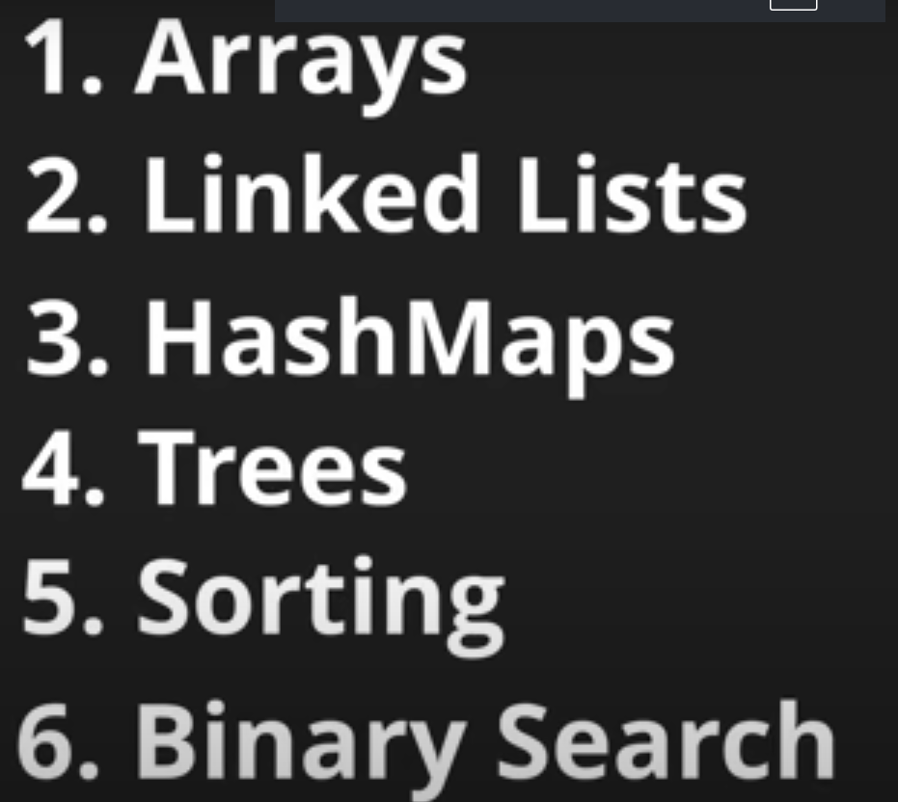
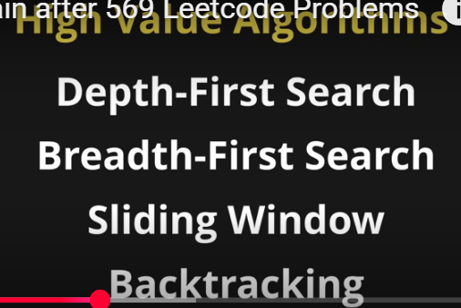

First concept I did:
HASHMAPS
https://www.youtube.com/watch?v=vJvqYFKXo5E
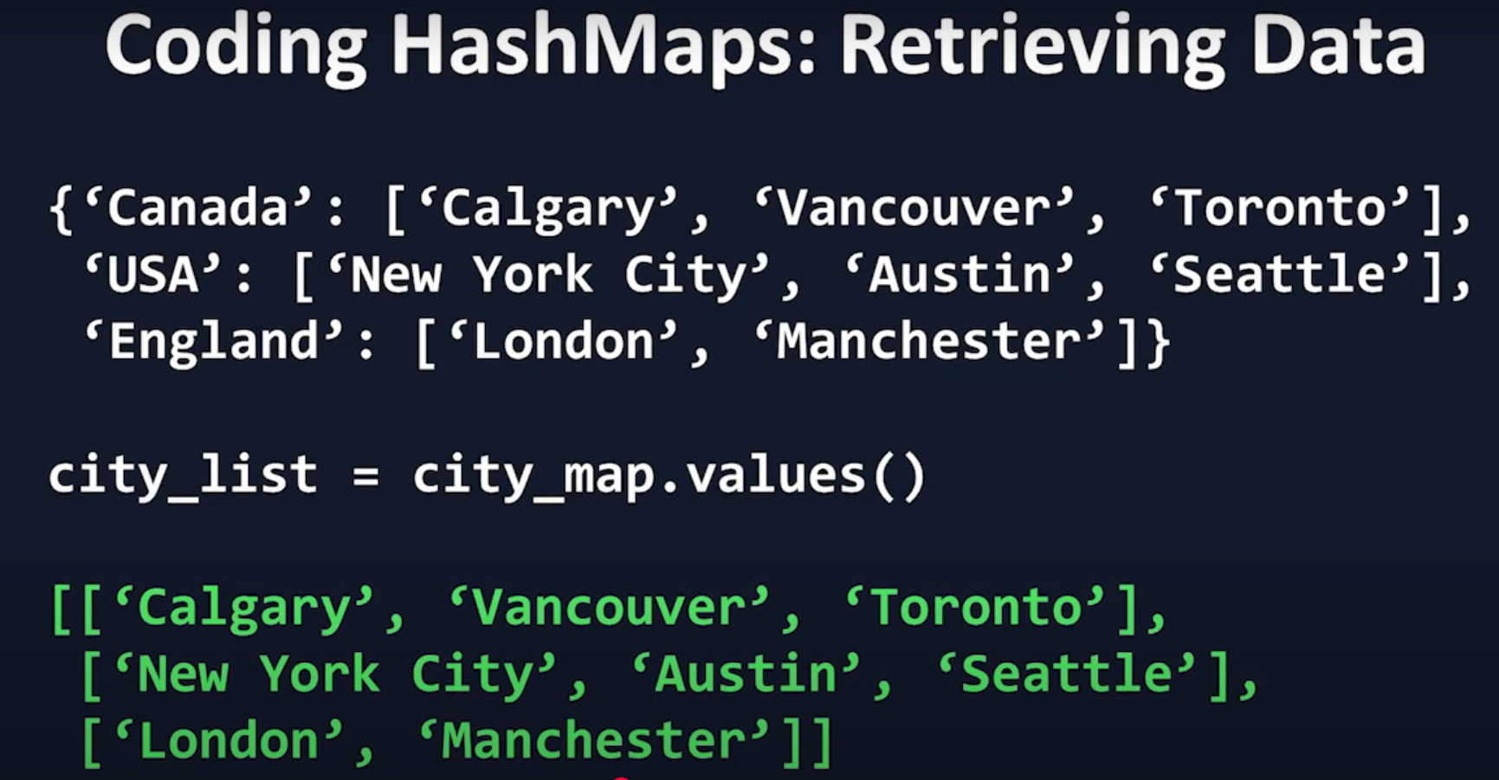
Todo:
https://www.youtube.com/watch?v=RcZsTI5h0kg
leetcode 49- anagrams

Concept #2:
Linked-list

