Border Control & Visa Management System
Database Systems (Lab)



Submitted by: Abdul Wali & Muhammad Khezir
Submitted to: Sir Ali Hassan

Semester: IV - BSSE (Group-A)
Course Code: CSC 451
Session 2024 –2028 (Fall)

INSTITUTE OF MANAGEMENT SCIENCES
HAYATABAD, PESHAWAR (2025)

Topic | Version | Prof Remarks | Date
ERD & Schema | Version 1.0 |  | April 25, 2026

Entity Relationship Diagram (ERD)

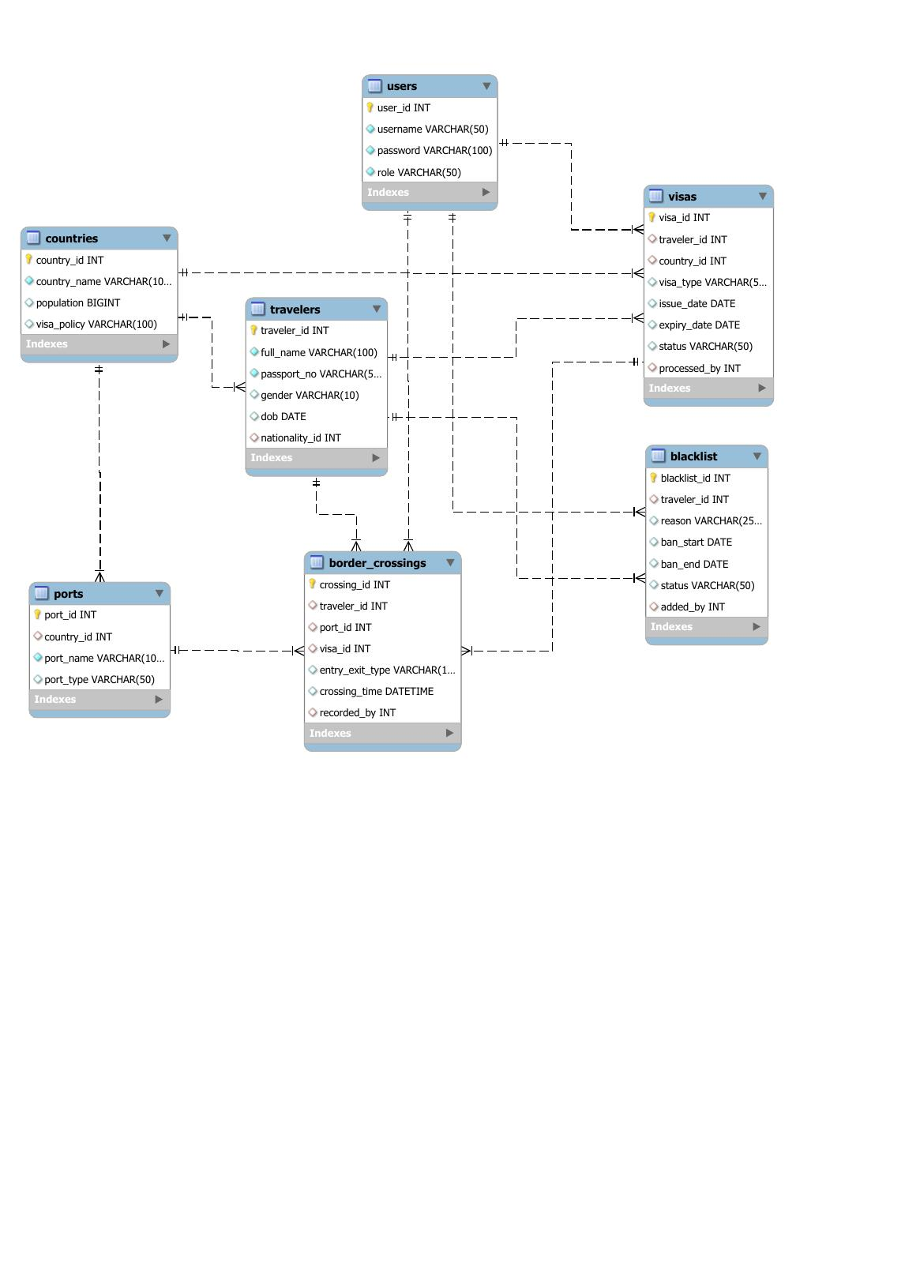
Relational Database Schema

Table Name | Attributes | Keys | Description
travelers | traveler_id, full_name, passport_no, gender, dob, nationality_id | PK: traveler_id | Stores traveler personal information
visas | visa_id, traveler_id, country_id, visa_type, issue_date, expiry_date, status, processed_by | PK: visa_id, FK: traveler_id, country_id, processed_by | Records visa information and status
countries | country_id, country_name, population, visa_policy | PK: country_id | Stores country information and visa policies
ports | port_id, country_id, port_name, port_type | PK: port_id, FK: country_id | Stores border port information
border_crossings | crossing_id, traveler_id, port_id, visa_id, entry_exit_type, crossing_time, recorded_by | PK: crossing_id, FK: traveler_id, port_id, visa_id, recorded_by | Records border crossing entries and exits
blacklist | blacklist_id, traveler_id, reason, ban_start, ban_end, status, added_by | PK: blacklist_id, FK: traveler_id, added_by | Maintains traveler blacklist with ban periods
users | user_id, username, password, role | PK: user_id | System user accounts and access control

Relationship Summary
The system uses a normalized relational schema where travelers is the main table, linked with visas, border_crossings, and blacklist through foreign keys.
The countries table is connected to visas and ports to manage country data. Ports stores border checkpoints, while border_crossings records traveler entry and exit movements.
The users table manages accounts and roles, and links with operational tables to maintain an audit trail of staff activities.
.

