ADAPT 2.0
AI-Powered Adaptive Student Learning and Support Platform
Project documentation: requirements, design, algorithms, testing and results

Document date: 11 October 2026
Project type: personal / portfolio project, built on the ADAPT adaptive planning engine (project proposal dated 10 October 2026)

Status of this document. Stage 1, the C++17 planning engine, has been implemented and tested; every result in sections 13 and 14 was measured on that engine and can be reproduced from the project files. Stages 2 to 5 (notes library, OCR, AI explanations, quizzes, originality tools, Urdu and low-bandwidth support) are designed here but not built. No results are reported for them, and their test tables are left blank on purpose.

Contents
1. Abstract
2. Introduction and problem statement
3. Aim and objectives
4. Scope and how ADAPT 2.0 differs from ADAPT 1.0
5. Users and use cases
6. Requirements
7. Workflow pipeline
8. System architecture
9. Engine design (Stage 1)
10. ADAPT 2.0 modules (Stages 2 to 5, design only)
11. Worked example
12. Testing methodology
13. Test results (Stage 1)
14. Interpretation, defect log and limits
15. Test plans for Stages 2 to 5
16. Roadmap and project plan
17. Risks, ethics and limitations
18. Conclusion
19. References
20. Appendices: A reproduction guide, B sample data, C viva questions, D submission checklist, E glossary

1. Abstract
ADAPT is an adaptive planning engine that repairs a student's study plan when reality changes, instead of rebuilding the whole plan. ADAPT 2.0 widens the project into a student learning and support platform: students upload notes, the system extracts and explains the material, generates practice questions, and turns weak topics into revision tasks that the C++ planner schedules, repairs after disruptions and re-estimates from feedback.
Stage 1, the planner, is implemented in C++17 using only the standard library. It passed all 10 planned scenario tests. On 900 randomised scenarios it scheduled as many tasks as a full rescheduler while moving 1.70 fewer unaffected tasks per disruption (5.70 vs 4.00), and it produced no hard-constraint violations. The remaining stages are specified here with their own test plans and will be reported only after they are built and measured.

2. Introduction and problem statement
Most planners produce a schedule and stop. When a class is cancelled, a task takes twice as long, or an urgent assignment appears, the student has to rebuild the plan by hand. A tool that rebuilds everything from scratch can also move tasks that were fine, which makes the plan feel unstable and hard to trust.
Students also lose time outside planning: notes are scattered across phones, folders and chat apps, difficult material is hard to understand, and many students have limited bandwidth, money or access to tutoring. ADAPT 2.0 treats these as one workflow rather than separate tools.
Research question for Stage 1: can a C++ planning engine selectively repair a disrupted schedule, keep hard constraints, explain its changes and improve its duration estimates from feedback, while moving fewer unaffected tasks than a full rescheduler?
Design principle for the whole project: ADAPT should help students learn, not just produce answers for them.

3. Aim and objectives
- Build a working C++ prototype that repairs study plans after disruptions (done for Stage 1).
- Represent tasks, priorities, deadlines, durations, available time and fixed commitments (done).
- Detect which tasks a disruption affects and keep the rest where they are when that is feasible (done).
- Score alternative plans with an explicit cost function and reject any plan that breaks a hard constraint (done).
- Explain every proposed change and let the user approve or reject it (done).
- Record actual outcomes and update duration estimates with a documented rule (done).
- Evaluate against a fixed-plan and a full-reschedule baseline (done on synthetic scenarios; user pilot pending).
- Add a notes library, OCR, AI explanations, quizzes and originality tools around the engine (designed, not built).
- Make the basic planner and notes library usable on slow connections and in simple English, with Urdu support where feasible (designed, not built).

4. Scope and how ADAPT 2.0 differs from ADAPT 1.0
ADAPT 1.0 is a focused planning engine with a command-line interface. ADAPT 2.0 keeps that engine as its core and adds learning and support features around it. The two source documents disagreed on several points, so the following decisions were made and are used throughout this documentation.

Topic | ADAPT 1.0 proposal | ADAPT 2.0 idea | Decision in this document
Language | C++17 only; 'no Python engine' | C++ plus web, OCR and AI services | C++17 owns scheduling, constraints and repair. Other languages may be used for the web interface, OCR and AI calls; they never make scheduling decisions.
Deadlines | Hard boundary in some places, 'weighted lateness' in others | Not specified | Deadlines are hard. A task that cannot finish in time is reported as unscheduled. The lateness metric is replaced by unscheduled priority points.
Storage | CSV / JSON; SQLite later | SQLite initially | CSV for the engine now; SQLite when the notes library is built.
Users and accounts | Single user; no cloud accounts | Account database | Single local user for Stage 1. Accounts only if the project becomes a shared service, with the privacy plan in section 10.6.
Privacy | Local storage, fictional data | Uploads to OCR and AI services | Users must be told when text leaves their device; uploads can be deleted; no use of private notes for training.
Timeline | 10 weeks, one semester | Five stages, no dates | Stage 1 is the semester deliverable. Stages 2 to 5 are future work (section 16).
Machine learning | Not in first version | LLMs for explanations and quizzes | No model is trained. Hosted or licensed models are called only from Stage 3 onward.

Out of scope for Stage 1: notes upload, OCR, AI features, accounts, calendars, mobile apps, medical or psychological advice, automatic actions without approval, and any claim of perfect prediction.

5. Users and use cases
Primary user: a university student managing several assignments, quizzes and exams. Secondary evaluators: a teacher reviewing the design and a small group of volunteer students testing usability.
ID | Use case | Stage
UC-01 | Create a task: title, estimated duration, deadline, priority, splittable or not | 1
UC-02 | Set availability: study windows and fixed commitments | 1
UC-03 | Generate a baseline plan | 1
UC-04 | Report a disruption: lost time, a new task or a changed duration | 1
UC-05 | Repair the plan, preserving unaffected tasks | 1
UC-06 | Compare alternatives and read the reasons for each change | 1
UC-07 | Approve or reject a proposal; the decision is logged | 1
UC-08 | Record actual duration so estimates improve | 1
UC-09 | Upload notes (PDF, Word, photo) and see the extracted text | 2
UC-10 | Organise and search notes by subject, semester and topic | 2
UC-11 | Get a summary and simple explanation of a topic | 3
UC-12 | Practise with flashcards and a quiz; see which topics need revision | 3
UC-13 | Send quiz-driven revision tasks to the planner | 3
UC-14 | Check writing for overlap with sources and get citation help | 4

6. Requirements

6.1 Functional requirements
ID | Requirement | Stage | Status
FR-01 | Create, edit, list and delete tasks | 1 | Engine data model implemented; CLI menu pending
FR-02 | Each task has unique id, title, duration, priority, deadline, splittable flag | 1 | Implemented and validated
FR-03 | Store study windows and fixed commitments | 1 | Implemented (free-time intervals)
FR-04 | Generate a baseline plan from valid input | 1 | Implemented
FR-05 | Accept lost time, new tasks and changed durations | 1 | Implemented
FR-06 | Identify affected tasks; preserve unaffected tasks where possible | 1 | Implemented
FR-07 | Score candidate plans; explain the main reasons for changes | 1 | Implemented
FR-08 | User approves or rejects a proposal | 1 | Implemented (session object)
FR-09 | Record planned duration, actual duration and feedback | 1 | Estimator implemented; persistence pending
FR-10 | Update estimates with a documented rule | 1 | Implemented (EMA, alpha 0.3)
FR-11 | Export plans and test logs to CSV or text | 1 | Test logs and benchmark exported as CSV
FR-12 | Upload PDF, Word and image files within a stated size limit | 2 | Planned
FR-13 | Extract text; flag low-confidence OCR regions instead of guessing | 2 | Planned
FR-14 | Organise notes by subject, semester, topic; full-text search | 2 | Planned
FR-15 | Let the user delete uploads and derived data | 2 | Planned
FR-16 | Summaries and simple-English explanations tied to source passages; Urdu where feasible | 3 | Planned
FR-17 | Flashcards and quizzes generated from notes and reviewed against the source | 3 | Planned
FR-18 | Create revision tasks from quiz results and pass them to the C++ engine | 3 | Planned
FR-19 | Similarity check with source references; citation help | 4 | Planned
FR-20 | AI-writing indicator shown as advisory only, with its limits explained | 4 | Planned
FR-21 | Basic planner keeps working when AI services are unavailable | 3 | Planned

6.2 Non-functional requirements
ID | Requirement | Evidence so far
NFR-01 | Hard constraints are checked before a plan is shown as feasible | Independent checker; 0 violations in 13,500 method runs
NFR-02 | Every moved or unscheduled task has a human-readable reason | Implemented (see section 11)
NFR-03 | Malformed input must not crash the program | T6 and T10 passed
NFR-04 | 100 tasks scheduled and repaired in under 2 seconds (target) | Measured about 0.63 ms (median) on the test machine
NFR-05 | Privacy: store only what planning needs; tell users when text leaves the device | Local-only in Stage 1; policy for Stages 2 to 4 in section 10.6
NFR-06 | Core engine compiles with a standard C++17 compiler | g++ 13.3.0, no warnings with -Wall -Wextra
NFR-07 | Modular design: model, planner, repair, scoring, storage, tests | Engine split into logical modules (single header for now)
NFR-08 | Low-bandwidth: pages and previews kept small | Target to be set and measured in Stage 5
NFR-09 | Cost transparency: free limits stated honestly; no promise of unlimited storage or processing | Policy decision

7. Workflow pipeline
The strongest idea in ADAPT 2.0 is that its features feed each other. A photo of notes becomes searchable text, then an explanation and a quiz; weak quiz topics become revision tasks; the planner fits those tasks around the student's real week and repairs the plan when something changes; actual times flow back into better estimates.
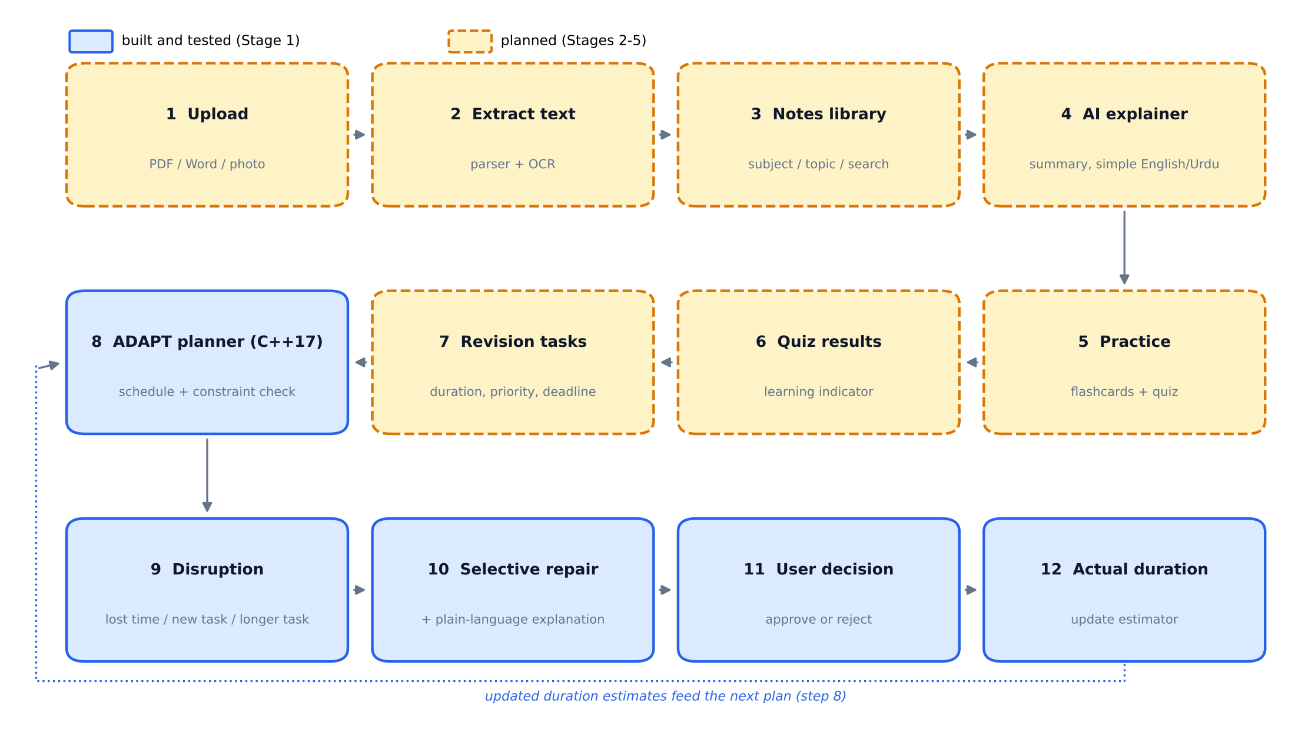
Figure 1. ADAPT 2.0 workflow. Blue steps are implemented and tested (Stage 1); amber dashed steps are planned.
# | Step | What happens | Owner | Status
1 | Upload | Student adds a PDF, Word file or photo of notes | Web interface | Planned (Stage 2)
2 | Extract text | Parser or OCR reads the file; unclear regions are flagged, not guessed | Parser + OCR | Planned (Stage 2)
3 | Notes library | Notes organised by subject, semester and topic; full-text search | Backend + database | Planned (Stage 2)
4 | AI explainer | Summary, key terms and simple-English explanation tied to source passages | AI model | Planned (Stage 3)
5 | Practice | Flashcards and a short quiz generated from the notes | AI model | Planned (Stage 3)
6 | Quiz results | Scores are treated as a learning indicator, not a measure of understanding | Backend | Planned (Stage 3)
7 | Revision tasks | Weak topics become tasks with duration, priority and deadline | Backend | Planned (Stage 3)
8 | Plan | Tasks are scheduled around fixed commitments and deadlines | C++ engine | Implemented + tested
9 | Disruption | Lost time, a new urgent task or a longer-than-expected task | C++ engine | Implemented + tested
10 | Selective repair | Only affected tasks move; every change gets a reason | C++ engine | Implemented + tested
11 | User decision | Approve or reject; rejection keeps the old plan and is logged | C++ engine | Implemented + tested
12 | Actual duration | Estimator is updated with planned vs actual time | C++ engine | Implemented + tested

8. System architecture
The C++ engine handles planning and decision logic. Parsers, OCR, AI models and similarity tools handle language and documents. They communicate through the application backend, which means the planner can be developed, tested and used without any of them.
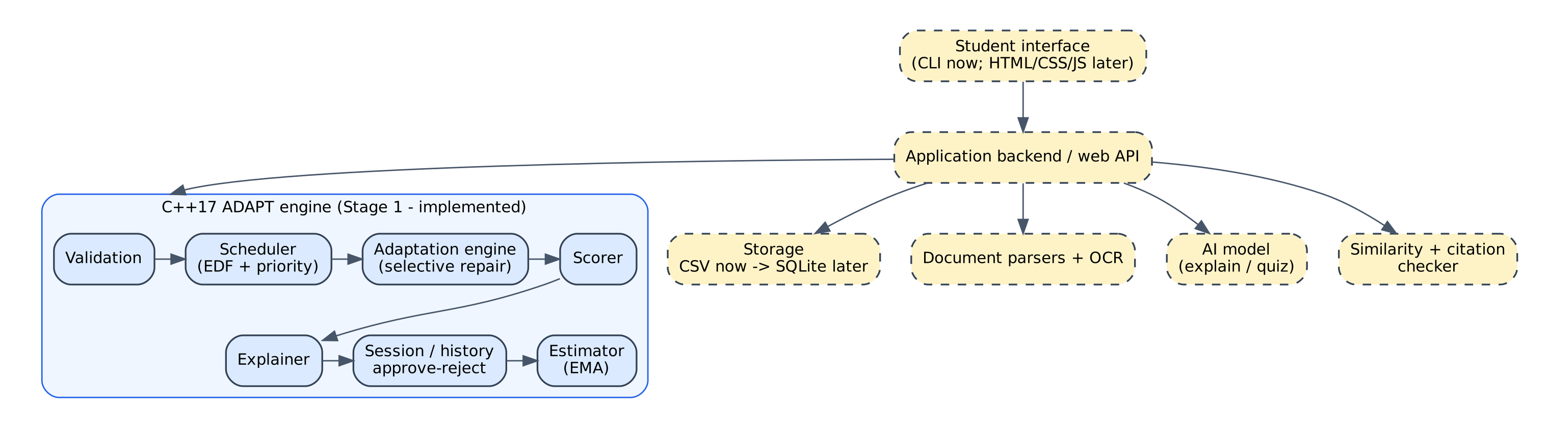
Figure 2. Proposed architecture. Blue: implemented in Stage 1. Amber dashed: planned.
Module | Responsibility | Status
Validation | Rejects malformed tasks; all-or-nothing CSV loading | Implemented
Scheduler | Earliest deadline first, then priority, then shorter task | Implemented
Adaptation engine | Finds affected tasks, builds selective / expanded / full candidates | Implemented
Scorer | Checks hard constraints and computes the cost | Implemented
Explainer | Plain-language reason for every moved or unscheduled task | Implemented
Session and history | Approve / reject, audit log | Implemented
Estimator | Exponential moving average of task durations | Implemented
Storage | CSV now; SQLite later | CSV implemented; SQLite planned
Interface | Command-line now; web interface later | Planned
Notes library + OCR | Upload, extract, organise, search | Planned
AI explainer + quiz | Explanations, flashcards, quizzes | Planned
Originality tools | Similarity check, citation help, advisory AI-writing indicator | Planned

Suggested technology
Component | Technology | Purpose
Planning engine | C++17 | Scheduling, constraints, repair, estimator
Interface | CLI now; HTML, CSS, JavaScript later | Task entry, plan view, uploads, reader
Backend | A suitable web API | Connects interface to engine and services
Database | CSV now; SQLite, then PostgreSQL if needed | Tasks, plans, history, notes metadata
File storage | Local folder for prototype; object storage later | PDFs and images
Text extraction | PDF / Word parsers and an OCR engine | Make scanned notes searchable
AI explanations | Hosted model via API or a suitably licensed local model | Summaries, explanations, quizzes
Similarity | Text comparison plus a legitimate source-checking service if available | Possible matches with references

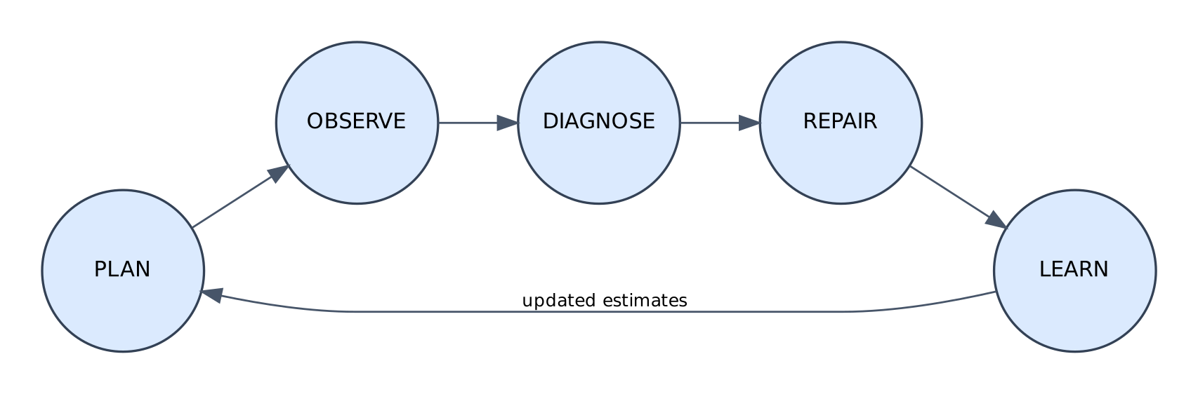
Figure 3. The Plan - Observe - Diagnose - Repair - Learn loop.

9. Engine design (Stage 1)

9.1 Data model
Object | Fields
Task | id, title, category, duration (minutes), priority 1 to 5, hard deadline (minute since Monday 00:00), splittable
Interval | start, end (free study time after fixed commitments are removed)
Chunk | task id, start, end (a splittable task may have several chunks)
Plan | chunks, unscheduled task ids, cost, explanation notes
World | free intervals and tasks
Disruption | lost window, new task, or changed duration
Session | approved plan, pending proposal, history log

9.2 Initial planning heuristic
- Validate every task (positive duration, priority 1 to 5, title, unique id, positive deadline).
- Sort by earliest deadline, then higher priority, then shorter duration.
- Place each task in the earliest free time that fits and ends before its deadline. A non-splittable task needs one continuous gap; a splittable task may use several.
- If a task cannot fit, list it as unscheduled with the reason. The engine never pretends it fits.

9.3 Selective repair
- Apply the disruption to the world (remove lost time, add a task, or change a duration).
- Mark affected tasks: those overlapping lost time, the task whose duration changed, or the new task.
- Candidate C1 (selective): freeze every unaffected task and re-place only the affected ones.
- If the disruption left a previously scheduled (or new) task unscheduled, also build C2 (expanded: later-deadline tasks may move) and C3 (full reschedule).
- Reject any candidate that fails the hard-constraint check; score the rest; pick the lowest cost.
- Write a reason for every moved or unscheduled task and show the proposal. The user approves or rejects; a rejection keeps the old plan and is logged.
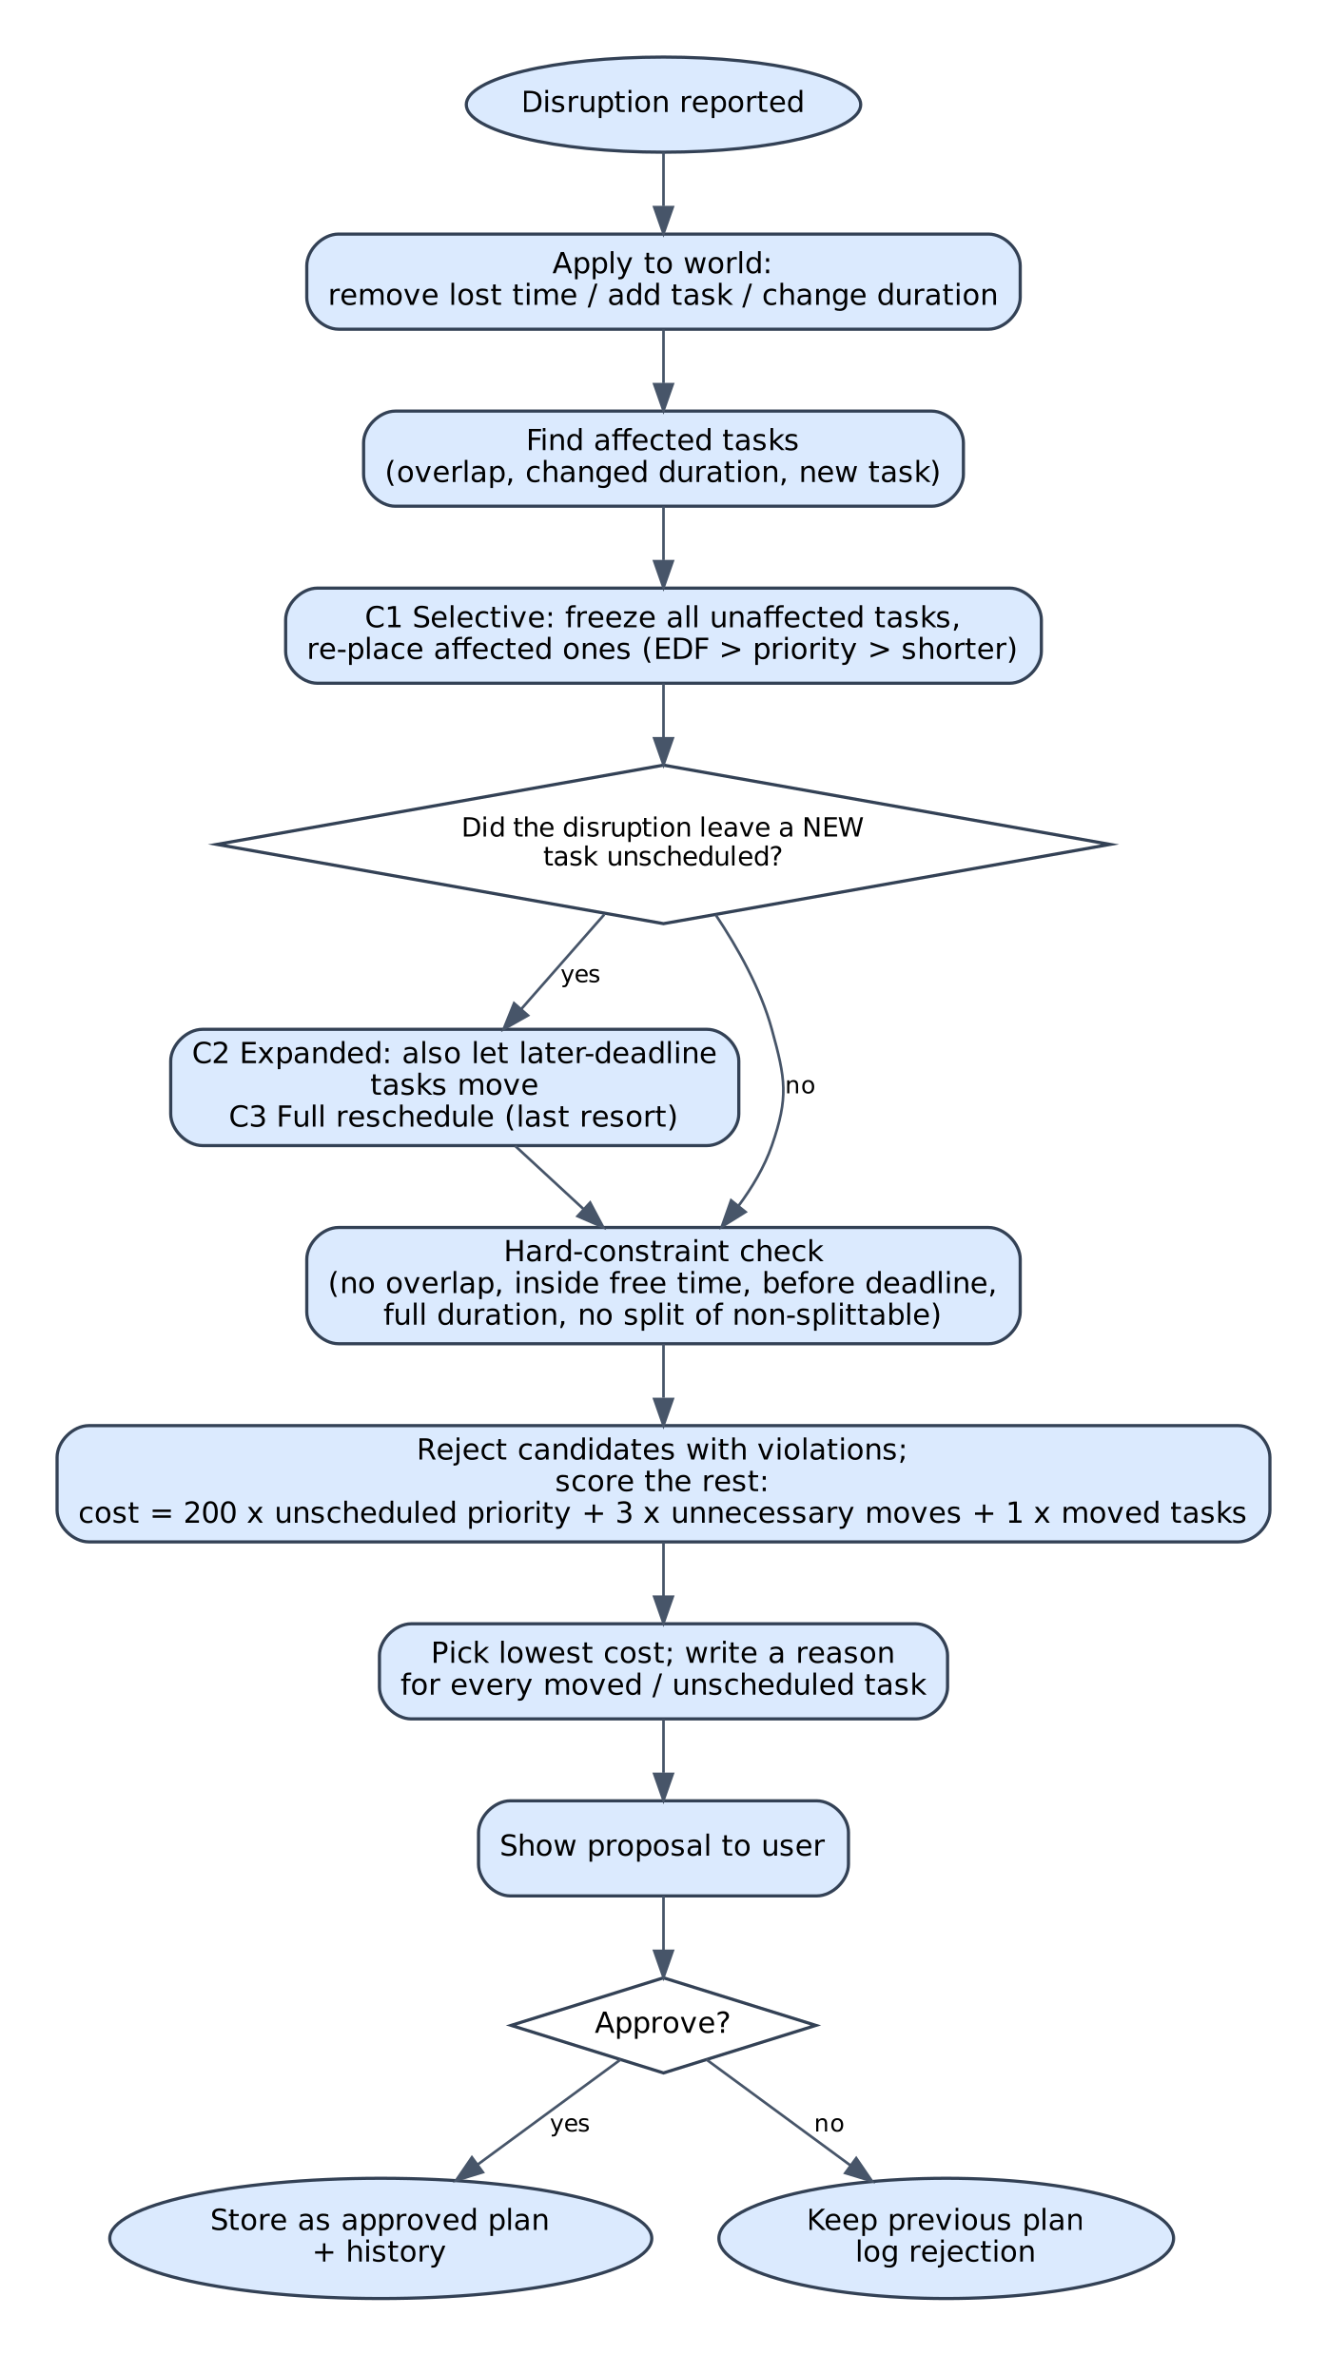
Figure 4. Selective repair with approval.

9.4 Hard constraints and cost
Hard constraints, checked independently of the planner: no two chunks overlap; every chunk lies inside free time (so fixed commitments are never used); every chunk ends before its deadline; a scheduled task receives exactly its duration; a non-splittable task is never split.
Cost = 200 x (priority points of unscheduled tasks) + 3 x (unaffected tasks moved) + 1 x (previously scheduled tasks whose time changed). Plans that violate a hard constraint are disqualified rather than penalised. The weights are initial design choices; section 13.4 shows the effect of changing the first one.

9.5 Duration estimator
For each task category the engine keeps an estimate E. When the user records an actual duration A, it updates E_new = alpha x A + (1 - alpha) x E_old with alpha = 0.3. Missing or non-positive outcomes are ignored. A category with fewer than three observations is marked low-confidence so the interface can say so. Test T7 confirms E = 60 and A = 80 gives 66.0.

9.6 File format
Tasks are loaded from CSV with columns id, title, duration_min, priority, deadline_min, splittable. Loading is all-or-nothing: any malformed line or duplicate id returns errors and no tasks, so a bad file can never half-replace good data (test T10).

10. ADAPT 2.0 modules (Stages 2 to 5, design only)
Nothing in this section has been built or tested. It is the specification the later stages will be built and measured against.

10.1 Notes library and OCR (Stage 2)
- Accepted files: PDF, Word, common image formats, within a published size limit.
- Digital PDFs and Word files go through a parser; photographs and scans go through OCR.
- OCR output keeps a confidence value per region. Unclear regions are shown as unclear, not silently guessed, especially for handwriting.
- Notes are organised by subject, semester and topic and searched by full text.
- Users can delete a file and everything derived from it (text, index entries, generated material).

10.2 Notes explainer (Stage 3)
- Short and detailed summaries, key terms and definitions, step-by-step explanations of hard concepts, in simple English; Urdu where quality can be checked by a fluent speaker.
- Every explanation links back to the passage of the user's notes it is based on, so it can be checked.
- The model is told to say when the notes do not contain the answer.

10.3 Quiz and revision rule (Stage 3)
Quiz results are a learning indicator, not a measurement of understanding. A revision task is created only after at least 5 questions on a topic, using this initial rule (design values, to be tuned with real data):
Quiz score on topic | Revision task | Priority
below 50% | 45 minutes | 5
50% to below 75% | 30 minutes | 4
75% or above | 15-minute spaced review | 2

The task's deadline is set before the exam date the student entered. The C++ engine then schedules it like any other task, and repairs it when plans change.

10.4 Originality tools (Stage 4)
- Similarity check and citation help. Highlights passages that overlap with available sources, shows the source where known, finds missing quotation marks or citations, and explains citation styles such as APA. It can only compare against sources it has access to, so a clean result is never proof of originality.
- The feature is called an Originality Assistant: it helps students fix problems and understand sources. It does not promise to remove plagiarism or avoid detection.
- AI-writing indicator. Advisory only, shown with an explanation of the signals used and a warning that detectors make mistakes. ADAPT never labels anyone as cheating from a score.
- Published research found that common AI-text detectors wrongly flag writing by non-native English speakers more often (Liang et al., 2023). Because many target users write English as a second language, the indicator must be tested for false positives on such text (test S4-4) before it is shown to anyone, and may be dropped if it cannot be made fair.

10.5 Accessibility and low-bandwidth support (Stage 5)
- Compressed previews and light pages; saved notes can be reopened without re-uploading.
- Simple-English explanations; Urdu support where it can be reviewed by a fluent speaker.
- The basic planner and notes library keep working if an external AI service is down.
- Free limits are stated honestly. Truly unlimited storage or processing cannot be promised.

10.6 Privacy and data handling
- Store only what the feature needs. Keep demonstration data fictional.
- Tell the user before any text leaves their device for OCR or AI processing.
- Provide deletion of uploads and derived data.
- Do not use private notes to train models. Do not collect grades, passwords or private messages in pilots.

11. Worked example
Data are the five fictional tasks from the original proposal. Study windows are 16:00 to 22:00 Monday to Thursday, with a fixed commitment on Monday 19:00 to 20:00. The disruption removes Monday 16:00 to 18:00.
id | title | duration (min) | priority | deadline | splittable
A01 | AI quiz revision | 60 | 5 | Mon 18:00 | No
A02 | OOP practice | 60 | 4 | Tue 20:00 | Yes
A03 | Math revision | 45 | 5 | Mon 21:00 | Yes
A04 | English reading | 30 | 2 | Wed 19:00 | Yes
A05 | Lab report | 90 | 4 | Thu 17:00 | Yes

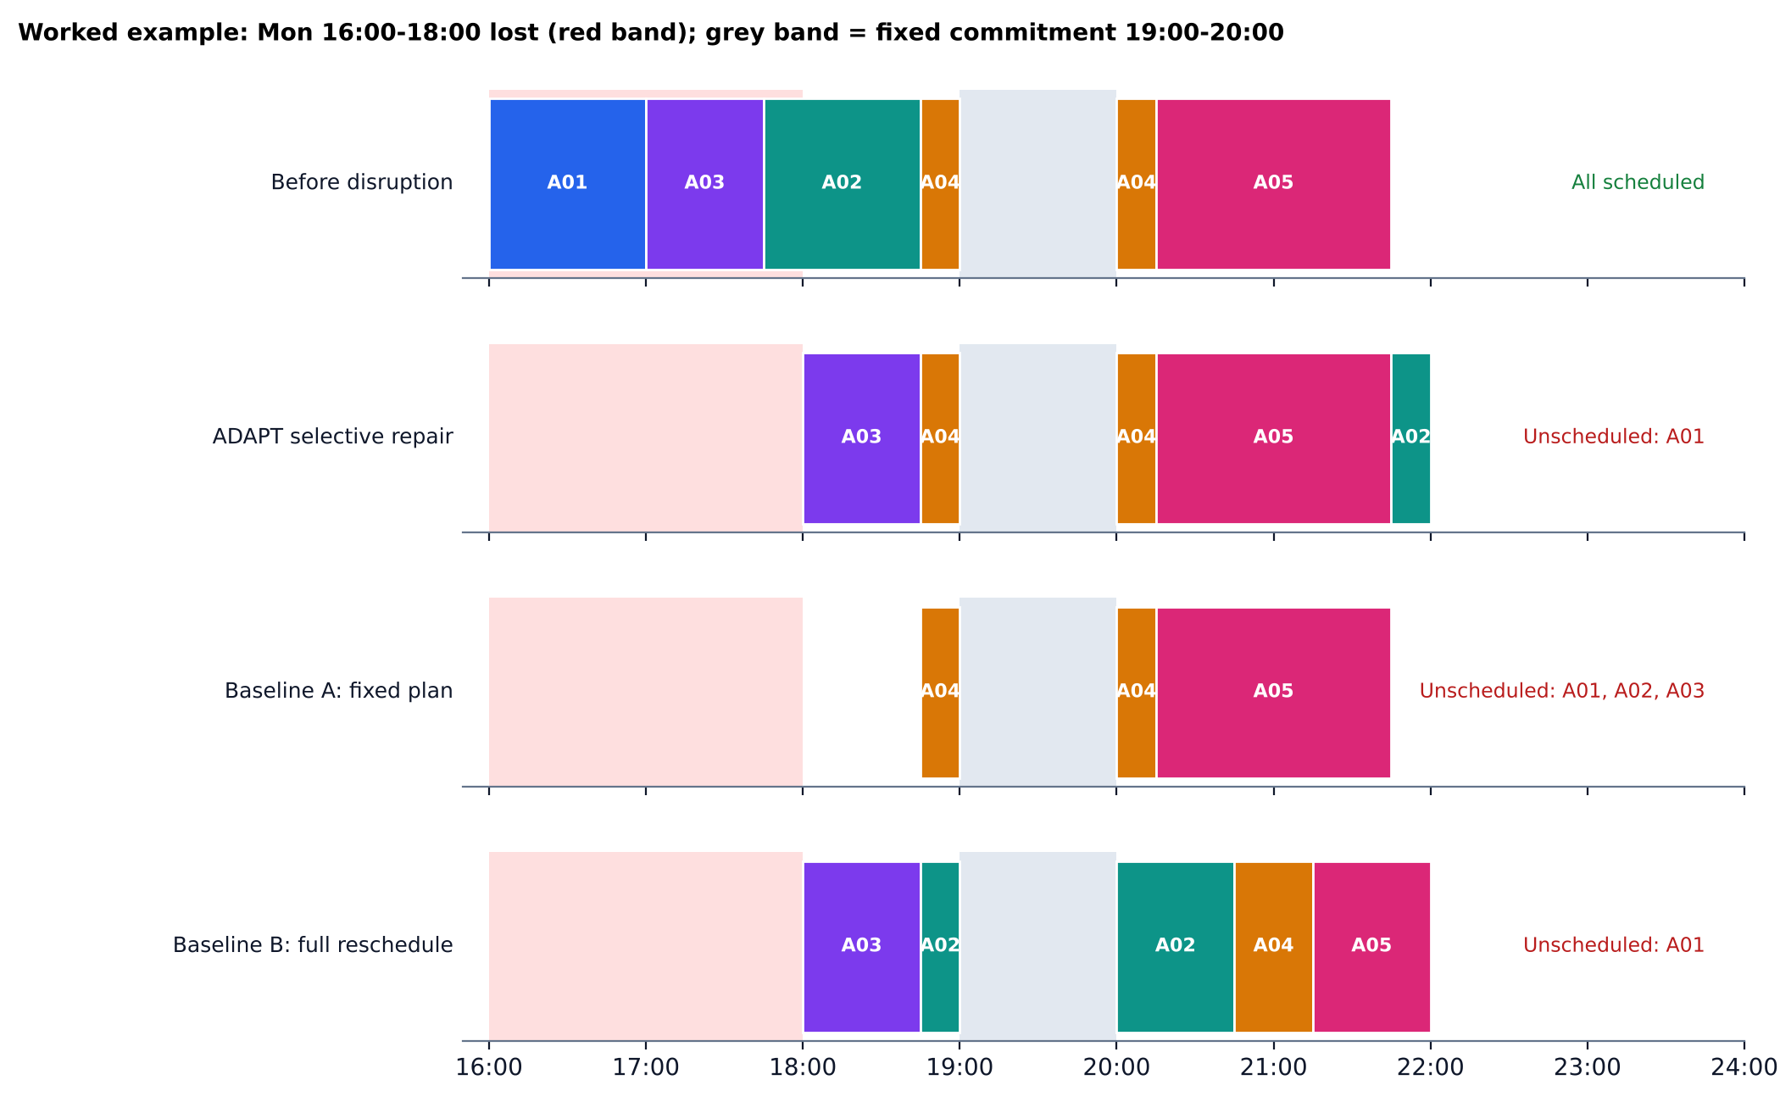
Figure 5. The same disruption handled by ADAPT and the two baselines (output of the real engine).
Method | Scheduled | Unscheduled | Tasks changed | Unaffected tasks moved
A Fixed plan | A04, A05 | A01, A02, A03 | 3 | 0
B Full reschedule | A02, A03, A04, A05 | A01 | 5 | 2 (A04, A05)
ADAPT selective repair | A02, A03, A04, A05 | A01 | 3 | 0

A01 has a Monday 18:00 deadline, so once 16:00 to 18:00 is gone it cannot be done in time. ADAPT reports that instead of hiding it. It keeps A04 and A05 exactly where they were; the full reschedule moves both for no benefit. Explanations produced by the engine:
- A01 cannot be scheduled before its deadline (directly affected by the disruption)
- A02 moved to Mon 21:45 (directly affected by the disruption)
- A03 moved to Mon 18:00 (directly affected by the disruption)

12. Testing methodology
- Scenario tests T1 to T10 from the original proposal's test matrix, run on the demo data.
- Randomised benchmark: 900 scenarios = 3 load levels (8, 14, 20 tasks) x 3 disruption types x 100 seeds (generator seed 2026). 4-day horizon; study windows 09:00-12:00 and 16:00-22:00; about half the days have a 60-minute fixed commitment; task length 30-120 min; priority 1-5; 60% splittable. Lost windows and longer tasks are applied to a task that is actually scheduled.
- Methods compared on identical inputs: A fixed plan (affected tasks are dropped, nothing repaired), B full reschedule (same heuristic, rebuild everything), and ADAPT selective repair.
- Metrics: share of scenarios with all tasks scheduled; unscheduled priority points; previously scheduled tasks whose time changed; unaffected tasks moved; hard-constraint violations; runtime.
- Scale test: 25 to 400 tasks over 40 days, median of 21 runs per size.
- Environment: Ubuntu 24.04, g++ 13.3.0 (-std=c++17 -O2), 2 CPU cores, cloud container. Timings are not from a student laptop.

13. Test results (Stage 1)

13.1 Scenario tests T1 to T10
ID | Scenario | Actual output (measured) | Result
T1 | No disruption | tasks moved=0, violations=0 | PASS
T2 | Lost study window Mon 16:00-18:00 | affected=3, moved=3, unnecessary=0, unscheduled=1, fixed Mon19-20 used=no, violations=0 | PASS
T3 | A02 duration 60 -> 120 min | A02 scheduled minutes=120, violations=0, unnecessary moves=0 | PASS
T4 | Urgent new task N01 (prio 5, 60 min, Tue 12:00) | N01 placed=yes, strategy=expanded, notes=4, violations=0 | PASS
T5 | Impossible workload (8 extra 2-h tasks due Mon 23:20) | unscheduled=7, false-feasible claim=no, violations=0 | PASS
T6 | Negative duration, missing title, priority 9 | 3 validation errors, no crash | PASS
T7 | alpha=0.3, E=60, A=80 | E: 60 -> 66.0 (expected 66.0); invalid actual ignored=yes | PASS
T8 | Second disruption on the approved revised plan | history entries=5, unnecessary moves=0, violations=0 | PASS
T9 | User rejects suggestion | approved plan unchanged=yes, last log=REJECT prefer to keep Monday evening free"" | PASS
T10 | Malformed numeric field; duplicate id; valid control file | malformed errors=1, duplicate errors=1, control loaded tasks=2 | PASS

10 of 10 passed. These are functional checks on one demo dataset; they show the required behaviours exist, not how well the engine performs in general.

13.2 Benchmark results
Method | All tasks scheduled | Tasks scheduled (mean) | Unscheduled priority points | Tasks changed | Unaffected tasks moved | Hard violations
A Fixed plan | 0% | 12.3 / 14.3 | 6.85 | 1.05 | 0.00 | 0
B Full reschedule | 55% | 13.5 / 14.3 | 2.50 | 6.75 | 5.70 | 0
ADAPT selective repair | 55% | 13.5 / 14.3 | 2.48 | 5.04 | 4.00 | 0

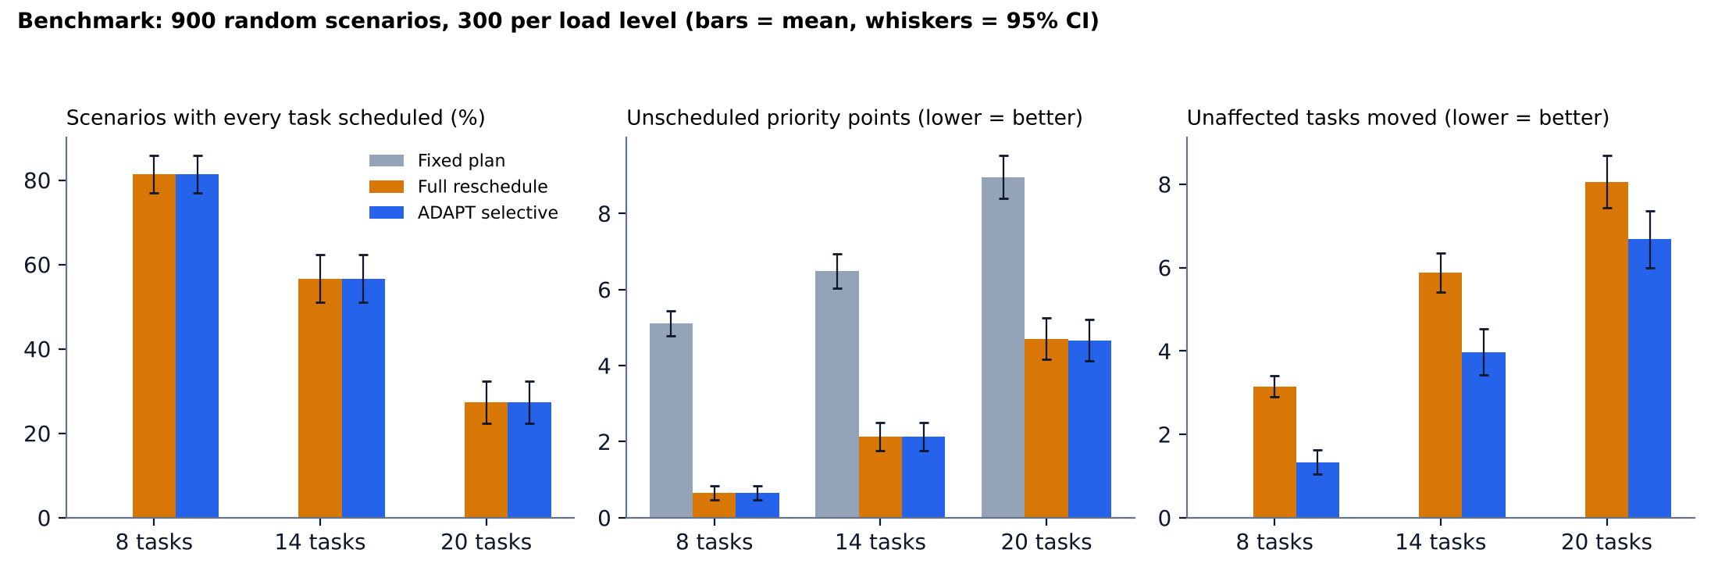
Figure 6. Results by load level (900 scenarios). Whiskers are 95% confidence intervals.
Load | Method | All scheduled | Unscheduled points | Unaffected moved
8 tasks | A Fixed | 0% | 5.11 | 0.00
8 tasks | B Full | 81% | 0.65 | 3.15
8 tasks | ADAPT | 81% | 0.65 | 1.33
14 tasks | A Fixed | 0% | 6.49 | 0.00
14 tasks | B Full | 57% | 2.13 | 5.88
14 tasks | ADAPT | 57% | 2.12 | 3.97
20 tasks | A Fixed | 0% | 8.96 | 0.00
20 tasks | B Full | 27% | 4.70 | 8.06
20 tasks | ADAPT | 27% | 4.66 | 6.68

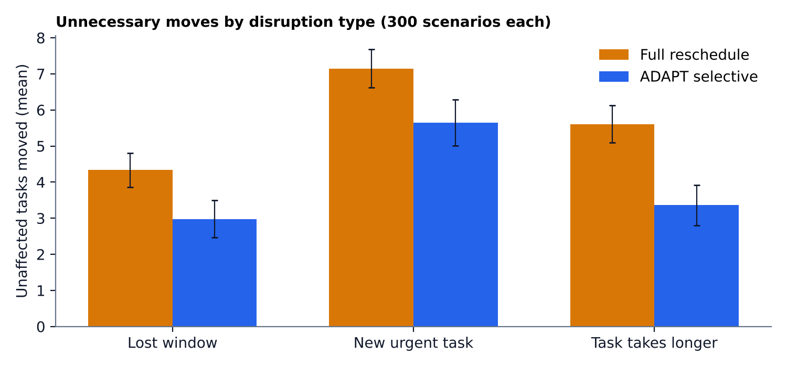
Figure 7. Unaffected tasks moved, by disruption type.
Disruption type | B Full reschedule | ADAPT
Lost study window | 4.33 | 2.98
Urgent new task | 7.15 | 5.65
Task takes longer | 5.61 | 3.36

Main finding. ADAPT completed as many scenarios as the full rescheduler (55%) and left slightly fewer priority points unscheduled (2.48 vs 2.50), while moving 1.70 fewer unaffected tasks per scenario (95% CI +/- 0.18; 5.70 vs 4.00). It moved fewer unaffected tasks in 47% of scenarios and the same number in 53%; it never moved more. Hard-constraint violations across all 13,500 method runs: 0.

13.3 Selected strategy
With the default weights, ADAPT kept the purely selective plan in 56% of scenarios, chose the expanded plan in 44% and fell back to a full reschedule in 0.6%.

13.4 Choosing the cost weight
The weight on unscheduled priority was swept while everything else was held fixed. Lower weights make ADAPT more conservative: fewer unaffected tasks move, but more work is left unscheduled.
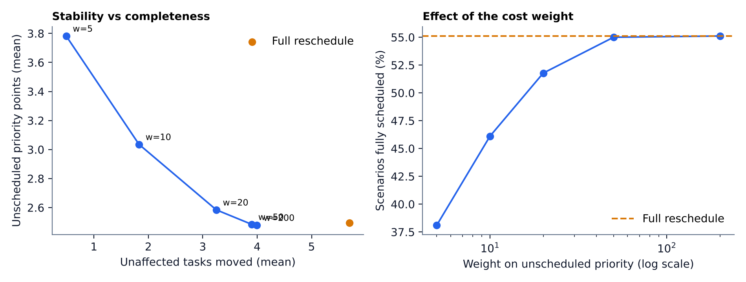
Figure 8. Stability versus completeness as the weight changes.
Weight on unscheduled priority | All scheduled | Unscheduled points | Unaffected moved
200 (default) | 55% | 2.48 | 4.00
50 | 55% | 2.48 | 3.90
20 | 52% | 2.58 | 3.25
10 | 46% | 3.04 | 1.83
5 | 38% | 3.78 | 0.49

A weight near 20 keeps most of the completeness (52% vs 55% fully scheduled) while moving about 19% fewer unaffected tasks than the default. The right trade-off depends on how much students value stability, and should be decided with user feedback.

13.5 Runtime
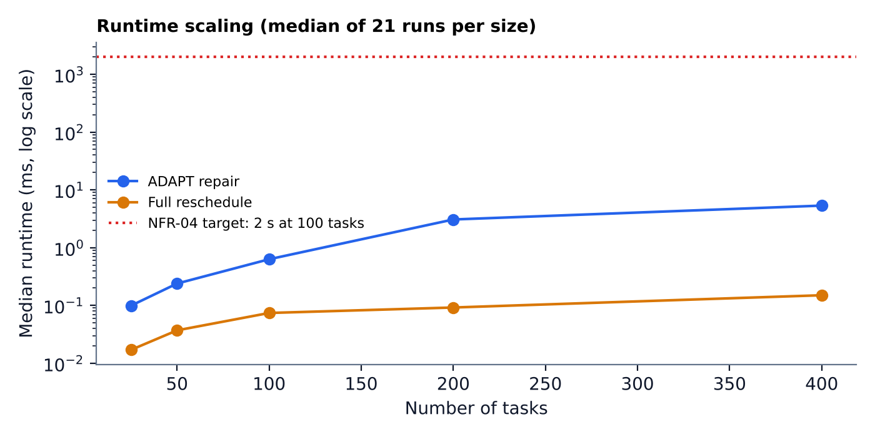
Figure 9. Median repair time versus number of tasks.
Tasks | ADAPT repair, median (ms) | Full reschedule, median (ms)
25 | 0.10 | 0.02
50 | 0.24 | 0.04
100 | 0.63 | 0.07
200 | 3.07 | 0.09
400 | 5.34 | 0.15

The 100-task target of under 2 seconds is met by a wide margin (about 0.6 ms). ADAPT is slower than a plain rebuild because it evaluates several candidates, but stays within a few milliseconds even at 400 tasks.

13.6 Raw data sample
First two benchmark scenarios (default weights). Full data: results/benchmark.csv (13,500 rows).
scen. | load | disruption | method | strategy | scheduled/total | unsched pts | changed | unnecessary | viol. | us
0 | 8 | lost_window | fixed_plan | - | 6/8 | 5 | 2 | 0 | 0 | 1
0 | 8 | lost_window | full_reschedule | - | 8/8 | 0 | 5 | 3 | 0 | 3
0 | 8 | lost_window | adapt_selective | selective | 8/8 | 0 | 2 | 0 | 0 | 33
1 | 8 | lost_window | fixed_plan | - | 6/8 | 7 | 2 | 0 | 0 | 1
1 | 8 | lost_window | full_reschedule | - | 8/8 | 0 | 2 | 0 | 0 | 2
1 | 8 | lost_window | adapt_selective | selective | 8/8 | 0 | 2 | 0 | 0 | 16

14. Interpretation, defect log and limits

14.1 Defect found by testing
The first benchmark run showed ADAPT moving 4.01 unaffected tasks per scenario, more than expected. The suspected cause was that ADAPT escalated to wider candidates even when the unscheduled tasks had already been unscheduled before the disruption. The trigger was changed to react only to newly unscheduled tasks, but the result barely changed (4.01 to 4.00). The real cause is the cost function: with 200 points per unscheduled priority point and 3 per unnecessary move, ADAPT will reshuffle many tasks to rescue one. That is a modelling choice, not a bug, which is why section 13.4 sweeps the weight. The first run is kept as results/benchmark_v0.1_defect.csv.

14.2 Limits of these results
- Synthetic scenarios. They come from one random generator. Real student timetables may behave differently; the planned user pilot is the real test.
- ADAPT includes the full reschedule as a fallback candidate. So it cannot leave more priority points unscheduled than the full reschedule by construction. The meaningful comparison is the number of unaffected tasks moved.
- Baseline A is deliberately weak. It drops affected tasks without trying to repair them; it mainly shows the cost of doing nothing.
- Timings come from a cloud container, not a student's laptop.
- Only Stage 1 is tested. Nothing here says whether OCR, AI explanations, quizzes or originality tools will work well.
- No novelty claim. Adaptive scheduling and constraint optimisation are established research areas. This project claims a specific selective-repair design and measures it; it does not claim to be the first or the best.

15. Test plans for Stages 2 to 5
These tables are blank on purpose. The last column is filled only with measured results after each stage is built.

Stage 2 - Notes library and OCR
ID | Scenario | Expected result | Actual result
S2-1 | Upload a valid PDF | Text extracted and searchable | not run yet
S2-2 | Upload a file above the size limit | Clear rejection message; nothing stored | not run yet
S2-3 | Photo of printed text | Character error rate measured against a typed reference | not run yet
S2-4 | Photo of handwriting | Unclear regions flagged as low confidence | not run yet
S2-5 | Search for a term in three notes | All notes containing the term are returned | not run yet
S2-6 | Delete an upload | File, text and search index entries removed | not run yet

Stage 3 - AI explainer and quizzes
ID | Scenario | Expected result | Actual result
S3-1 | Explain a notes page | Each claim traceable to a source passage | not run yet
S3-2 | Generate 20 quiz questions | Share answerable from the notes, judged by a human reviewer | not run yet
S3-3 | AI service unavailable | Planner still works; user told AI features are offline | not run yet
S3-4 | Quiz score below 50% | 45-minute priority-5 revision task created by the documented rule | not run yet

Stage 4 - Originality tools
ID | Scenario | Expected result | Actual result
S4-1 | Copy a paragraph from a source in the corpus | Flagged with a source reference | not run yet
S4-2 | Properly quoted and cited paragraph | Not reported as a missing citation | not run yet
S4-3 | AI-writing indicator shown | Advisory wording only; no accusation; explains the signals used | not run yet
S4-4 | Human-written text by non-native English writers | False-positive rate measured before the feature is shown to anyone | not run yet

Stage 5 - Accessibility and pilot
ID | Scenario | Expected result | Actual result
S5-1 | Load the dashboard on a throttled connection | Page weight and load time recorded against a target set first | not run yet
S5-2 | Urdu explanation of one topic | Reviewed by a fluent Urdu speaker | not run yet
S5-3 | Usability pilot with 5 to 10 students | 1 to 5 ratings for clarity, trust and ease of use | not run yet

Stage 5 pilot: invite 5 to 10 volunteer students, subject to instructor approval and university rules. Use fictional or non-sensitive tasks, and do not collect grades, passwords or private messages. Compare time to repair a plan manually versus with ADAPT, unnecessary moves, and 1 to 5 ratings for clarity, trust and ease of use. The sample is small and exploratory and cannot prove general effectiveness.

16. Roadmap and project plan
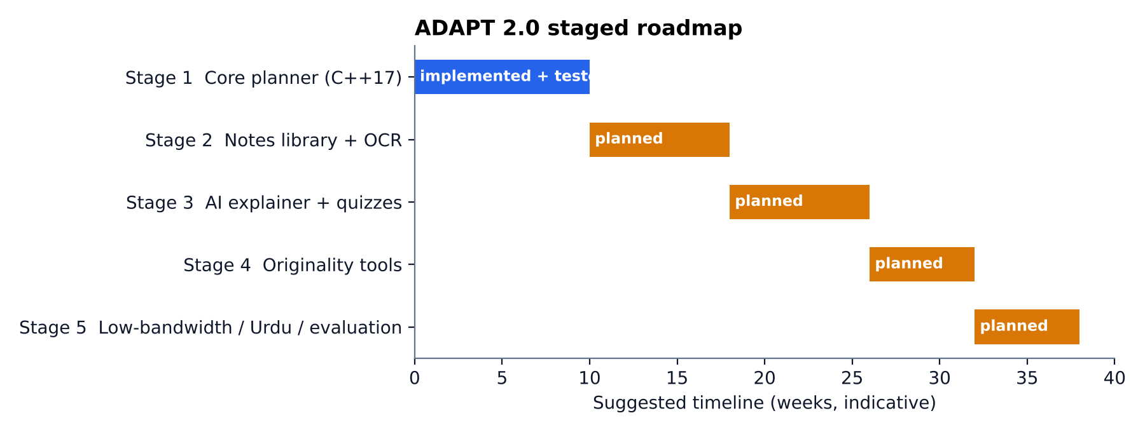
Figure 10. Staged plan. Only Stage 1 is built; week counts are indicative.
Stage | Deliverable | Done when
1 Core planner | C++17 scheduler, repair, scoring, explanations, estimator, tests | All T1-T10 pass; benchmark reported (done); CLI and user pilot pending
2 Notes library | Upload, extraction, OCR, organisation, search, delete | S2 tests run and recorded
3 AI explainer | Summaries, explanations, flashcards, quizzes, quiz-to-task rule | S3 tests run; human review of quiz quality recorded
4 Originality tools | Similarity, citation help, advisory AI-writing indicator | S4 tests run, including false-positive check on non-native English text
5 Support | Low-bandwidth pages, Urdu, usability pilot, cost report | S5 results recorded

Remaining Stage 1 work: a menu-driven CLI around the engine, persistent history, and the usability pilot from the original proposal.

17. Risks, ethics and limitations
Risk | Mitigation
Duration estimates are wrong | Show them as estimates; allow correction; show low confidence when data is sparse
Schedules can be impossible | Report infeasibility clearly; never claim all tasks fit
Over-optimised plans ignore preferences | User approval and manual override stay in the loop
Private notes sent to external services | Tell the user; allow deletion; no training on notes; local-only fallback for the planner
AI explanations or quizzes are wrong | Tie explanations to source passages; show when the notes lack an answer; human review of quiz samples
AI-writing indicator is unfair | Advisory only; test on non-native English text; drop it if it cannot be made fair
OCR misreads handwriting | Flag low-confidence regions; do not present guesses as fact
Scope creep | Stages are built and tested in order; later stages start only after earlier ones are measured
Costs of AI and OCR | State free limits honestly; keep the planner independent of paid services

18. Conclusion
ADAPT 2.0 keeps a working, tested planning engine at its centre and adds a learning workflow around it. The engine met every functional test and, on 900 synthetic scenarios, matched a full rescheduler on completeness while moving fewer unaffected tasks and breaking no hard constraints. The rest of the platform is specified and has test plans, but is unbuilt. The project's value will be decided by measured results at each stage, not by the number of features.

19. References
- Liu, C. L. and Layland, J. W. (1973). Scheduling algorithms for multiprogramming in a hard-real-time environment. Journal of the ACM, 20(1), 46-61. (earliest-deadline-first scheduling)
- Liang, W., Yuksekgonul, M., Mao, Y., Wu, E. and Zou, J. (2023). GPT detectors are biased against non-native English writers. Patterns, 4(7). (AI-text detector bias)
- Google OR-Tools, C++ guide and constraint optimisation overview: https://developers.google.com/optimization (optional future solver; not used in Stage 1). Record the access date when you consult it.
- cppreference.com, C++ chrono and filesystem libraries: https://en.cppreference.com/w/cpp
- ADAPT project proposal and design documentation, 10 October 2026 (original proposal).

Appendix A - Reproduction guide
Project layout (C++17, standard library only):
src/adapt.hpp engine: scheduler, repair, baselines, estimator, session, CSV loader
tests/run_tests.cpp T1-T10, writes results/test_results.csv
tests/bench.cpp 900-scenario benchmark, weight sweep and scale test
tests/demo.cpp worked example schedules
docs/make_figs.py charts, flowcharts and summary statistics
results/ test_results.csv, benchmark.csv, benchmark_v0.1_defect.csv, scale.csv, demo_schedules.csv, summary_stats.json
Commands:
g++ -std=c++17 -O2 -Wall -Wextra -o run_tests tests/run_tests.cpp && ./run_tests
g++ -std=c++17 -O2 -o bench tests/bench.cpp && ./bench
g++ -std=c++17 -O2 -o demo tests/demo.cpp && ./demo
python3 docs/make_figs.py
Times are minutes since Monday 00:00 (Tuesday 16:00 is 1440 + 960 = 2400). Benchmark timings vary slightly from run to run; counts and means of schedule metrics are deterministic for seed 2026.

Appendix B - Sample data
id | title | duration (min) | priority | deadline | splittable
A01 | AI quiz revision | 60 | 5 | Mon 18:00 | No
A02 | OOP practice | 60 | 4 | Tue 20:00 | Yes
A03 | Math revision | 45 | 5 | Mon 21:00 | Yes
A04 | English reading | 30 | 2 | Wed 19:00 | Yes
A05 | Lab report | 90 | 4 | Thu 17:00 | Yes

Fictional demonstration data. Do not use a real student's private timetable without consent. Study windows: 16:00-22:00 Monday to Thursday; fixed commitment Monday 19:00-20:00.

Appendix C - Viva questions (updated for ADAPT 2.0)
Q1. Why is the planning engine written in C++? C++ gives structured data models, efficient algorithms and clear modules. Scheduling, constraints and repair stay in C++; OCR and AI calls may use other tools through the backend.
Q2. Is ADAPT deep learning? No model is trained. The planner uses a heuristic, constraints and an exponential moving average. From Stage 3 it calls a hosted or licensed language model for explanations and quizzes.
Q3. What is the main contribution? Selective plan repair with explanations and feedback, measured against a fixed plan and a full reschedule, inside a workflow that connects notes, practice and planning.
Q4. How is it different from a normal planner? It identifies affected tasks, moves as few others as it can, explains each change, records the user's decision and learns durations.
Q5. What if no schedule is feasible? It reports which tasks cannot be scheduled and why. Deadlines are hard, so nothing is silently placed late.
Q6. How was it tested? 10 scenario tests and 900 randomised scenarios against two baselines, with an independent hard-constraint checker. A user pilot is still to do.
Q7. What did the results show? Same completeness as a full reschedule with 1.70 fewer unaffected tasks moved per scenario, no violations. The advantage depends on the cost weights, and the scenarios are synthetic.
Q8. Can you claim it is the first of its kind? No. Adaptive scheduling is an established field. The claim is limited to this design and its measured results.
Q9. What are the risks of the AI-writing indicator? Detectors make mistakes and can be unfair to non-native English writers. It is advisory only and must pass a false-positive test first.
Q10. What is the main limitation? Only Stage 1 exists and its tests are synthetic. Duration estimates and user input can be wrong, and some disruptions make it impossible to finish everything.

Appendix D - Submission checklist
- Confirm the project title and scope with the course instructor.
- Check university formatting, citation and plagiarism requirements.
- Replace 'planned' with measured results only after each stage is built.
- Add screenshots of the real program only after the CLI or interface exists.
- Record compiler version, OS, test dates, scenario data, metrics and defects (done for Stage 1).
- Verify each reference URL and record access dates.
- Keep source code, test data and this report under version control.

Appendix E - Glossary
Term | Meaning
Hard constraint | A rule that must never be broken: no overlap, inside free time, before the deadline, full duration
Selective repair | Moving only the tasks a disruption affects, unless widening the search is needed
Full reschedule | Rebuilding the whole plan from scratch with the same heuristic
EDF | Earliest deadline first
EMA | Exponential moving average; the estimator's update rule
Unscheduled priority points | Sum of the priorities of tasks that could not be scheduled; lower is better
Unnecessary move | A task not affected by the disruption whose time changed anyway
OCR | Optical character recognition: reading text from images

