Title: Implementation of GPT-2 from Scratch
Prepared By: Abdul Waqar

Introduction:
A language model is a type of artificial intelligence model designed to understand and generate human language by predicting the next token (word or character) in a sequence based on the previous context. By learning patterns, grammar, syntax, and semantic relationships from large text datasets, language models can perform tasks such as text generation, question answering, translation, summarization, and conversational assistance. Modern language models are built using the Transformer architecture, which employs self-attention mechanisms to capture long-range dependencies within text more efficiently than traditional recurrent neural networks.
The purpose of developing GPT-2 from scratch is to gain a comprehensive understanding of the underlying principles of transformer-based language models rather than relying on high-level deep learning libraries. In this project, every core component of GPT-2, including tokenization, embeddings, positional encoding, masked multi-head self-attention, feed-forward networks, layer normalization, transformer blocks, softmax, cross-entropy loss, backpropagation, and the AdamW optimizer, is implemented manually using Python and NumPy. This hands-on implementation provides valuable insight into how GPT-2 processes text, learns contextual relationships, and generates coherent sequences, making it an effective educational approach for understanding modern large language models.

GPT-2 Architecture Overview
The GPT-2 (Generative Pre-trained Transformer 2) architecture is a decoder-only Transformer model designed for autoregressive language modeling. It generates text by predicting the next token in a sequence based on all previously observed tokens. Unlike encoder-decoder architectures, GPT-2 consists only of stacked Transformer decoder blocks, each containing masked multi-head self-attention, layer normalization, feed-forward neural networks, and residual connections. During training, the model learns contextual relationships between words by minimizing the next-token prediction error, enabling it to generate coherent and contextually relevant text.
In this project, a simplified GPT-2 model was implemented from scratch using Python and NumPy. The input text is first converted into numerical token IDs using a custom tokenizer. These token IDs are transformed into dense vector representations through a token embedding layer, while positional embeddings are added to preserve the order of tokens within the sequence. The resulting embeddings are then passed through multiple Transformer blocks. Each block applies masked multi-head self-attention to capture contextual dependencies, followed by a feed-forward neural network to learn higher-level feature representations. Layer normalization and residual connections are used throughout the architecture to stabilize training and improve gradient flow.
After passing through all Transformer blocks, the final hidden representations are projected to the vocabulary size using the language modeling head, producing a set of logits for every token position. The softmax function converts these logits into probability distributions over the vocabulary, and the token with the highest probability is selected as the predicted next token during text generation. During training, cross-entropy loss measures the difference between predicted and actual tokens, while backpropagation and the AdamW optimizer update the model parameters iteratively. This complete pipeline enables the model to learn language patterns from text data and generate meaningful sequences one token at a time.
The overall workflow of the implemented GPT-2 model is illustrated below:
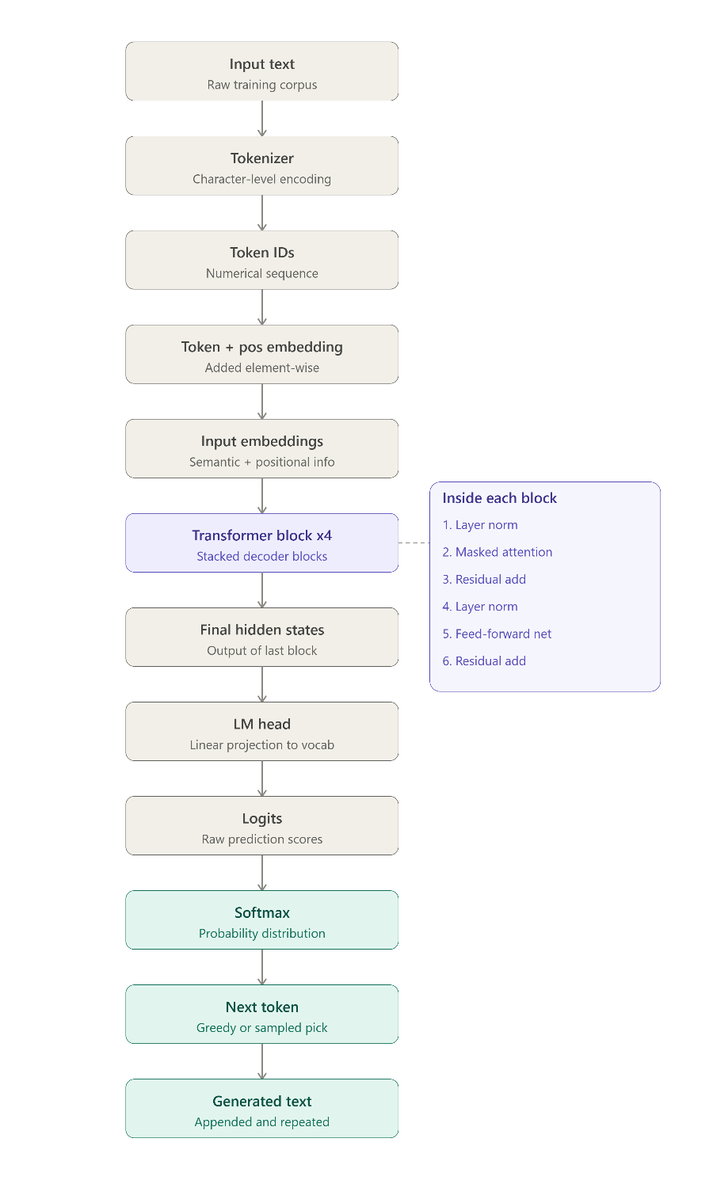

Dataset
The model was trained on a text corpus containing natural language sentences. The dataset is used to teach the model language patterns by predicting the next word in a sequence. During preprocessing, the text is divided into fixed-length input and target sequences, where the target sequence is shifted by one token for next-token prediction.

Tokenization
A custom character-level tokenizer was implemented to convert text into numerical token IDs. Instead of splitting the text into words, the tokenizer splits the text into individual characters — including letters, spaces, and punctuation marks. All unique characters present in the text are collected to build the vocabulary, and each character is assigned a unique integer ID. In this project, the training text contained 27 unique characters, giving a vocabulary size of 27.
Two mapping dictionaries are created: one that converts each character to its ID (stoi), and one that converts an ID back to its character (itos). Using these mappings, an encode function converts input text into a sequence of token IDs, and a decode function converts a sequence of token IDs back into readable text. These token IDs are then used as input to the embedding layer for training the GPT-2 model.

Model Components

1 Token Embedding
The Token Embedding layer converts each token ID into a dense vector of fixed dimension (d_model). Instead of processing integer token IDs directly, the model learns a continuous vector representation for every word in the vocabulary. These embeddings capture semantic relationships between words and serve as the initial input to the Transformer.

2 Position Embedding
Since the Transformer architecture does not inherently understand the order of tokens, positional embeddings are added to the token embeddings. Each position in the sequence is assigned a learnable embedding vector, allowing the model to distinguish between tokens appearing at different positions.

3 Input Embedding
The Input Embedding layer combines the token embeddings and positional embeddings through element-wise addition. The resulting vectors contain both semantic information about each token and its position in the sequence, forming the input to the Transformer blocks.

4 Layer Normalization
Layer Normalization normalizes the activations of each token across its feature dimensions. This stabilizes training, improves gradient flow, and accelerates convergence by maintaining consistent activation distributions throughout the network.

5 Self-Attention
The Self-Attention mechanism enables each token to attend to relevant previous tokens in the sequence. Query (Q), Key (K), and Value (V) vectors are computed for every token, and attention scores determine how much information should be gathered from other tokens. A causal mask is applied to ensure that future tokens are not visible during training.

6 Multi-Head Attention
Multi-Head Attention applies several self-attention heads in parallel. Each head learns different contextual relationships within the sequence. Their outputs are concatenated and projected back to the original embedding dimension, allowing the model to capture richer language patterns.

7 Feed Forward Network
The Feed Forward Network consists of two fully connected layers with a ReLU activation function between them. It processes each token independently after the attention layer and learns higher-level feature representations before passing them to the next Transformer block.

8 Transformer Block
A Transformer Block combines Multi-Head Attention, residual connections, Layer Normalization, and the Feed Forward Network. Multiple Transformer blocks are stacked together to progressively learn more complex contextual representations from the input sequence.

9 GPT-2 Model
The GPT-2 model begins with the input embedding layer, followed by multiple Transformer blocks. The final hidden representations are projected to the vocabulary size using the language modeling head, producing logits for next-token prediction. During inference, the predicted token is appended to the input sequence to generate text autoregressively.

Training Process
After the model produces its output, it needs to check how good or bad its prediction was, then fix its parameters to do better next time. This is the training process. It has four main steps: Softmax, Cross Entropy Loss, Backpropagation, and the AdamW Optimizer.

1 Softmax
The model's raw output (called logits) is just a list of numbers, and these numbers don't directly tell us "how confident" the model is. Softmax turns these numbers into probabilities, so every value becomes between 0 and 1, and all values together add up to 1. This way, we can see which token the model thinks is most likely to come next. Softmax is used both while training (to check predictions) and while generating text (to pick the next word).

2 Cross Entropy Loss
Cross Entropy Loss tells the model how wrong its prediction was. For every token, we look at the probability the model gave to the correct answer. If the model gave a high probability to the right token, the loss is small. If it gave a low probability, the loss is large. This loss is calculated for every token in the batch and then averaged into one single number. This number is what the model tries to reduce during training — the lower the loss, the better the model is performing.

3 Backpropagation
Once we know the loss (the error), the model needs to figure out which part of it caused how much of the mistake. Backpropagation does this by sending the error backward, layer by layer, from the output all the way back to the embeddings. Each layer (attention, feed-forward, layer norm, etc.) calculates its own share of the error and passes it further back. This is how the model learns which weights need to increase and which need to decrease to reduce the loss next time.

4 AdamW Optimizer
After backpropagation tells us how much each weight contributed to the error, the AdamW optimizer actually updates the weights. It doesn't just move the weights blindly — it keeps track of the past gradients (direction of error) and adjusts the learning speed for each parameter individually. It also applies a small penalty called weight decay, which stops the weights from becoming too large and helps the model generalize better instead of just memorizing the training text.
The model used these settings while training: learning rate = 6e-4, beta1 = 0.9, beta2 = 0.999, epsilon = 1e-8, weight decay = 0.01, batch size = 16, block size = 32, trained for 2000 epochs.

Text Generation
Once the model is trained, it can be used to generate new text. This is done one token at a time, using a function that keeps predicting and adding the next token to the sequence.
The process works like this: we give the model a starting prompt (some text), and the model looks at it and predicts the most likely next character. This predicted character is added to the sequence, and now the model looks at this new, longer sequence to predict the next character again. This is repeated again and again until we get the desired number of new characters.
Two settings control how the generation behaves:
- Temperature – controls how "safe" or "creative" the model's choices are. A low temperature makes the model stick to the most likely options, while a higher temperature allows it to pick less obvious choices, making the output more varied.
- Greedy vs Sampling – in greedy mode, the model always picks the single most probable next token. In sampling mode, the model picks a token randomly, but based on the probabilities from softmax, so higher probability tokens are still more likely to be chosen.
In this project, text was generated using the prompt "the", with temperature = 0.8 and greedy = False (sampling mode), generating 50 new characters. The model produced the following output:
the is the question,
whether tis tis a noble r minob
This shows that the model learned some real patterns from the training text (like "the question," and "whether tis"), which are phrases that actually appeared in the training data.

Results
The model was trained for 2000 epochs, and the loss was printed every 100 epochs to track learning progress. The loss started high and kept dropping as training went on, which shows the model was successfully learning:
Epoch | Loss
0 | 3.2865
100 | 2.3756
300 | 1.0632
500 | 0.5168
700 | 0.2687
900 | 0.2231
1200 | 0.1726
1600 | 0.1378
1900 | 0.1338
At the start (epoch 0), the loss was around 3.28, which means the model's predictions were close to random guessing. By epoch 900, the loss had dropped below 0.25, showing the model had learned strong patterns from the text. After around epoch 1000, the loss stayed low and mostly flat, going up and down slightly between 0.13 and 0.18. This is expected, since the training text is very small (only 430 tokens), so the model quickly memorizes it rather than learning general language rules.
The generated text output also confirms this — it reproduces exact phrases from the training text ("the question,", "whether tis"), which means the model learned the patterns of this specific small dataset well.

Conclusion
This project successfully implemented GPT-2, a decoder-only Transformer language model, completely from scratch using Python and NumPy, without relying on any deep learning framework. Every core component — tokenization, token and positional embeddings, layer normalization, self-attention, multi-head attention, feed-forward networks, transformer blocks, softmax, cross-entropy loss, backpropagation, and the AdamW optimizer — was built and understood at a fundamental level.
Training the model on a small text sample showed a clear drop in loss over time, from about 3.28 to below 0.15, proving that the model was correctly learning patterns from the data. The text generated after training also picked up real phrases from the training text, confirming that the model was working as intended.
Overall, this project provided a strong hands-on understanding of how modern large language models like GPT-2 actually work internally — how text is converted into numbers, how attention allows the model to understand context, and how training through backpropagation and optimization allows the model to improve over time. While the model here is very small and trained on a tiny dataset, the same principles apply directly to large-scale models like real GPT-2, just with much bigger data, more parameters, and more computing power.

