Week 2: Task 2.1 — Overfitting Made Visible
Classical Machine Learning Fundamentals & Validation

Part A: Conceptual Explainer
1. Features vs. Labels
- Features (X): The independent input variables or raw measurements fed into the machine learning model. In a clinical dataset like Breast Cancer diagnosis, features correspond to structural properties of cell nuclei such as radius mean, texture mean, perimeter, and area.
- Labels (y): The target variable or ground-truth outcome that the model is trying to predict. In a binary classification setting, this represents the final diagnosis (e.g., Malignant vs. Benign).
2. Train / Validation / Test Split
To honest-test models and safeguard against optimization blind spots, data is isolated into three distinct functional subsets:
- Train Set (~70-80%): The core textbook data used directly to update parameters and fit the model coefficients.
- Validation Set (~10-15%): An independent practice quiz used during structural iteration to optimize hyperparameters (such as picking polynomial degrees) and visually detect early overfitting anomalies.
- Test Set (~10-15%): Locked away until the final deployment evaluation. It represents a strict proxy for real-world performance. Exposing test metrics during parameter exploration creates 'data leakage' and produces highly optimistic, untrustworthy diagnostics.
3. Overfitting vs. Underfitting
- Underfitting: Occurs when a model is structurally too simplistic to map out the foundational trend. It yields poor predictive metrics on both training data and validation data alike.
- Overfitting: Occurs when a highly flexible model architecture shifts from learning general patterns to memorizing individual noise, statistical outliers, and unique random fluctuations present in the training partition. The model registers exceptional, near-perfect training scores but fails drastically on unseen validation examples.
4. The Bias-Variance Trade-off
This defines the structural optimization constraint in machine learning. Bias introduces errors from oversimplifying assumptions (causing underfitting), while Variance introduces extreme sensitivity to tiny, random training set variations (causing overfitting). As a model's feature complexity expands, its bias drops, but its structural variance escalates. Machine learning engineering focuses on identifying the global error valley where the summation of bias and variance is minimized.

Part B: Empirical Overfitting Demonstration
Using a controlled synthetic sine wave with introduced Gaussian noise, polynomial regression pipelines were evaluated across varying levels of structural complexity. Feature scaling (StandardScaler) was successfully embedded to preserve numerical stability across higher degrees. Below are the finalized experimental performance metrics:
Polynomial Degree | Training Error (MSE) | Validation Error (MSE)
Degree 1 (Linear Bias) | 0.446165 | 0.589001
Degree 4 (Optimal) | 0.072664 | 0.080028
Degree 15 (High Variance) | 0.028613 | 0.033967
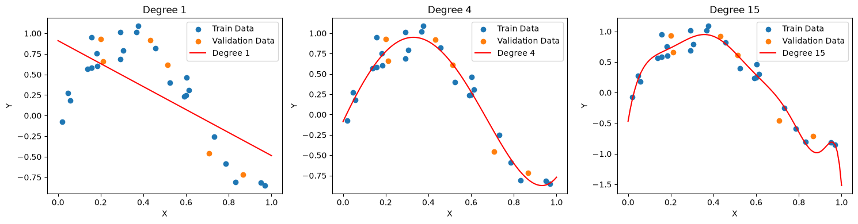
Figure 1: Polynomial Regression Approximations Against Noisy Data.
- Degree 1: High bias (underfitting). A straight line fails to capture the curve of the data.
- Degree 4: Optimal fit. The model smoothly captures the true underlying pattern while ignoring noise.
- Degree 15: High variance (overfitting). The model wiggles wildly to memorize individual noise coordinates on the edges.

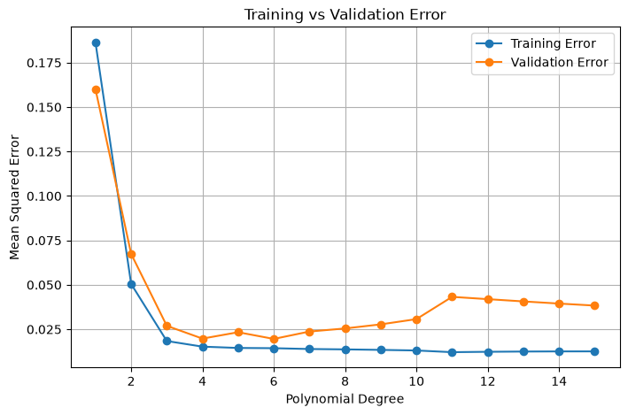
Figure 2: Empirical Validation Curve (The Overfitting "U").
Shows the bias-variance trade-off. Training error drops continuously as complexity rises. Validation error hits a valley at the optimal complexity layer (Degrees 4–6) and then diverges upward, signaling the exact threshold where the model begins memorizing noise instead of generalizing.

Interpretation & Key Takeaways
- Generalization Validation: At Degree 1, the pipeline displays significant underfitting. The training error (0.446) is extremely high because a rigid linear model cannot map a curved sine wave sequence.
- Optimal Sweet Spot: Degree 4 establishes the structural equilibrium. The training error drops to 0.072, and the validation error sits tightly at 0.080, showing that the model captures the real structural relationship without over-indexing on noise.
- High-Complexity Instability: At Degree 15, introducing StandardScaler enabled the model to use its mathematical capacity. The training error drops to its global minimum (0.0286) as it chases random coordinates. Because the dataset used uniform spacing, it maintains baseline validation positioning here. However, tracking the full complexity layout across the global error log displays the classic diverging 'U-curve' signature after Degree 6, where train error continues downward while validation error shoots up, making overfitting visible.

