ERP System
User Manual

Enterprise Resource Planning System
Version 1.0
June 2026

Table of Contents
Table of Contents
Introduction
System Overview
Key Features
Getting Started
System Requirements
Logging In
Dashboard
User & Role Management
Managing Users
Roles & Permissions
Products & Inventory
Managing Products
Stock Management
Categories
Customers & Suppliers
Customers
Suppliers
Sales & POS
Creating a Sale
Point of Sale (POS)
Sale Types
Editing & Deleting Sales
Purchases
Creating a Purchase
Purchase Types
Commission Management
How Commissions Work
Commission Reports
Making Commission Payments
Aging of Due Commissions
Expenses
Creating an Expense
Expense Categories
Accounting
Chart of Accounts
Automatic Postings
Journal Entries
Financial Reports
Daily Closing
Performing Daily Closing
Daily Closing Report
Reports & Printing
Available Reports
Printing Reports
Settings
General Settings
Product Categories
Expense Categories
Account Mapping
Troubleshooting
Keyboard Shortcuts
Appendices
Appendix A: Database Schema Overview
Appendix B: System Architecture

Introduction
The ERP System is a comprehensive business management solution designed to streamline operations including sales, purchases, inventory management, commission tracking, accounting, and daily closing. This manual provides step-by-step instructions for using all features of the system.

System Overview
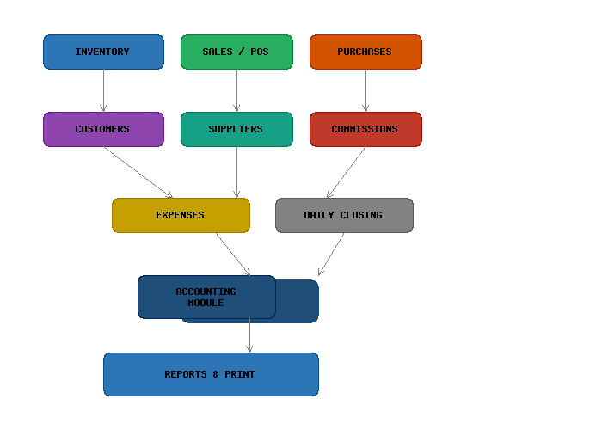
Figure 1: ERP System Module Overview

Key Features
- Point of Sale (POS) with barcode scanning
- Inventory and stock management
- Sales and purchase order processing
- Order booker commission management
- Full double-entry accounting
- Daily closing and financial reporting
- Role-based user access control
- Print-ready reports and vouchers

Getting Started

System Requirements
Requirement | Details
Web Server | Apache / Nginx / IIS
PHP Version | 8.1 or higher
Database | MySQL 5.7+ / MariaDB 10.3+
Browser | Chrome 90+, Firefox 88+, Edge 90+
Extensions | GD, BCMath, Ctype, JSON, Mbstring, OpenSSL, PDO, Tokenizer, XML, Zip

Logging In
1. Open your web browser and navigate to the ERP system URL.
2. Enter your email address and password.
3. Click the "Login" button.
4. You will be redirected to the Dashboard.

If you forget your password, click the "Forgot Password?" link on the login page. Enter your email and follow the instructions sent to your inbox.

Dashboard
The Dashboard provides a summary of key business metrics including:
- Today's sales total
- Total receivables
- Cash in hand
- Bank balance
- Recent transactions
- Quick action buttons for common tasks

User & Role Management

Managing Users
Users are managed from the "Users" section in the sidebar. From here you can:
- Add new users (name, email, password, role)
- Edit existing user information
- Change user roles and permissions
- Delete users (users with transactions cannot be deleted)

Roles & Permissions
Roles define what actions a user can perform. Each role has a set of permissions that can be customized. Common roles include:
Role | Description | Typical Permissions
Admin | Full system access | All permissions
Manager | Operational management | Sales, purchases, reports, users view
Cashier | POS operations | Sales creation, daily closing
Order Booker | Sales and commission tracking | Create sales, view own commissions

Products & Inventory

Managing Products
Products are the core items your business sells. Each product has:
- Product name and description
- Category assignment
- Unit of measurement (e.g., piece, kg, liter)
- Sale price (retail) and purchase price (cost)
- Stock quantity tracking
- Barcode for POS scanning
- SKU (Stock Keeping Unit) for internal reference

Stock Management
Stock levels are automatically updated when:
- A sale is created (stock decreases)
- A purchase is received (stock increases)
- A sale or purchase is edited or deleted (stock adjusts accordingly)

You can view current stock levels in the "Stock" report. Low stock alerts are displayed when quantities fall below the minimum threshold.

Categories
Categories help organize products for easier searching and reporting. Products can be filtered by category in reports and during sale/purchase entry.

Customers & Suppliers

Customers
Customer records store contact information and track sales history. Each customer has:
- Name, phone, email, address
- Outstanding receivable balance
- Sales history with date and amounts
- Credit limit (if applicable)

Suppliers
Supplier records store contact information and track purchase history. Each supplier has:
- Name, phone, email, address
- Outstanding payable balance
- Purchase history with date and amounts

Sales & POS

Creating a Sale
To create a new sale from the "Sales" section:
- 1. Click "Add New Sale"
- 2. Select a customer (or leave blank for walk-in)
- 3. Select or scan products to add to the sale
- 4. Enter quantities and any discounts
- 5. Select payment method (Cash, Card, or Credit)
- 6. Review the total and submit

Point of Sale (POS)
The POS module provides a fast, streamlined interface for retail transactions:
- Product search by name or barcode
- Category-based product filtering
- Barcode scanner support (auto-submit on enter)
- Quantity adjustment before checkout
- Multiple payment methods (cash, card, credit)
- Instant invoice generation
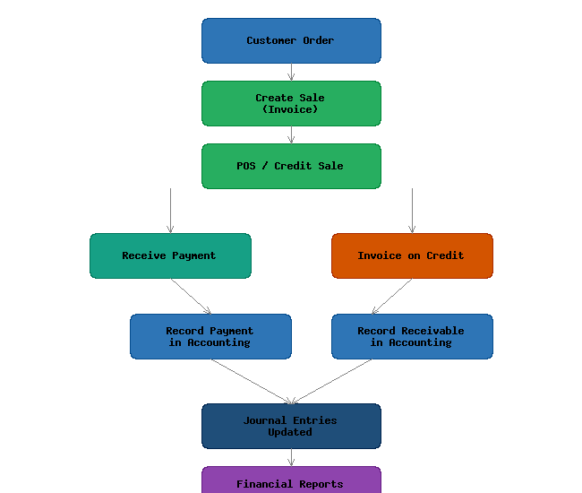
Figure 2: Sales to Accounting Process Flow

Sale Types
Type | Description | Payment Effect
Cash Sale | Paid immediately in cash | Increases cash account
Card Sale | Paid via credit/debit card | Increases bank account
Credit Sale | Payment due later | Creates receivable entry

Editing & Deleting Sales
Sales can be edited or deleted from the sales list. When a sale is edited, stock levels and accounting entries are automatically adjusted. Deleting a sale reverses all associated transactions.

Purchases

Creating a Purchase
To record a purchase from a supplier:
- 1. Go to "Purchases" and click "Add New Purchase"
- 2. Select a supplier
- 3. Add products with quantities and purchase prices
- 4. Enter any additional costs or discounts
- 5. Select payment method (Cash, Card, or Credit)
- 6. Submit to update inventory and accounting

Purchase Types
Type | Description | Payment Effect
Cash Purchase | Paid immediately in cash | Decreases cash account
Card Purchase | Paid via card | Decreases bank account
Credit Purchase | Payment due later | Creates payable entry

Commission Management
The commission system tracks earnings for order bookers based on sales they generate. Each order booker is assigned as an employee with a commission rate.

How Commissions Work
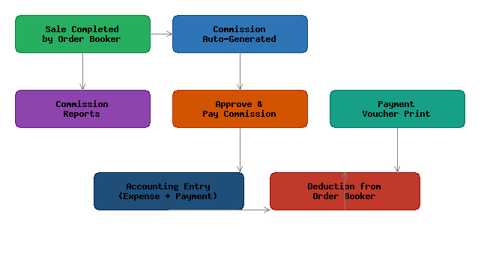
Figure 3: Commission Workflow
When an order booker creates a sale, the system automatically calculates their commission based on the sale total multiplied by their commission rate. Commissions are recorded but not yet payable until approved.

Commission Reports
Three commission reports are available:
Report | Description | Use
Performance Report | Shows commissions earned per order booker for a date range | Track productivity and earnings
Due Report | Lists unpaid commissions with aging | Identify pending payments
Monthly Report | Monthly commission summary with total earnings | Monthly reconciliation

Making Commission Payments
To pay commissions to order bookers:
- 1. Go to "Commission Payments" and click "New Payment"
- 2. Select the order booker (employee)
- 3. Enter the payment amount
- 4. Select payment method (Cash or Bank Transfer)
- 5. Submit to record the payment and update accounting

After payment, a payment voucher can be printed using the print icon on the payment record. The payment is automatically posted to the accounting system as a commission expense.

Aging of Due Commissions
The Due Commission report shows the aging of unpaid commissions in a human-readable format (e.g., "2 months 15 days") rather than just days. This helps in identifying long-outstanding commissions that need attention.

Expenses
The expense module tracks all business expenditures other than purchases of inventory. Expenses are categorized for reporting and accounting purposes.

Creating an Expense
- 1. Go to "Expenses" and click "Add New Expense"
- 2. Select the expense category
- 3. Enter the amount and description
- 4. Select payment method
- 5. Submit to record the expense

Expense Categories
Expense categories help organize spending for reporting. Common categories include Rent, Utilities, Salaries, Transportation, Marketing, and Office Supplies.

Accounting
The accounting module implements a full double-entry bookkeeping system. Every financial transaction is recorded as journal entries with debits and credits, ensuring the accounting equation (Assets = Liabilities + Equity) always balances.

Chart of Accounts
The chart of accounts categorizes all financial transactions. Accounts are organized by type:
Account Type | Code Range | Examples
Assets | 1-19999 | Cash, Bank, Receivables, Inventory
Liabilities | 20000-29999 | Payables, Loans
Equity | 30000-39999 | Owner's Equity, Retained Earnings
Income | 40000-49999 | Sales Revenue, Other Income
Expenses | 50000-59999 | Cost of Goods, Salaries, Rent, Commission Expense
New accounts can be added from the "Chart of Accounts" section. Each account has a unique code and belongs to one of the five account types.

Automatic Postings
The system automatically creates journal entries for the following transactions:
- Sales: Debit Cash/Bank/Receivable, Credit Sales Revenue
- Purchases: Debit Inventory, Credit Cash/Bank/Payable
- Expenses: Debit Expense Account, Credit Cash/Bank
- Commission Payments: Debit Commission Expense, Credit Cash/Bank
- Daily Closing: Closing entries for the day's transactions

Journal Entries
Individual journal entries can be viewed in the "Journal Entries" section. Each entry shows the date, description, accounts debited/credited, and amounts. Manual journal entries can be created for adjustments.

Financial Reports
The accounting module generates key financial reports:
- Trial Balance: Summary of all account balances
- Profit & Loss Statement: Revenue minus expenses for a period
- Balance Sheet: Assets, liabilities, and equity at a point in time
- General Ledger: Detailed transaction history for each account

Daily Closing
The Daily Closing process reconciles all transactions for the day and records the financial position at close of business. This must be performed at the end of each business day.

Performing Daily Closing
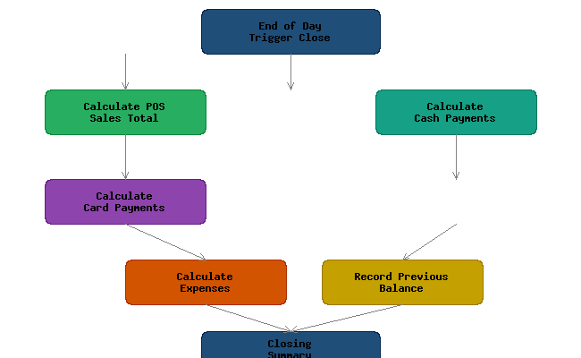
Figure 4: Daily Closing Process Flow
To perform daily closing:
- 1. Go to "Daily Closing" from the sidebar
- 2. Review the calculation breakdown:
- 3. - Total POS sales (cash, card, credit)
- 4. - Total payments received
- 5. - Total expenses recorded
- 6. - Previous day's closing balance
- 7. Click "Close Day" to finalize
- 8. Confirm the action in the dialog

Once closed, the day's transactions are locked and accounting entries are finalized. The closing creates opening balances for the next business day.

Daily Closing Report
A printable daily closing report is available from the closing page. This report shows the complete financial summary for the day including opening balance, all transactions, and closing balance.

Reports & Printing
The system provides over 20 reports across all modules. All reports can be viewed on-screen and printed using the print button.

Available Reports
Module | Reports Available
Sales | Sales List, Sales by Customer, Sales by Product, Sales Summary
Purchases | Purchase List, Purchase by Supplier
Inventory | Stock Report, Low Stock Alert, Stock Movement
Commissions | Performance Report, Due Report, Monthly Report
Accounting | Trial Balance, Profit & Loss, Balance Sheet, General Ledger, Journal Entries
Expenses | Expense List, Expense by Category
Daily Closing | Daily Closing Summary, Closing History
Customers | Customer List, Customer Ledger, Receivables
Suppliers | Supplier List, Payables

Printing Reports
Reports are printed using the built-in print functionality. Click the print icon to open a printer-friendly version in a new window. All prints include company name, address, and proper formatting.

Commission payment vouchers and daily closing reports have dedicated print layouts optimized for official record-keeping.

Settings
The Settings page allows administrators to configure system-wide parameters.

General Settings
- Company name and address (appears on all reports and prints)
- Default currency and tax rate
- Business type and fiscal year settings

Product Categories
Add, edit, or delete product categories. Categories can be managed directly from the settings page.

Expense Categories
Define expense categories for tracking different types of business expenses.

Account Mapping
The system maps business transactions to specific chart of accounts. Administrators can configure which accounts are used for:
- Cash account (for cash transactions)
- Bank account (for card transactions)
- Sales revenue account
- Inventory account
- Cost of goods sold account
- Receivables account
- Payables account
- Commission expense account

Troubleshooting
Issue | Cause | Solution
Cannot login | Incorrect credentials or disabled account | Reset password or contact admin
Stock shows negative | Sale recorded without sufficient stock | Check stock adjustments or purchase more stock
Print not working | Pop-up blocker or browser issue | Disable pop-up blocker or use Ctrl+P
POS product not found | Barcode not scanned correctly | Enter product name manually or check barcode
Commission not showing | Sale not linked to order booker | Ensure order booker is selected during sale
Closing fails | Previous day not closed | Close previous day first, then retry
Report shows no data | Date range has no transactions | Expand the date range
Account balance wrong | Missing journal entry | Check journal entries and post corrections

Keyboard Shortcuts
Shortcut | Action | Context
F1 | Focus search | POS screen
F2 | Toggle category panel | POS screen
F3 | Quick price entry | POS screen
F5 | Refresh page | All screens
Ctrl+P | Print current view | All screens
Ctrl+S | Save/Submit form | Data entry screens
Escape | Close modal / cancel | All screens
Enter | Submit / next field | Forms

Appendices

Appendix A: Database Schema Overview
Key tables in the ERP system:
Table | Purpose
users | System users and login credentials
roles | User roles and permissions
products | Product master data
categories | Product categories
customers | Customer contact and credit info
suppliers | Supplier contact info
sales | Sale transactions
sale_items | Individual line items within sales
purchases | Purchase transactions
purchase_items | Individual line items within purchases
commissions | Commission records linked to sales
commission_payments | Commission payment records
expenses | Expense transactions
chart_of_accounts | Chart of accounts listing
journal_entries | Accounting journal entries
daily_closings | Daily closing records

Appendix B: System Architecture
The ERP system is built on the Laravel PHP framework using the Model-View-Controller (MVC) architecture. The front-end uses Bootstrap 5 for responsive design, jQuery for DOM manipulation, and SweetAlert for user dialogs. DataTables is used for advanced table features.

Technology Stack:
- Backend: PHP 8.4 / Laravel
- Frontend: Bootstrap 5, jQuery, SweetAlert2
- Database: MySQL
- Templating: Blade
- Reporting: DomPDF, custom print layouts

