

Abdul Wasay
2023908
CS327 – GPU PROGRAMMING
Faculty of Computer Science and Engineering
BSAI

Task 1: GPU Properties
The properties output matched expectations.

Output below:
Device Number: 0
Device name: NVIDIA GeForce MX130
Memory Clock Rate (KHz): N/A (Unknown in this toolkit)
Memory Bus Width (bits): N/A (Unknown in this toolkit)
Peak Memory Bandwidth (GB/s): ~40.1
Clock Rate (KHz): N/A (Unknown in this toolkit)
Compute capability: 5.0
Multiprocessor count: 3
Estimated Cores per SM: 128 (Total Cores: 384)
Peak Compute Performance (GFLOPs): 861.695984

Task 2: CPU Matrix Multiplication

Matrix multiplication implemented in C++. Output format: Two matrices of size rA x cA and rA x cB space-separated floats.

Task 3: GPU Matrix Multiplication (Naive)

Matrix multiplication logic ported to CUDA. To calculate computational intensity:
Computational Intensity = (Total FLOPS) / (Total Memory Access in Bytes)
Memory Bytes = (N*N + N*N + N*N) * 4 bytes = 12 * N^2 bytes.
Floating Point Operations = N^3 multiplications + (N-1)N^2 additions ≈ 2*N^3 FLOPS.
Intensity = 2*N^3 / (12 * N^2) = N / 6 FLOPS/byte

Task 4: Measure Computation Time

Below is the visualization of the naive CPU and GPU execution times measured.
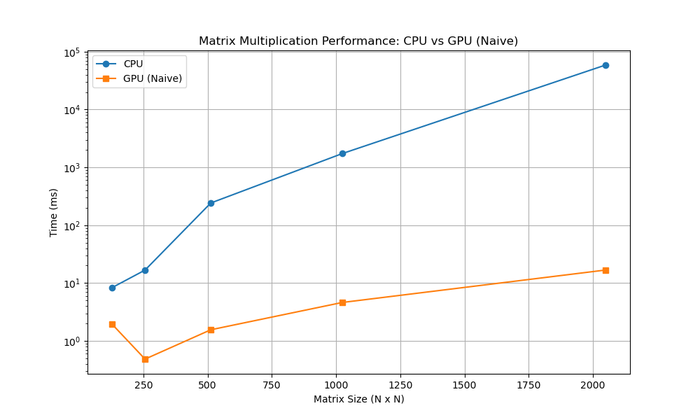

Task 5: Improve Performance with Tiling

The maximum tile size that fits across architectures is typically 32x32, allowing all 1024 threads to leverage 48KB shared memory effectively.
Computational Intensity = 2*N^3 / ((2*N^3 / 32) * 4) = 16 FLOPS/byte.
Below is a plot comparing CPU execution time, GPU Naive Execution time, and GPU Tiled Execution time for different sizes of matrix dimensions.

