Question 1: I used a linearly separable data set to test the perceptron algorithm and obtained convergence in terms of a decision boundary, as shown by the graph below. It shows the number of updates at each epoch becomes 0 once we reach epoch 15. The data set I used was:

Locations of points: np.array([[1.],[2.],[4.],[8.],[16.],[32.],[64.],[128.],[256.],[512.]])

Classifications of points: np.array([-1,-1,-1,-1,-1,1,1,1,1,1])

Since the locations are in order, and the classifications are split down the middle after the fifth index, the data set is linearly separable.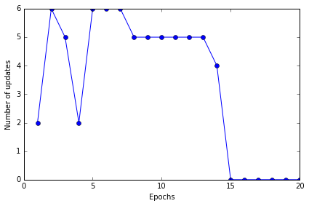

Question 2: With a linearly non-separable data set, the perceptron never attained convergence, even after 50 epochs, it was repeatedly updating the weights, as shown by the graph below. The data set I used was:

Locations of points: np.array([[1.],[2.],[3.],[5.],[8.],[13.],[21.],[34.],[55.],[89.]])

Classifications of points: np.array([-1,1,-1,-1,1,1,-1,-1,1,1]))

Since the locations of points are in order, and the classifications of points are scattered, the data set is not linearly deparable.

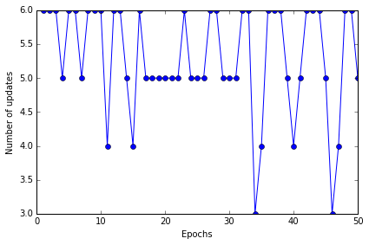

Question 3: After downloading the Titanic data set, I singled out six criteria that I was able to convert into numerical values: class, sex, age, sibling/spouse count, parent/child count, and fare. They were placed in a 2-dimensional array. Survival data was also collected in a vector. The data was split into the first 70% used as the training data, and the last 30% used as the testing data. Adaline was able to correctly predict survival only 67.9% of the time, which is quite a poor score. I used 100 iterations and a learning rate of 0.0000006, which just barely allowed the error to decline. The error decline is shown in the graph below.

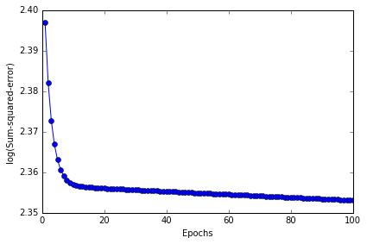

Question 4: The weights given by Adaline to each category of the data were:

Class: -7.93329035e-03

Sex: -7.42874292e-03

Age: -9.59726446e-03

Sibling/spouse count: -3.19831909e-03

Parent/child count: 2.04808266e-05

Fare: 4.67332548e-03

This shows that some were negatively correlated with survival and others positively correlated. The variable with the highest magnitude is age, followed closely by class, then sex, then fare, then sibling spouse count. Parent/child count seemed to have little influence on survival.