MIRMAKHMUD KOMILOV  Backend Developer | PHP / Laravel  Tashkent, Uzbekistan | +998 95 008 02 22 | mahmudkamilof@gmail.com  github.com/mirmakhmudx | 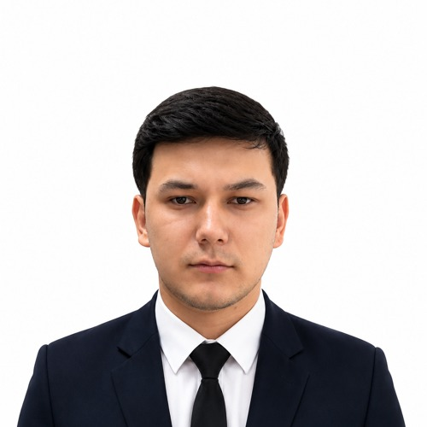

PROFESSIONAL SUMMARY
Backend developer with hands-on experience in PHP and Laravel, gained in a production environment. Skilled in designing REST APIs, building and optimizing relational databases, and integrating third-party services such as Telegram Bot API and OpenAI API. Comfortable working with modern development tools (Docker, Git, Postman, ClickUp) and quick to pick up new technologies in a team setting.
WORK EXPERIENCE
Backend Developer (PHP / Laravel) — SAB GAMES 2025 — Present
- Develop and maintain the Laravel-based backend for the company's internal and customer-facing products
- Design and implement REST API endpoints consumed by the frontend team
- Design and optimize MySQL / PostgreSQL databases and queries
- Manage version control with Git and actively participate in team code reviews
Freelance / Contract Work
- a5apteka.uz — contributed to the Laravel backend of an online pharmacy platform (orders and product catalog modules)
TECHNICAL SKILLS
Languages: PHP, C#, JavaScript, Python
Framework: Laravel
Frontend: HTML, CSS, Bootstrap
Databases: MySQL, PostgreSQL
Tools & Platforms: Docker, Git / GitHub, Postman, ClickUp, REST API
AI Integration: OpenAI API integration, basic computer vision (OpenCV)
PORTFOLIO PROJECTS
AI Chatbot — OpenAI API Integration
A conversational chatbot built with Python, integrating the OpenAI API to generate automated responses to user queries.
People Counter — Computer Vision
A real-time people-counting application using a camera feed, built with Python and OpenCV to detect and count people passing through a frame.
SkyJet_avialable — Flight Availability System
A system for tracking and managing flight ticket availability. Technologies: JavaScript.
BarberBook — Barbershop Booking System
An online appointment booking system for a barbershop, with an admin panel to manage schedules. Technologies: PHP, Laravel.
Restaurant_management — Restaurant Management System
A management dashboard for handling tables, orders, and menu items. Technologies: Laravel, Blade, MySQL.
Full project list: github.com/mirmakhmudx
LANGUAGES
Uzbek — Native | Kazakh — Fluent | English — B1 (Intermediate) | Russian — A2 (Elementary)
EDUCATION
PDP University — Software Engineering, 4th-year student

