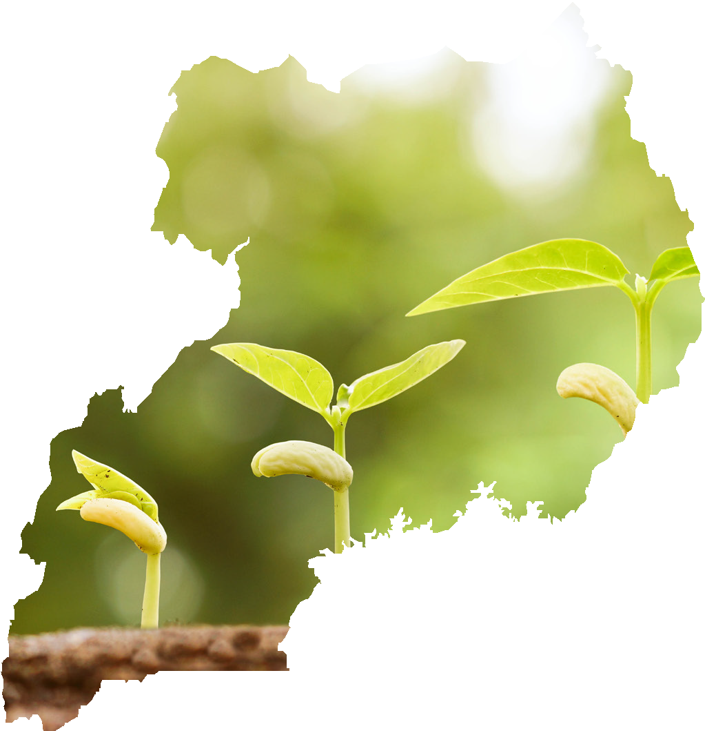



The Republic of Uganda

MINISTRY OF AGRICULTURE, ANIMAL INDUSTRY AND FISHERIES

PROCESS OF REGISTRATION AND ACCREDITATION OF AEAS PROVIDERS

CONTENTS
FOREWORD AND ACKNOWLEDGEMENT III
ACRONYMS IV
DEFINITIONS AND INTERPRETATIONS OF KEY TERMS V
  - BACKGROUND TO REGISTRATION AND ACCREDITATION 1
  - INTRODUCTION 1
  - THE PURPOSE OF THE REGISTRATION AND ACCREDITATION 1
  - WHO SHOULD BE REGISTERED AND ACCREDITED? 2
  - INTERIM PHASE FOR REGISTRATION AND ACCREDITATION 3
  - SENSITISATION AND REGISTRATION 3
  - FORMATION OF A NATIONAL AGRICULTURAL EXTENSION AND ADVISORY SERVICES REGULATORY BODY 5
  - COORDINATION OF PROFESSIONAL EXTENSION ASSOCIATIONS 6
  - PROCEDURES FOR ACCREDITATION 7
  - ACCREDITATION COURSE AND ASSESSMENT 7
  - APPLICATION (FORM AND MINIMUM REQUIREMENTS) 7
  - VETTING AND APPROVAL APPLICATION 8
  - ACCRÉDITATION 8
  - RENEWAL 8
ANNEXES 9
APPENDIX 17

FOREWORD AND ACKNOWLEDGEMENT
In 2016, the Ministry of Agriculture, Animal Industry and Fisheries, formulated the National Agricultural Extension Policy (NAEP) which was approved by Cabinet on 26th October 2016 and launched on 6th December of the same year. The Policy envisions a pluralistic delivery system with multiple providers. To ensure that the wide range of agricultural extension service providers offer quality service to farmers and other beneficiaries, NAEP provided for the development guidelines and standards to guide and regulate the players.

The process for registration and accreditation of Agricultural Extension and Advisory services (AEAS) providers is part of the strategy aimed at establishing a high quality, well-coordinated and harmonized pluralistic agricultural extension delivery system for sustainable development. Its aim is to promote professionalism, accountability and ethical conduct among the actors for increased efficiency and effectiveness of the agricultural extension system.

This process has been developed through a consultative and participatory process involving a wide range of stakeholders from the Private and Public sectors. It is recommended that this document is taken to be official for the purpose it has been developed, to which additions or alterations may be made as need arises.
I wish to thank everyone who contributed to the development of this document, particularly; the stakeholders that provided input into the drafting and validation of this document; members of the Technical Working Group for reviewing the documents and steering the whole process; Feed the Future Uganda Enabling Environment for Agriculture Activity for facilitating the process and the Uganda Forum for Agricultural Advisory Services (UFAAS) and its consultants for the technical expertise in the development of the document.
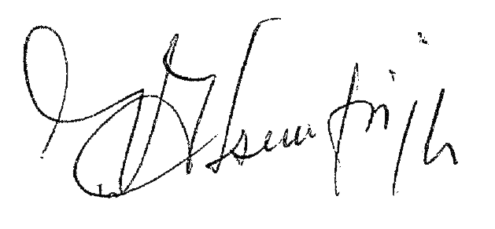
For God and My Country

Hon. Vincent Bamulangaki Ssempijja (MP)
MINISTER
MINISTRY OF AGRICULTURE,

ACRONYMS
AB Accreditation Bodies
AEAS Agricultural Extension and Advisory Services BSc Bachelor of Sciences
CEO Chief Executive officer
CPD Continuous Professional Development
DAES Directorate of Agricultural Extension Services
DPO District Production Officer
ICT Information and Communication Technology
GA General Assembly
NAEASRB National Agricultural Extension and Advisory Services Regulatory Body
NAEP National Agricultural Extension Policy NAES National Agricultural Extension Strategy
MAAIF Ministry of Agriculture, Animal Industry and Fisheries
NGO Non-Governmental Organizations
NSA Non State Actors
PhD Doctor of Philosophy

DEFINITIONS AND INTERPRETATIONS OF KEY TERMS
Agricultural extension services: These include interventions/activities by government and Non State Actors (NSAs) that facilitate the access of organizations, and other value chain actors to knowledge, information, and technologies; mediate their interaction with other relevant organizations; and assist them to develop their technical and management capacity in agriculture and family life.

Agricultural advisory services: These are extension services provided to agricultural value chain actors on a demand driven basis.
Agricultural extension and advisory services (AEAS): An all-encompassing term used to include both proactive extension interventions and advisory services offered on-demand.
Agricultural Extension System: The agricultural extension system includes the entire set of organizations and institutions (public, private, civil society) that are involved in providing agricultural extension services.
Agricultural Extension and Advisory Service Provider: A person or organization that works directly with agricultural value chain beneficiaries providing agricultural extension and advisory services. The services can be in a range of disciplines including agriculture (crop, animal, soil, etc.), environment, forestry, food science and nutrition, land management, and other areas relevant to agricultural value chain development.

Accreditation: This is a formal, independent verification that an individual, a program or institution passes through to meet established quality standards certifying that they are competent to carry out specific tasks. This may include testing, inspection, and certification.
Registration: This means capture and documentation of the name and other information necessary for profiling an AEAS provider for purposes of creating a database for national use by various stakeholders at different levels.
Professional: An individual that holds a degree (at Bachelors, Masters or PhD level) in agriculture (crop, animal, soil, etc.), environment, forestry, food science and nutrition, land management, and other areas relevant to agricultural value chain development.
Para-professionals: An individual that holds a certificate or diploma in the
above mentioned areas.

AEAS Organization: An organization or institution that offers Agricultural Extension and Advisory Services to any category of beneficiaries along the agricultural value chain.
Practitioner: An individual without formal training in the relevant fields who is involved in providing AEAS to other actors along the value chain especially farmers.
Farmer Institutions: A generic term that includes farmer groups, associations and federations; farmer cooperative societies, unions and alliances; and other types of formal and informal collective farmer structures.

BACKGROUND TO REGISTRATION AND ACCREDITATION

INTRODUCTION
The National Agricultural Extension Policy (NAEP) 2016 recognizes that access to quality extension and advisory services is a critical ingredient to technology uptake by farmers and other stakeholders. The importance of putting in place a system to regulate the quality of extension services by all providers and meet appropriate standards is also emphasized. The Government, through the Directorate of Agricultural Extension Services (DAES) under MAAIF has established systematic procedures for regulation of extension services provided by the range of service providers under the pluralistic extension system. Among the strategies to promote professionalism and quality extension services are procedures for registration and accreditation of extension service providers under the pluralistic delivery system hence this document to guide that process.

THE PURPOSE OF THE REGISTRATION AND ACCREDITATION
The process of registration and accreditation is aimed at establishing a high quality, well-coordinated and harmonized pluralistic agricultural extension delivery system for sustainable development. Its mission is to promote professionalism, accountability and ethical conduct among the AEAS actors for increased efficiency and effectiveness of the agricultural extension system. The ultimate goal of this process is to sensitize stakeholders and establish an autonomous council that will take over the responsibility of registration and accreditation of the AEAS providers in the long term. The main objectives of this whole process are:

    - To register all agricultural extension and advisory services providers in the country and maintain a database of their profiles as a reference for national use.
    - To accredit professional agricultural extension and advisory services providers (individuals and organizations) according to the approved procedures for registration and accreditation.
    - To ensure continued capacity development of extension professionals for them to remain up-to date with emerging issues and needs in extension.
    - To promote networking and information sharing among the AEAS professionals
    - To ensure a conducive environment for agricultural extension and advisory services providers.
    - To sanction and discipline errant AEAS actors

WHO SHOULD BE REGISTERED AND ACCREDITED?
All individuals and organizations offering agricultural extension and advisory services (AEAS) to farmers and other actors in agricultural value chains will be registered and accredited by government. Key AEAS include training and other capacity development services, business development services, technology dissemination, and advice in agriculture, agri-business, veterinary medicine, fisheries, forestry and related areas. Examples of targeted actors are training and research institutions; professional bodies, associations, NGOs and other civil society organizations; the media (print and electronic); farmer trainers/ community based facilitators.

The agricultural extension and advisory services providers are grouped into the following categories for purposes of registration and accreditation:

    - Professionals holding a degree (at Bachelors, Masters or PhD level) in agricultural disciplines (crop, animal, soil, etc.), environment, forestry, food science and nutrition, land management, and other areas relevant to agricultural value chain development.
    - The Para-professionals holding a certificate or diploma in the above
mentioned areas.
    - Organizations that offer AEAS (for example NGOs, Higher Lever
Institutions, Companies, etc.)
    - Practitioners without formal training in the relevant fields who are involved in providing AEAS to other actors along the value chain especially farmers. These include, input suppliers, Farmer trainers or Community Based Facilitators and experienced practicing farmers and other value-chain actors. These should be practicing at the particular value chain level on which they are training or advising others and should obtain appropriate short term training from recommended and accredited organizations and individuals.

INTERIM PHASE FOR REGISTRATION AND ACCREDITATION

The process of registration and accreditation will be established in a phased manner and where necessary, the Ministry of Agriculture, Animal Sciences and Fisheries (MAAIF), through the Extension Directorate (DAES) will establish formal partnerships with other qualified organizations and institutes to undertake the various activities. During the first 5 years MAAIF will concentrate on sensitization, registration and setting up the legal and institutional framework for the body that will subsequently take over the whole process including accreditation. This will be an autonomous regulatory body established by an act of parliament.
The interim phase of 5 years is illustrated below:
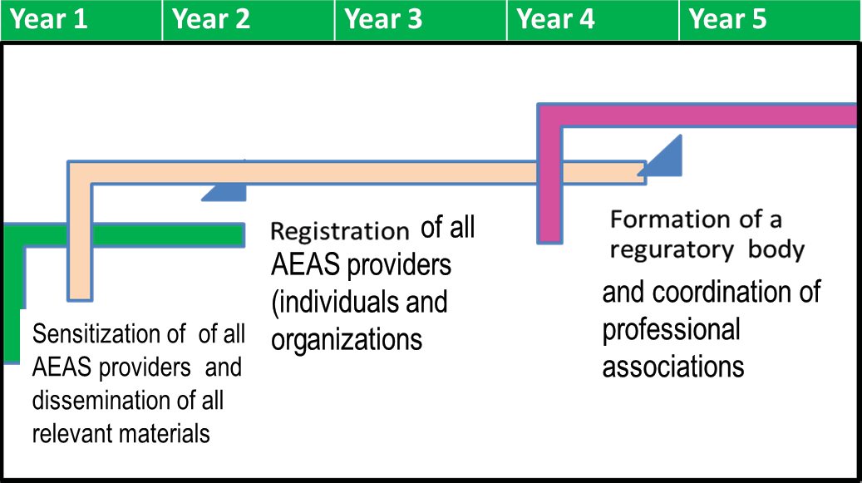
Figure 1: Proposed interim phase for the registration and accreditation process

SENSITISATION AND REGISTRATION

Dissemination and Sensitization:
All the relevant documents (Policy, Strategy, Guidelines and standards and Ethical code of conduct, Procedures for registration and accreditation) will be disseminated and the AEAS providers, beneficiaries and stakeholders sensitized about the value of a professional and quality extension system. Appropriate channels will be used to ensure that each AEAS actor is aware and

progressively understands and appreciates the above documents, which will also be appropriately packaged for each particular category of providers and other stakeholders. This process will involve:

      - Packaging of the documents in popular versions that are understandable to the AEAS providers.
      - Mass distribution of the materials using channels that are easily accessible. This may include both online and mass distribution of hard copies.
      - Sensitizing the providers using different fora (such as mass media, workshops, posters placed in public places, etc.) interpreting and emphasizing the importance of these documents.

Registration of the AEAS service providers:
All categories of AEAS providers will be required to register at the appropriate levels, in order to create a database of their profiles that can be used by government and other stakeholders. Different stakeholders will be able to access the date base to search for any relevant information they require. These may be researchers, policy makers, technical AEAS persons, farmers, etc.)
Registration will be done using a combination of user-friendly online tools that will either be directly accessed and filled by the providers or by trained data collectors, especially at the lower levels (district and sub county) who will interview the providers for quick data capture. The data collectors will eventually enter the information into the online forms. This work will be done in close partnership with the district production departments and organizations accredited for that purpose. Two registration forms will be used; one for individuals and another one for organizations.

      - The form for individuals will record: Name, Sex, Contacts and location, qualification and field, work place and sector, etc. See (Annex 1 A) for professionals, (Annex 1 C) for Practitioners and (Annex 1 D) for foreigners.
      - The form for organizations will capture information about: Name of organization, Contacts and location, Number of extension staff, their sex and qualification and field, work place and sector, etc. (Annex 1B)
The professionals, paraprofessionals and extension organizations will be sensitized and encouraged to register themselves online at a national level, while practitioners will be registered by trained Data entry people at a local government levels, (district or sub-county) depending on their reach.

This process of registration will involve:
      - Establishing an ICT team that will be responsible for establishing and monitoring the online database.
      - Online formatting of the forms into user-friendly tools that can be easily filled by all providers and data collectors
      - Identifying and partnering with companies that can facilitate easy access of the tools by the providers. These may be internet based, Mobile Phone Companies or any other.
      - Testing and fine-tuning of the tools
      - Training of data collectors, preferably at district level
      - Mass mobilization of all providers to register
      - Monitoring of the data base by the ICT team
The database and information systems at local government and national levels shall be linked to facilitate electronic uploading of information and access.

FORMATION OF A NATIONAL AGRICULTURAL EXTENSION AND ADVISORY SERVICES REGULATORY BODY
MAAIF will establish a National Agricultural Extension and Advisory Services Regulatory Body (NAEASRB) to take on the responsibility of regulating extension services. The proposed body will be semi-autonomous and passed by an act of parliament. The process of facilitating and guiding the formation of this new body will involve:

- Establishing all the necessary legal and other institution processes to
the level of semi-autonomy
- Appointing a council or board, by the Minister-MAAIF, that will oversee the activities of the body. This council should have a representation of all key categories of AEAS providers (i.e. Public, Private, NGOs, Farmer Institutions)
- Establishing and operationalizing the structure including a secretariat with staff that will handle the different activities.
- Entrusting the process of registration and accreditation of the extension service providers, once the body is well established.
- Regulating, supervising and monitoring the activities of the body by MAAIF.
Details on the proposed National Agricultural Extension and Advisory Services Regulatory Body (NAEASRB) is attached in Appendix 1

COORDINATION OF PROFESSIONAL EXTENSION ASSOCIATIONS

Within the agricultural Extension and advisory services system, various uniform groupings of actors may choose to associate to accomplish common goals. The categorization may be commodity or profession based or any other factor convenient to the providers associating. The biggest role of MAAIF will be to create a conducive environment for their growth and also ensure that they are coordinated, through the DAES and specificity the body, which may partner also with this association depending on their interest and profession. Credible organized bodies of professionals that satisfy criteria set by MAAIF will be eligible to send representatives to the Council of the regulatory body.

PROCEDURES FOR ACCREDITATION

After the establishment of National Agricultural Extension and Advisory Services Regulatory Body (NAEASRB) and Government’s approval, accreditation will begin. All AEAS professionals and organizations will be required, by law to move on to the second stage of professionalism which is accreditation, for specified professions, duties and tasks. The accreditation process will involve testing/ assessment, application, vetting, approval and pledging and renewal.

ACCREDITATION COURSE AND ASSESSMENT
For any person to be accredited, they will need to take a short course after being registered and working in the field for at least 2 years in an agricultural extension programme or project. A 3-weeks course (done once or staggered over 6 months) will be instituted for this purpose. The course will aim at equipping AEAS providers with up to date practical skills in extension and communication to address contemporary needs identified from time to time. The course will be designed and conducted by a consortium of accredited institution(s), at the end of which the candidate will be offered a certificate of completion.

This principle will also apply to organizations that will go through a thorough assessment if they want to be accredited for offering special AEAS services like training, registration, etc.

APPLICATION (FORM AND MINIMUM REQUIREMENTS)
For individuals, after completing the accreditation course, the intending extension provider applies to be accredited by filling an application form which may be online or physical. The organizations will be further assessed in order to validate the information on the form.

    - Apart from the general information, the application form for individuals will capture; Registration Number, Test grade, Length and field of practice, Professional level, Field and specific area for accreditation, indication whether renewal or new entry, Field referees, etc.
    - The organizations that apply to be accredited will be assessed to confirm their capacity as extension agencies. Apart from the general information, the application form for organizations will capture; Registration Number, Field and specific area for accreditation, indication whether renewal or new entry, Referees (DAES at national or DPMO at District level), etc.

All application forms will be verified by recognized AEAS professionals, e.g. Professionals of High Level Academic institutions, Directors or Chief Executive Officers of institutions, District Production or any other related officer, etc.

VETTING AND APPROVAL APPLICATION
Under the regulatory body, an assessment team will be formed and charged with the vetting and approval of the applications. Applying organizations will be visited to verify what is indicated on the application form, especially concerning the location, activities and personnel.

ACCRÉDITATION
After approval, the applicant will:
    - Pay a set fee (determined by the governing council of the regulatory body)
    - Sign an oath to uphold the laws and standards that govern the AEAS provision, keep abreast with the developments and maintenance of professional competency, maintain high principles of moral, ethical and legal conduct. A pledge form will be developed for this purpose
    - Be issued with a certificate of accreditation.
This certificate can be revoked any time the applicant defaults on the set extension ethics and standards or any other national legal requirement.

RENEWAL
After accreditation for the first time, renewal will be done on 3-years basis, where the individual or organization is assessed, approved and pays a renewal fee. The assessment will be based on:

    - Individuals’ performance and self-updating (through practice, refresher
courses/ workshops).
    - Organizational report including continuous building of the capacity its AEAS staff
The renewal process may be made easier by the regulatory body convening regular events that bring together the providers for purposes of assessment and renewal.

ANNEXES

ANNEX 1 A: REGISTRATION FORM - INDIVIDUAL
REG. NO. .............................................................................................................................................................
- Name............................................................................................................................................................
- Date of Birth............................................................................................................................................
- Sex: □ Female □ Male
- National Identification No............................……………..................................................................
- Telephone: ………………….......................................……………….........……………………………………….
- Email: ………………………………………………….........................................................……….........………….
- Postal Address: …………....................................................………………………………………............……
- Physical Address: …………………………………………………...........................................................……
- Field: □ Crop □ Animal Science □ Fisheries
□ Forestry □ other (specify) ………………………….............
- Qualification: □ PhD □ Masters □ BSc.
□ Diploma □ Certificate
□other (specify) …………….........................................................……....
- Any further Training: □ YES □ NO
- Which fields and how long?
- ………………………………………….....................................................................................................
- ………………………………………........................................................................................................
- ……………………………………...........................................................................................................
- Your Work status: □ Employed □ Self-employed
□ Other Specify …………………………...................................................
- Organization/Firm …………………………………… Your Position ……………...................………..
- Your Sector □ Public □ Private □Academia
□ NGO □ Farmers Organization
Other (specify) …………………………………….........................................
- Agricultural Sector focus □ General □ Specialized
- If specialized, which one?
- Animal Production:
□ All □ Large livestock (cattle)
□ small livestock (Sheep, goats)
□ Micro livestock (Rabbits)
□ Birds (Chicken, Turkeys, ducks)
□ Bees
□ Fisheries
□ other (specify) ….................................................................................................................
- Crops production
□ All
□ Traditional cash crops (tea, cocoa, coffee, sugarcanes)
□ Cereals and legumes (maize, rice, sorghum, beans, soya, peas)
□ Bananas □ Fruits and Vegetables □ Commercial Trees

□ other (specify) ….................................................................................................................
- □ Post-Harvest Handling
- □ Agribusiness Development Services
- □ Other (specify) ………………..................................................……………………
If already working:
- Area of operation (Target Districts)
□ All
□ Some (if some, which ones under each region below)
□ Central | □ East | □ North | □ West
Districts | Districts | Districts | Districts
………………… | ………………… | …………………. | ………………….
………………… | ………………… | …………………. | ………………….
………………… | ………………… | …………………. | ………………….
- Key beneficiaries of your work:
□ Farmers □ Students □ Field Extension workers
□ Others (specify) ………………………....................................................…………
- If farmers, which ones?
Category: □ All farmers □ Rural □ Peri-Urban
□ Others-specify …………….................................................................................
Gender: □ All genders □ Women □ Youths
□ Others-specify ………………..............................................................................
- In case of verifying the information above, who should be contacted
Name ………………………………………..............................................................................................................…
Title…………………………………………...................................................................................................................
Organization/ institution…………………………………................................................................................ Telephone ………………………….......………….e-mail ……………..........................………………….……………
Note: This should be recognized AEAS professionals, e.g. Professionals of High Level Academic institutions, Directors or Chief Executive Officers of institutions, District Production or any other related officer, etc.

ANNEX 1 B: REGISTRATION FORM - ORGANIZATION
REG. NO. …..........................................................................................................................................................
- Name of organization/ institution …………………………………………………………………
- Date of registration.....................................................................................................................
- Legal Registration Entity No (NGO or Company) ……........……………………………..
- Telephone: ………………………………………………………................................................................
- Email: ……………………………………………………………………..........................................................
- Website (if any)…………………………………………………………...................................................
- Postal Address: …………………………………………………………….............................................…
- Physical Location:
District ………………………….............Town …………….........…………Street …………....………..
- Contact person:
Name.....……………………......................................................Position.............……………………..
Telephone……………………………. Email …………….............................…………………………….
- Number of AEAS staff ………..........................…… □ Male □ Female
- Number of staff at each level:
PhD (……W……. M) Masters (……W……. M) BSc (…W…. M ) Diploma (…W…. M) □ Certificate (…W…. M)
Other (specify) (…W…. M)
- Sector □ Public □ Private □ Academia
□ Professional body □ NGO □ Farmers Organization
□ Media □ Other (specify) …………………………....................................................…
- Agricultural Sector focus □ General □ Specific
- If specific
  - Animal Production:
□ All
□ Large livestock (cattle
□ small livestock (Sheep, goats)
□ Micro livestock (Rabbits)
□ Birds (Chicken, Turkeys, ducks)
□ Bees
□ Fisheries
□ other (specify) ….................................................................................................................
  - Crops production
□ All
□ Traditional cash crops (tea, cocoa, coffee, sugarcanes)
□ Cereals and legumes (maize, rice, sorghum, beans, soya, peas, etc.)
□ Fruits/ Vegetables
□ Commercial Trees
□ other (specify) …

  - □ Post-Harvest handling
  - □ Agribusiness Development services
  - □ Consultancy
  - □ Other (specify) ……………….....................................................................……
- Mission Statement ………………………………………………………………………………………..…
- Area of operation :
Target Districts
□ All
□ Some (if some, which ones under each region below)
□ Central
□ East
□ North
□ South
Districts | Districts | Districts | Districts
………………… | ………………… | …………………. | …………….......
……………… | ………………… | …………………. | …………………
………………… | ………………… | …………………. | …………………

Students
17. | Key beneficiaries:
 | □ Farmers | □
 | □ Field Extension workers | □
18. | If farmers, which ones?
A. | Category:
 | □ All farmers | □
 | □ Peri-Urban | □
B. | Gender:
 | □ All genders | □
 | □ Youths | □

Others (specify) …………………………………

Rural
Others-specify …………......................……
Women
Others-specify ………………
- In case of verifying the information above, who should be contacted
Name ………………………………………..............................................................................................................…
Title…………………………………………...................................................................................................................
Organization/ institution…………………………………................................................................................ Telephone ………………………….......………….e-mail ……………..........................………………….……………
Note: This should be recognized AEAS professionals, e.g. Professionals of High Level Academic institutions, Directors or Chief Executive Officers of institutions, District Production or any other related officer, etc.

ANNEX 1 C: REGISTRATION FORM - INDIVIDUAL PRACTITIONERS
REG. NO. …..........................................................................................................................................................
- Name of organization/ institution …………………………………………………………………
- Date of registration.....................................................................................................................
- Legal Registration Entity No (NGO or Company) ……........……………………………..
- Telephone: ………………………………………………………................................................................
- Email: ……………………………………………………………………..........................................................
- Website (if any)…………………………………………………………...................................................
- Postal Address: …………………………………………………………….............................................…
- Physical Location:
District ………………………….............Town …………….........…………Street …………....………..
- Field Training:
□ Crop □ Animal Science
□ Fisheries □ Forestry
□ other (specify) …………………………...................................................................................
- How long (Months)?……………………………………….............................................................….
- Your Work status:
□ Employed □ Self-employed
□ other (specify) …………………………...................................................................................
- Organization/Firm related to …………..............................……………………………………..… Your Position ……………………......................................................................................................
- Its Sector
□ other (specify) …………………………...................................................................................
□ Public
□ Private □ Academia
□ NGO □ Farmers Organization
□ Other (specify) …………………………….....................................................................………
- Are you specialized □ YES □ NO
- If specialized, which one?
- Animal Production:
□ All
□ Large livestock (cattle
□ small livestock (Sheep, goats)
□ Micro livestock (Rabbits)
□ Birds (Chicken, Turkeys, ducks)
□ Bees
□ Fisheries
□ other (specify) ….................................................................................................................
- Crops production

□ All
□ Traditional cash crops (tea, cocoa, coffee, sugarcanes)
□ Cereals and legumes (maize, rice, sorghum, beans, soya, peas, etc.)
□ Fruits/ Vegetables
□ Commercial Trees
□ other (specify) ….................................................................................................................
- □ Post-Harvest Handling
- □ Agribusiness Development Services
- □ Other (specify) ……………………………………
- Area of operation
- Region (tick one) □ Central □ East □ North □ West
- District (s) ………………………................................................................………………………………..
- Sub county(ies) ………………………………………………................................................................
- Parish(es) …………………………………........................................................................................…..
- Key beneficiaries of your work:
□ Farmers □ Others (specify) …………………………..................................………
- If farmers, which type of farmers? Category:
□ All farmers □ Rural □ Peri-Urban
□ Others-specify ……………… .............................................................................................

Gender:
□ All genders □ Women □ Youths
□ Others-specify ……………… .............................................................................................

- In case of verifying the information above, who should be contacted
Name ………………………………………..............................................................................................................…
Title…………………………………………...................................................................................................................
Organization/ institution…………………………………................................................................................ Telephone ………………………….......………….e-mail ……………..........................………………….……………
Note: This should be recognized AEAS professionals, e.g. Professionals of High Level Academic institutions, Directors or Chief Executive Officers of institutions, District Production or any other related officer, etc.

ANNEX 1 D: REGISTRATION FORM – INDIVIDUAL FOREIGNERS
REG. NO. .............................................................................................................................................................
- Name ……………………...........................................…………………………………………………………..
- Date of Birth....................................................................................................................................
- Sex □ Female □ Male
- Passport No ………………………………….........................................................................................
- Work Permit No. ……………………………………………………………..............................................
- Expiry date of the work permit ………………………………...................................................
- Telephone: …………………………………………………………………………........................................
- Email: ……………………………………………………………………..........................................................
- Postal Address: …………………………………………………………...................................................
- Physical Address: …………………………………………………………...............................................
- Field: □ Agriculture □ Veterinary □ Forestry
□ other (specify) ………………………….................................................................................
- Qualification: □ PhD □ Masters □ BSc. □ Diploma
□ Certificate □ other (specify) ………………................................................…
- Any further Training: □ YES □ NO
- Which fields and how long?
  - …………………………………….........................................................................................................…….
  - …………………………………………..........................................................................................................
  - ……………………………………….............................................................................................................
- Your Work status: □ Employed □ Self-employed
□ Other Specify ............................................................................………………………………
- Organization/Firm ………………………....................................................………………………..… Your Position ……………………......................................................................................................
- Your Sector
□ Public □ Private
□ Academia □ NGO
□ Farmers Organization
□ Other (specify) ……………………………....................................................................………
- Agricultural Sector focus □ General □ Specialized
- If specialized, which one?
  - Animal Production:
□ All
□ Large livestock (cattle
□ small livestock (Sheep, goats)
□ Micro livestock (Rabbits)
□ Birds (Chicken, Turkeys, ducks)
□ Bees
□ Fisheries
□ other (specify) ….................................................................................................................

  - Crops production
□ All
□ Traditional cash crops (tea, cocoa, coffee, sugarcanes)
□ Cereals and legumes (maize, rice, sorghum, beans, soya, peas, etc.)
□ Fruits/ Vegetables
□ Commercial Trees
□ other (specify) ….................................................................................................................
  - □ Post-Harvest Handling
  - □ Agribusiness Development Services
  - □ Other (specify) …………………......................................................................…………………
If already working:
- Area of operation (Target Districts)
□ All □ Some (if some, which ones under each region below)
□ Central
□ East
□ North
□ South
Districts Districts Districts Districts
………………… ………………… …………………. …………….......
……………....… ………………… …………………. …………………
………………… ………………… …………………. …………………
- Key beneficiaries of your work:
□ Farmers □ Students □ Field Extension workers
□ Others (specify) …………………...................................................................………………
- If farmers, which ones? Category:
□ All farmers □ Rural
□ Peri-Urban □ Others-specify ……….......................................………
Gender: □ All genders □ Women □ Youths
□ Others-specify ……………….................................................…………………………………
- In case of verifying the information above, who should be contacted
Name ………………………………………..............................................................................................................…
Title…………………………………………...................................................................................................................
Organization/ institution…………………………………................................................................................ Telephone ………………………….......………….e-mail ……………..........................………………….…………… Note: This should be recognized AEAS professionals, e.g. Professionals of High Level Academic institutions, Directors or Chief Executive Officers of institutions, District Production or any other related officer, etc.

APPENDIX

APPENDIX 1: THE NATIONAL AGRICULTURAL EXTENSION AND ADVISORY REGULATORY BODY
A National Agricultural Extension and Advisory Services Body (AEASRB) will be established as already indicated in section 2.2. This will be a semi-autonomous body passed by an Act of Parliament, under MAAIF, to regulate the conduct of all agricultural extension and advisory services providers and maintain the standard of extension in Uganda. The body should:

- Go through approved processes of institution formation and if it is an
existing one identified, it will have to be oriented to this new role.
- Be semi-autonomous working under the Ministry (MAAIF) and with other bodies / organizations that are involved in complementary activities to extension regulation and networking.
- Be facilitated and funded by the Government.
- Be dedicated to serving the public interest by strengthening the profession and contributing to the growth and development of Uganda’s economy.

Functions and specific activities of the body
The broad functions and specific activities of the body will be:

Registration
  - Mobilization and sensitization of all AEAS providers and stakeholders
about the importance and mechanisms for registration and accreditation
  - Generation of a list of requirements for registration of service providers.
  - Development and or updating of the registration documents e.g. forms.
  - Keeping an updated database of all professional and paraprofessional AEAS providers.
  - Publication and dissemination of data base and accreditation list on a regular basis

Accreditation
  - Mobilization and sensitization of all AEAS providers and stakeholders about the importance, mechanisms and requirements for accreditation.
  - Validation of the course designed and instituted by the accredited institutions
  - Development and or updating of the registration & accreditation documents e.g. forms.

  - Establishment and supporting a mechanism for vetting applicants.
  - Accrediting of professional and paraprofessional AEAS providers, qualified in agricultural fields and offering technical services to various agricultural value chain beneficiaries.
  - Updating of the standards and code of ethics in relation to the
international and national requirements

Networking and Capacity Development
  - Liaising with and coordinating all the other bodies or institutions accredited to perform complementary activities
  - Networking and sharing relevant information to facilitate growth of AEAS professional and paraprofessional AEAS providers
  - Identification and Continuous Professional Development (CPD) of
providers on emerging issues related to agricultural development

Monitoring and evaluation of the members
  - Establish and support a mechanism for monitoring and updating the accredited.
  - To provide government with regular information about the quality of the
AEA services and system

Others
  - Facilitating resource mobilization
  - Instituting Rewards and Sanctions to professional and paraprofessional AEAS providers basing on the provisions within the extension guidelines and legal framework
  - Lobbying and advocacy for a conducive environment
  - Lobbying for a conducive environment for the accredited AEAS professional and paraprofessional AEAS providers

Governance and management
The Body will be governed by a board appointed by the Minister of Agriculture, Animal Industry and Fisheries (MAAIF). The governing council will be composed of: a chair, vice, general secretary and members, preferably representing the different sectors. The council will have a supervisory role over the secretariat that will be established that will run the day to day business of the body. This will be headed by a Chief Executive officer (CEO), who is an accredited member and whose title will be stipulated in the Body’s constitution. The secretariat, in addition to having a Finance and Admin section, will recruit other staff commensurate to the broad functions of the body, for example registration and accreditation, communication, information and knowledge management, capacity building and advocacy.

In order to strengthen and sustain the governance and management of the body, policies and procedures that guide its operations will be put in place by developing relevant management manuals, for example an institutional development manual, financial policy, human resource development manual, and so on. Board will have committees that will look at finance and development, sanctions and rewards and other committees as deemed necessary

Figure 2: Proposed organogram of the regulatory body
Supervisory
Governing Board
Secretariat (CEO)
Finance and Administration
Registration & Accreditation
Networking and Capacity Development
Lobby and advocacy
Disciplinary
Support Staff
Partner Organizations
MAAIF

Partner organizations and their roles
The partner organizations will include other organizations accredited by government to perform complementary activities to the national body’s major role of registration and accreditation, at different levels. These will be accredited to support the body in the processes of registration, training, testing and/or updating the AEAS providers at different levels. Examples of such organizations are; Training Institutes, Professional Associations, civil society organizations. The criteria for selecting such organizations will be:

  - Agriculture focused

  - Accredited for the specific function or activity
Some of these may already have professional codes of conduct and accreditation
processes, but these should not in any way conflict with the extension process.

MINISTRY OF AGRICULTURE, ANIMAL INDUSTRY AND FISHERIES
P.O. Box 102, Entebbe, Uganda Tel: +256 414 320 004
Email: ps@agriculture.go.ug Website: www.agriculture.go.ug

