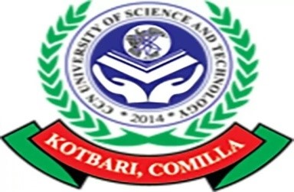

**Department of CSE**

# Course Title: Software Development using

# JAVA (sessional)

**Course Code: CSE-**

**Submitted To:**

Tazkia Binty Faruqui

Lecturer,

Department of CSE

CCN UST

**Submitted By:**

Abdur Rahman

ID: 111118046

Department of CSE

CCN UST

**Submission Date: 16- 12- 2021**