(Font size 14, Bold, Times New Roman and Centered OR Select “Heading 1, Chapter_Heading_MTE_Thesis” from Styles) (One Blank Lines after Chapter 1)
Introduction
(One Blank Lines)

Project report layout
The heading of a section should be: Font size: 12, Bold, Font name: Times New Roman, Spacing before and after: 6 pt, Line spacing: 1.5, and Left Indent OR select “Heading 2,MTE_Thesis_Section” from Styles.
The text should be: Font name: Times new roman, Font size: 12pt, Line spacing: 1.5 lines, Justified text pattern].

Table format
The table should be centered on with a title above it. The title should be: Font name: Times New Roman, Font size: 10 pt, centered, Spacing before and after: 6 pt OR select Caption, Caption_Table_MTE_Thesis’ from Styles. Table 1.1 shows the sample.
The font size inside the table is 12.
Table 1.1. Title of the Table
SI no. | Column 1 | Column 2 | Column 3
1 | ddddd | ddddd | ddd
2 | dddd
(After table there should be a blank line)

Sub section
The heading of sub section should be: Font size: 12, Italic, Font name: Times New Roman, Line spacing: 1.5, Spacing before and after: 6 pt OR select “Heading 3,Subsection_MTE_Thesis” from Styles.

Figure format
We suggest that you use a 1x1 table to insert a graphic (which is ideally a 300 dpi TIFF or EPS file or any other vector file, with all fonts embedded). The title should be: Font name: Times New Roman, Font size: 10 pt, centered, Spacing before and after: 6 pt OR select Caption, Caption_Table_MTE_Thesis’ from Styles. Figure 1.1 shows a sample.
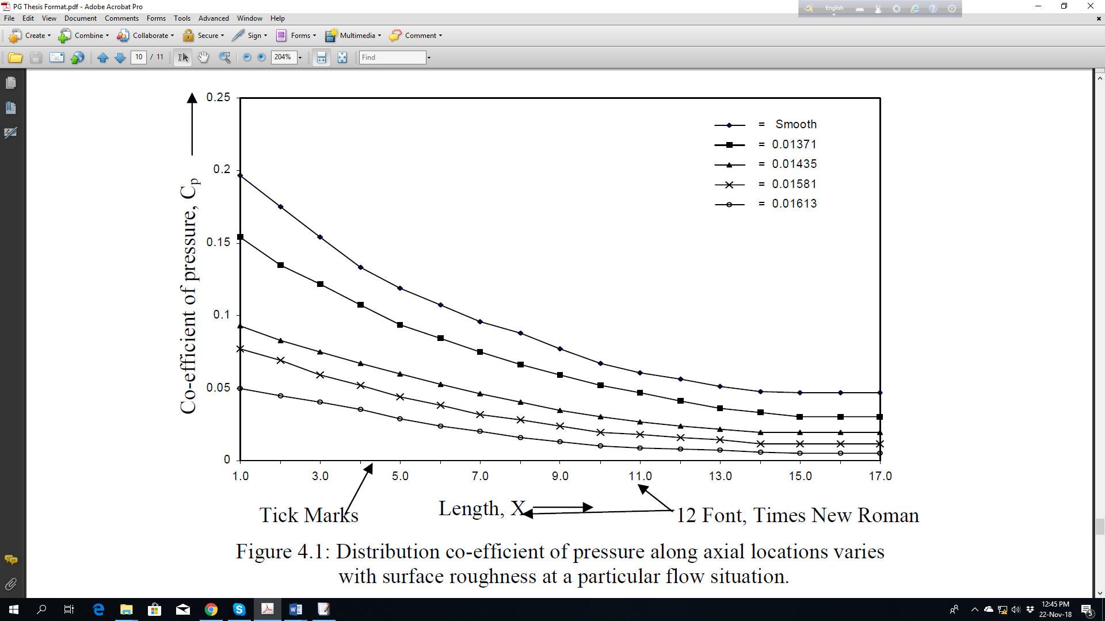
Figure 1.1. Caption of a figure.
After inserting the figure, please remove the border.

Literature review

Early methods

