Artistbor Dashboard

Responsive Tables & Status Navigation

STATUS  Proposed — investigation complete |  | OWNER  Dashboard frontend |  | LAST UPDATED  August 26, 2026

Authors | Dashboard engineering
Reviewers | Product, frontend, QA
Related docs | DESIGN.md; AGENTS.md; CLAUDE.md
Scope | Orders and Artists responsive navigation, filters, tables, and cards.

1. Abstract
The current Orders and Artists screens overflow because navigation, filters, and data views decide responsiveness from the viewport instead of the page’s real width after the sidebar and page padding are applied. This proposal keeps Artistbor’s extracted design system and existing components, but assigns width ownership explicitly so labels stay readable and horizontal scrolling is isolated.
Scope: admin Orders and Artists first, followed by shared table/filter primitives. No backend payload, status code, permission, routing, or business-rule change is included. The design must support Uzbek and Russian labels, expanded or collapsed navigation, light and dark themes, keyboard use, and touch scrolling.

2. Goals and Non-Goals
Goals | Non-goals
Keep all statuses reachable and the active tab visible. | Do not change backend status codes, counts, or API contracts.
Make layout decisions from available content width. | Do not replace Artistbor tokens, typography, icons, or component language.
Reduce avoidable padding and wrapping in data-dense tables. | Do not redesign unrelated dashboard pages in the first release.
Pass UZ/RU, zoom, keyboard, light/dark, and sidebar-state tests. | Do not add decorative motion or new frontend dependencies.

3. Background and Problem Statement
The regression is confirmed in the working tree. Orders grew from six to eight status tabs when status 25 (payment verification) and 35 (rejected) were added, but the existing shrink-0 buttons and 28px gaps were unchanged. Artists simultaneously added a 360px search variant inside a six-column filter grid. The screenshot shows the final Orders tab clipped and the browser scrollbar sharing the active-indicator area.
Existing layout constraints magnify the issue: AdminLayout enforces a 1280px minimum width at lg and overflow-x-hidden; Orders switches from cards to a min-width 920px table at the viewport lg breakpoint; Artists always renders a min-width 1012px table; shared cells spend 28px of horizontal padding per column. The page therefore reacts to screen width, not the smaller content width available beside the sidebar.

4. Proposed Architecture
Adopt a page-level responsive boundary that measures available content width. Existing status tabs, filter controls, table cells, status badges, mobile order cards, tokens, typography, radii, and Lucide icons remain the building blocks.
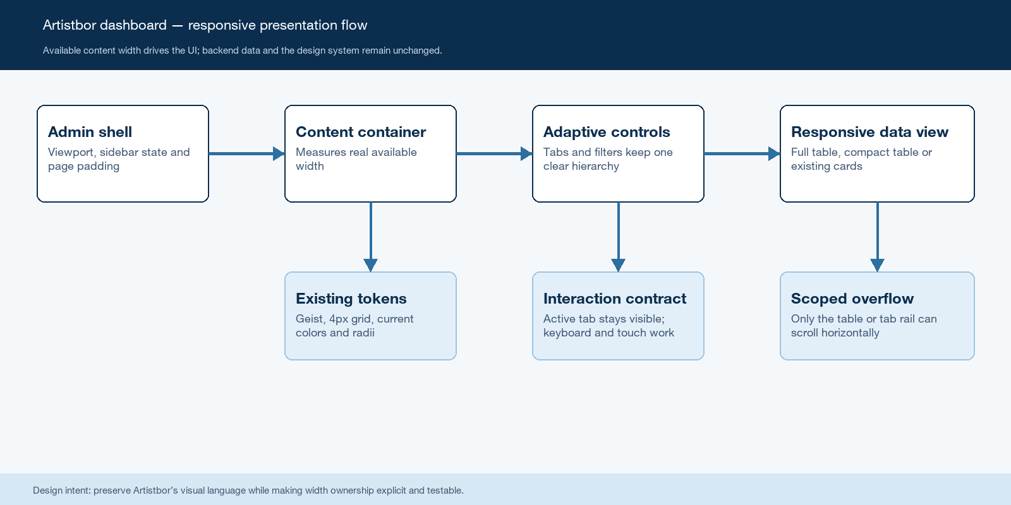
Figure 1. Artistbor responsive presentation flow.

Core components
The change deepens existing components instead of creating a parallel design system. Width policy belongs to shared presentation primitives; domain pages continue to supply labels, columns, data, and actions.
Component | Responsibility | Reuses | Failure behavior
Admin content boundary | Expose real inline size after sidebar and padding. | AdminLayout | Falls back to compact presentation; never forces page scroll.
Status tab rail | One-line tabs, active visibility, accessible overflow. | OrderStatusTabs / ApplicationStatusTabs | All tabs remain reachable by touch and keyboard.
Responsive filter panel | Wrap controls by group and preserve usable widths. | Filter shell, Ant Input/Select, DateFilterSelect | Controls move rows instead of clipping.
Responsive data view | Choose full table, compact table, or cards by container. | OrdersDataTable, OrderMobileCard, ArtistsTable | Local table scroll is the last fallback.
Density primitives | Centralize cell padding, nowrap, and column priority. | DataTable, TableHead/TableCell, StatusBadge | Page overrides remain possible during migration.

5. Layout Decision Lifecycle
- AdminLayout exposes the content container; sidebar state and page padding reduce its measured inline size.
- The status rail renders all statuses in one line. At constrained widths it becomes a keyboard- and touch-scrollable region with edge affordances; the active tab is scrolled into view.
- The filter panel lays out by container width. Search can flex, atomic selects keep usable minimums, custom date inputs wrap as a group, and Reset moves to the next row rather than forcing overflow.
- The data view selects full table, compact table, or existing card presentation from available content width—not from the viewport lg breakpoint.
- Full and compact tables preserve one-line primary values and use secondary lines for metadata. Low-priority columns are removed before cell text is allowed to wrap unpredictably.
- If irreducible table width still exceeds the container, horizontal scrolling remains inside the table shell only; page and admin shell never become horizontal scrollers.
- Interaction uses existing 150–200ms color transitions only. No layout or decorative animation is introduced, and prefers-reduced-motion remains authoritative.

6. UI Contracts and Accessibility

Responsive UI contract
This is a presentation contract only. The existing Orders and Artists API calls, filters, statuses, counts, sorting, pagination, and mutations remain unchanged.
Field | Type | Required | Description
availableWidth | CSS container | Yes | Inline size after sidebar and page padding.
presentationMode | full | compact | cards | Yes | Derived only from availableWidth and page policy.
activeStatus | existing tab key | Yes | Preserved across scroll, resize, and locale changes.
minTableWidth | number | Yes | Page-owned irreducible width; scrolling stays local.
columnPriority | primary | secondary | optional | Yes | Determines what disappears before text wraps.
locale | uz | ru | Yes | Existing i18n source; no duplicated responsive labels.
reducedMotion | media preference | Yes | Disables nonessential transitions as today.

Contract guarantees

- The selected status is always fully visible after initial render, locale change, resize, or user selection.
- Status labels never wrap; overflow is discoverable without covering the active indicator.
- Primary table values remain readable; secondary columns disappear before essential content wraps.
- Uzbek and Russian use identical behavior even when Russian labels are longer.
Keyboard focus, arrow/Tab navigation, touch scrolling, and accessible region labels remain available.
Source of truth: design-analysis/artistbor-dashboard-design/DESIGN.md and the existing dashboard components.

7. Consistency, Localization, and Interaction

Container thresholds and column priorities are shared; page-specific content stays local. Locale changes can alter measured label widths without changing the selected status or filter state. Overflow and table/card mode are deterministic and do not depend on fetched row count.
Scenario | Expected behavior | Reasoning
Status count grows | Rail scrolls or tightens spacing; no tab is clipped. | Labels are data, not a fixed-width assumption.
Locale switches to Russian | Active key and filters stay stable; width is re-evaluated. | Status identity is code/key, not translated text.
Sidebar toggles | Presentation mode updates from content width. | Viewport width alone is insufficient.
Resize or zoom | One deterministic mode; no page-level horizontal scroll. | Container policy owns the fallback order.

8. Security and Privacy Considerations

- No authentication, authorization, API proxy, permission, or data ownership behavior changes.
- No new data is stored, logged, cached, or sent to a third party.
- Visible public order IDs and existing customer fields keep their current access controls.
- Responsive state is local presentation state; it must not be accepted as authorization input.
- The implementation must preserve focus visibility and avoid clipping destructive or privileged actions.

9. Responsive Acceptance Matrix
Signal | Target | Owner | Launch gate
Expanded sidebar at 1536px | All 8 UZ/RU tabs reachable; no indicator overlap. | Frontend | Required
Content width 1040px+ | Full table; primary values do not wrap. | Frontend / QA | Required
Content width 760–1039px | Compact columns; actions remain visible. | Frontend / QA | Required
Content width below 760px | Existing card pattern; no horizontal page scroll. | Frontend / QA | Required
125% zoom + Russian | No clipped tab, filter, badge, or action; keyboard focus and reduced motion pass. | QA | Required
Global launch gate: UZ/RU, light/dark, expanded/collapsed sidebar, touch, keyboard, and reduced-motion checks pass without page-level horizontal scroll.

10. Before / After / Why

The recommendation below follows the current Artistbor design system and Emil design-engineering constraints: less motion, clear width ownership, compact 4px-grid spacing, and no ornamental UI.
Before | After | Why
8 shrink-0 tabs with 28px gaps and a scrollbar under the indicator. | 12–16px token-aligned gap; one-line accessible rail; active tab auto-visible; overflow affordance separated from indicator. | Fits the screenshot width and remains usable when labels grow.
lg viewport switches Orders to a 920px table. | Container width selects full, compact, or existing card view. | Sidebar and page padding make viewport breakpoints inaccurate.
Artists search is fixed at 360px inside a six-column filter row. | Search flexes within safe bounds; filter groups wrap; nested padding becomes one 12px layer. | Prevents custom dates and Reset from forcing a hidden horizontal rail.
Every 7-column Artists row spends 28px per cell and keeps all columns. | Shared density uses 12px per side in full tables, 8px in compact mode, and column priority before wrapping. | Recovers width without changing typography, colors, status badges, or actions.

11. Open Questions
- Confirm whether Artists should use a compact priority-column table or a card view below the medium container threshold.
- Confirm whether desktop tab overflow uses edge chevrons plus hidden native scrollbar, or a reserved thin scrollbar gutter.
- Validate the proposed container thresholds against the longest production Russian labels and 125% browser zoom.
- Decide whether the first migration should extract shared StatusTabRail immediately or stabilize Orders first and extract after verification.

12. Decision and Next Steps
Recommended decision: approve an incremental responsive refactor. First fix width ownership and the Orders status rail, then migrate Orders table/card switching and Artists filters/table density, then consolidate the proven behavior into shared primitives. Release only after the matrix below passes in UZ/RU, light/dark, expanded/collapsed sidebar, keyboard navigation, and zoom tests.
Milestone | Deliverable | Exit criteria
M1 | Admin content-width boundary and Orders status rail. | 8 tabs pass UZ/RU, sidebar, zoom, keyboard, and reduced-motion tests.
M2 | Orders container-driven table / compact / card modes. | No page-level horizontal scroll from 320px through desktop widths.
M3 | Artists wrapping filters and priority-column/card policy. | Custom date range and all actions remain reachable without clipping.
M4 | Extract proven shared primitives and migrate adjacent pages. | No visual-system duplication; targeted regression suite passes.

Use footnotes for definitions, assumptions, or terms that need precision without interrupting the main narrative.

