JIMMA UNIVERSITY

INSTITUTE OF TECHNOLOGY

PROGRAM: Artificial Intelligence



Distribution of Youth Volunteers on Peace Minister Project

|  |  |
| --- | --- |
| Group Members | |
| Name | ID Number |
| Abdurhman Abrar | RM0940/14 |

JIMMA, ETHIOPIA

Contents

INTRODUCTION 3

PROJECT OBJECTIVE 4

BUSINESS UNDERSTANDING 5

Problem Definition 5

Data Acquisition, Data Sources, Data Collection Process & Understanding 5

EXPLORATORY DATA ANALYSIS 6

Basic Structure 6

Summary Statistics 6

## INTRODUCTION

Youth Volunteer Management System is web-based application developed by Jimma University ICT development Office in collaboration with Ministry of Peace, National Volunteerism program to automate the entire process of national volunteerism program from online application up to deployment and community engagement. I have been participated on this project as developer and I have data about volunteers and I want to drive output from this data like distribution of volunteer’s participation among different regions.

## PROJECT OBJECTIVE

Main reason why I choose this data is because I have participated as programmer to develop this system. And one of the features this system have is that number of volunteers must be proportional to regional quota of number of volunteers. For example, Oromia region have more quota than Afar region. So, in this dataset I want to show distribution of number of volunteers among different regions using different graphs and plots.

## BUSINESS UNDERSTANDING

### Problem Definition

After volunteer candidates go through the process of online application form and submit their data for peace ministry training. We want to plot or show in the graph distribution of volunteers among different regions. Based on the plotting we can easily identify what regions participate a lot and we can use it for business side recommendation and decision.

### Data Acquisition, Data Sources, Data Collection Process & Understanding

The data is extracted from the database that volunteers submitted from online application form. This data is belonged to Peace minister project called Youth volunteer management system. This data contains 13 columns, and above 4000 records.

## EXPLORATORY DATA ANALYSIS

## Basic Structure

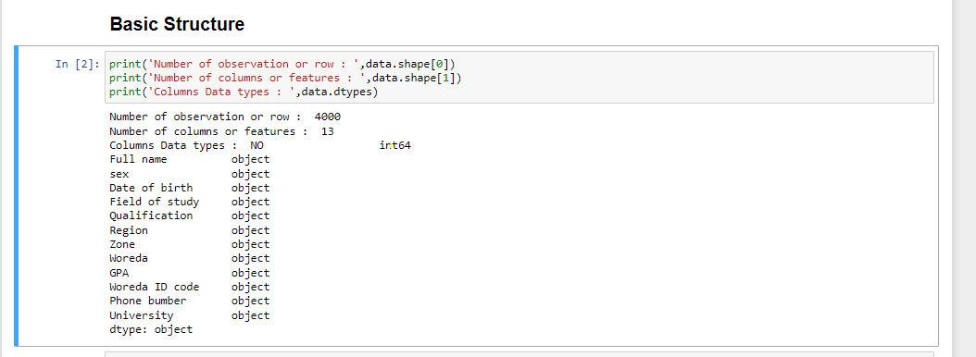

Figure Basic structures

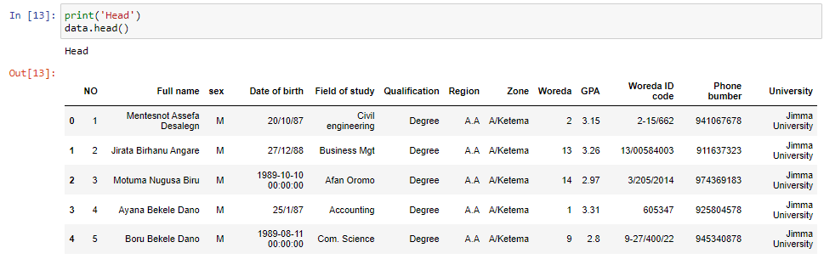

Figure Head or fist five items

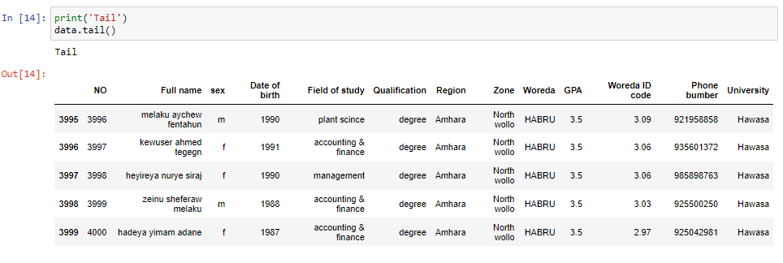

Figure Tail or last five items

## Summary Statistics

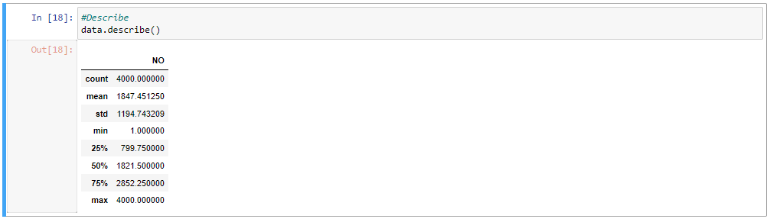

Figure Data describe for Summary Statistics

## Distributions

Grouping

Here I group data by regions where the volunteers come from.

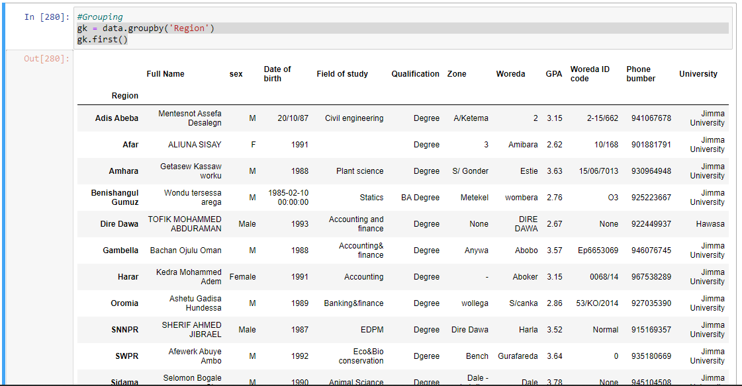

Figure Grouping based no region the volunteer come from

## Crosstabs & Pivot

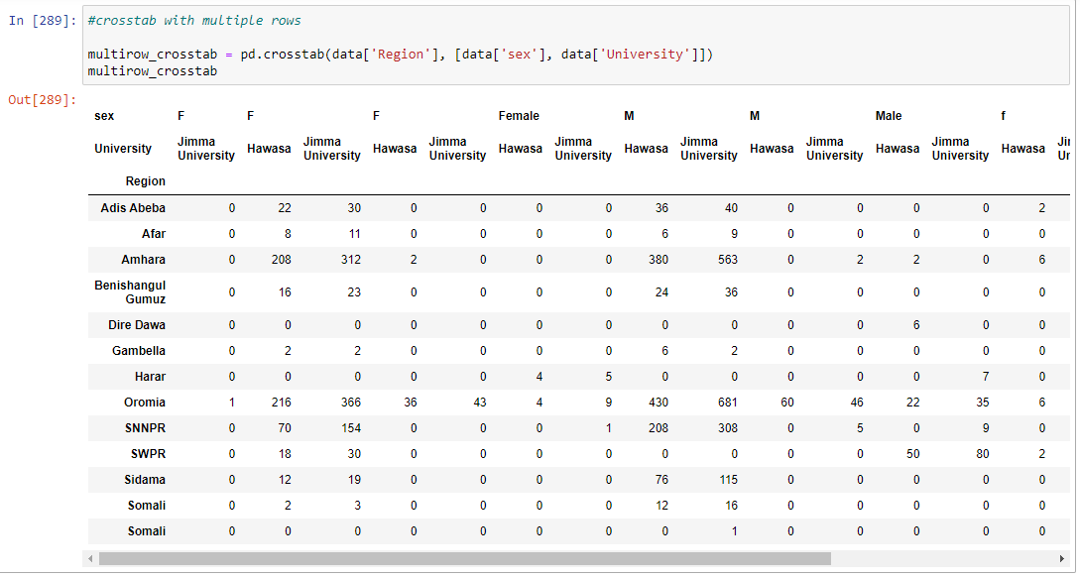

Figure Crosstab with multiple rows

## Conclusions

As we see in the above screenshot I tried to use data-set of peace minister project called young volunteer management system. And from that I showed basic data, statistics, and dashboard using streamlit.