Verification of SPI Core using UVM with Wishbone and SPI Slave UVCs

1. Introduction
This project focuses on the functional verification of a Serial Peripheral Interface (SPI) core using the Universal Verification Methodology (UVM). The SPI core under verification was sourced from an OpenCores implementation, which closely resembles the Motorola M68HC11 SPI protocol with enhancements like configurable FIFO depth and programmable interrupts. The SPI core supports a Wishbone interface for register access and communicates externally through the standard SPI signals: mosi_o, miso_i, sck_o, and ss_o.
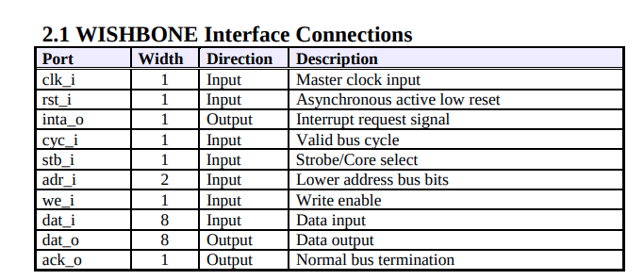
To comprehensively verify the SPI core, a UVM testbench was constructed that includes two major verification components (UVCs): a Wishbone UVC to configure and control the SPI core and an SPI Slave UVC to interact with and monitor SPI transfers. The verification process includes stimulus generation, signal observation, protocol checking, and scoreboard-based result comparison.
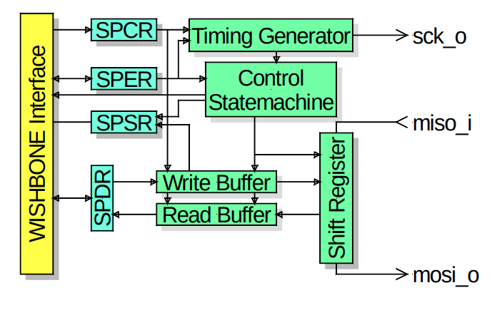

2. SPI Core Overview
The SPI core implements full-duplex, synchronous serial communication. It is controlled through memory-mapped registers accessible via a Wishbone bus:
- SPCR (Control Register): Enables SPI, selects modes (CPOL, CPHA), etc.
- SPDR (Data Register): Writing initiates transfer; reading retrieves received byte.
- SPER (Extended Register): Enhances control.
- FIFO Buffers: 4-byte deep buffers for transmit and receive.
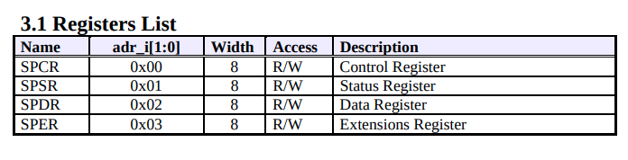
Transfers begin when data is written to SPDR. The core drives the SPI clock (sck_o) and sends data on mosi_o, while simultaneously receiving data on miso_i. The signal ss_o indicates active communication (active-low slave select).

3. UVM Testbench Architecture
The testbench follows a modular, layered UVM architecture and consists of the following major components:

3.1 Wishbone UVC
The Wishbone UVC acts as the master interface to configure the SPI core:

- Driver: Sends address, data, and control signals (cyc_i, stb_i, adr_i, we_i, dat_i) to write/read the SPI registers.
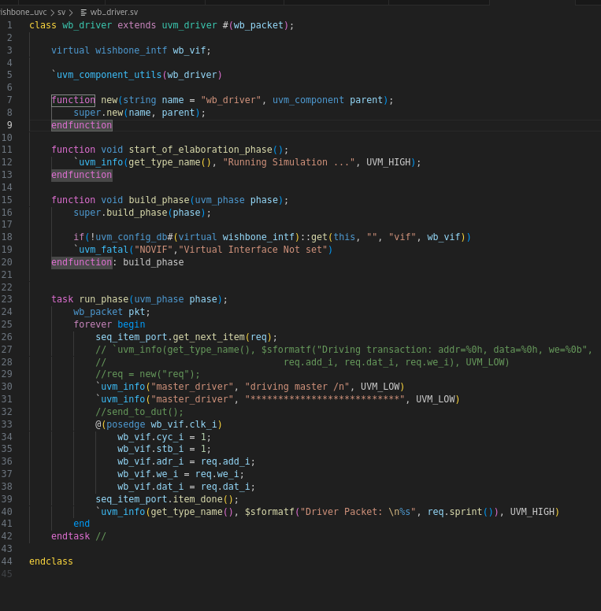
- Monitor: Observes bus transactions and records them for checking.
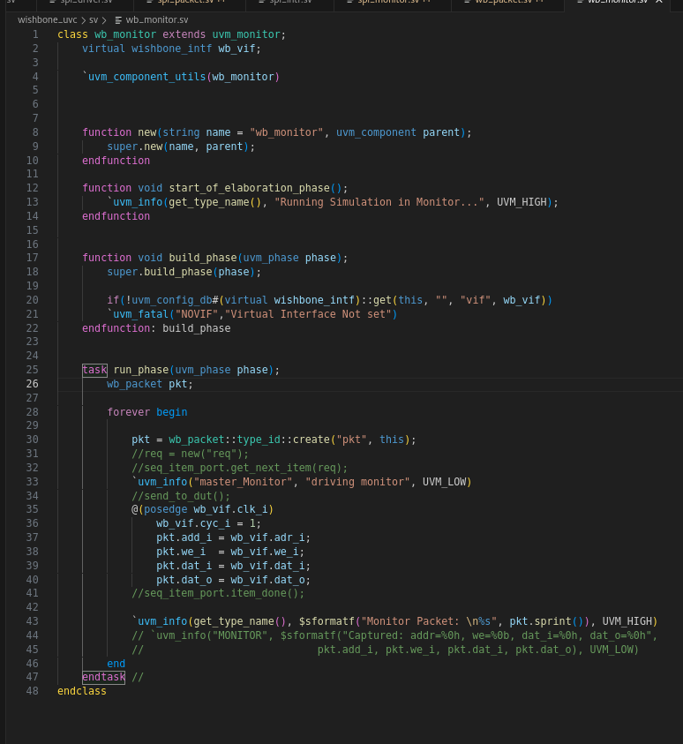
- Sequencer: Provides stimuli (register-level transactions).
- Transaction Class (wb_packet): Contains randomized or directed fields such as address, write enable, data_out and write data.
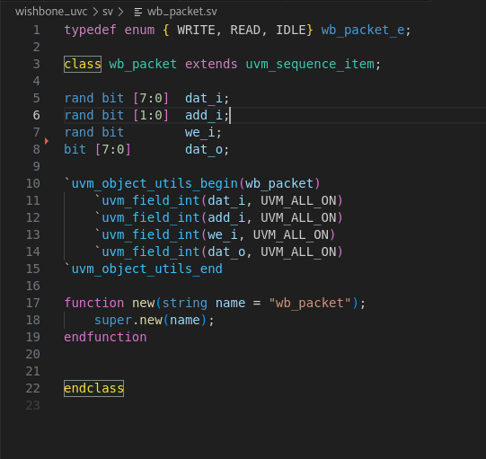
This UVC is responsible for initializing the SPI core, enabling it, and writing data to the SPDR register to trigger transfers. All signals were handled through a virtual interface connected to the DUT's Wishbone port.
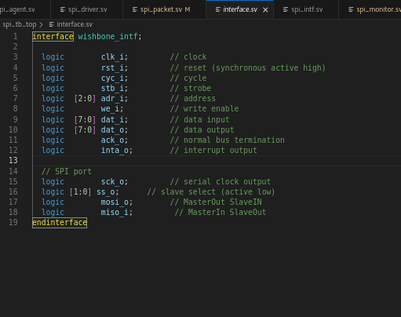
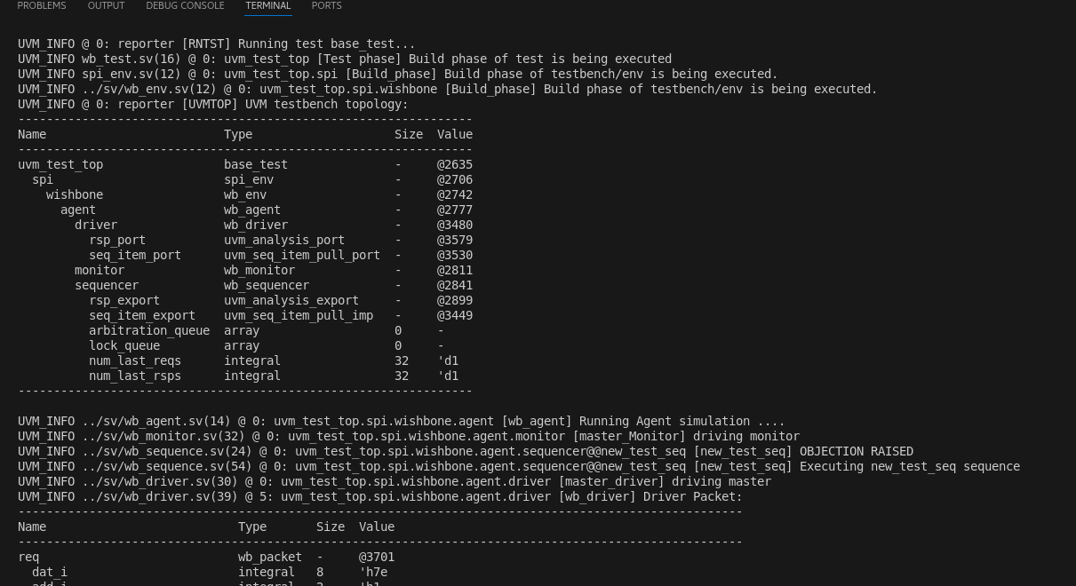

3.2 SPI Slave UVC
The SPI Slave UVC emulates a basic SPI slave device:
- Driver: Waits for ss_o to go low (transfer start), and on each posedge sck_o, drives one bit of miso_i using a shift register, simulating the slave’s data output.
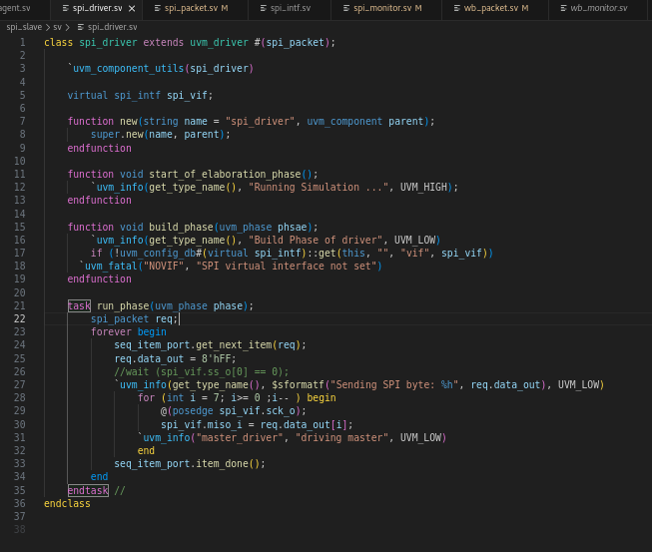
- Monitor: Also waits for active slave select and captures 8 bits of data sent by the master on mosi_o, while logging the slave’s response on miso_i.
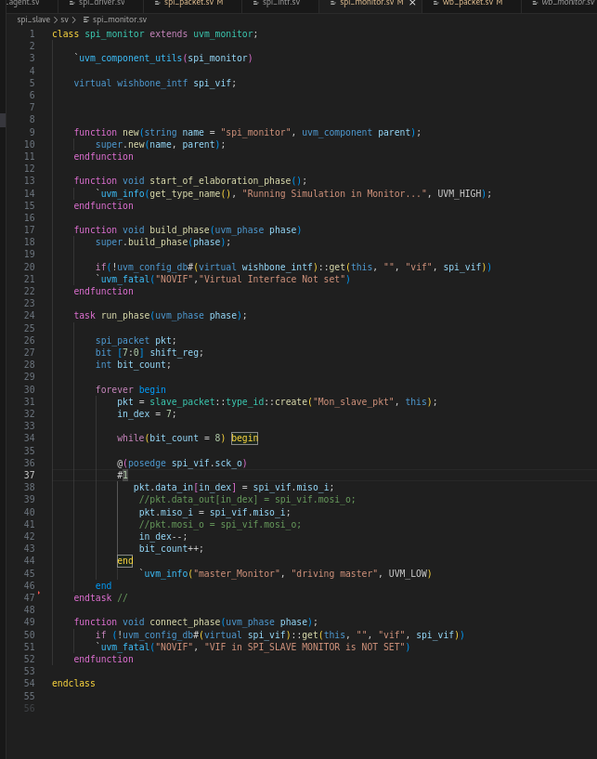
- Transaction Class (spi_packet): Contains data_in, data_out, and bit-level fields for protocol observation.
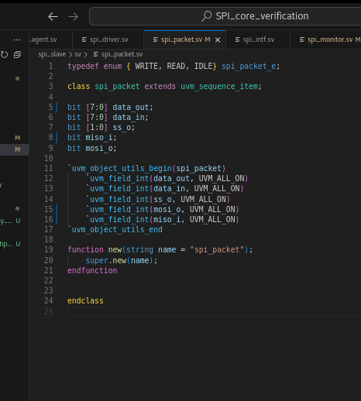
The SPI slave driver uses the same sck_o as a reference to drive the output in sync with master timing. The monitor stores both transmitted and received bits into a transaction object.

4. Clocking and Reset Logic
A synchronous clock (clk_i) with a fixed period was created in the top.sv module. The SPI core is configured to operate off this clock. An initial active-high reset (rst_i) is asserted and then deasserted early in the simulation. All transactions, both Wishbone and SPI, are synchronized to this clock.

5. Simulation Flow and Control
The entire simulation follows a time-accurate flow:
- Reset phase: Clock starts, rst_i is asserted and deasserted.
- Configuration phase: The Wishbone UVC writes to SPCR (enable SPI) and then SPDR with a test byte.
- Transfer phase: Upon writing to SPDR, the SPI core asserts ss_o, begins toggling sck_o, and sends bits on mosi_o.
- Slave response: The SPI driver detects ss_o == 0 and begins sending response bits via miso_i.
- Monitor observation: The SPI monitor records both directions of the byte transfer and forwards them to the scoreboard.
- Scoreboard checking: Received transactions are compared to expected values to verify protocol correctness.
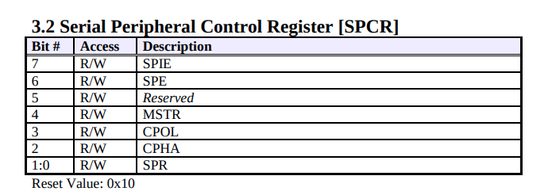

6. Synchronization and Full-Duplex Behavior
SPI’s full-duplex nature was carefully modeled. During each clock cycle, the master sends and receives one bit. The driver shifts out bits on miso_i, while the monitor captures mosi_o at the same clock edge. This reflects real-world SPI operation, where data flows in both directions simultaneously.

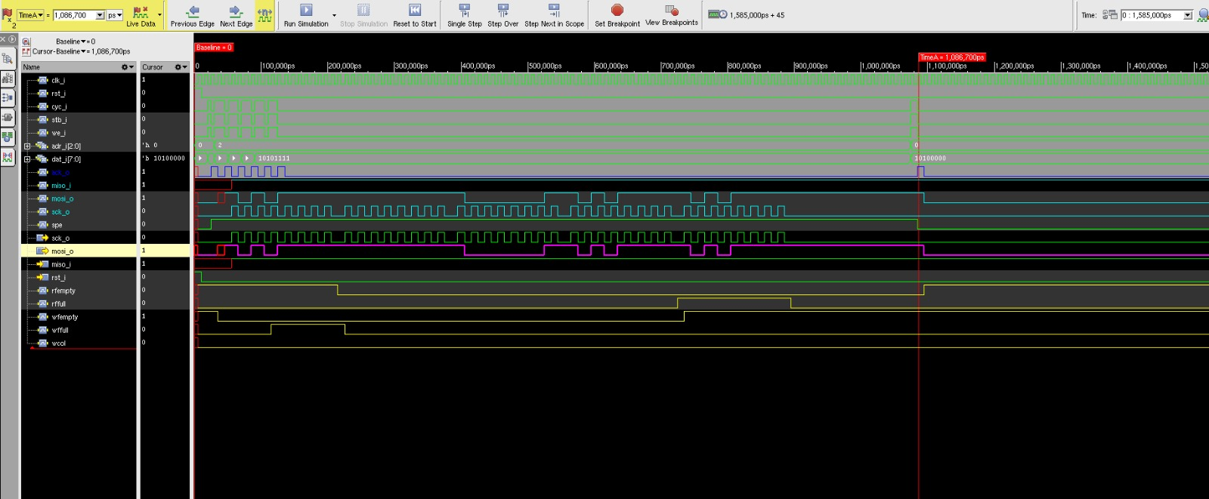

7. Debug and Traceability
Each monitor and driver logs transactions using UVM's builtin transaction recording. The sprint() method of each packet class is used to print the byte-level contents to the transcript for debug purposes. Additionally, top-level test cases use uvm_top.print_topology() to print instantiated components, aiding visibility and debug.

8. Results and Conclusion
The verification testbench successfully stimulated the SPI core via the Wishbone interface, initiated real-time SPI transfers, and monitored the data exchange accurately. The modular design allowed independent testing of each layer.
The Wishbone UVC was responsible for configuration and control, while the SPI slave UVC emulated actual SPI transfer behavior and monitored the data exchange. The monitors fed results to the scoreboard, which validated the correctness of transmitted and received data. This approach models a reusable, layered UVM-based verification environment. It can now be extended to cover more features, including edge case handling, mode testing (CPOL/CPHA), FIFO overrun scenarios, and protocol assertion checks.

