
1
1
UVM – Lab43-UVM_Sequences

AbdurRafay dv-c1-2025-021
Submitted to: NCDC
NCDC Training
Task 1
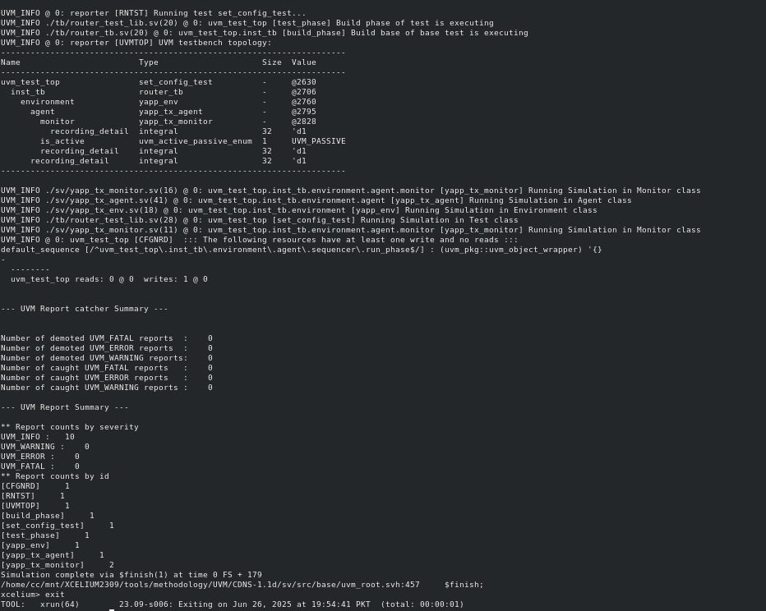

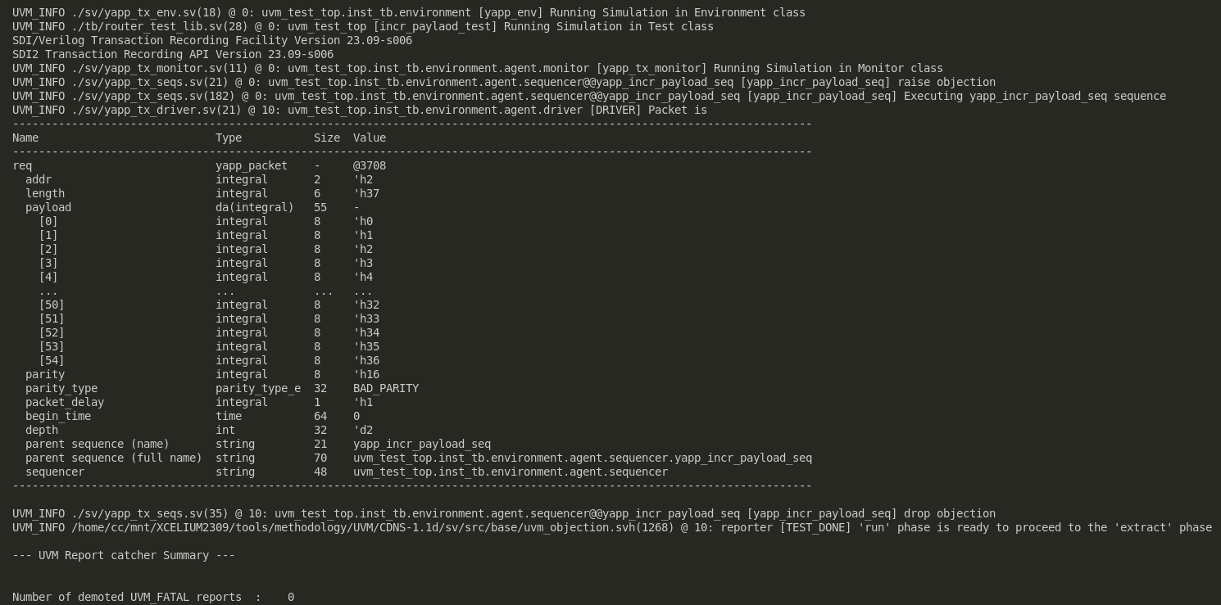

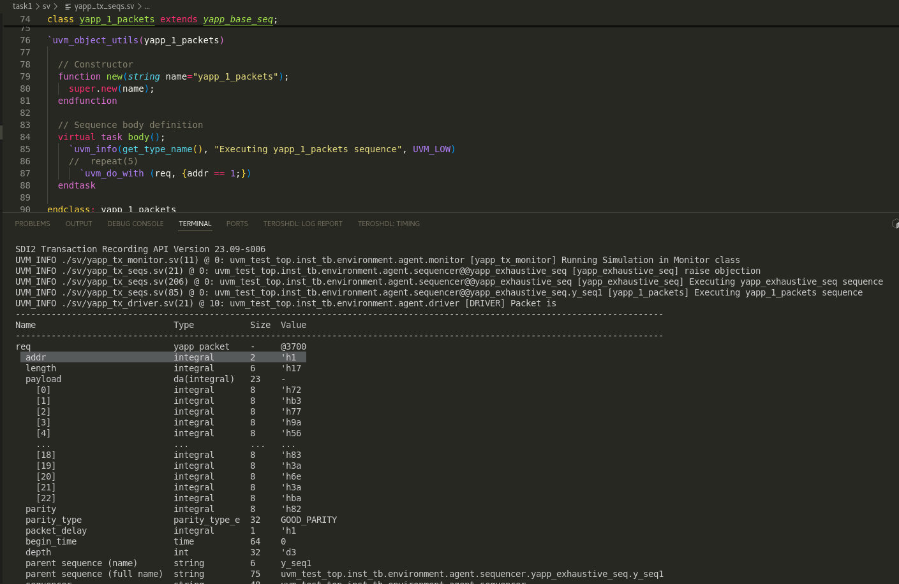

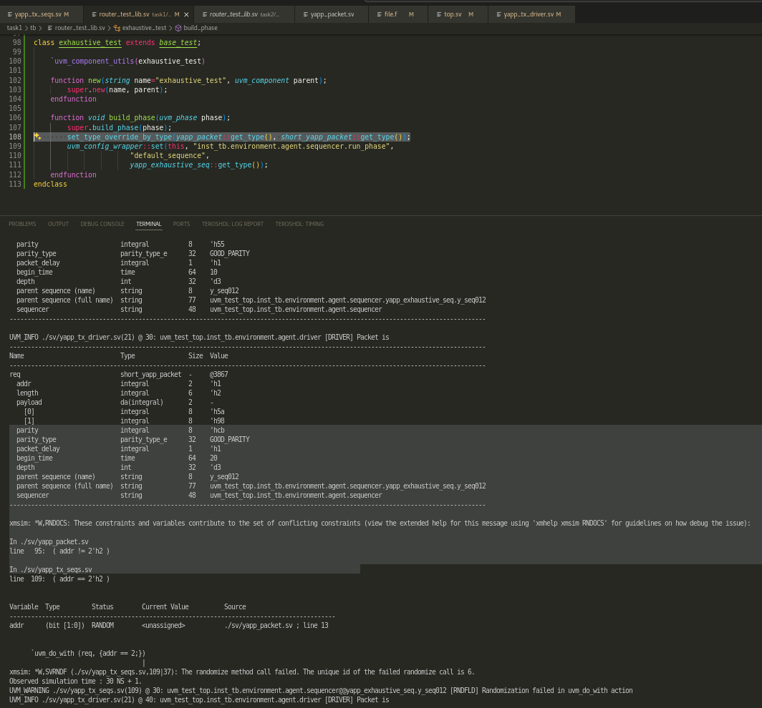
there is error as there is constraint mismatch between short_yapp_packet and y_seq012.

yapp_111_packets
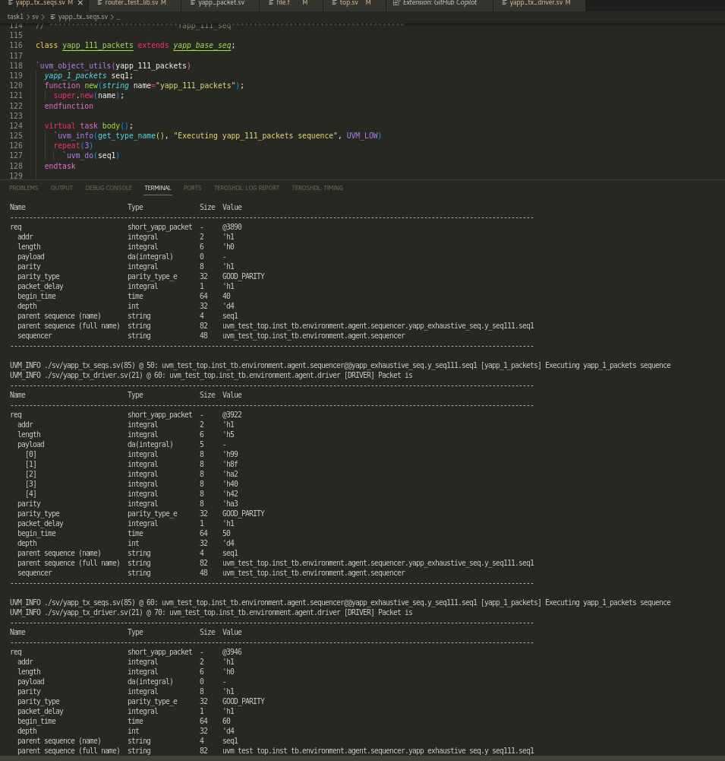

yapp_repeat_addr_packets
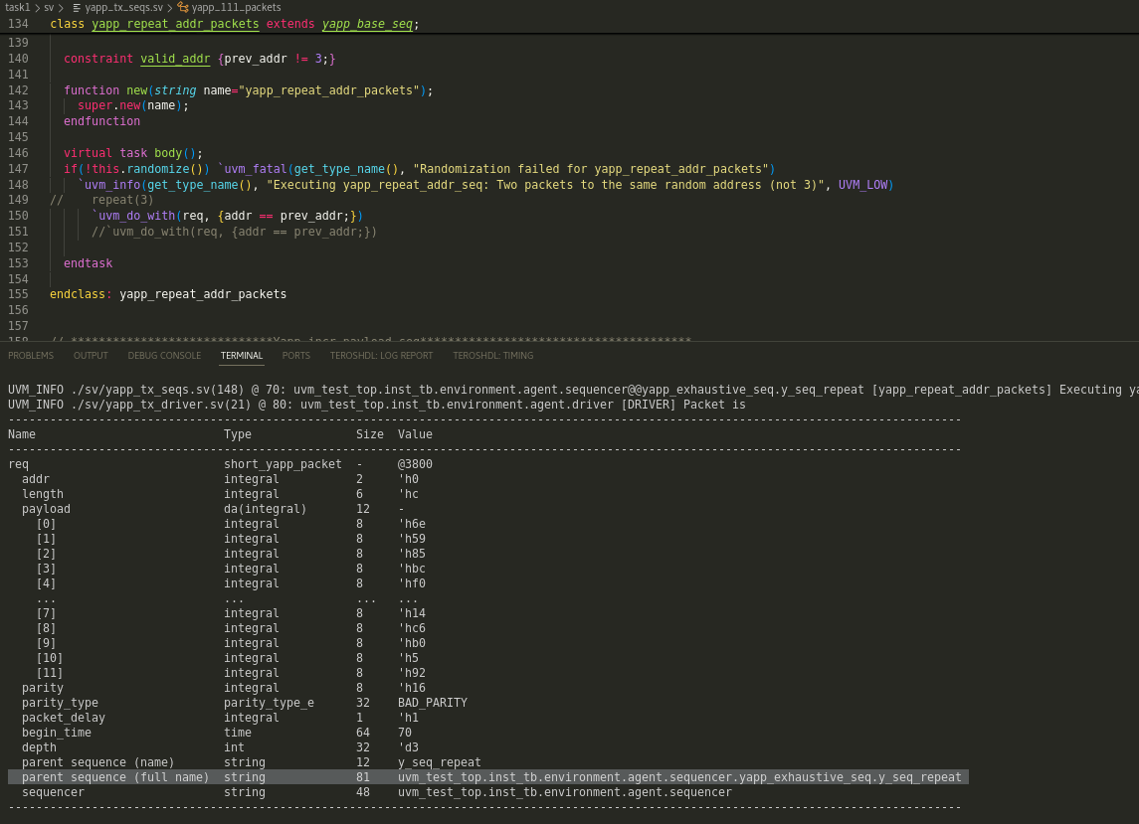

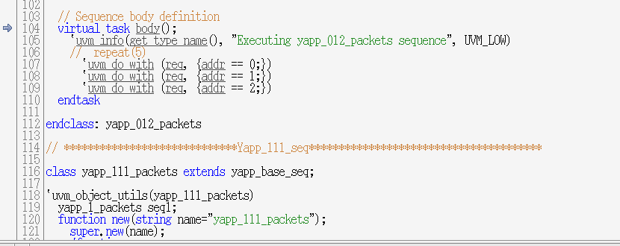

yapp_incr_payload_seq
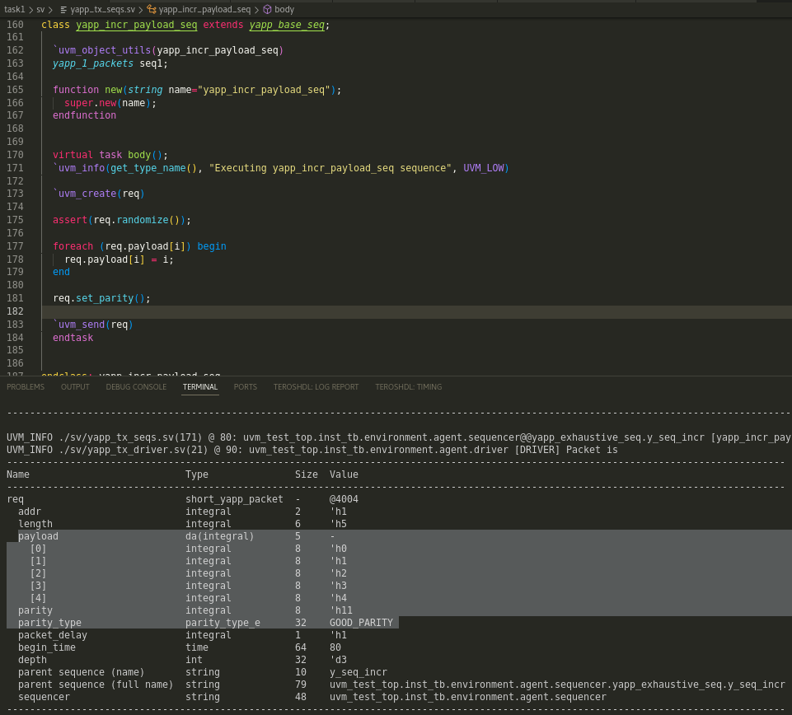

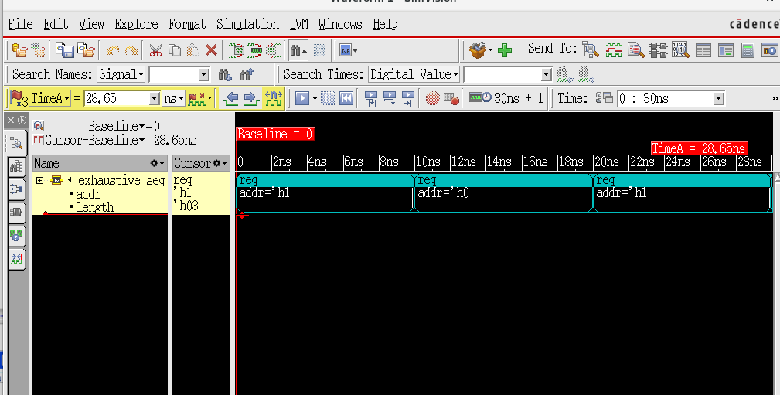
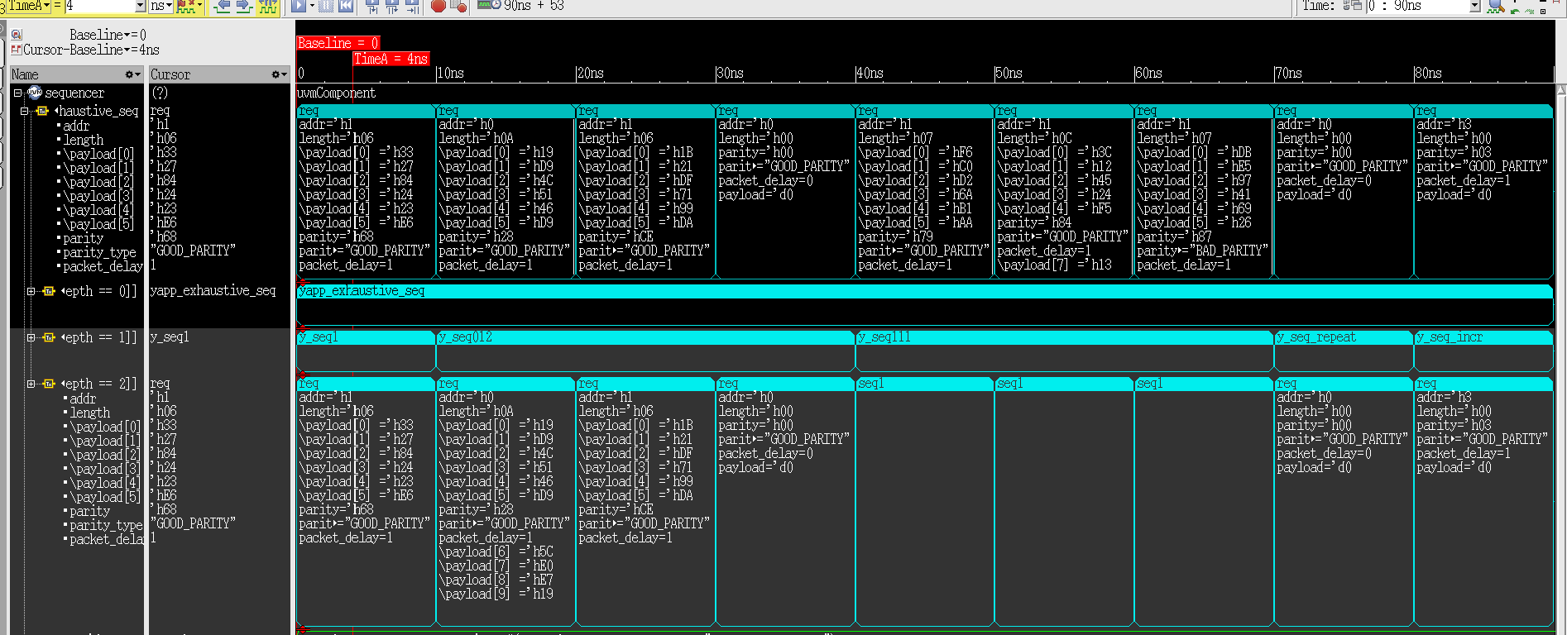

Step – 16
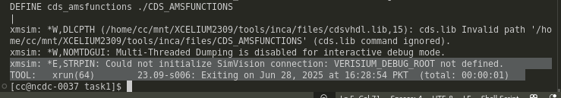

Why do you get randomization violations?
Answer: Constraint in short_yapp_packet class( addr!=2) and constraint in yapp_012_seq class (addr = 2)

What happens to the packet when a constraint violation is found?
Answer: it did not stop instead it generated another packet at addr 0.

How could you fix these violations?
Answer: just remove the constraint from one of them.

Fixing code
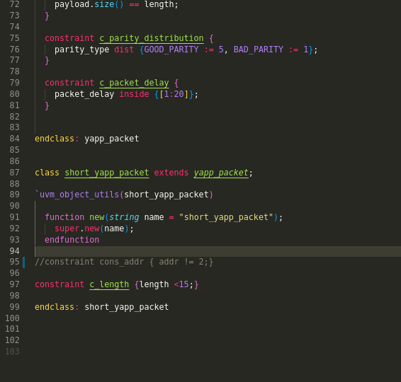
Now conflict resolved.

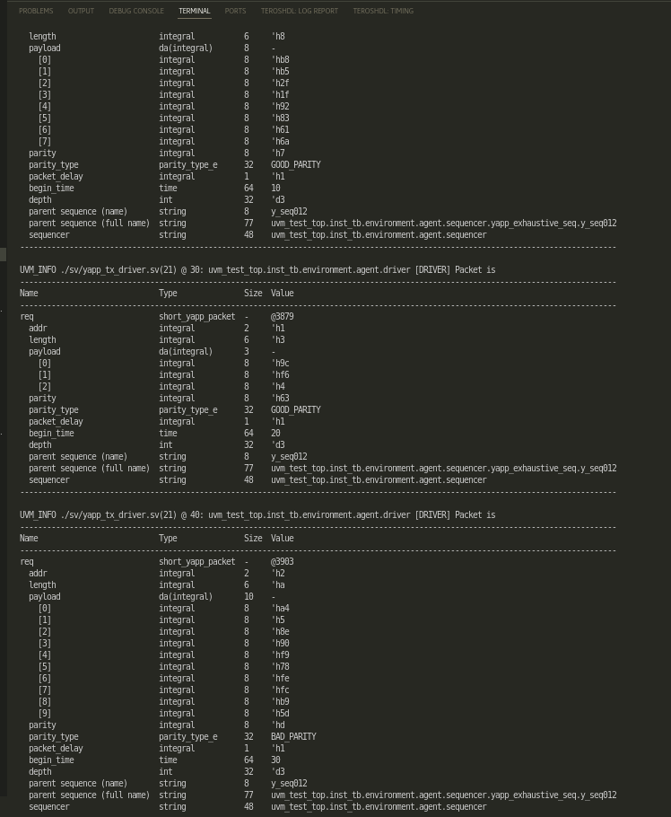

As rand count value is 3. we are seeing 3 packets.

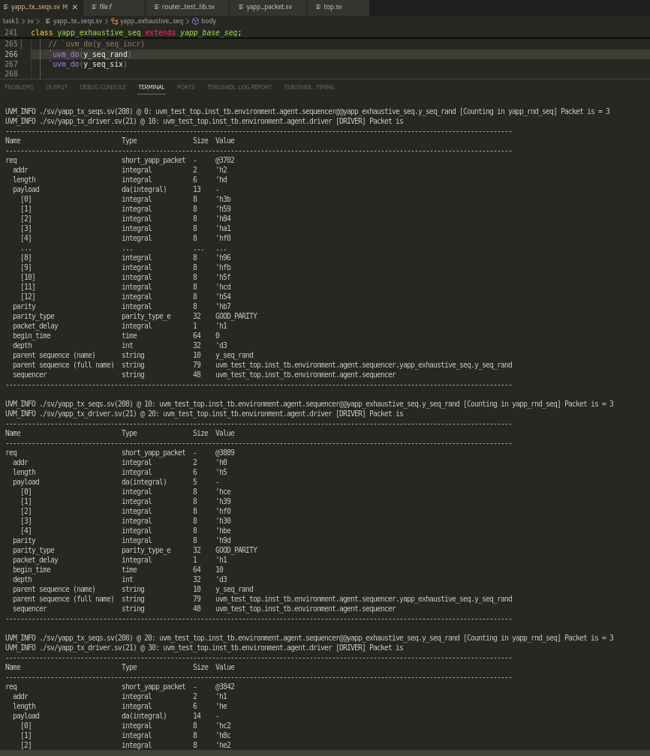

Now I have set it to 6.
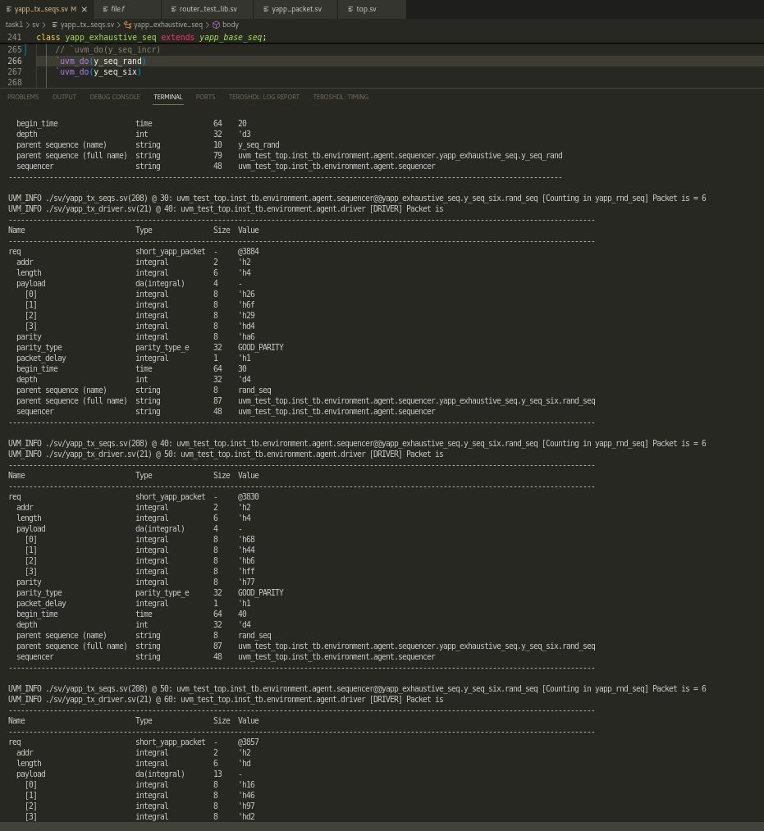

Task 2
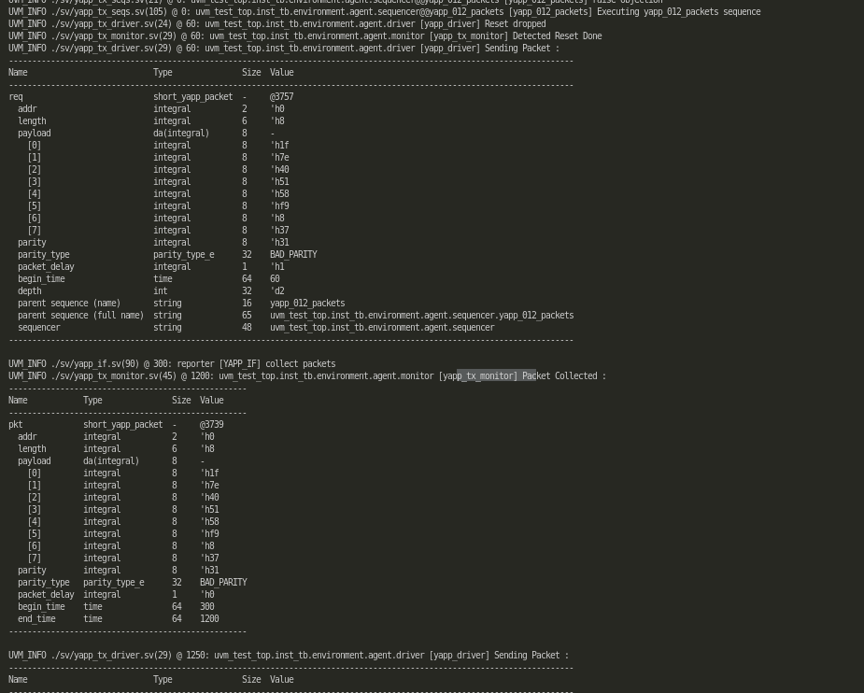

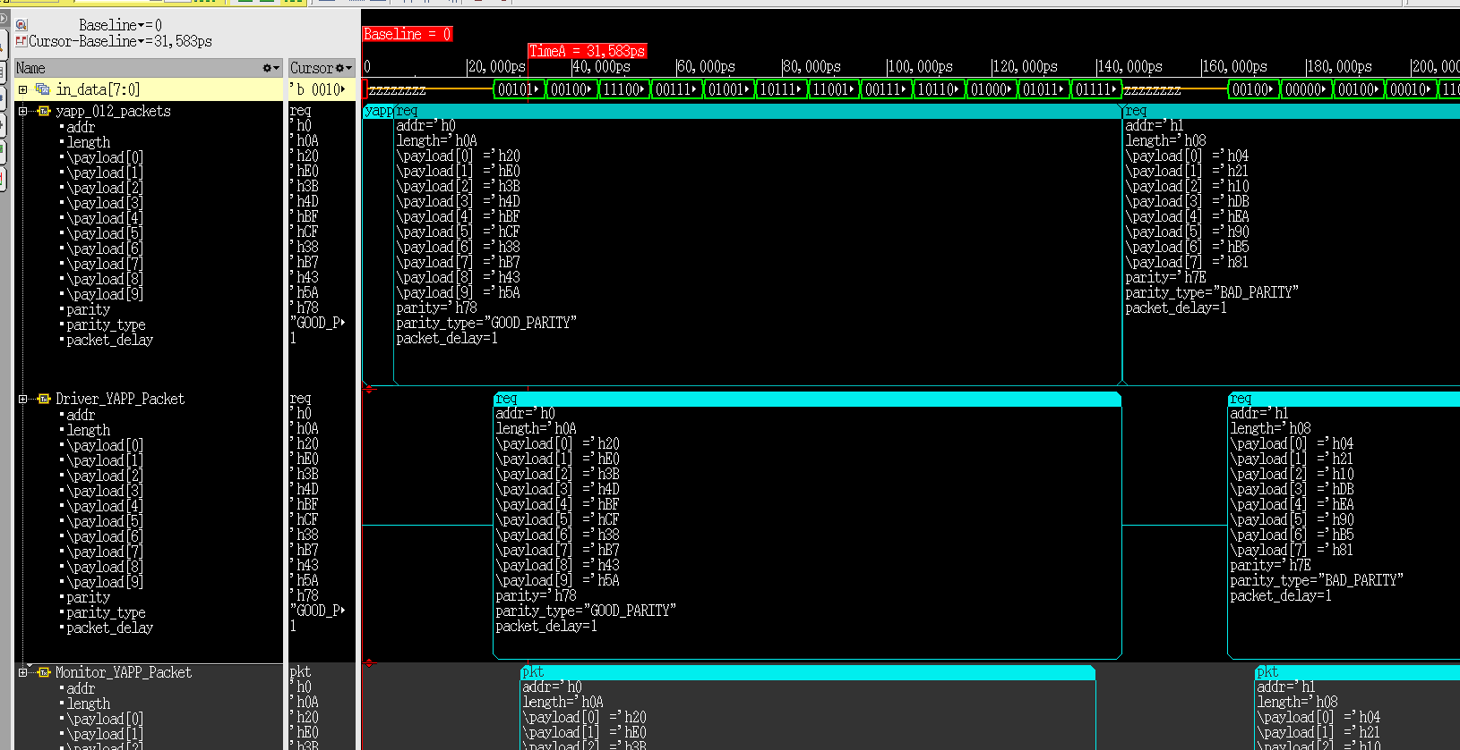
As we can see, we are getting same data from driver and monitor. As we dont have any DUT right now, so Driver sending data and monitor monitoring data would be same.
Note that as the first 2 bits denote address. It is 0. and remaining are length. As length is 10. we can see that data_in is 10. and last one is parity.
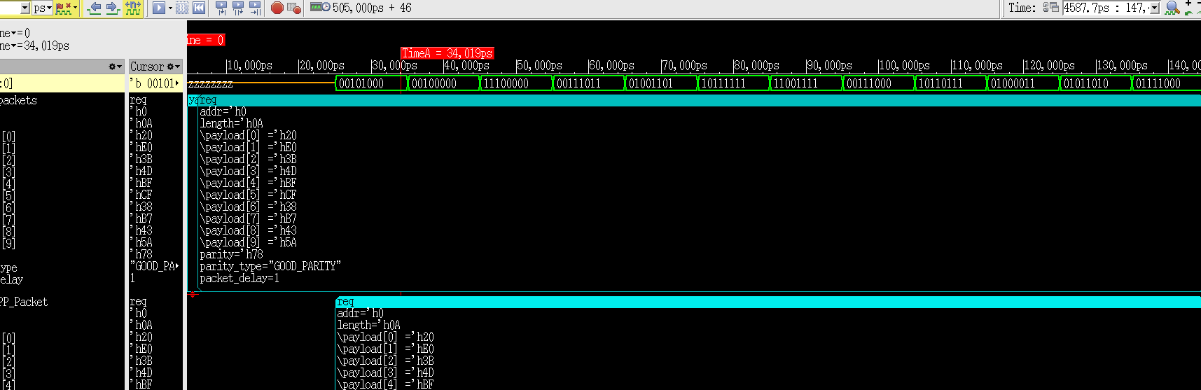
Length = 10,

