Order #SP2381
Dec 20, 2025
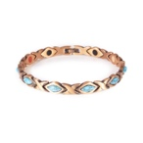
Sierra - Negative Ion Bracelet, Copper and Turquoise
7"
£113.40
Subtotal
£113.40
Order discount
-£75.60
Shipping
£35.00
Tax
£0.00
Total
£148.40

Payment method
Shop Pay
£148.40
•••• •••• •••• 7419

Shipping address
SARAH TURNER
67A, RICHMOND WOOD ROAD
bournemouth
Bournemouth
BH8 9DQ
United Kingdom

Billing address
Same as shipping address

Shipping method
Priority Mail International

Email address
sarah@rebelscientist.com

Store

P

