

**EE 462**

**EXPERIMENT #3**

**Group Member: Abdurrahman Aydın**

**Ayberk Kaan Filik**

**Cem Kavuncu**

**Olgun Erdoğan**

**Raşit Gökmen**

**Yusuf Basri Yılmaz**

**Date:03.06.2018**

# Introduction

# Results

## 1)

|  |  |  |  |  |  |  |  |  |  |  |
| --- | --- | --- | --- | --- | --- | --- | --- | --- | --- | --- |
| **5.3.2 Pump Load Characteristics** | | | | | | | | | | |
| Speed ref (rpm) | T(Nm) | N(rpm) | P1(kW) | Q1(kVAR) | P2(kW) | pf | V(Volts l-l) | f(Hertz) | Vgen | Tgen |
| 75 | 1.3 | 75 | 0.5 | 0.92 | N.A. | N.A. | 43 | 5 | 34.5 | 0.18 |
| 200 | 9.25 | 200 | 0.78 | 1.34 | 0.5 | 0.21 | 95 | 13.3 | 91.6 | 1.19 |
| 300 | 20.62 | 300 | 1.31 | 2.12 | 0.98 | 0.28 | 140 | 19.95 | 137 | 2.64 |
| 400 | 37.03 | 400 | 2.33 | 3.5 | 1.85 | 0.4 | 178 | 26.7 | 183.9 | 4.76 |
| 500 | 58.34 | 500 | 4 | 5.7 | 3.3 | 0.54 | 220 | 33.44 | 233 | 7.56 |
| 600 | 83.32 | 600 | 6.5 | 8.75 | 5.5 | 0.68 | 249 | 40 | 285 | 10.9 |
| 720 | 120 | 720 | 11.15 | 13.7 | 9.5 | 0.73 | 293.3 | 48 | 356 | 16 |
| **5.3.3 Electric Traction Load Characteristics** | | | | | | | | | | |
| Speed ref (rpm) | T(Nm) | N(rpm) | P1(kW) | Q1(kVAR) | P2(kW) | pf | V(Volts l-l) | f(Hertz) | Vgen | Tgen |
| 75 | 51.1 | 75 | 1 | 1.6 | N.A. | N.A. | 45 | 5 | 29 | 6.67 |
| 200 | 58.45 | 200 | 1.95 | 3 | 1.5 | 0.56 | 95 | 13.3 | 88.8 | 7.6 |
| 300 | 66.6 | 300 | 2.95 | 4.3 | 2.4 | 0.61 | 137 | 20 | 136 | 8.7 |
| 400 | 76 | 400 | 4.25 | 5.8 | 3.5 | 0.65 | 175 | 26.7 | 186 | 10 |
| 500 | 88.15 | 500 | 5.9 | 8 | 4.9 | 0.69 | 210 | 33.4 | 237 | 11.6 |
| 600 | 101.45 | 600 | 8 | 10.5 | 6.8 | 0.72 | 243 | 40 | 289 | 13.43 |
| 720 | 120.4 | 720 | 11.2 | 13.7 | 9.5 | 0.73 | 296 | 48 | 356 | 16 |

## 2)

|  |  |  |  |  |
| --- | --- | --- | --- | --- |
| Speed ref (rpm) | Motor Output Power(W) | Motor Efficiency  % | Drive Efficiency | Overall Efficiency |
| 75 | 10.21 | N.A. | 0.5 | 0.92 |
| 200 | 68 | 13.6 | 0.78 | 1.34 |
| 300 | 647 | 66 | 1.31 | 2.12 |
| 400 | 1551 | 86 | 2.33 | 3.5 |
| 500 | 3057 | 92 | 4 | 5.7 |
| 600 | 5235 | 95 | 6.5 | 8.75 |
| 720 | 9047 | 95.2 | 11.15 | 13.7 |

## 3)

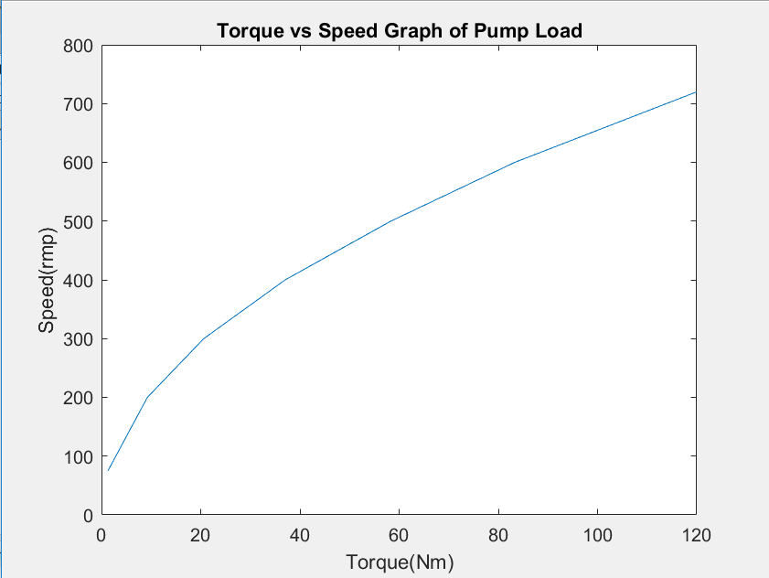

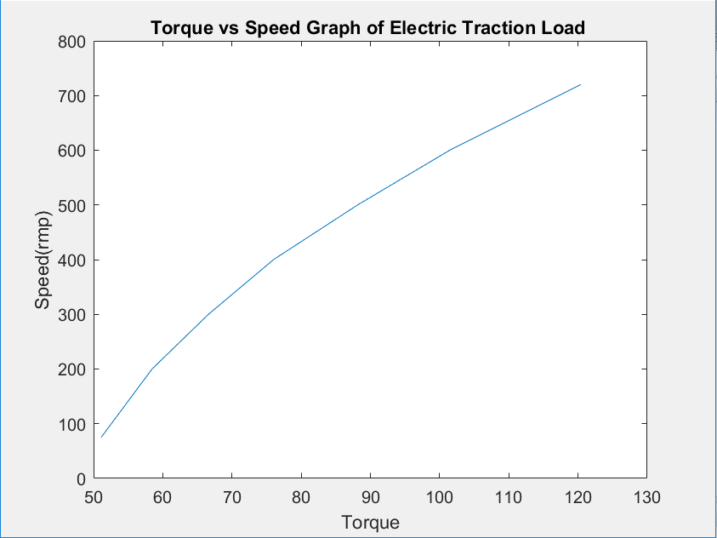

## 4)

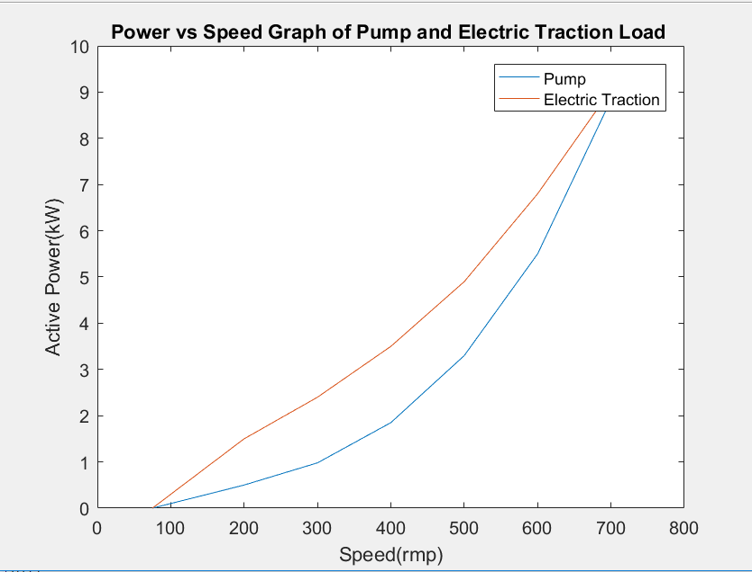

## 6)

## 

# Conclusions