|  |  |
| --- | --- |
| Article | Manuscript ID: 684862 |
| Title: | Surface and Size Effects on the behaviors of point defects in irradiated crystalline solids |

We sincerely thank the referees for their assessment of our manuscript. The report below has the referees’ comments and authors’ response. The changes made in response to these comments are explained.

Thank you,

Abdurrahman Ozturk, Merve Gencturk, Karim Ahmed

**___________________________________________________________________________**

**Reviewer #1:**

(1)- It is said on page 9 that « the instability appears effectively in relatively large grains (> 100 nm) with any nonzero value of production bias (even as low as 0.001%). The initiation of this instability is attributed to the fact that production bias breaks the symmetry of the balance of point defects leading to non-uniform bulk recombination and non-uniform losses to surfaces (effectively transforming neutral sinks to biased), which eventually results in the development of distinct steady-state profiles for the different point defects. »

I think this explanation is too vague and the way this instability develops is still unclear. More efforts should be given to interpret all the profiles of Figures 3. The explanation given suggests the role of bulk recombination, but nothing is said about the parameter used to simulate it.

This instability is non-linear which makes a bit subtle and cannot be explained using linear stability theory. However, we conducted further investigations to study the effect of diffusivity ratio, as suggested by the reviewer (see below). Our explanation is still valid, but there is indeed a threshold ratio below which such instability is absent. We also clearly defined the rate constants for both the recombination term and the defect-sink interactions (see Page 3, Eq. 2 in manuscript).

In fact, a lot of questions remain unanswered: why only interstitials are concerned at steady state and not vacancy?

The reversed pattern experienced by interstitials when the instability is triggered is because interstitials are produced at a lower rate than vacancies and because they are the faster species. If one runs a hypothetical simulation with those conditions reversed, the steady-state spatial profiles of vacancies and interstitials will also be reversed. We added this discussion to manuscript (Page 10).

Only the effects of the dose rate, grain size and production bias are discussed but what is the effect of the ratio Di/Dv?

That is a fair point. We performed several simulations to investigate the effect of this ratio. Since the diffusion coefficients are temperature dependent, the Di/Dv ratio changes with temperature. Table A and Figure A show the exact relationship between this ratio and temperature for pure Ni.

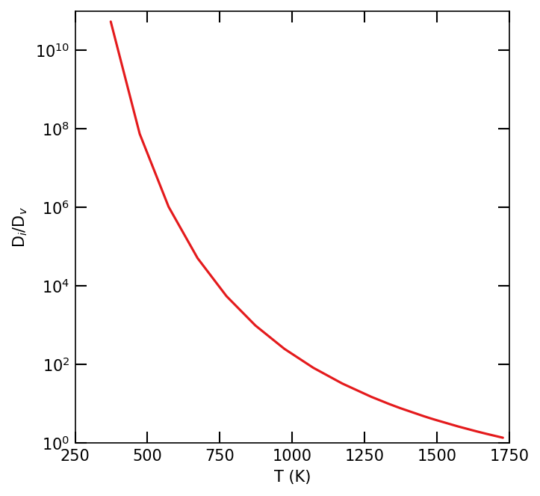

|  |  |  |  |  |
| --- | --- | --- | --- | --- |
| **Table A** | | | | |
| **T (K)** | **Di/Dv** |  | **T(K)** | **Di/Dv** |
| 373 | 5.42E+10 |  | 1073 | 82.97258 |
| 473 | 75367307 |  | 1173 | 32.99902 |
| 573 | 1041390 |  | 1273 | 15.16978 |
| 673 | 51364.69 |  | 1373 | 7.809497 |
| 773 | 5524.862 |  | 1473 | 4.39966 |
| 873 | 988.5845 |  | 1573 | 2.666247 |
| 973 | 252.1606 |  | 1728 | 1.375624 |

Figure A. The change of Di/Dv with temperature

Then to investigate the effect of Di/Dv ratio, several simulations were conducted for different temperatures with a production bias of 5% and a production rate of 1e-3 dpa/s in a 1000 nm grain. The results are presented in Fig. B. As evident form the figure, there is a critical ratio (~33 for Ni) below which the instability is suppressed. In other words, there is a critical temperature only below which the instability develops. This discussion was also added to the manuscript (see page 11 and Fig. 4)

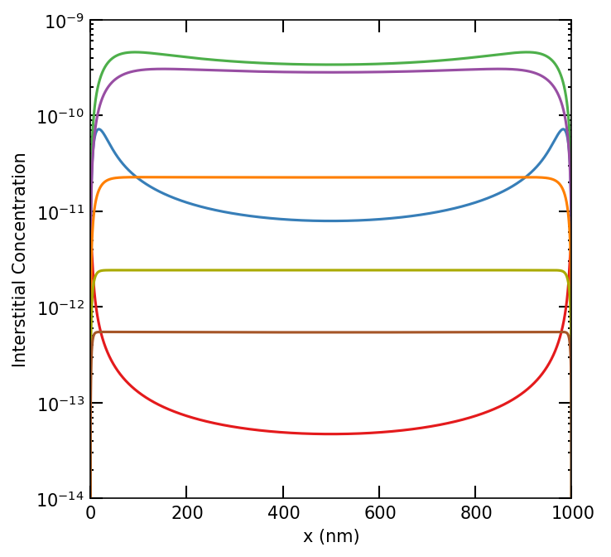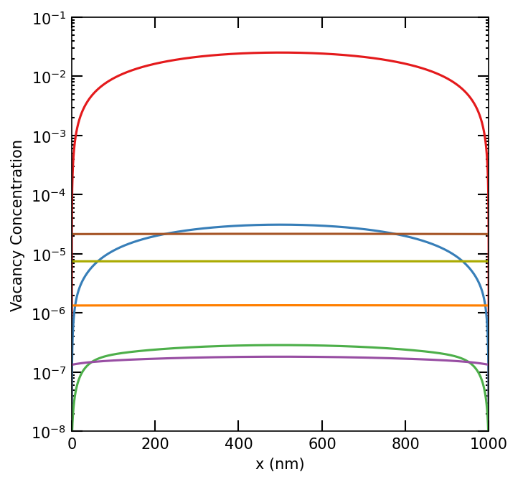

**Figure B**. Effect of temperature/diffusivity ratio on the development of the instability.

Is there also an effect of the geometry (planar vs spherical)?

The equations were solved in both cartesian and spherical geometries. The difference in the steady state concentration profiles is negligible as can be seen in Figure C below. In most simulations, we used planar geometry. We only used spherical geometry in the benchmark problem since the analytical solution is developed for such geometry.

**Figure C**. Effect of Geometry type on concentrations

What is the definition of the quasi-steady state in Figure 3.? It would help to know the time associated to each profile in Figure 3.

By quasi-steady state here we just mean an intermediate state before the instability is triggered. Also, at this point the profiles of the point defect show the expected pattern with a maximum in the domain center and minima at the boundaries. We included the info about the times of quasi-steady state and steady state in the caption of Fig 3 in manuscript (Page 10).

This(1) is my major concern about this work.

(2)- Is there any direct or indirect experimental observation to support the existence of such instability?

It is unfeasible to measure experimentally the densities of single point defects in a direct way. However, our results here can be indirectly validated by the well-known existence of void denuded zones close to grain boundaries. Since the instability in our results show accumulation of interstitials and depletion of vacancies adjacent to GBs, it is expected that void formation will be suppressed under such conditions.

There is also the relatively recent study by P. Mao et al., Quantitative investigation on sink strength of nano-grain boundary for irradiation resistance, Journal of Nuclear Materials 526 (2019) 151741. In that study, the sink strength of nano-GB is quantitatively investigated in the nano-grained Cu and dilute Cu-W alloys with the average grain size ranging from ~20 to ~500 nm by ~300 keV He ions irradiation at room temperature and 673 K. The irradiation induced void volume ratio, size and distribution are confirmed to strongly depend on the grain size and irradiation temperature. It was found that there is a critical size below which the samples are completely radiation resistant and almost no voids form. Moreover, such full radiation tolerance was only achieved at the high temperature but not the low temperature. Those findings are clearly in agreement with our prediction here.

(3)- On Figure 4, the steady-state concentrations of point defects increase with grain size, but this increase saturates above a critical size. Explaining this phenomenon by saying that the surface to volume ratio becomes negligible above this size is not a satisfactory explanation.  
In figure 4, it would be more illustrative to show the profiles for values of the grain size around the critical size to show the transition.

Note that this Figure was only included to demonstrate that the instability is triggered by production bias, though zero bias is unrealistic. In the absence of production bias, instability is absent and size effect saturates. The latter is indeed because of the vanishing surface to volume ratio. Recall that the predictions of the classical homogenous rate theory are size independent. This is because it is implied that the system is large enough (and hence the densities of internal or external surface defects are low) to safely ignore gradients. In this case, the balance of defects is mainly dominated by production and losses to bulk sinks. Both scale with size linearly, leaving the average of surviving defects unchanged. Hence, our results here agree with the expected outcome that homogeneous rate theory can give reasonable prediction in large systems, but cannot be trusted in nano systems, where losses to surface defects cannot be ignored in comparison to losses to bulk defects.

As evident from our detailed study, the critical size is dependent on temperature, dose rate, and bias. These dependencies cannot be summarized in one figure, instead we thoroughly investigated them and presented those investigations in Figs. 4-12.

**Change**: Since this figure does not introduce a new contribution, we decided to eliminate it in favor of a figure that show the effect of temperature (D_i/D_v ratio) on the development of instability.

(4)- For all the simulations, nothing is said about the values of the parameters used to simulate the bulk recombination and the bulk sink strength.

We regret omitting these details from our manuscript. Input parameters and expressions were included in the revised version. (Page 4-6)

(5)- Specify more systematically the geometry used for the simulations, for example, this information is not given for the Ni-Cr part.

In most simulations, we used planar geometry. We only used spherical geometry in the benchmark problem since the analytical solution is developed for such geometry.

**Changes:** The geometry and coordinate system information were given in 2.3 Model Parameter and Numerical Implementation section. An informative sentence added to RIS section. “The geometry is represented in Cartesian coordinates in MOOSE model.”

(6)- Equations 6 are not clear: why the parameter tau is missing? The expressions of D tilde and delta tilde should be given.

This was a typo and was fixed. The expressions for all non-dimensionalized parameters were added. (Page 5-6)

Equations with the sink strength (3) should also be given in their nondimensionalized form.

**Changes:** The non-dimensionalized form of Eq.3 was added (Page 6)

(7)- Top of page 6: do a table with all the values instead of specifying them in the text.

All values were originally given in a table format. However, unfortunately tables are treated as figures and count against the total allowed number of figures. Hence, we decided to eliminate tables in favors of figures.

Not to exceed that limit, tables was converted into text.

What is the value of the ratio Di/Dv in this case?

Diffusion coefficients are assumed constant during our simulations, so the ratio Di/Dv is a constant value of around 1e4 for T=773K. To make it clear for reader, the ratio can be added at the end of section for that specific temperature. We also fully investigated the effect of this ratio as discussed before.

Same remark at the end of p 21: do a table for the parameters concerning the Ni-Cr system

Again, unfortunately tables are treated as figures and count against the total allowed number of figures. Hence, we decided to eliminate tables in favors of figures.

Moreover, here is a list of small mistakes to be corrected:  
Missing parenthesis at page 2: Was (2017)   
Missing dot at the end of page 3  
« It is also important » p4 (is missing)  
Missing dot at the end of the caption of Figure1.   
Caption of Figure 10: « while it decreases with bias for vacancies »  
In Figure 9, I think there is an inconsistency in the notations: the legend k^2_i and k^2_v refers to the grain boundary total sink strength, not to the bulk sink strength.   
In the conclusion, « steady-state concatenations » ?

Typos were corrected. **We thank the reviewer for the careful reading of the manuscript.**

Subscript (gb) was added to GB parameters appearing in both the legend and caption of Figures 9-12 captions.

**Reviewer #3:**

(1)- The authors assume that the sinks are uniformly distributed along the depth. This is usually not supported by experimental results. Very often some depletion zones are observed near the surfaces or grain boundaries. This heterogeneous distribution of sinks leads to a modification of the concentration profiles, so some of the conclusions of this work may not be valid in all cases. This should be more discussed.

That is a good point. However, we are here looking into the short-term irradiation (up to ~100 sec and <0.1 dpa) when the steady-state concentrations of point defects are first established. It usually takes longer times before the heterogeneous distribution of extended defects is realized. Moreover, we believe that it is the patterns and instabilities developed first in the point defects that might trigger the non-uniform distribution of the extended defects. For instance, the void denuded zone commonly observed near GBs agree with the accumulation of interstitials and depletion of vacancies that we see in our results.

We discussed the connection between our model predictions and some experimental observations in Section 3.1 (Page 11-12) .

Nonetheless, considering the co-evolution of point and extended defects is important and will be the focus of our future work. We added a paragraph in the conclusion section on the limitations of the current model and how to improve it.

(2)- The production bias model described here is rather simple. To describe production bias quantitatively, it would be necessary to include clusters in the model. In particular, the second component of the production bias model (high mobility of some self-interstitial clusters) is not included in the current model. Cluster dynamics simulations would certainly lead to somewhat different results. The authors oppose their 'high-fidelity simulations' to the previous 'lower-fidelity simulations', but they should also clearly mention in the conclusions the limitations of their model.

We agree with the reviewer that the production bias model is a simplification and to get an exact value for the bias, a comprehensive multiscale approach must be implemented. Not just cluster dynamics model is necessary to represent clustering, but lower scale models are required to estimate the binding and dissociation energies and mobilities of those clusters. However, such a complete model is beyond the reach of a single study. Here, we rather treated the bias factor as unknown and conducted a parametric study of its effect.

Nonetheless, the simplicity of the bias model was mentioned as a limitation of the current model in the conclusion section.

(3)- The sink strength of a grain boundary is determined with respect to the concentration in the middle of the domain (C_0). There is another convention in the literature, which uses the average concentration instead. Given the highly heterogeneous defect profiles (in particular self-interstitial atom profiles), changing the convention would probably affect the grain boundary sink strengths. A discussion on the implications of this choice would be useful to the reader.

That is a good point. We did in fact examine that, but we did not report it in the manuscript. As shown in Fig. D below, there are only relatively small quantitative differences between the average and center concentrations. But the qualitative trends as function of size are the same. Therefore, the qualitative trends for sink strengths are also unchanged.

**Figure D**. Average vs Center Concentration

(4)- Figures are not always very clear, it would be good to indicate conditions on the graphs (flux, type of defects), put the labels on the same side of the graphs (see Fig. 12).

Figures would be very crowded if we add all relevant info on the graphs. We include those in the caption and text instead.

For Fig. 12, some of the 3D subplots are rotated differently to make the entire plot clearer.

(5)- In section 2.1, the authors mention "the preferential absorption of dislocations to interstitials". Probably they want to say, "the preferential absorption of interstitials to dislocations."

**That is correct. We changed it to read “**the preferential absorption of interstitials by dislocations” (Page 4)

(6)-  I don't really understand the "other form" of Eq. 1 written in Eqs. 2 and 3. To me this is just the same equation but changing K_is into k_i^2 and K_vc into k_v^2, so a change in notations.

Eqs.2 and Eqs. 3 are basically same equation, but in different formats. Eqs. 3 was added to help reader to understand sink strength calculations. Also, some classical references on radiation effects use one or the other and we wanted researchers who are more familiar with one version to be able to follow along.

(7)- Could the authors explain how the length "l" in Eq. 4 is chosen?

We just used a length scale, l, that is much smaller than the lowest grain size in our simulations. Since our smallest grain size was 5nm, we used a length scale of 0.1 nm in all simulations. We added this info to the model parameters section. (Page 6)

(8)- In Eq. 5, the time derivatives should probably be with respect to "tau", not "t"

**That is correct. We fixed the typo. We thank the reviewer for the careful reading of the manuscript.**

(9)- It is not always clear if a "planar" or a "spherical" grain is chosen, please mention it explicitly when required.

The equations were solved in both cartesian and spherical geometries. The difference in the steady state concentration profiles is negligible as can be seen in Figure 3 below. In most simulations, we used planar geometry. We only used spherical geometry in the benchmark problem since the analytical solution is developed for such geometry.

The geometry and coordinate system information were given in 2.3 Model Parameter and Numerical Implementation section.

**Changes :** “Equations were first solved for a test case in both Cartesian and spherical coordinates to represent planar and spherical geometries, respectively. The difference in results was not significant, so Cartesian coordinate system was used in simulations unless otherwise stated.” (Page 6)

(10)- Writing the expressions of the fluxes for the NiCr part would be useful (Eq. 17), to better understand the interdependence of vacancy, self-interstitial and Cr concentrations.

**Changes :** New equations were added for fluxes,Ji, Jv, and related. (Eq.22-25 , Page 22-23)

(11)- There are some typos in the text, for example: "deceases" instead of "decreases" in caption of Fig. 10, "concatenations" instead of "concentrations" in the conclusion, among others.

Typos were corrected. **We thank the reviewer for the careful reading of the manuscript.**