Table Of Contents

Table Of

Table Of Contents 1

1. INTRODUCTION 5

2. PURPOSE 5

3. DOCUMENT CONVENTIONS 5

3.1) Requirement IDs: 6

3.2) Priority Levels 6

3.3) Formatting 6

3.4) Standards 6

4. INTENDED AUDIENCE AND READING SUGGESTIONS 6

4.1) Developers 6

4.2) Project Managers 6

4.3) Testers 6

4.4) Stakeholders 6

5. SUGGESTED READING SEQUENCE 7

5.1) Introduction and Purpose 7

5.2) Product Scope and Overall Description 7

5.3) System Features 7

5.4) Appendices 7

6. PRODUCT SCOPE 7

6.1) Domain: Education Technology 7

• Study Partner Matching 7

• AI Tutor Support 7

• Gamified Progress Tracking 7

6.2) Goals and Objectives 7

6.3) Key Features (as per the documentation) 8

7. REFERENCES 8

7.1) Phase 1 Documentation 8

7.2) Phase 2 Documentation 8

8. OVERALL DESCRIPTION 9

8.1) PRODUCT PERSPECTIVE 9

8.1.1) User Management 9

8.1.2) AI Integration 9

8.1.3) Session Management 9

8.1.4) Gamification Module 9

8.2) PRODUCT FUNCTIONS 9

8.2.1) User Registration and Authentication 9

8.2.2) Profile Management 9

8.2.3) Study Partner Matching 9

8.2.4) AI Tutor Integration 9

8.2.5) Gamified Progress Tracking 9

8.2.6) Search and Filter Sessions 9

8.2.7) Notifications and Alerts 10

8.2.8) Leaderboard and Social Features 10

9. OPERATING ENVIRONMENT 10

9.1) Hardware Requirements 10

9.2) Software Requirements 10

9.3) Connectivity 10

9.4) Third-Party Services 10

10. DESIGN AND IMPLEMENTATION CONSTRAINTS 11

10.1) Regulatory Constraints 11

10.2) Hardware Limitations 11

10.3) Third-Party Dependencies 11

10.4) Technology Stack 11

10.5) Security Requirements 11

10.6) Resource Availability 11

11. USER DOCUMENTATION 12

11.1) User Manuals 12

11.2) Interactive Tutorials 12

11.3) Online Help Center 12

11.4) Language Support 12

12. ASSUMPTIONS AND DEPENDENCIES 12

12.1) Assumptions 12

12.2) Dependencies 13

• AI Tutoring System 13

• Data Hosting Services 13

• Regulations 13

13. EXTERNAL INTERFACE REQUIREMENTS 13

13.1) USER INTERFACES 13

13.1.1) Design Principles 13

13.1.2) Interface Features 13

13.2) HARDWARE INTERFACES 13

13.3) SOFTWARE INTERFACES 14

13.4) COMMUNICATION INTERFACES 14

14. SYSTEM FEATURES 14

14.1) System Feature 1: Study Partner Matching 14

14.1.1) Description and Priority 14

14.1.2) Functional Requirements 15

14.2) OTHER NON-FUNCTIONAL REQUIREMENTS 15

14.2.1) PERFORMANCE REQUIREMENTS 15

14.2.2) SAFETY REQUIREMENTS 15

14.2.3) SECURITY REQUIREMENTS 16

14.2.4) SOFTWARE QUALITY ATTRIBUTES 16

14.2.5) BUSINESS RULES 17

15. DIAGRAMS 17

15.1) Goal Modelling using GRL 17

15.2) Use Case Diagram 18

15.3) Erd diagram 19

15.4) Class Diagram 20

15.5) State Diagram 20

• Exploring study buddy app 21

• Requesting AI Tutor Assistance 22

15.6) Sequence diagram of 3 important scenarios 23

• Requesting AI Tutor Assistance 23

• Matchmaking with other users 24

• Tracking study progress 25

15.7) DFD Zero level + Level 25

level 0 26

Level 1 26

APPENDICES 27

Appendix A: Glossary 27

Appendix B: Analysis Models 27

Appendix C: To Be Determined (TBD) List 28

# INTRODUCTION

The **Study Buddy App** is a modern education-focused mobile platform designed to connect students for interactive and collaborative learning. The app supports peer-to-peer study sessions and incorporates an AI-powered tutor for personalized assistance. This document outlines the software requirements for the app, detailing its core functionalities, system constraints, and development priorities. By addressing challenges like a lack of self-discipline, understanding complex topics, and finding compatible study partners, the Study Buddy App aims to improve students' learning experiences through a mix of human collaboration and AI assistance.

# PURPOSE

The purpose of this Software Requirements Specification (SRS) is to document the requirements for the development and operation of the Study Buddy App (Version 1.0). The scope of this document includes:

* Defining the app's functional and non-functional requirements.
* Prioritizing core features to ensure effective development planning.
* Providing a structured reference for developers, testers, and stakeholders.
* The app's scope in this release includes critical functions such as user matching, AI tutor integration, and gamified progress tracking. The SRS excludes advanced features and functionalities planned for future iterations.

# DOCUMENT CONVENTIONS

The following conventions have been adopted to maintain clarity and consistency throughout the document:

* 1. Requirement IDs: Each requirement is labeled (e.g., REQ-1, REQ-2) for traceability.
  2. Priority Levels: Requirements are classified as High, Medium, or Low based on their impact and importance.
  3. Formatting:
* Key terms are in **bold**.
* Important system features are presented in tables or as bullet points.
* Visuals such as diagrams (e.g., use-case, ER diagrams) are used where necessary to provide clarity.
  1. Standards: The SRS follows IEEE 830 standards for clarity and comprehensiveness, ensuring that every requirement is testable and verifiable.

# INTENDED AUDIENCE AND READING SUGGESTIONS

This SRS is intended for a broad audience, including:

1. Developers: To understand and implement the functional and non-functional requirements.
2. Project Managers: To oversee timelines, prioritize development phases, and ensure milestones are met.
3. Testers: To create test plans, validate functionalities, and ensure the app operates as intended.
4. Stakeholders: To assess the alignment of features with business goals and user needs.

# SUGGESTED READING SEQUENCE

1. Introduction and Purpose: Provides an overview of the app’s goals and scope.
2. Product Scope and Overall Description: Offers insights into the app's features and its integration with the broader system.
3. System Features: Details the app's functional and non-functional requirements.
4. Appendices: Includes supporting diagrams, use-case scenarios, and references.

# PRODUCT SCOPE

1. Domain: Education Technology **(EdTech)**

The Study Buddy App enables students to overcome learning challenges by offering:

* Study Partner Matching: Facilitates collaboration with peers based on shared interests and availability.
* AI Tutor Support: Provides instant, topic-specific help when no partners are available.
* Gamified Progress Tracking: Encourages consistent learning through badges, leaderboards, and goal setting.

## Goals and Objectives

* Establish a global learning community.
* Combine human collaboration with AI tutoring to enhance engagement and learning outcomes.
* Deliver measurable improvements in user motivation and academic performance.

## Key Features (as per the documentation)

* Real-time and scheduled study sessions.
* AI-driven tutoring for instant support.
* Study session search and filtering capabilities.
* Gamification elements like leaderboards and badges.
* This scope aligns with the project’s goal to reach 50,000 users within six months, with an 80% retention rate​​.

# REFERENCES

The following documents and resources are referenced in this SRS:

1. Phase 1 Documentation:
   * Problem statement and business requirements.
   * Vision of the solution, scope, and use-case examples.
   * Key features and workflows​.
2. Phase 2 Documentation:
   * Functional requirements and prioritization techniques.
   * Comparative analyses and prioritization outcomes (Wiegers, Volere, AHP).
   * Recommendations for iterative development and resource allocation.

* External references include educational data privacy laws, UI style guides, and technical standards relevant to EdTech development.

# OVERALL DESCRIPTION

## PRODUCT PERSPECTIVE

1. User Management: Supports registration, authentication, and profile customization.
2. AI Integration: Connects with an external AI engine to provide topic-specific guidance.
3. Session Management: Enables users to create, join, or search for study sessions.
4. Gamification Module: Tracks user progress and achievements through badges and leaderboards.

## PRODUCT FUNCTIONS

The Study Buddy App provides the following high-level functionalities:

1. User Registration and Authentication: Secure account creation and login.
2. Profile Management: Edit preferences and choose study topics.
3. Study Partner Matching: Find partners based on compatibility.
4. AI Tutor Integration: On-demand assistance from an AI tutor.
5. Gamified Progress Tracking: Track goals, study hours, and achievements.
6. Search and Filter Sessions: Find study sessions by topic, time, or popularity.
7. Notifications and Alerts: Inform users of updates, reminders, and achievements.
8. Leaderboard and Social Features: Foster healthy competition among users​​.

# OPERATING ENVIRONMENT

The Study Buddy App is designed to function in a modern, connected environment. The key operating conditions include:

1. Hardware Requirements**:**

* **Mobile Devices**: Smartphones or tablets with at least 2 GB RAM, 16 GB storage, and a 64-bit processor.
* **Desktops**: Systems with at least 4 GB RAM, dual-core processors, and a stable internet connection.

1. Software Requirements**:**

* **Mobile Operating Systems**: Android 8.0+ and iOS 12+.
* **Desktop Operating Systems**: Windows 10+ or macOS 10.15+.
* **Browser Compatibility**: Chrome, Safari, Firefox, and Edge (latest versions).

1. Connectivity**:**

* **Network**: Requires a stable internet connection (minimum 3 Mbps for video-based AI interactions).

1. Third-Party Services**:**

* AI services (e.g., NLP models for tutoring), email servers for notifications, and cloud-based data storage for scalability.

# DESIGN AND IMPLEMENTATION CONSTRAINTS

The following constraints define the boundaries within which the Study Buddy App must be developed:

1. Regulatory Constraints:

* Adherence to GDPR and COPPA to ensure user data privacy and compliance with educational standards.

1. Hardware Limitations:
   * Must optimize performance for older smartphones with limited processing power.
   * Efficient memory usage to prevent app crashes during intensive AI tutoring sessions.
2. Third-Party Dependencies:
   * Reliance on external AI engines and cloud storage solutions.
   * Possible licensing or subscription costs for integrating APIs.
3. Technology Stack:
   * Frontend: React Native for cross-platform mobile development.
   * Backend: Node.js with Express.js for server-side logic.
   * Database: MongoDB for scalable user data storage.
4. Security Requirements:
   * Implement end-to-end encryption for communication between users.
   * Multi-factor authentication for secure login processes.
5. Resource Availability:
   * Limited initial budget constraining development timelines and feature expansion.

# USER DOCUMENTATION

To support users, the following documentation will be provided:

1. User Manuals:
   * Detailed guides on creating accounts, joining sessions, and using the AI tutor.
   * Downloadable PDFs accessible within the app.
2. Interactive Tutorials:
   * Onboarding walkthroughs for new users.
   * Tooltips within the app to explain features.
3. Online Help Center:
   * FAQs, troubleshooting guides, and video tutorials hosted on the app’s website.
4. Language Support:
   * Manuals and tutorials will initially be available in English, with plans to expand to additional languages based on user demographics.

# ASSUMPTIONS AND DEPENDENCIES

1. Assumptions**:**

* Users will have consistent internet access for seamless operation.
* Students will be motivated to engage actively with study partners or AI tutors.
* Third-party AI services will remain accessible and functional throughout the app's lifecycle.

1. Dependencies**:**

* AI Tutoring System: The app depends on external NLP-powered AI services for providing intelligent, topic-specific assistance.
* Data Hosting Services: Relies on secure and scalable cloud providers (e.g., AWS or Azure) for data storage and processing.
* Regulations: Adherence to educational data privacy laws like FERPA, which impacts design decisions around data storage and sharing.

# EXTERNAL INTERFACE REQUIREMENTS

1. USER INTERFACES**:**
2. Design Principles:
   * Simple and intuitive navigation with responsive UI components.
   * Consistent color schemes and iconography for seamless usability.
3. Interface Features:
   * Home screen: Quick access to upcoming sessions, notifications, and progress stats.
   * AI Tutor Interface: Interactive chat window with real-time feedback.
   * Session Filters: Drop-down menus for selecting topics, times, and study preferences.
4. HARDWARE INTERFACES**:**

* Compatibility with devices supporting touch input, camera access for virtual sessions, and notifications.

1. SOFTWARE INTERFACES**:**

* Integration with external AI APIs (e.g., GPT-based models) for real-time tutoring.
* Connection with email servers for notifications and alerts.
* Database integration for secure and efficient data storage.

1. COMMUNICATION INTERFACES**:**

* Protocols: HTTPS for secure data transmission.
* Standards: Support for email protocols (SMTP) and REST APIs for backend communication.
* Encryption: Data exchange secured with AES-256 encryption to prevent unauthorized access.

# SYSTEM FEATURES

Each system feature is organized by its priority and functionality. Below is an example for one feature. Similar details apply to others, as specified in the SRS.

1. System Feature 1: Study Partner Matching**:**

* Description and Priority:  
  This feature matches users with compatible study partners based on shared topics, learning preferences, and availability.

**Priority**: High.

**Stimulus/Response Sequences**:

**User Action**: Selects a topic and availability.

**System Response**: Displays potential matches ranked by compatibility score.

* Functional Requirements:

**REQ-1**: System shall display up to five compatible study partners per search.

**REQ-2**: Matching algorithm shall consider user availability, topics, and preferences.

1. OTHER NON-FUNCTIONAL REQUIREMENTS**:**

### PERFORMANCE REQUIREMENTS

* The system must support up to **10,000 concurrent users**, ensuring a response time of less than **2 seconds** for key operations like session searches and user registration.
* The AI tutor must provide responses within **3 seconds** under normal server load conditions.
* Notification delivery time for reminders and alerts should not exceed **5 seconds** after the triggering event.

### SAFETY REQUIREMENTS

* The app must employ **content moderation algorithms** to prevent the sharing of inappropriate or harmful materials during study sessions.
* Users must be protected against accidental data loss by implementing **automated backup systems**, with backups occurring every **24 hours**.
* The system must provide a detailed **error-handling mechanism** to guide users through recovery steps in case of failures.

### SECURITY REQUIREMENTS

* All sensitive data, including user credentials and study session details, must be encrypted **in transit (using HTTPS/TLS)** and **at rest (using AES-256)**.
* Implement **multi-factor authentication (MFA)** to enhance user account security.
* Regular security audits must be conducted **quarterly** to identify and mitigate vulnerabilities.
* Compliance with data protection regulations such as **GDPR** and **COPPA** is mandatory.

### SOFTWARE QUALITY ATTRIBUTES

* **Usability**: The app must have an intuitive interface that requires no more than **5 minutes** for a first-time user to understand the core features.
* **Reliability**: The system must achieve **99.5% uptime**, ensuring minimal service disruption.
* **Scalability**: The architecture must support scaling up to **50,000 active users** within a year without major reengineering.
* **Maintainability**: New features or bug fixes should require no more than **5 developer-days** for implementation on average.
* **Interoperability**: The system must integrate seamlessly with third-party APIs, including AI services and cloud storage platforms.
* **Portability**: The app must operate consistently across Android, iOS, and modern web browsers.

### BUSINESS RULES

* Only registered and verified users can initiate or join study sessions.
* AI tutor responses are prioritized for queries flagged as **urgent**.
* Study partner ratings affect future match prioritization, ensuring high-quality matches over time.

1. DIAGRAMS**:**
2. Goal Modelling using GRL**:**

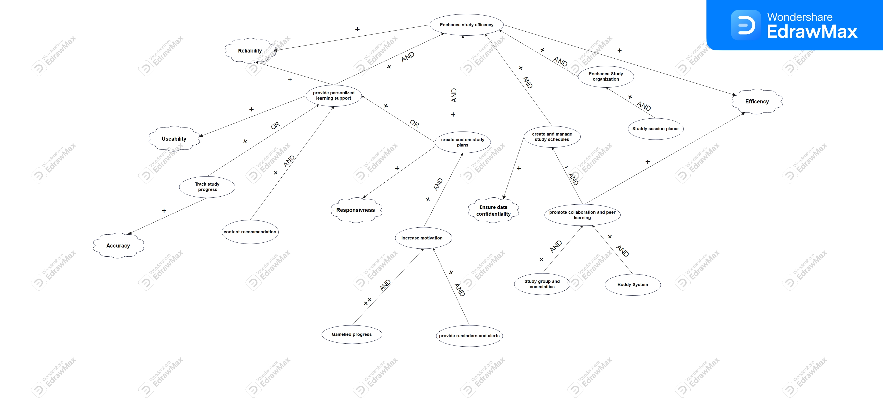

**FIGURE 1.**

1. Use Case Diagram**:**

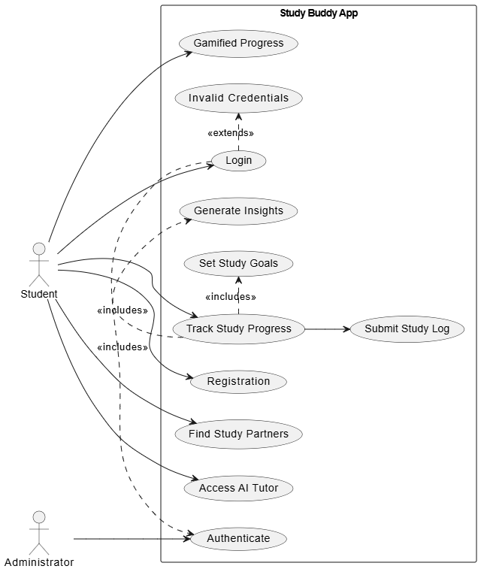

**FIGURE 2.**

1. Erd diagram**:**

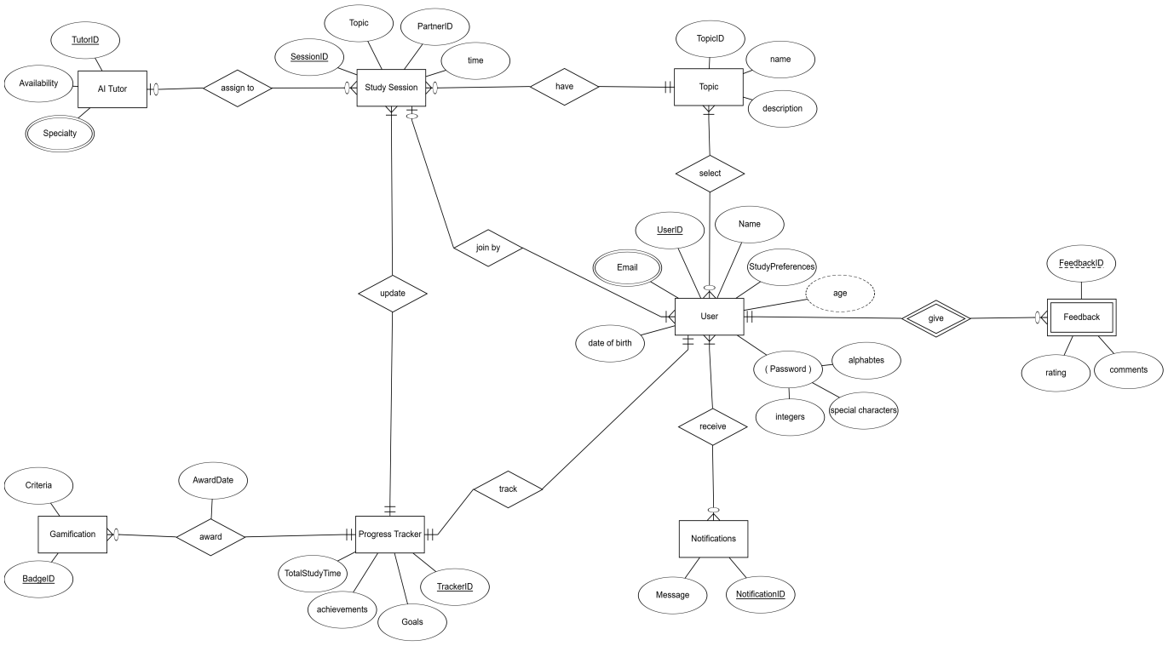

**FIGURE 3.**

## Class Diagram

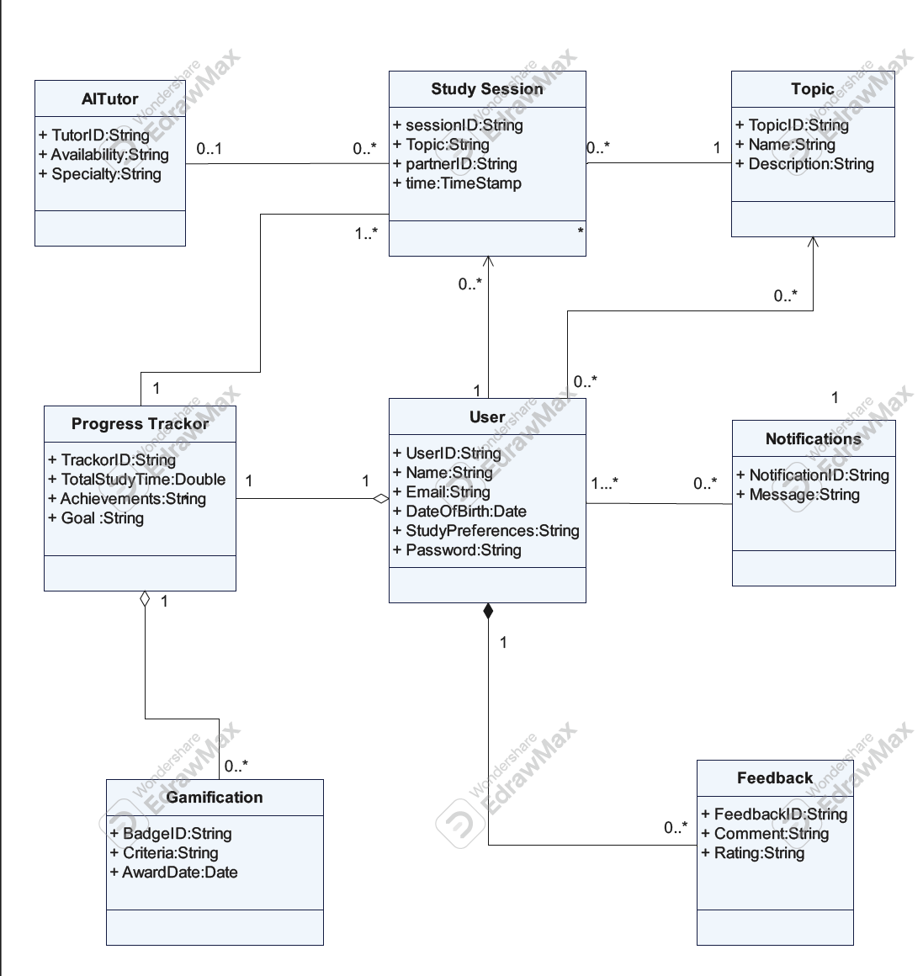

**FIGURE 4.**

## State Diagram

* Exploring study buddy app**:**

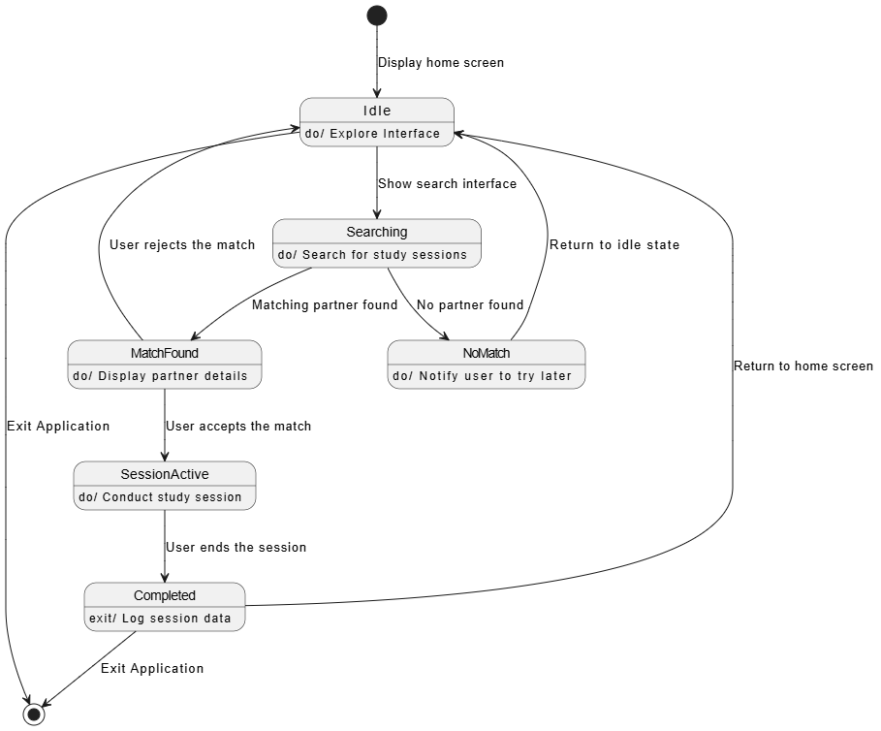

**FIGURE 5.**

* Requesting AI Tutor Assistance**:**

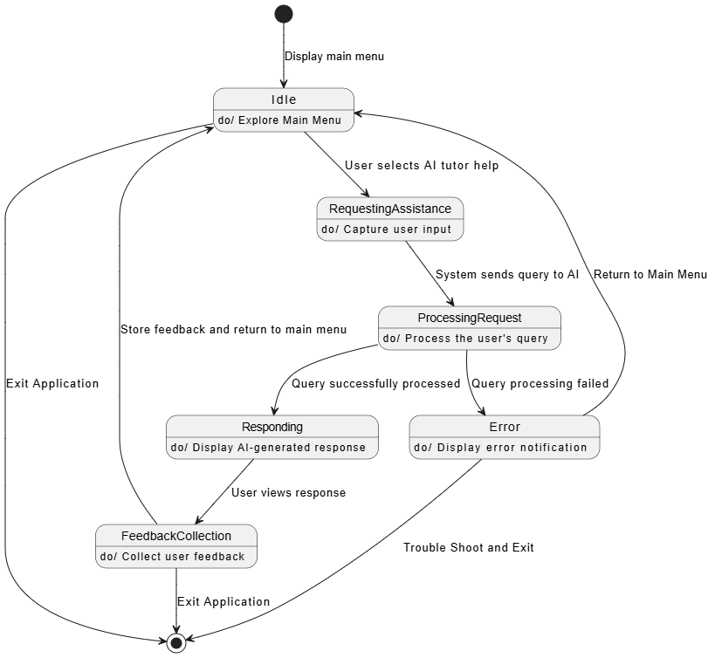

**FIGURE 6.**

## Sequence diagram of 3 important scenarios

* Requesting AI Tutor Assistance**:**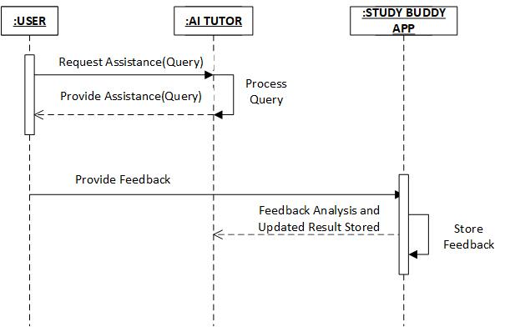

**FIGURE 7.**

* Matchmaking with other users**:**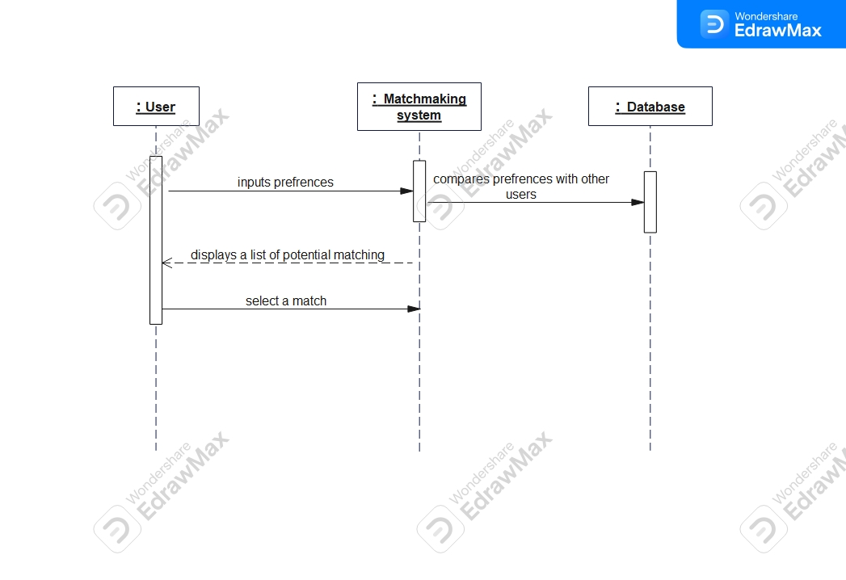

**FIGURE 8.**

* Tracking study progress**:**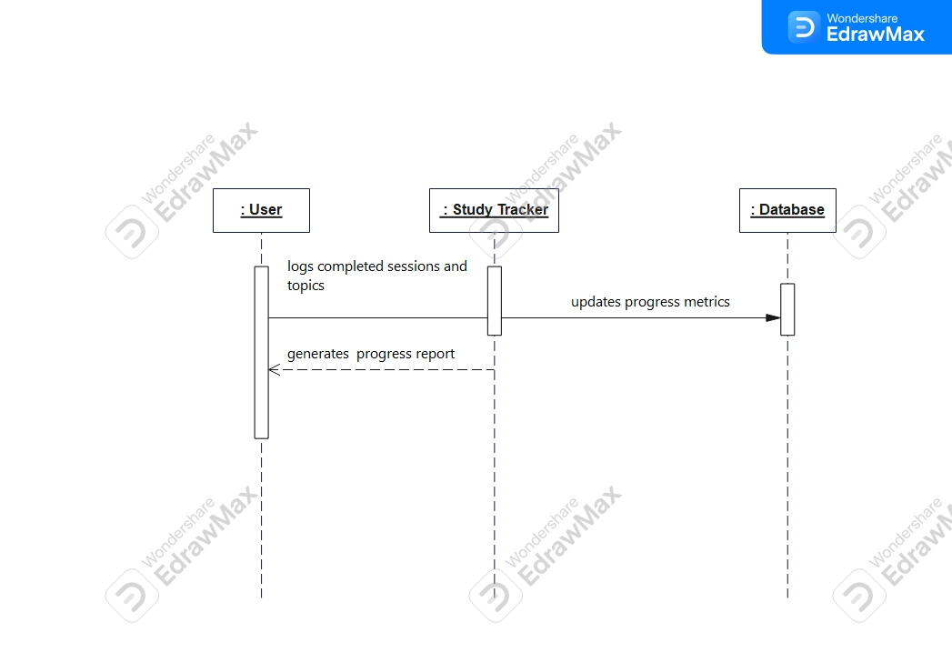

**FIGURE 9.**

## DFD Zero level + Level

level 0**:**

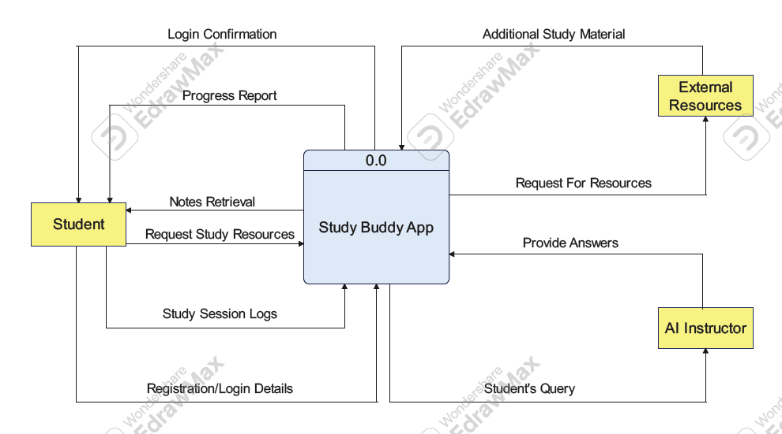

**FIGURE 10.**

Level 1**:**

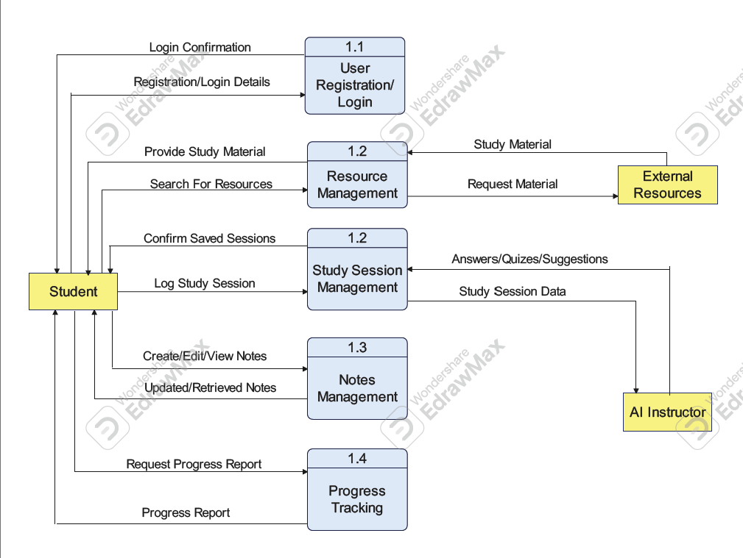

**FIGURE 11.**

# APPENDICES

## Appendix A: Glossary

* **AI Tutor**: A virtual assistant powered by artificial intelligence that provides instant topic-specific guidance.
* **Session**: A collaborative meeting between users for studying purposes.
* **Gamification**: The use of game-like elements such as badges and leaderboards to motivate users.
* **User Verification**: The process of confirming a user’s identity, typically through email or phone number verification.

## Appendix B: Analysis Models

The following diagrams are provided to support the requirements specification:

* **Goal Modeling using GRL**:

Captures the primary goals of the Study Buddy app, such as improving learning engagement and collaboration.

* **Use Case Diagram**:

Illustrates interactions between users and system features (e.g., user registration, AI tutor).

* **Entity-Relationship (ER) Diagram**:

Represents the data structure, including relationships between users, study sessions, and progress tracking.

* **Class Diagram**:

Details the app’s object-oriented design, including key classes such as User, Session, and AI_Tutor.

* **Sequence Diagrams**:

Depicts interactions for three scenarios: user registration, study partner matching, and AI tutor assistance.

* **State Diagrams**:

Represents states for two components: User (e.g., registered, active, inactive) and Session (e.g., created, ongoing, completed).

* **Data Flow Diagram (DFD)**:

Includes Level 0 and Level 1 diagrams showcasing the flow of data through the system.

* **User Interfaces (UIs)**:

Screenshots or mockups of three main interfaces (excluding login/logout): home screen, session management, and progress tracking.

## Appendix C: To Be Determined (TBD) List

* Integration of additional language support for non-English speakers.
* Detailed AI training requirements for specialized subjects.
* Implementation timeline for gamification expansions, including new badges and leaderboard categories.
* Vendor selection for AI and cloud services.