AbdurRehman

212201002

**do_while_loop**

**do_while_1**

#include <iostream>

using namespace std;

int main()

{

int num1, num2, max;

cout << "Enter 1st number ::";

cin >> num1;

cout << "Enter 2nd number ::";

cin >> num2;

max = (num1 > num2) ? num1 : num2;

do

{

if (max % num1 == 0 && max % num2 == 0)

{

cout << "LCM :: " << max << endl;

break;

}

else

{

max++;

}

} while (true);

system("pause");

return 0;

}

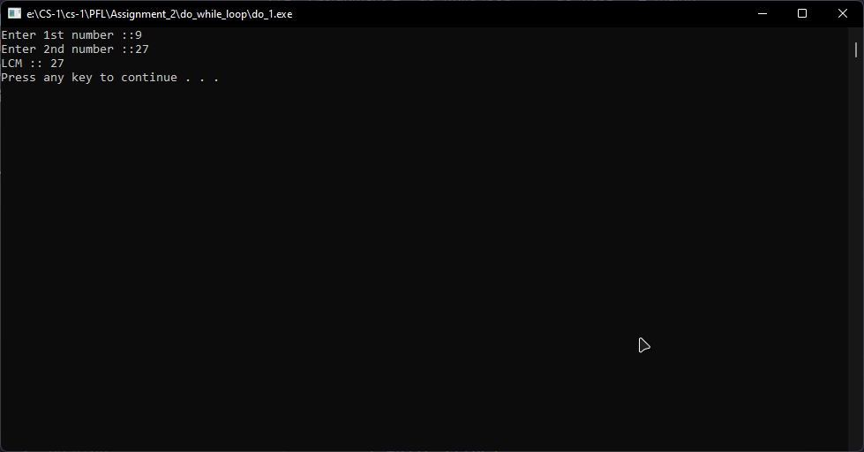

**do_while_2**

#include <iostream>

using namespace std;

int main()

{

int num1, num2, opt = 0;

char op;

do

{

system("CLS");

cout << "1-->Addition" << endl;

cout << "2-->Subtraction" << endl;

cout << "3-->Multiplication" << endl;

cout << "4-->Division" << endl;

cout << "5-->Remainder" << endl;

cout << "Enter Option :: ";

cin >> opt;

cout << "Enter 1st Number :: ";

cin >> num1;

cout << "Enter 2nd Number :: ";

cin >> num2;

switch (opt)

{

case 1:

cout << "Sum [a+b] = " << num1 + num2 << endl;

break;

case 2:

cout << "Difference [a-b] = " << num1 - num2 << endl;

cout << "Difference [b-a] = " << num2 - num1 << endl;

break;

case 3:

cout << "Product [a*b] = " << num1 * num2 << endl;

break;

case 4:

if (num1 == 0 && num2 == 0)

{

cout << "Result [a/b] = UNDEFINED" << endl;

cout << "Result [b/a] = UNDEFINED" << endl;

}

else if (num1 == 0 && num2 != 0)

{

cout << "Result [a/b] = " << num1 / num2 << endl;

cout << "Result [b/a] = UNDEFINED" << endl;

}

else if (num2 == 0 && num1 != 0)

{

cout << "Result [a/b] = UNDEFINED" << endl;

cout << "Result [b/a] = " << num2 / num1 << endl;

}else{

cout << "Result [a/b] = " << num1 / num2 << endl;

cout << "Result [b/a] = " << num2 / num1 << endl;

}

break;

case 5:

if (num1 == 0 && num2 == 0)

{

cout << "Remainder [a%b] = UNDEFINED" << endl;

cout << "Remainder [b%a] = UNDEFINED" << endl;

}

else if (num1 == 0 && num2 != 0)

{

cout << "Remainder [a/b] = " << num1 % num2 << endl;

cout << "Remainder [b/a] = UNDEFINED" << endl;

}

else if (num2 == 0 && num1 != 0)

{

cout << "Remainder [a/b] = UNDEFINED" << endl;

cout << "Remainder [b/a] = " << num2 % num1 << endl;

} else{

cout << "Remainder [a/b] = " << num1 / num2 << endl;

cout << "Remainder [b/a] = " << num2 / num1 << endl;

}

break;

default:

cout << "Option does not exist!!!!" << endl;

break;

}

cout << endl<< "Do you wish to continue.....? [Y|y] : ";

cin >> op;

} while (op == 'Y' || op == 'y');

system("pause");

return 0;

}

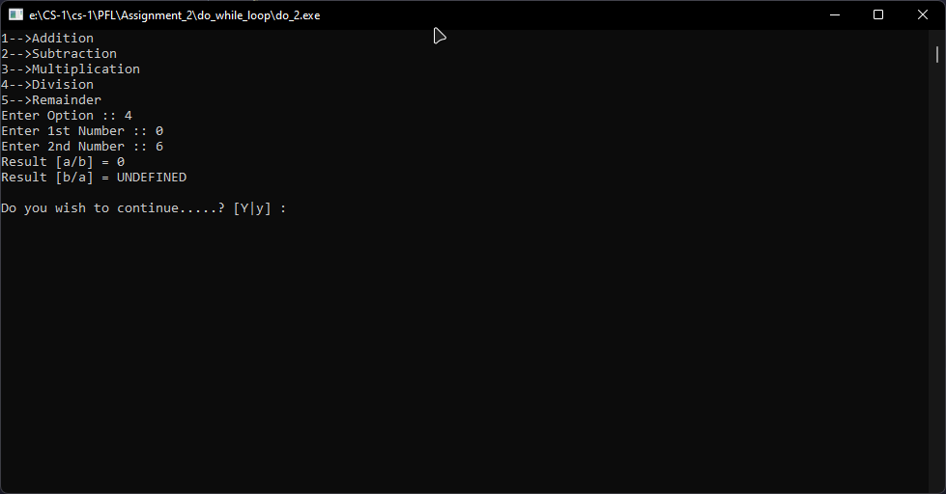

**do_while_3**

#include <iostream>

using namespace std;

int main()

{

float tea = 1.99, cake = 3.99, coffee = 2.49, croissant = 5.99, tax, total = 0;

int rank, opt;

char chk;

cout << "1-->Student" << endl;

cout << "2-->Teacher" << endl;

cout << "3-->Guest" << endl

<< endl;

cout << "Enter Rank ::";

cin >> rank;

switch (rank)

{

case 1:

tax = 0.29;

break;

case 2:

tax = 0.39;

break;

case 3:

tax = 0.49;

break;

}

do

{

system("CLS");

cout << "1-->Tea--> $" << tea << endl;

cout << "2-->Cake--> $" << cake << endl;

cout << "3-->Coffee--> $" << coffee << endl;

cout << "4-->Croissant--> $" << croissant << endl

<< endl;

cout << "Enter Option ::";

cin >> opt;

switch (opt)

{

case 1:

total += tea + tax;

break;

case 2:

total += cake + tax;

break;

case 3:

total += coffee + tax;

break;

case 4:

total += croissant + tax;

break;

default:

cout << "Please Select Correct Option!" << endl;

break;

}

cout << endl

<< "Do you wish to continue buying [y|Y] :: " << endl;

cin >> chk;

} while (chk == 'Y' || chk == 'y');

system("CLS");

cout << endl;

cout << "Your tax Bracket is $" << tax << endl;

cout << "Your Total is $" << total << endl;

system("pause");

return 0;

}

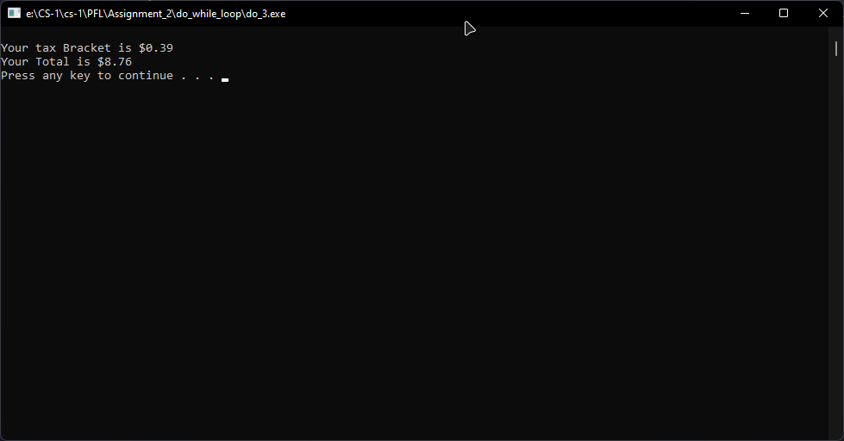

**do_while_4**

#include <iostream>

using namespace std;

int main()

{

int num, rev = 0;

cout << "Enter a number :: ";

cin >> num;

do

{

rev = rev * 10 + num % 10;

num /= 10;

} while (num != 0);

cout << "Reverse :: " << rev << endl;

system("pause");

return 0;

}

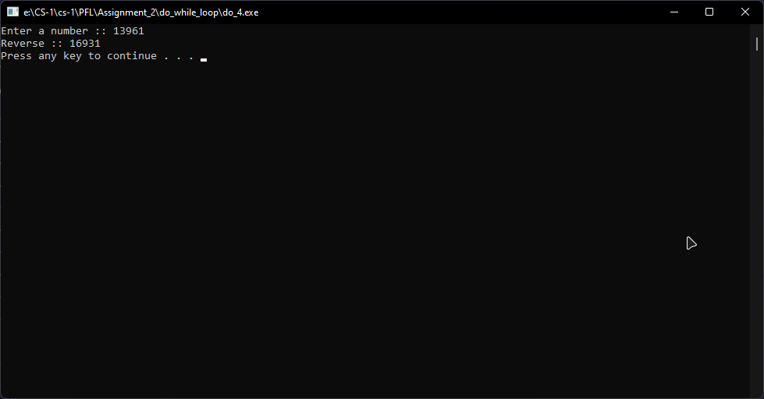

**do_while_5**

#include <iostream>

using namespace std;

int main()

{

int a;

cout << "Input Number :: ";

cin >> a;

int i = 1;

do

{

cout << a << " x " << i << " = " << a * i << endl;

i++;

} while (i <= 10);

system("pause");

return 0;

}

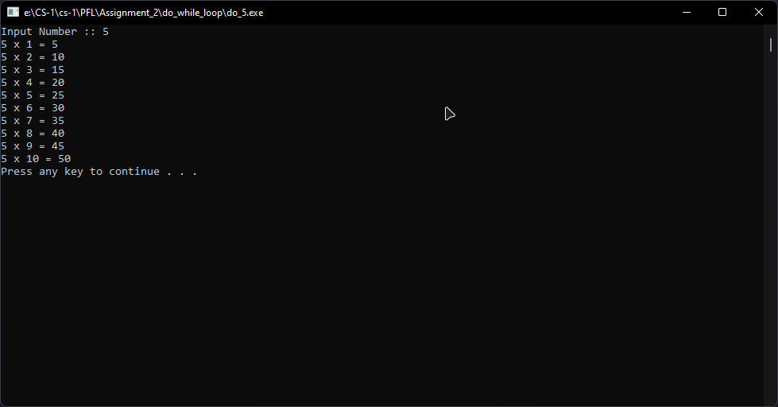

**do_while_6**

#include <iostream>

using namespace std;

int main()

{

int num, counter = 0;

cout << "Enter any Number :: ";

cin >> num;

do

{

num = num / 10;

counter++;

} while (num);

cout << "Number of digits :: " << counter << endl;

system("pause");

return 0;

}

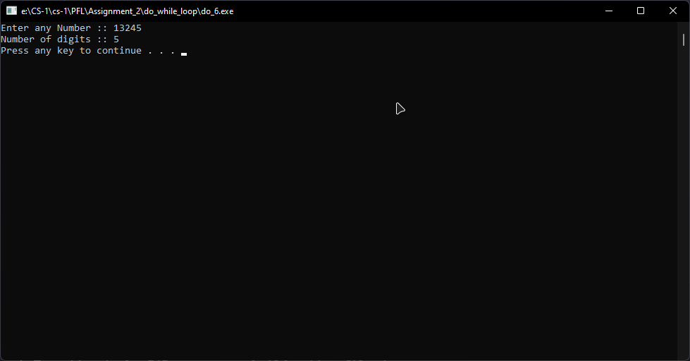

**do_while_7**

#include <iostream>

using namespace std;

int main()

{

int nth, i = 1;

cout << "Enter a Number :: ";

cin >> nth;

int cnt = 0, nth_even = 0;

do

{

if (i % 2 == 0)

{

cnt++;

nth_even = i;

}

i++;

} while (cnt != nth);

cout << nth << "th even number is :: " << nth_even << endl;

system("pause");

return 0;

}

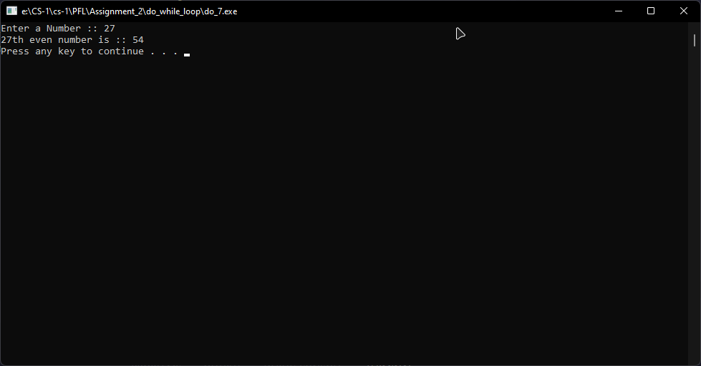

**do_while_8**

#include <iostream>

using namespace std;

int main()

{

int start, end, i;

cout << "Enter Range Start :: ";

cin >> start;

cout << "Enter Range End :: ";

cin >> end;

i = start;

cout << "Range :: "

<< "(" << start << "," << end << ")" << endl;

do

{

if (i % 2 == 0)

{

cout << i << " is Even!" << endl;

}

else

{

cout << i << " is Odd!" << endl;

}

i++;

} while (i >= start && i <= end);

system("pause");

return 0;

}

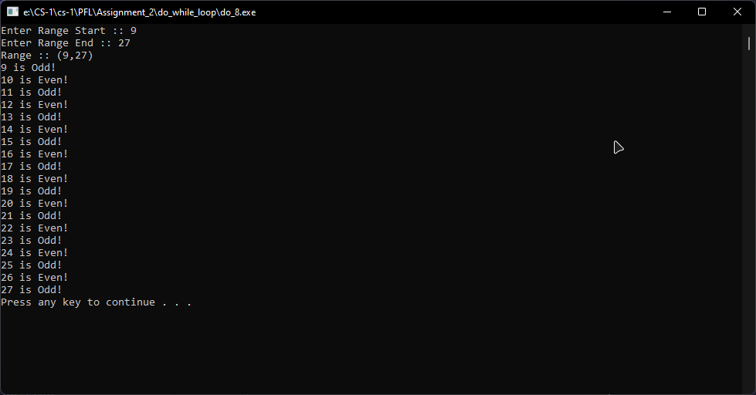

**do_while_9**

#include <iostream>

using namespace std;

int main()

{

int start, end, i, j;

bool flag = 1;

cout << "Enter Range Start :: ";

cin >> start;

cout << "Enter Range End :: ";

cin >> end;

i = start;

cout << "Range :: "

<< "(" << start << "," << end << ")" << endl;

do

{

j = 2;

while (j < i)

{

if (i % j == 0)

{

flag = 0;

}

j++;

}

if (flag == 1)

{

cout << i << " is Prime!" << endl;

}

flag = 1;

i++;

} while (i >= start && i <= end);

system("pause");

return 0;

}

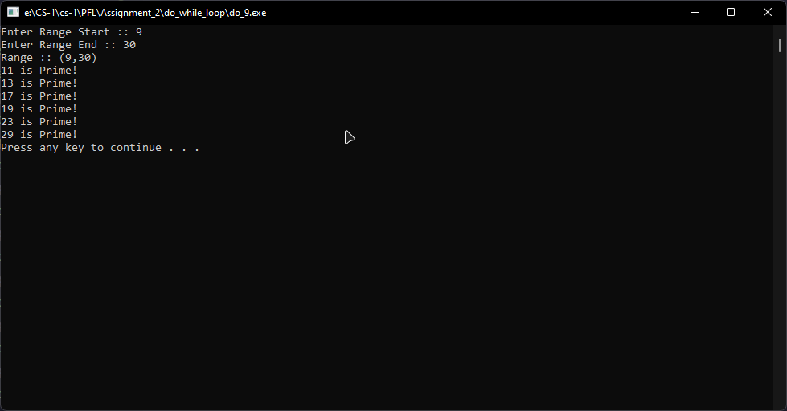

**do_while_10**

#include <iostream>

using namespace std;

int main()

{

char ch;

int i = 32;

cout << "Printing ASCII table :: " << endl;

do

{

ch = i;

cout << i << " --> " << ch << endl;

i++;

} while (i <= 127);

system("pause");

return 0;

}

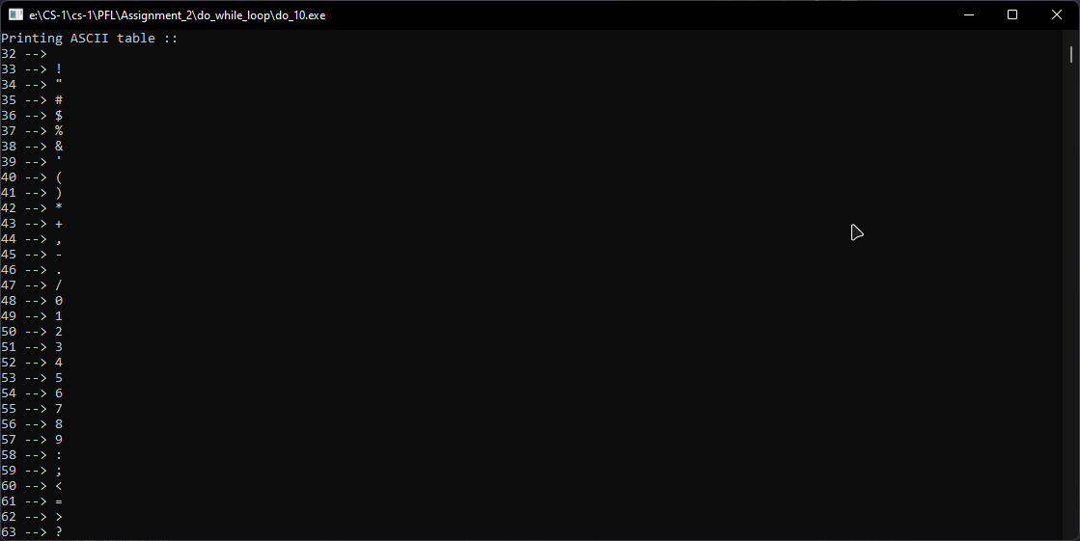

**while_loop**

**while_1**

#include <iostream>

using namespace std;

int main()

{

int num, rev = 0;

int tnum;

cout << "Input a number to reverse :: ";

cin >> num;

tnum = num;

cout << "Number :: " << num << endl;

while (num)

{

rev = rev * 10 + num % 10;

num = num / 10;

}

cout << "Reverse :: " << rev << endl;

if (tnum == rev)

{

cout << "Its a palindrome!" << endl;

}

else

{

cout << "Its not a palindrome!" << endl;

}

system("pause");

return 0;

}

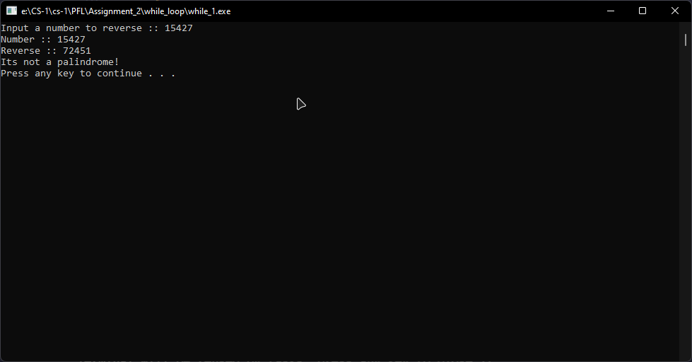

**while_2**

#include <iostream>

using namespace std;

int main()

{

int size, i = 0, j = 1, temp;

cout << "Enter Array Size :: ";

cin >> size;

int arr[size];

cout << "Array of size " << size << " created!" << endl;

while (i < size)

{

cout << "Input Value at index " << i << " :: ";

cin >> arr[i];

i++;

}

i = 0;

cout << "UnSorted Array : { ";

while (i < size)

{

cout << arr[i] << " ";

i++;

}

cout << "}" << endl;

i = 0;

while (i < size)

{

j = i;

while (j < size)

{

if (arr[i] > arr[j])

{

temp = arr[i];

arr[i] = arr[j];

arr[j] = temp;

j++;

}

else

{

j++;

}

}

i++;

}

i = 0;

cout << "Sorted Array : { ";

while (i < size)

{

cout << arr[i] << " ";

i++;

}

cout << "}" << endl;

system("pause");

return 0;

}

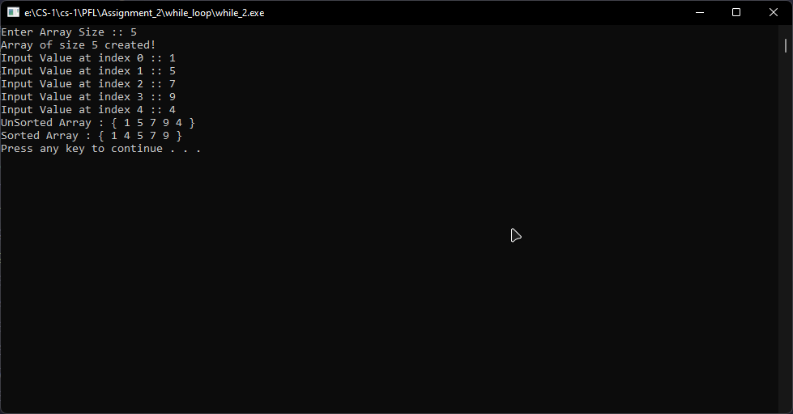

**while_3**

#include <iostream>

using namespace std;

int main()

{

int i = 0, nt, ft, sum = 0;

int tft; //temp ft;

cout << "Enter First Term :: ";

cin >> ft;

tft = ft;

cout << "Enter Number of Term :: ";

cin >> nt;

while (i <= nt)

{

cout << ft;

if (i < nt)

{

cout << " + ";

}

ft = ft * 10 + tft;

sum = sum + ft;

i++;

}

cout << " =" << sum << endl;

system("pause");

return 0;

}

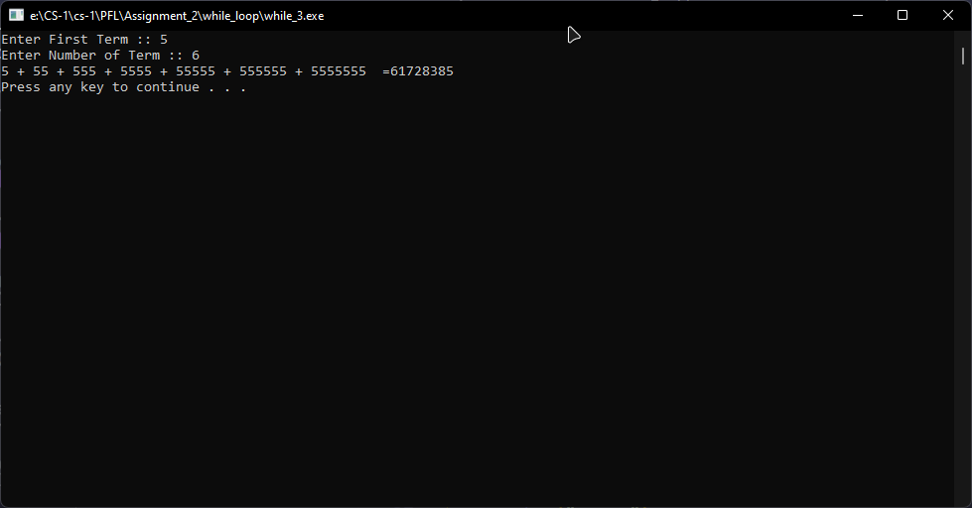

**while_4**

#include <iostream>

using namespace std;

int main()

{

int a;

cout << "Input Number :: ";

cin >> a;

int i = 1;

while (i <= 10)

{

cout << a << " x " << i << " = " << a * i << endl;

i++;

}

system("pause");

return 0;

}

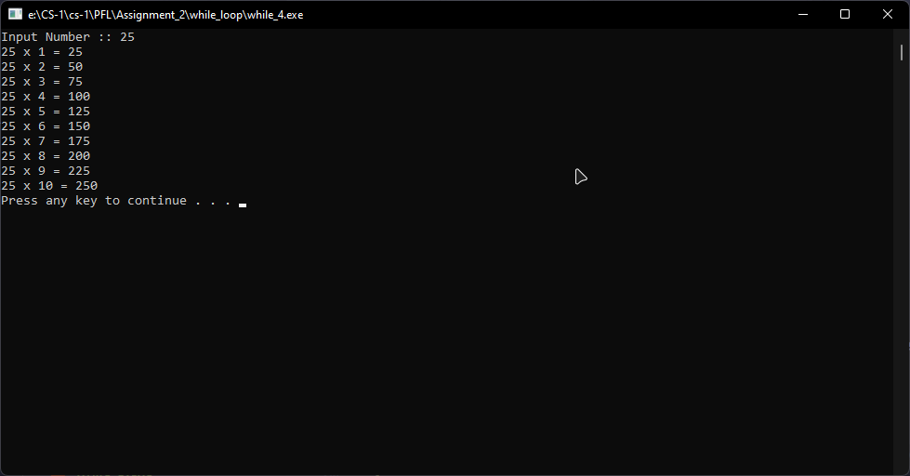

**while_5**

#include <iostream>

using namespace std;

int main()

{

int size, tmpsize, i = 1, x = 0, j = 1;

cout << "Enter size :: ";

cin >> size;

tmpsize = size;

while (i <= size)

{

x = 0;

while (x < tmpsize)

{

cout << " ";

x++;

}

tmpsize--;

j = 1;

while (j <= i)

{

cout << "* ";

j++;

}

cout << endl;

i++;

}

system("pause");

return 0;

}

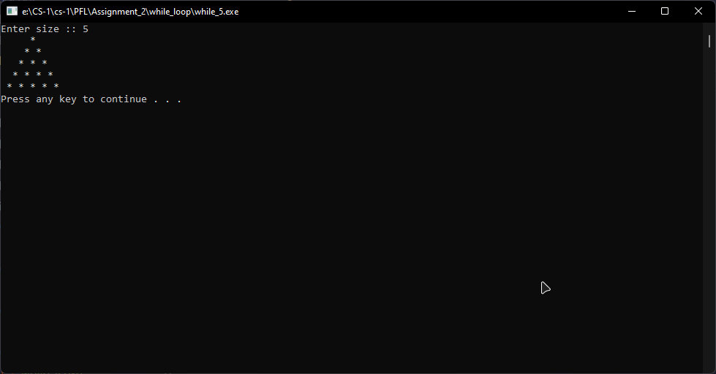

**while_6**

#include <iostream>

using namespace std;

int main()

{

int num, counter = 0;

cout << "Enter any Number :: ";

cin >> num;

while (num)

{

num = num / 10;

counter++;

}

cout << "Number of digits :: " << counter << endl;

system("pause");

return 0;

}

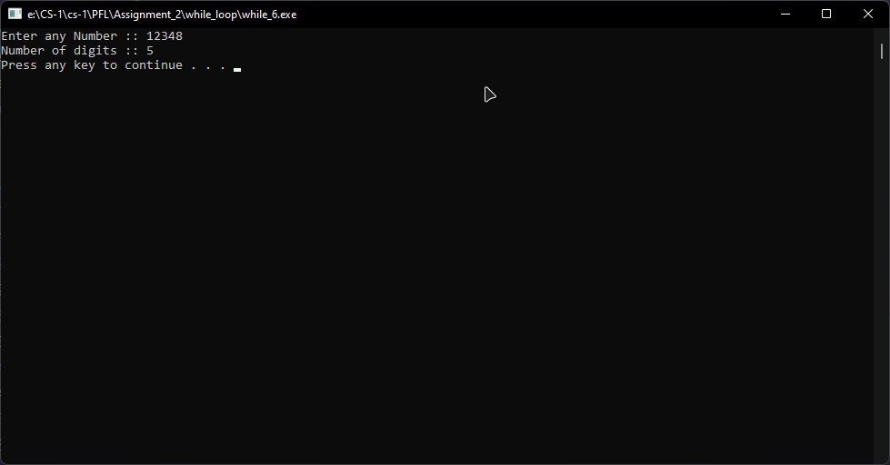

**while_7**

#include <iostream>

using namespace std;

int main()

{

int nth, i = 1;

cout << "Enter a Number :: ";

cin >> nth;

int cnt = 0, nth_even = 0;

while (cnt != nth)

{

if (i % 2 == 0)

{

cnt++;

nth_even = i;

}

i++;

}

cout << nth << "th even number is :: " << nth_even << endl;

system("pause");

return 0;

}

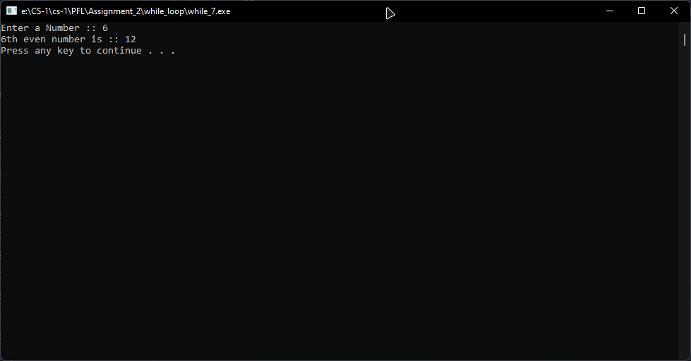

**while_8**

#include <iostream>

using namespace std;

int main()

{

int start, end, i, j;

bool flag = 1;

cout << "Enter Range Start :: ";

cin >> start;

cout << "Enter Range End :: ";

cin >> end;

i = start;

cout << "Range :: " << "(" << start << "," << end << ")" << endl;

while (i >= start && i <= end)

{

j = 2;

while (j < i)

{

if (i % j == 0)

{

flag = 0;

}

j++;

}

if (flag == 1)

{

cout << i << " is Prime!" << endl;

}

flag = 1;

i++;

}

system("pause");

return 0;

}

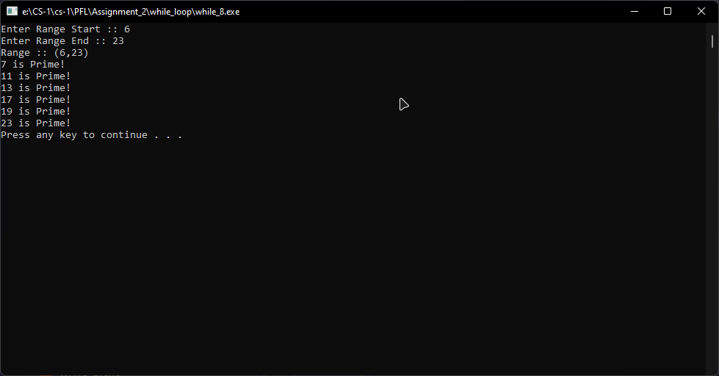

**while_9**

#include <iostream>

using namespace std;

int main()

{

int start, end, i;

cout << "Enter Range Start :: ";

cin >> start;

cout << "Enter Range End :: ";

cin >> end;

i = start;

cout << "Range :: "<< "(" << start << "," << end << ")" << endl;

while (i >= start && i <= end)

{

if (i % 2 == 0)

{

cout << i << " is Even!" << endl;

}

else

{

cout << i << " is Odd!" << endl;

}

i++;

}

system("pause");

return 0;

}

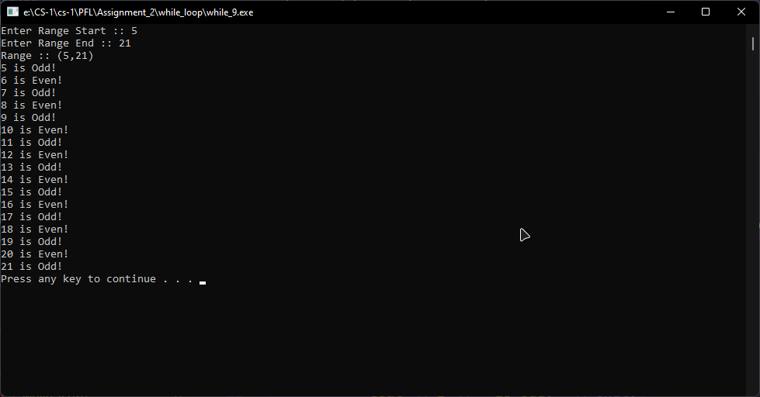

**while_10**

#include <iostream>

using namespace std;

int main()

{

char ch;

int i = 32;

cout << "Printing ASCII table :: " << endl;

while (i <= 127)

{

ch = i;

cout << i << " --> " << ch << endl;

i++;

}

system("pause");

return 0;

}

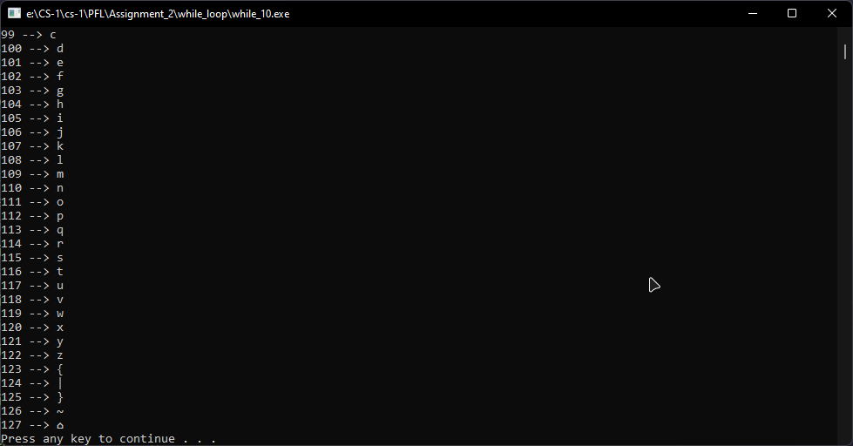

**for_loop**

**for_1**

#include <iostream>

using namespace std;

int main()

{

int num;

cout << "Enter a number to find the table of :: ";

cin >> num;

for (int i = 1; i <= 10; i++)

{

cout << num << " x " << i << " = " << num * i << endl;

}

system("pause");

return 0;

}

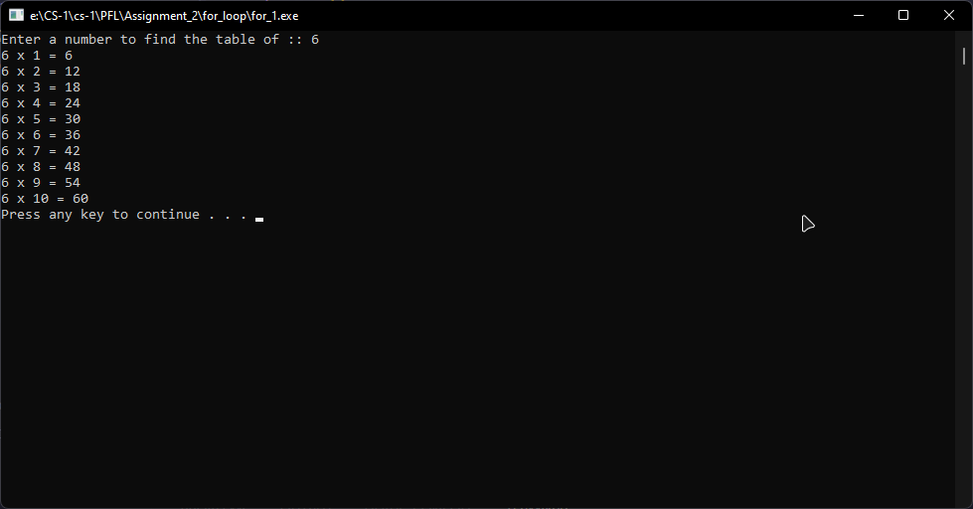

**for_2**

#include <iostream>

using namespace std;

int main()

{

int range;

cout << "Enter range to find even/odd numbers :: ";

cin >> range;

for (int i = 1; i <= range; i++)

{

if (i % 2 == 0)

{

cout << i << " --> Even" << endl;

}

else

{

cout << i << " --> Odd" << endl;

}

}

system("pause");

return 0;

}

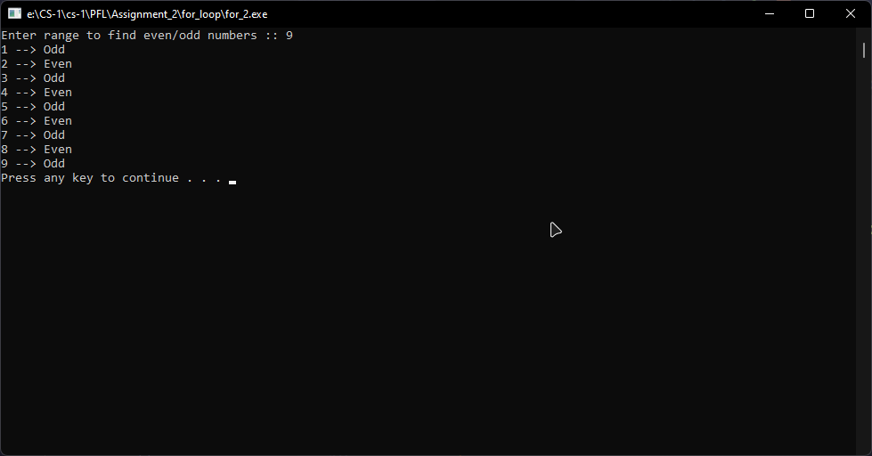

**for_3**

#include <iostream>

using namespace std;

int main()

{

int num1, num2, num3, smallest, hcf;

cout << "Enter 1st number ::";

cin >> num1;

cout << "Enter 2nd number ::";

cin >> num2;

cout << "Enter 3rd number ::";

cin >> num3;

smallest = ((num1 < num2) ? ((num1 < num3) ? (num1) : (num3)) : ((num2 < num3) ? (num2) : (num3)));

for (int i = 1; i <= smallest; i++)

{

if (num1 % i == 0 && num2 % i == 0 && num3 % i == 0)

{

hcf = i;

}

}

cout << "HCF :: " << hcf << endl;

system("pause");

return 0;

}

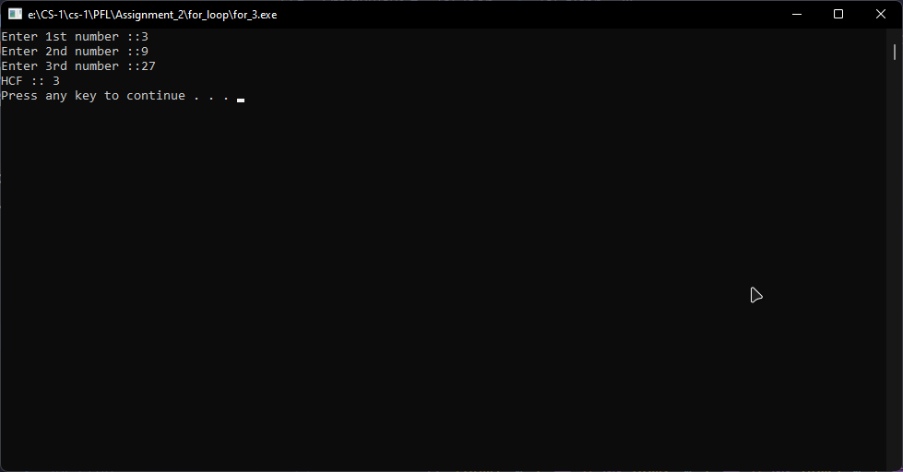

**for_4**

#include <iostream>

using namespace std;

int main()

{

int num, factorial = 1;

cout << "Enter a Number to find factorial :: ";

cin >> num;

for (int i = num; i >= 1; i--)

{

factorial *= i;

}

cout << "Factorial :: " << factorial << endl;

system("pause");

return 0;

}

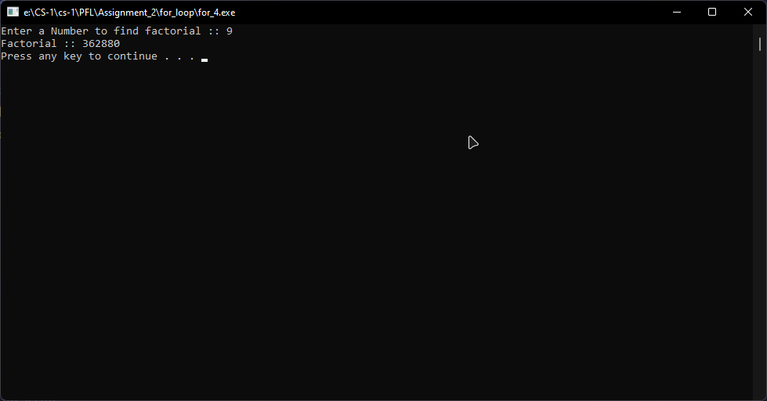

**for_5**

#include <iostream>

using namespace std;

int main()

{

int range, sum = 0;

cout << "Enter range :: ";

cin >> range;

for (int i = 1; i <= range; i++)

{

sum += i;

}

cout << "Sum :: " << sum << endl;

system("pause");

return 0;

}

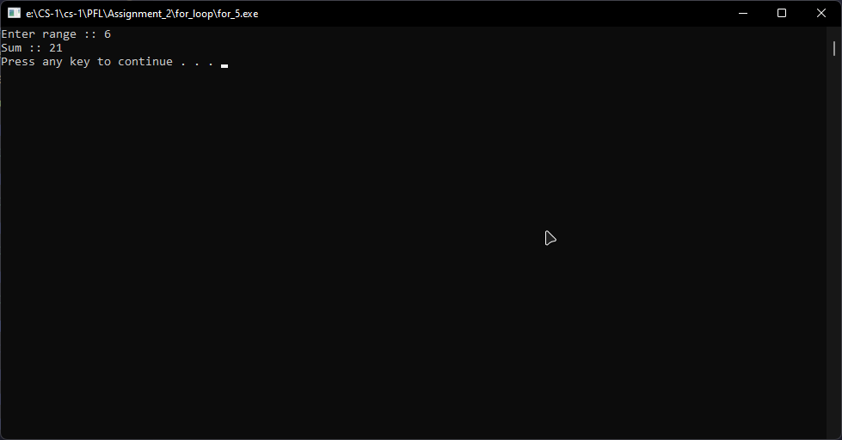

**for_6**

#include <iostream>

using namespace std;

int main()

{

int n, rem = 0;

cout << "Enter a number :: ";

cin >> n;

for (int i = 1; n != 0; i++)

{

rem += n % 10;

n /= 10;

}

cout << "Sum of Digits :: " << rem << endl;

system("pause");

return 0;

}

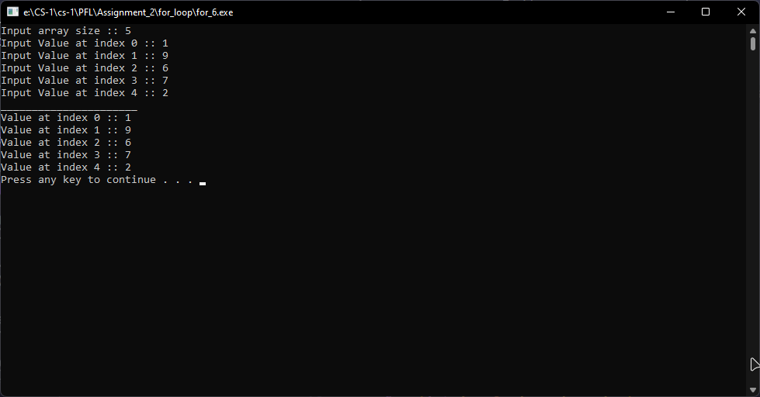

**for_7**

#include <iostream>

using namespace std;

int main()

{

int n, rem = 0;

cout << "Enter a number :: ";

cin >> n;

for (int i = 1; n != 0; i++)

{

rem += n % 10;

n /= 10;

}

cout << "Sum of Digits :: " << rem << endl;

system("pause");

return 0;

}

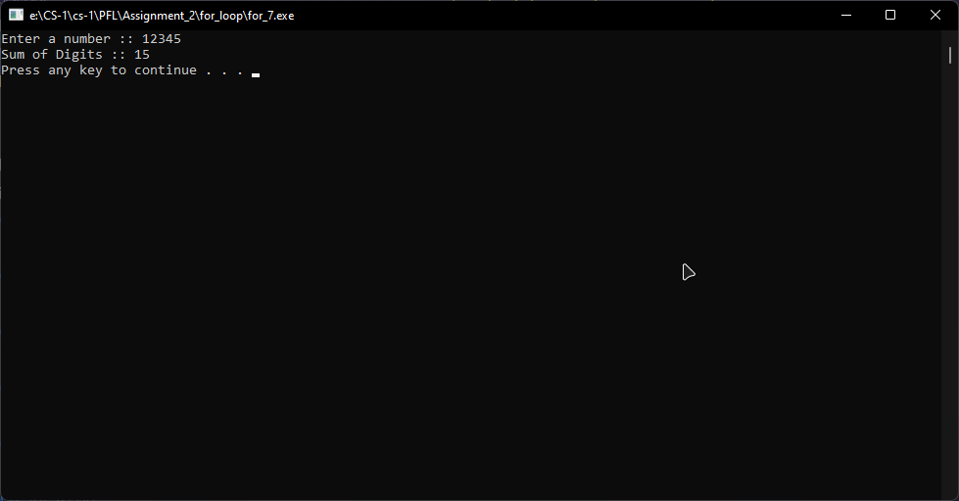

**for_8**

#include <iostream>

using namespace std;

int main()

{

int range, prev2 = 0, prev1 = 1, current;

cout << "Enter range :: ";

cin >> range;

cout << "Fibonacci Series upto " << range << " terms :: " << endl;

cout << prev2 << " , " << prev1;

for (int i = 3; i <= range; i++)

{

current = prev2 + prev1;

cout << " , " << current;

prev2 = prev1;

prev1 = current;

}

cout << endl;

system("pause");

return 0;

}

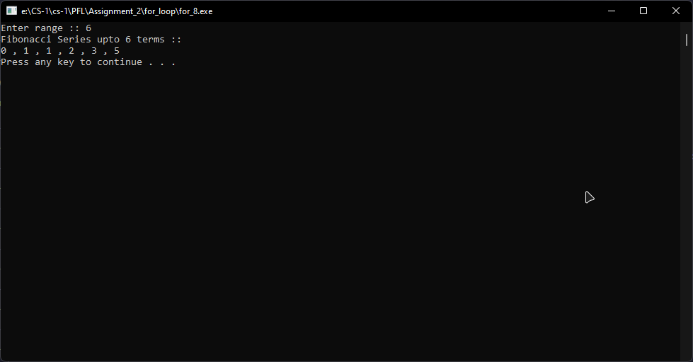

**for_9**

#include <iostream>

using namespace std;

int main()

{

int sr, er, num;

cout << "Enter starting range :: ";

cin >> sr;

cout << "Enter ending range :: ";

cin >> er;

cout << "Enter number :: ";

cin >> num;

for (int i = sr; i <= er; i++)

{

if (i % num == 0)

{

cout << i << " is completely divisible by " << num << endl;

}

}

system("pause");

return 0;

}

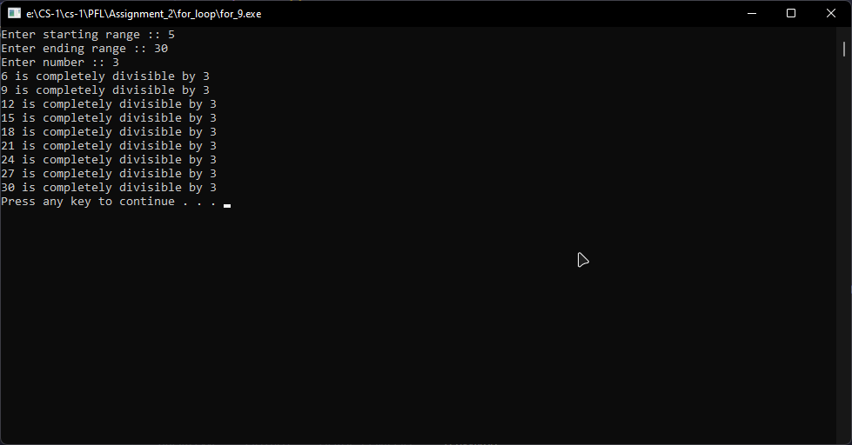

**for_10**

#include <iostream>

using namespace std;

int main()

{

int num;

bool flag = 1;

cout << "Enter a number to check prime :: ";

cin >> num;

for (int i = 2; i < num / 2; i++)

{

if (num % i == 0)

{

flag = 0;

}

}

if (flag == 1)

{

cout << num << " is Prime!" << endl;

}

else

{

cout << num << " is Not Prime!" << endl;

}

system("pause");

return 0;

}

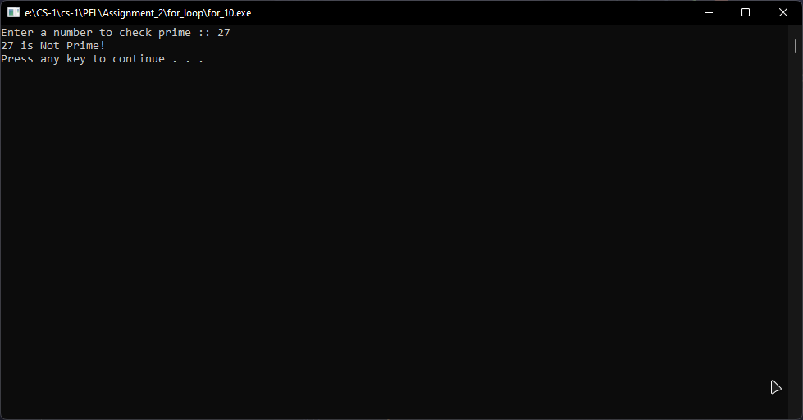

**nested_loop**

**nested_1**

#include <iostream>

using namespace std;

int main()

{

int range;

bool flag = 1;

cout << "Enter Range :: ";

cin >> range;

for (int i = 2; i <= range; i++)

{

for (int j = 2; j < i; j++)

{

if (i % j == 0)

{

flag = 0;

break;

}

}

if (flag == 1)

{

cout << i << " is Prime!";

}

else

{

cout << i << " is Not Prime!";

}

cout << endl;

flag = 1;

}

system("pause");

return 0;

}

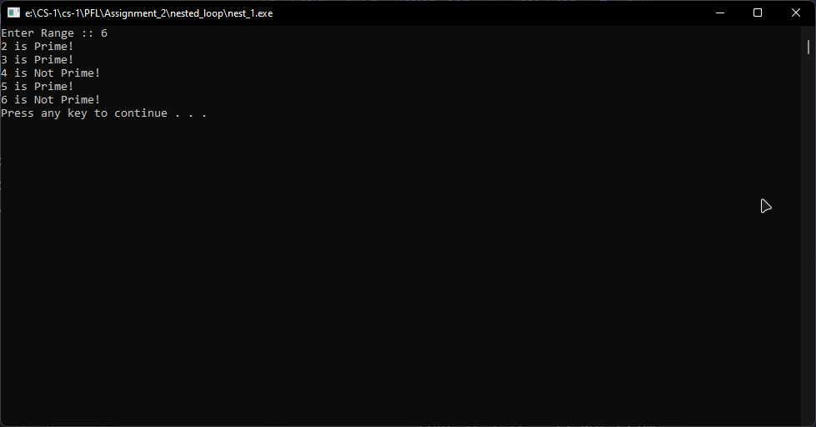

**nested_2**

#include <iostream>

using namespace std;

int main()

{

int range;

cout << "Enter Range :: ";

cin >> range;

for (int i = 1; i <= range; i++)

{

for (int j = 1; j <= i; j++)

{

cout << j;

}

cout << endl;

}

system("pause");

return 0;

}

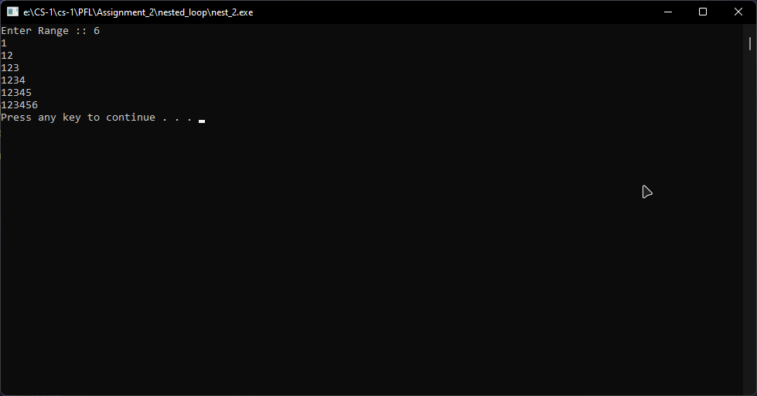

**nested_3**

#include <iostream>

using namespace std;

int main()

{

int num;

cout << "Enter a number :: ";

cin >> num;

for (int i = num; i > 0; i--)

{

for (int j = i; j > 0; j--)

{

cout << i;

}

cout << endl;

}

system("pause");

return 0;

}

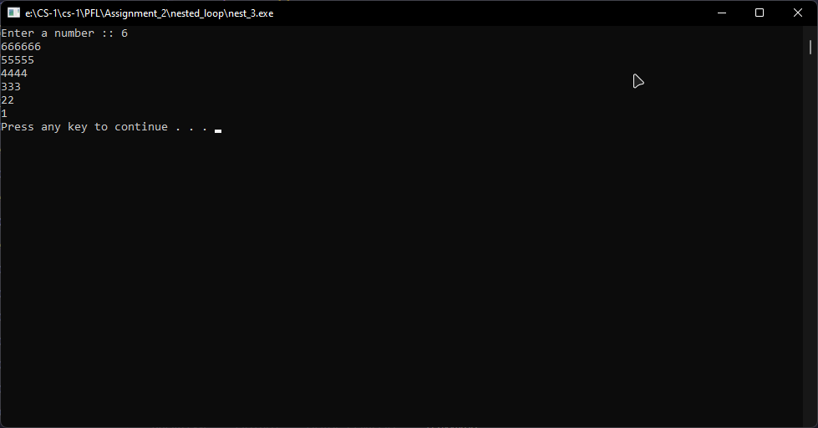

**nested_4**

#include <iostream>

using namespace std;

int main()

{

unsigned int row, col;

cout << "Enter Number of Rows :: ";

cin >> row;

cout << "Enter Number of Columns :: ";

cin >> col;

int arr[row][col];

cout << row << "x" << col << " Matrix Created!" << endl;

cout << "_____INPUT_____" << endl;

for (int i = 0; i < row; i++)

{

for (int j = 0; j < col; j++)

{

cout << "Input " << i << "x" << j << " :: ";

cin >> arr[i][j];

}

}

cout << "_____OUTPUT_____" << endl;

for (int i = 0; i < row; i++)

{

for (int j = 0; j < col; j++)

{

cout << arr[i][j] << " ";

}

cout << endl;

}

system("pause");

return 0;

}

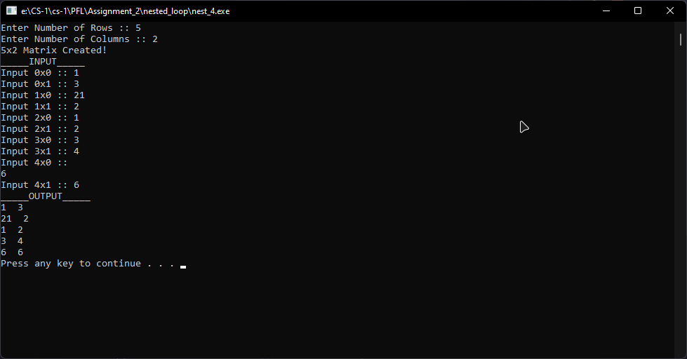

**nested_5**

#include <iostream>

using namespace std;

int main()

{

int range;

cout << "Enter Range :: ";

cin >> range;

for (int i = 1; i <= range; i++)

{

for (int j = 1; j <= i; j++){

for (int k = 1; k <= j;k++){

cout << j;

}

cout << endl;

}

cout << endl;

}

system("pause");

return 0;

}

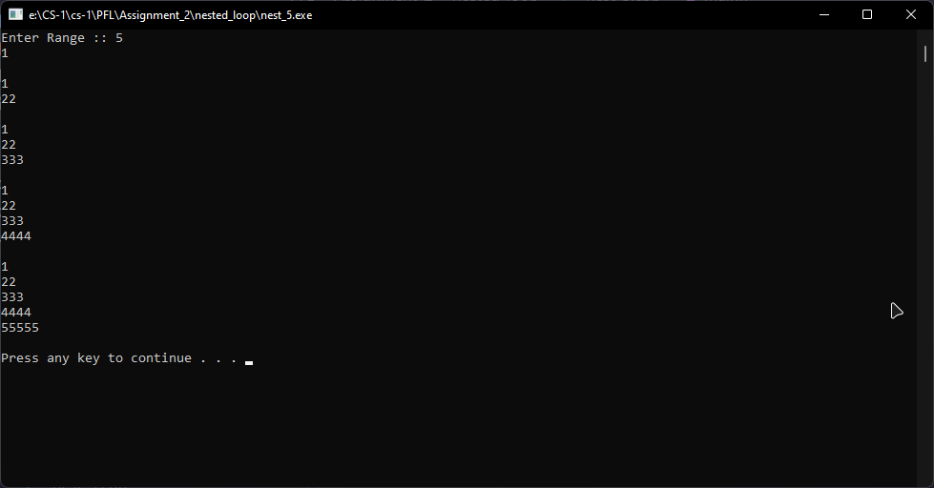

**nested_6**

#include <iostream>

using namespace std;

int main()

{

int range;

cout << "Enter Range :: ";

cin >> range;

for (int i = 1; i <= range; i++)

{

for (int j = 1; j <= i; j++)

{

cout << i;

}

cout << endl;

}

for (int i = range - 1; i > 0; i--)

{

for (int j = 1; j <= i; j++)

{

cout << i;

}

cout << endl;

}

system("pause");

return 0;

}

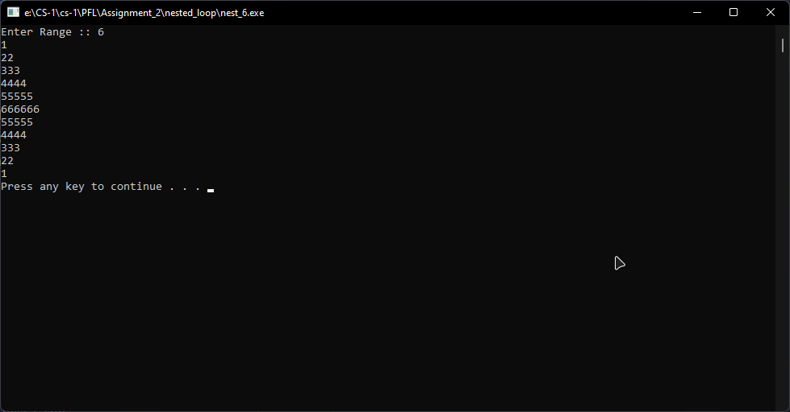

**nested_7**

#include <iostream>

using namespace std;

int main()

{

int size, i, j, cnt;

cout << "Enter Size :: ";

cin >> size;

for (i = 1; i <= size; i++)

{

for (j = 1; j <= i;)

{

if (i != size)

{

if (j == 1 || j == i)

{

cout << "* ";

j++;

}

else

{

cout << " ";

j++;

}

}

else

{

cout << "* ";

j++;

}

}

cout << endl;

}

system("pause");

return 0;

}

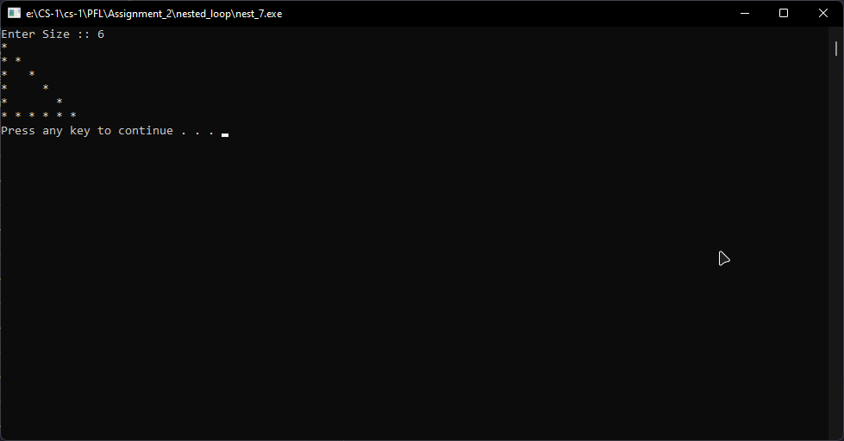

**nested_8**

#include <iostream>

using namespace std;

int main()

{

//Input Below 9

int range, i, j, end, start;

cout << "Enter range :: ";

cin >> range;

start = 0;

end = (range * 2);

for (i = range; i >= 0; i--)

{

for (j = 0; j <= range * 2; j++)

{

if (i != range)

{

if (j == end || j == start)

{

cout << "*";

}

else

{

cout << " ";

}

}

else

{

cout << "*";

}

}

end--;

start++;

cout << endl;

}

system("pause");

return 0;

}

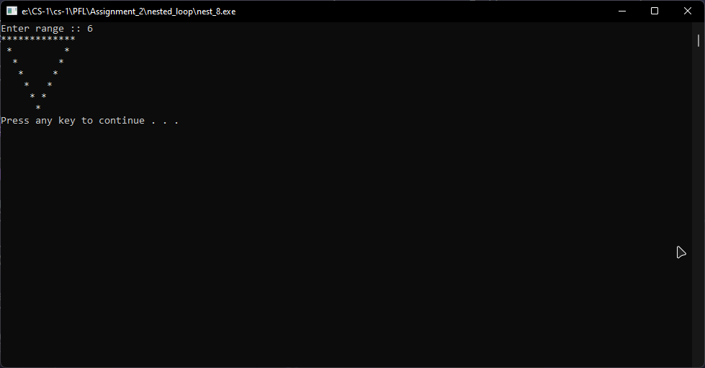

**nested_9**

#include <iostream>

using namespace std;

int main()

{

//Input Below 9

int range, i, j, end, start;

cout << "Enter range :: ";

cin >> range;

start = range;

end = range;

for (i = 1; i < range; i++)

{

for (j = 1; j < range * 2; j++)

{

if (j == end || j == start)

{

cout << "*";

}

else

{

cout << " ";

}

}

end++;

start--;

cout << endl;

}

start = 1;

end = (range * 2);

for (i = range; i > 0; i--)

{

for (j = 1; j <= range * 2; j++)

{

if (j == start || j == end-1)

{

cout << "*";

}

else

{

cout << " ";

}

}

end--;

start++;

cout << endl;

}

system("pause");

return 0;

}

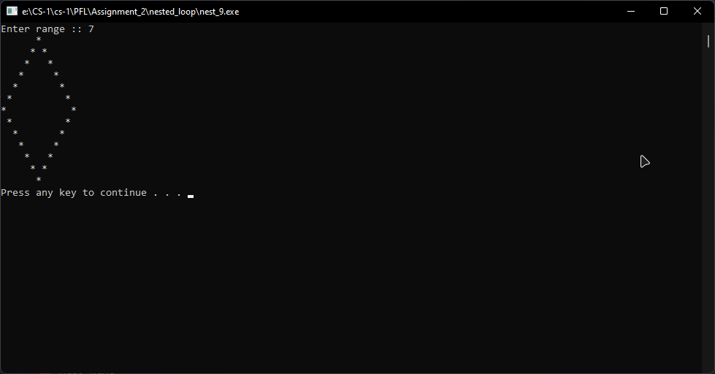

**nested_10**

#include <iostream>

using namespace std;

int main()

{

char ch;

int tab[95];

for (int i = 0; i <= 95; i++)

{

tab[i] = i + 32;

}

cout << "_____OUTPUT_____" << endl<< endl;

cout << "Decimal\t\tChar" << endl;

for (int i = 0; i < 95; i++)

{

for (int j = 0; j < 2; j++)

{

if (j == 0)

{

cout << tab[i] << "\t\t";

}

else

{

ch = tab[i];

cout << ch << " ";

}

}

cout << endl;

}

system("pause");

return 0;

}

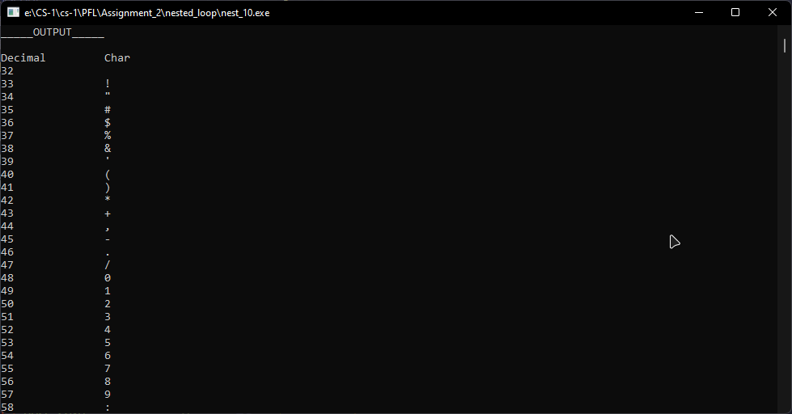

**Pattern**

**pattern_1**

#include <iostream>

using namespace std;

int main()

{

int i, j, range;

int cnt;

cout << "Input Range :: ";

cin >> range;

for (i = 1; i <= range * 2; i++)

{

if (i > range)

{

cnt--;

}

else

{

cnt = i;

}

for (j = 1; j <= cnt;)

{

cout << "*";

j++;

}

cout << endl;

}

system("pause");

return 0;

}

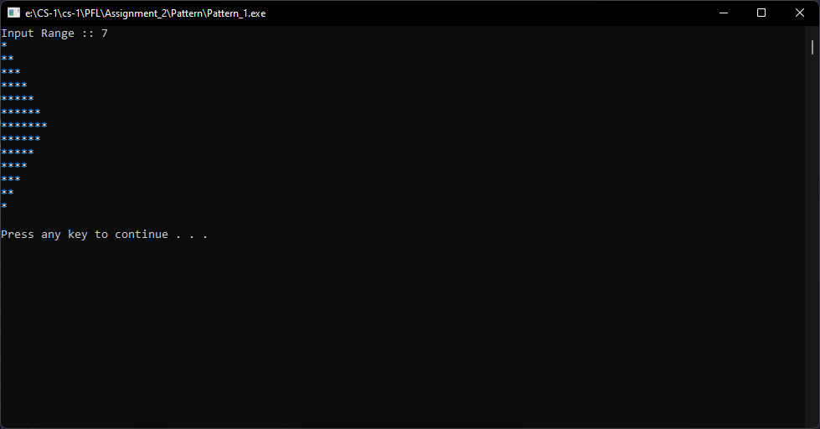

**pattern_2**

#include <iostream>

using namespace std;

int main()

{

int i, j, range;

int cnt;

cout << "Enter Range :: ";

cin >> range;

for (i = 1; i < range * 2; i++)

{

if (i > range)

{

--cnt;

}

else

{

cnt = i;

}

for (j = range; (j >= cnt && j != 0);)

{

cout << "*";

j--;

}

cout << endl;

}

system("pause");

return 0;

}

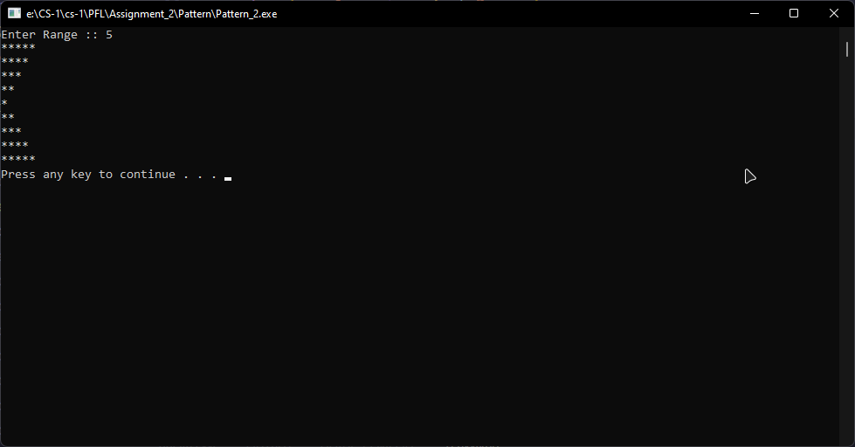

**pattern_3**

#include <iostream>

using namespace std;

int main()

{

int i, j, range;

int cnt, rtemp, temp;

cout << "Enter Range :: ";

cin >> range;

rtemp = range;

temp = rtemp;

for (i = 1; i <= range * 2; i++)

{

if (i > range)

{

cnt--;

}

else

{

rtemp = --temp;

cnt = i;

}

for (j = 1; j <= cnt;)

{

if (rtemp > 0)

{

cout << " ";

rtemp--;

}

else

{

cout << "*";

j++;

}

}

cout << endl;

}

system("pause");

return 0;

}

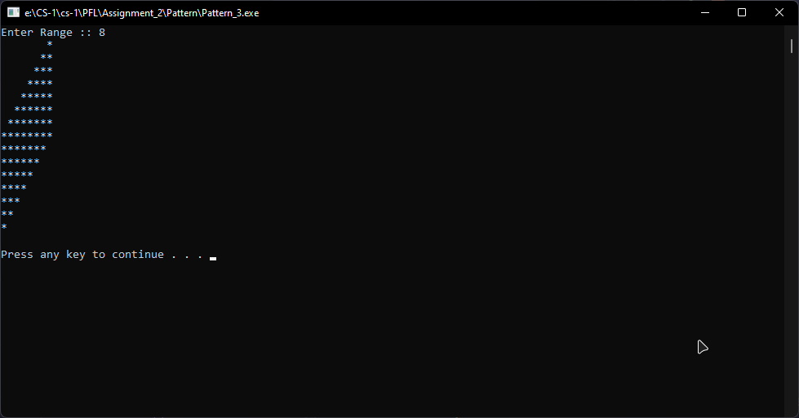

**pattern_4**

#include <iostream>

using namespace std;

int main()

{

int i, j, range;

int cnt, rtemp, temp;

cout << "Enter Range :: ";

cin >> range;

rtemp = range;

temp = rtemp;

for (i = 1; i <= range * 2; i++)

{

if (i > range)

{

cnt--;

rtemp = ++temp;

}

else

{

rtemp = --temp;

cnt = i;

}

for (j = 1; j <= cnt;)

{

if (rtemp > 0)

{

cout << " ";

rtemp--;

}

else

{

cout << "*";

j++;

}

}

cout << endl;

}

system("pause");

return 0;

}

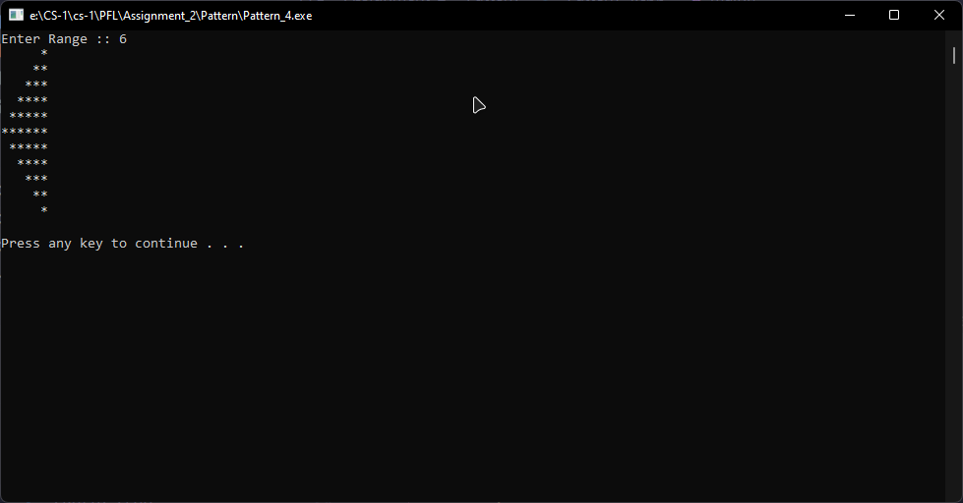

**pattern_5**

#include <iostream>

using namespace std;

int main()

{

//Input Below 9

int range, i, j, end, start;

cout << "Enter range :: ";

cin >> range;

start = range;

end = range;

for (i = 1; i <= range; i++)

{

for (j = 1; j < range * 2; j++)

{

if (i != range)

{

if (j == end || j == start)

{

cout << "*";

}

else

{

cout << " ";

}

}

else

{

cout << "*";

}

}

end++;

start--;

cout << endl;

}

system("pause");

return 0;

}

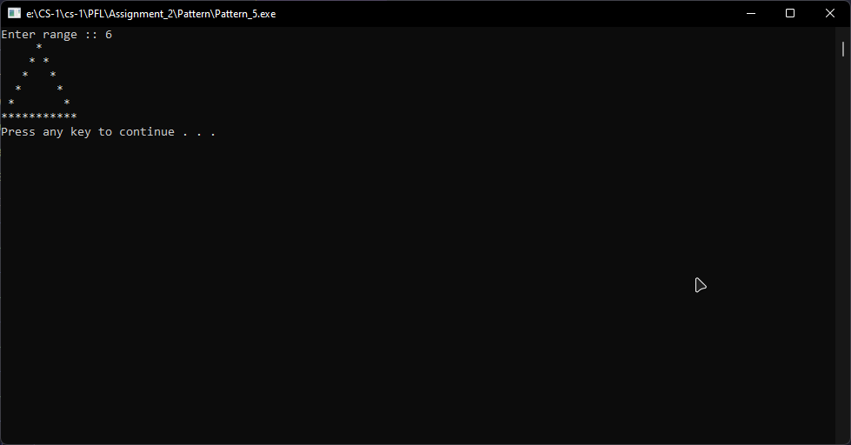

**pattern_6**

#include <iostream>

using namespace std;

int main()

{

int range, i, j, end, start;

cout << "Enter range :: ";

cin >> range;

start = 1;

end = (range * 2);

for (i = 1; i <= range; i++)

{

for (j = 1; j < range * 2; j++)

{

if (j >= start && j < end)

{

cout << "*";

}

else

{

cout << " ";

}

}

end--;

start++;

cout << endl;

}

system("pause");

return 0;

}

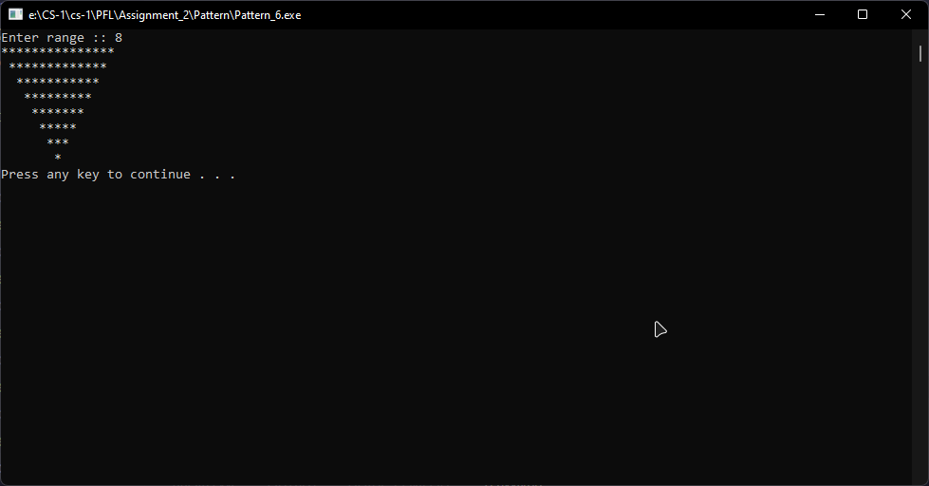

**pattern_7**

#include <iostream>

using namespace std;

int main()

{

int range, i, j, end, start;

cout << "Enter range :: ";

cin >> range;

start = range;

end = range;

for (i = 1; i <= range; i++)

{

for (j = 1; j < range * 2; j++)

{

if (j <= end && j >= start)

{

cout << "*";

}

else

{

cout << " ";

}

}

end++;

start--;

cout << endl;

}

system("pause");

return 0;

}

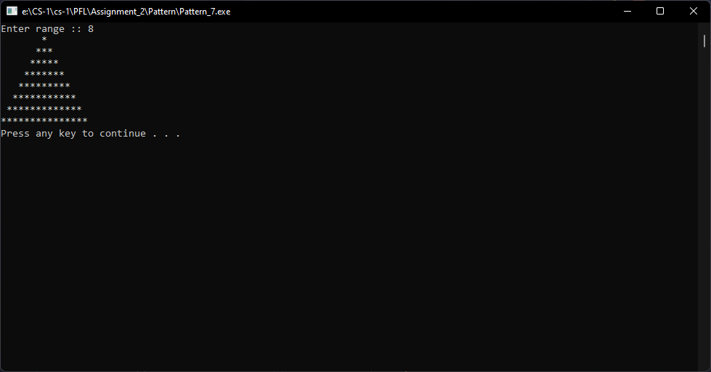

**pattern_8**

#include <iostream>

using namespace std;

int main()

{

int range, i, j, end, start;

cout << "Enter range :: ";

cin >> range;

start = range;

end = range;

for (i = 1; i <= range; i++)

{

for (j = 1; j < range * 2; j++)

{

if (j < end && j > start)

{

cout << " ";

}

else

{

cout << "*";

}

}

end++;

start--;

cout << endl;

}

system("pause");

return 0;

}

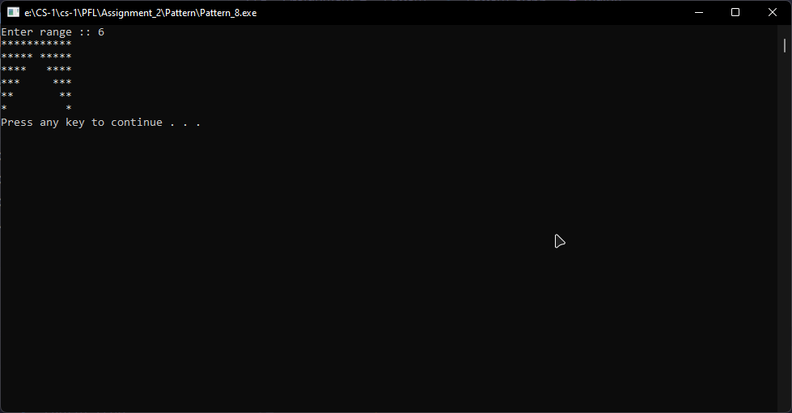

**pattern_9**

#include <iostream>

using namespace std;

int main()

{

int range, i, j, end, start;

cout << "Enter range :: ";

cin >> range;

start = 1;

end = (range * 2);

for (i = 1; i <= range; i++)

{

for (j = 1; j < range * 2; j++)

{

if (j > start && j < end - 1)

{

cout << " ";

}

else

{

cout << "*";

}

}

end--;

start++;

cout << endl;

}

system("pause");

return 0;

}

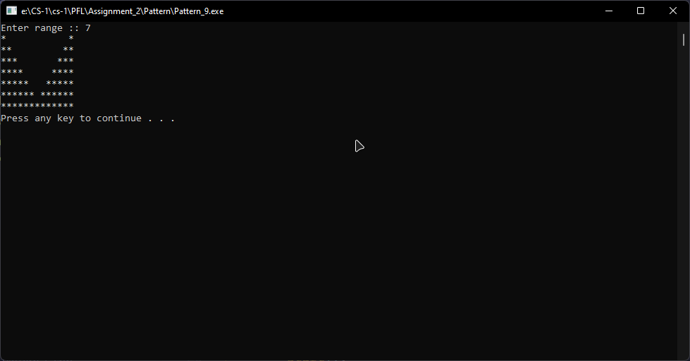

**pattern_10**

#include <iostream>

using namespace std;

int main()

{

int size, i, j, cnt;

cout << "Enter Size :: ";

cin >> size;

for (i = 1; i <= size * 2; i++)

{

if (i > size)

{

cnt--;

}

else

{

cnt = i;

}

for (j = 1; j <= cnt;)

{

if (i != size)

{

if (j == 1 || j == cnt)

{

cout << "* ";

j++;

}

else

{

cout << " ";

j++;

}

}

else

{

cout << "* ";

j++;

}

}

cout << endl;

}

system("pause");

return 0;

}

