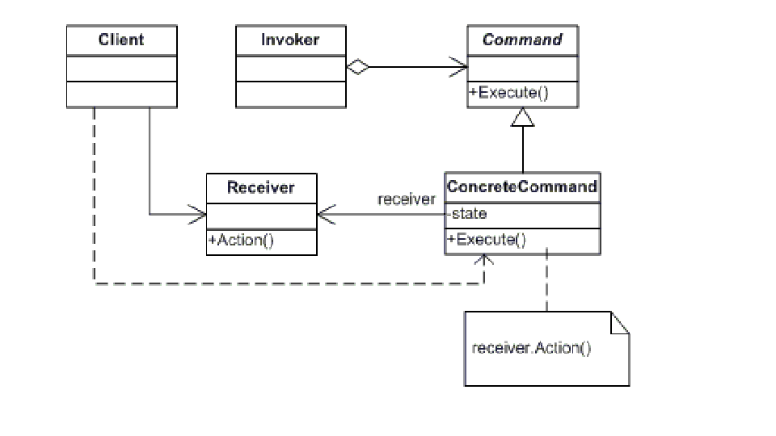

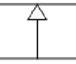 this indicates inheritance / Generalisation

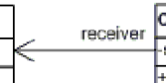 means association : one class knows/uses another

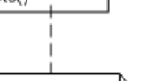 means dependency

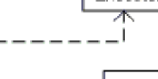---------> dependency with direction (who depends on whom)

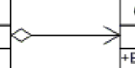

Main UML relationship types (core ones):
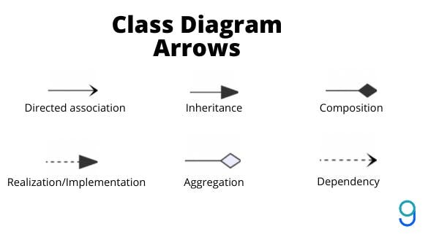
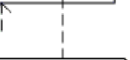
dependency

