NAME – ABDUS SAMAD BITS ID – 2024EB01250
MODERN DATABASES SGA2

The screenshots show me running the script as mysql_complete.sql. I renamed it to mysql.sql for submission, and the README.md instructions use that filename. The SQL statements are the same, so please use mysql.sql from the submission ZIP when running the script.

FIRST PART – CONNECTING WITH DATABASES

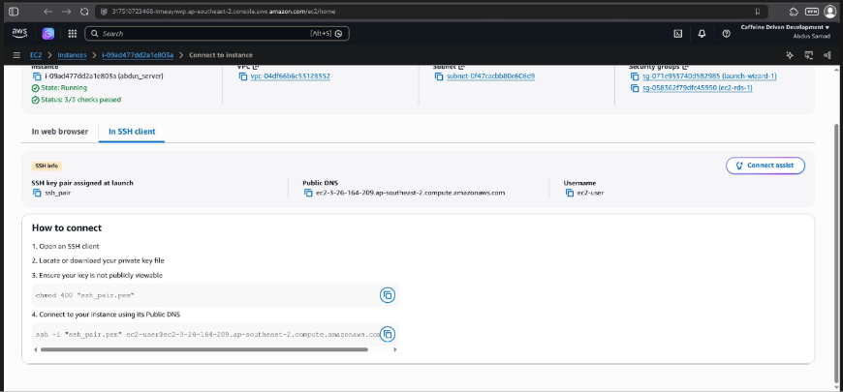
Figure 1. SSH connection details for the Amazon EC2 instance. I used the public DNS name, ec2-user username and SSH key pair shown in the AWS console to connect to the instance from my local terminal.

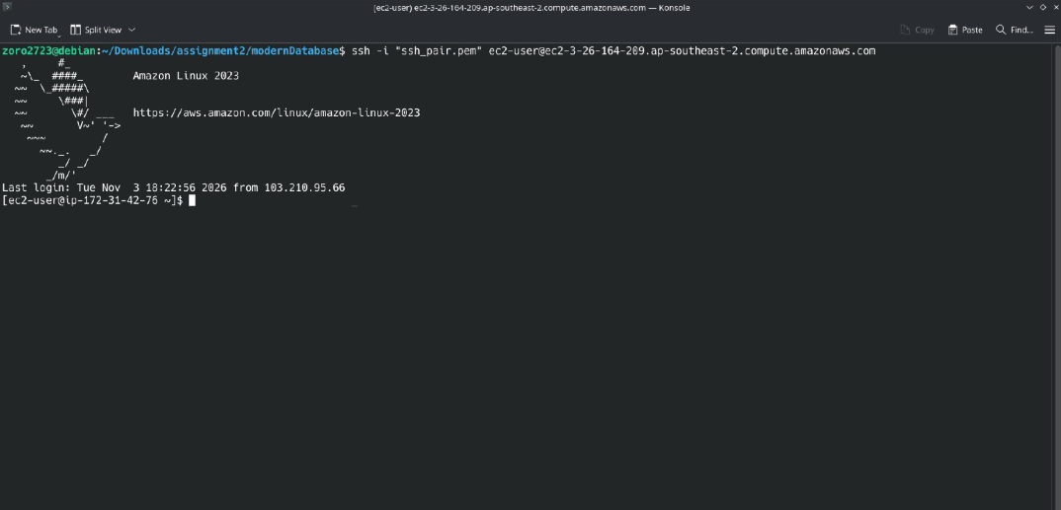
Figure 2. Successful SSH login to the Amazon EC2 instance.
I connected from my local terminal using the ssh command. The Amazon Linux 2023 banner and the ec2-user prompt confirm that I reached the EC2 shell.
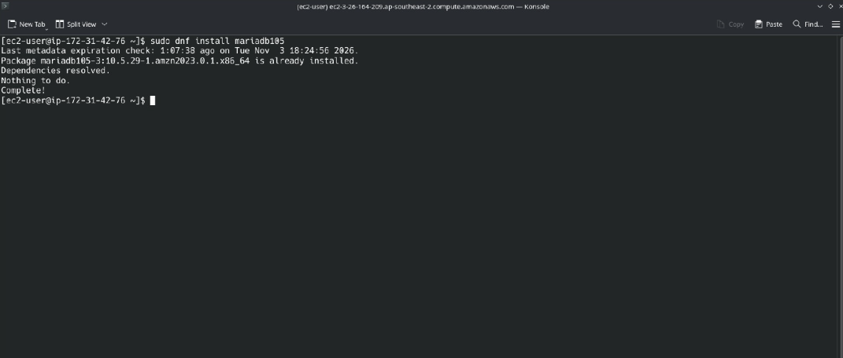
Figure 3. Verifying the database client on the EC2 instance. I ran sudo dnf install mariadb105 on EC2. The package manager confirmed that the MariaDB client package was already installed.

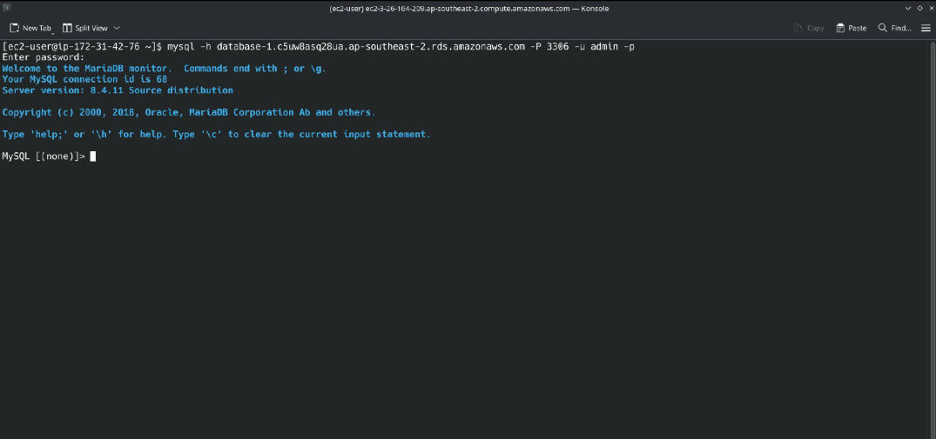
Figure 4. Successful connection from Amazon EC2 to Amazon RDS for MySQL.
I used the MariaDB command-line client on EC2 to connect to the RDS endpoint on port 3306. The MySQL prompt confirmed the connection and the server reported version 8.4.11

Database setup and sample data
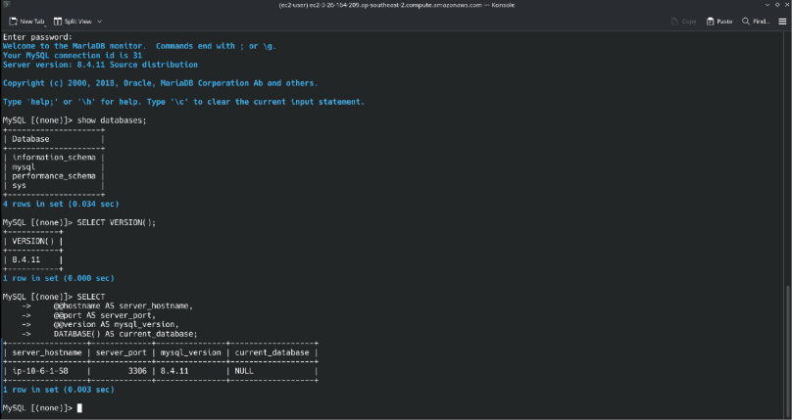
Figure 5. Verifying the MySQL server and session details.
After logging in, I ran SHOW DATABASES; to list the four system databases: information_schema, mysql, performance_schema and sys.
I used SELECT VERSION(); to confirm that the server was running MySQL 8.4.11.
The final query displayed the server hostname, port 3306, MySQL version and current database. The NULL value under current_database showed that the session had no database selected.

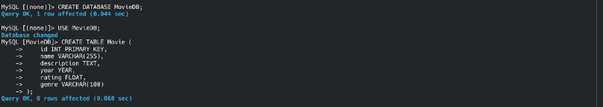
Figure 6. Creating MovieDB and the Movie table. I created and selected MovieDB then created Movie with id as the primary key and fields for the name, description, release year, rating and genre.

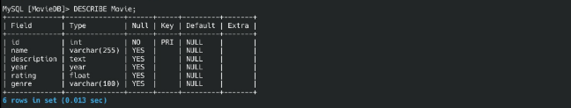
Figure 7. Verifying the Movie table structure. I ran DESCRIBE Movie to check all six columns, their data types and the primary key on id.

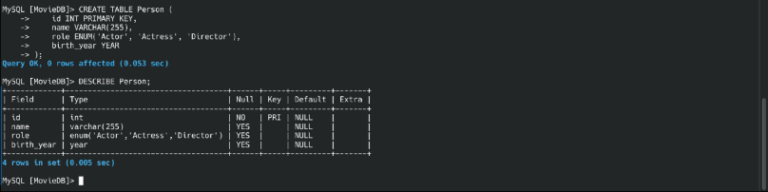
Figure 8. Creating and verifying the Person table.
I created the table with id as the primary key and columns for name, role and birth year then verified its structure with DESCRIBE Person.

Figure 9. Listing tables in MovieDB. I ran SHOW TABLES to confirm that the Movie and Person tables had been created.

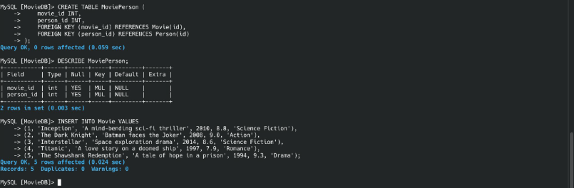
Figure 10. Creating MoviePerson and inserting movie records. I created MoviePerson with foreign keys to Movie and Person, checked its columns with DESCRIBE and inserted five records into Movie.

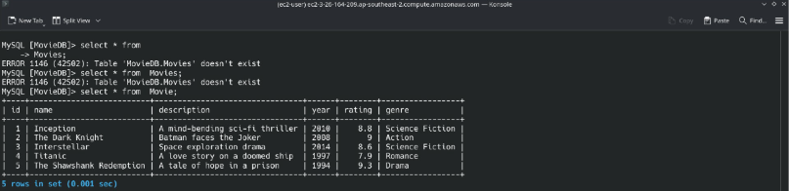
Figure 11. Verifying the records in Movie. I corrected the table name from Movies to Movie and ran SELECT * FROM Movie, which returned all five movie records.

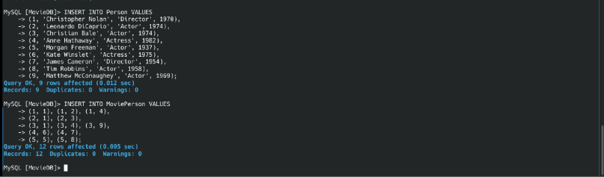
Figure 12. Populating the Person and MoviePerson tables.
I inserted nine people into Person and twelve movie–person links into MoviePerson. MySQL reported no duplicates or warnings for either insert.

Queries Answer -:
Q1 – Retrieve all movies released after the year 2000
Answer –
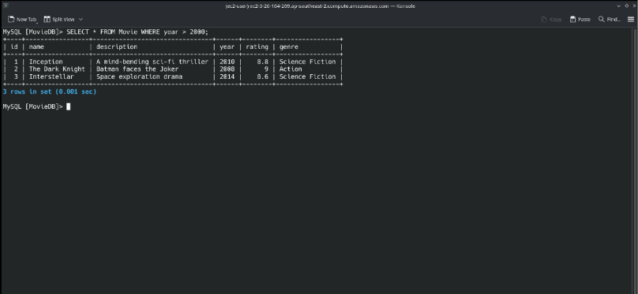
Figure 13. The query filtered the Movie table using year > 2000 and returned three films: Inception, The Dark Knight, and Interstellar.

Q2 – List all directors from the Person table.
Answer -:
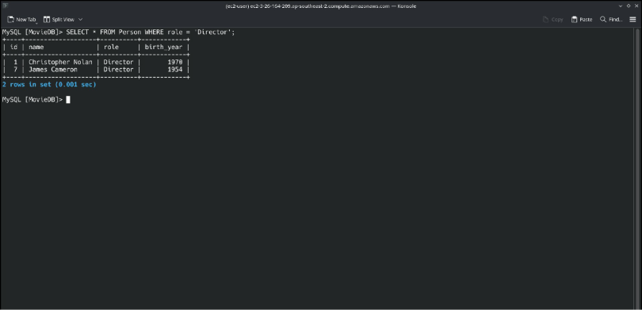
Figure 14. Filtering by role = 'Director' returned two records: Christopher Nolan and James Cameron.

Q3 – Find all movies with a rating greater than 8.0
Answer -:
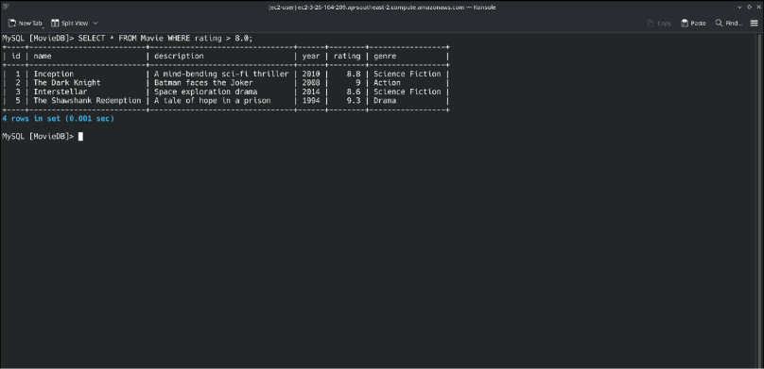
Figure 15. The filter rating > 8.0 returned four movies: Inception, The Dark Knight, Interstellar and The Shawshank Redemption.

Q4 Answer -:
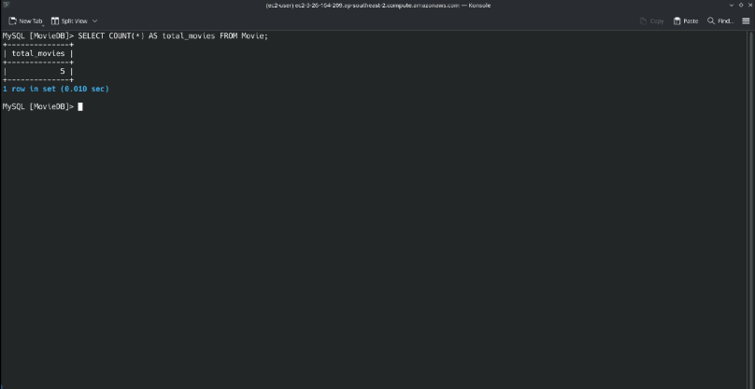
Figure 16. Q4 - Total number of movies. COUNT(*) returned 5 confirming that the Movie table contains five records.

Q5 Answer -:
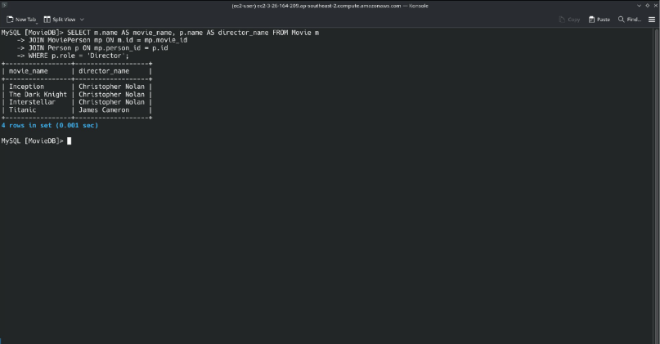
Figure 17. Q5 - Movies and their recorded directors. Joining Movie, MoviePerson and Person returned four matches. Christopher Nolan was listed for three movies and James Cameron for Titanic. The Shawshank Redemption is absent from the result because the supplied data does not link it to a director

Q6 Answer -:
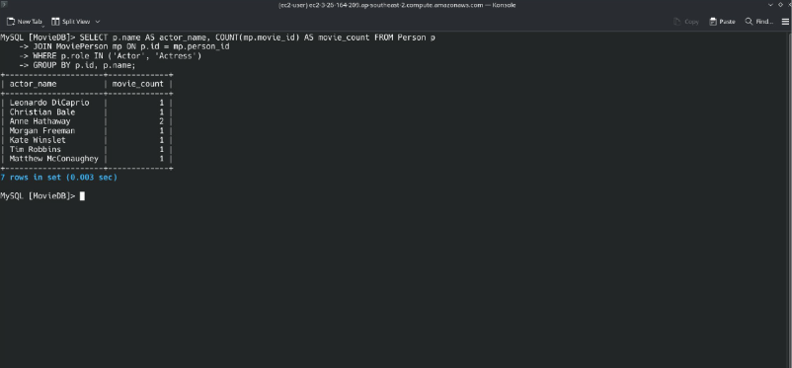
Figure 18. Q6 - Movie count for each actor and actress. The query counted movies for seven performers. Anne Hathaway appeared in two movies and each of the other six appeared in one.

Q7 Answer -:
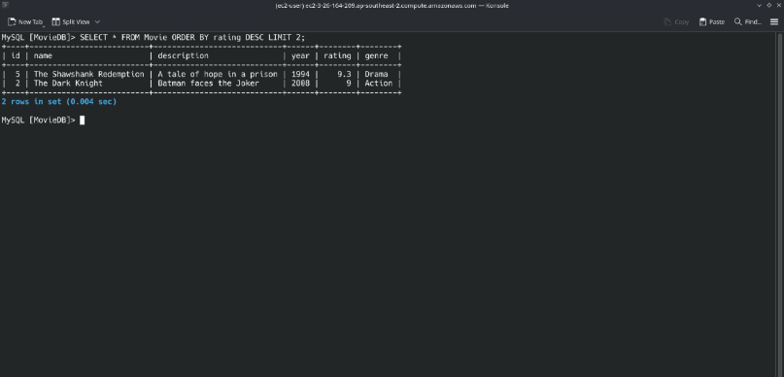
Figure 19. Q7 - The two highest-rated movies. The query sorted movies by rating in descending order and returned The Shawshank Redemption (9.3) and The Dark Knight (9.0).

Q8 Answer -:
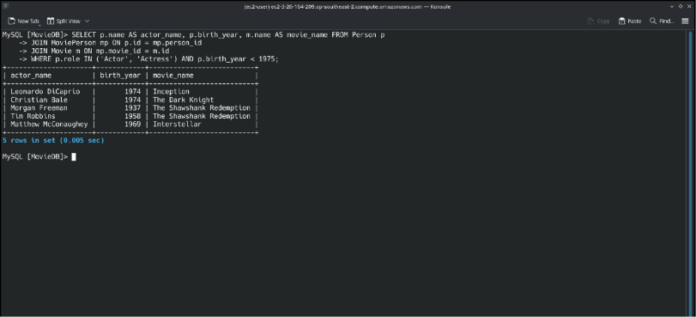
Figure 20. Q8 - Actors and actresses born before 1975 and their movies. The query returned five matches, showing each performer’s name, birth year and movie title.

Q9 Answer -:
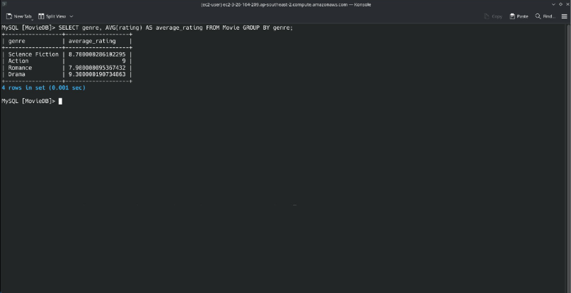
Figure 21. Q9 – Average movie rating by genre. The query used AVG(rating) to calculate the average for each genre. Rounded to one decimal place, the results were Science Fiction (8.7), Action (9.0), Romance (7.9) and Drama (9.3).

Q10 Answer -:
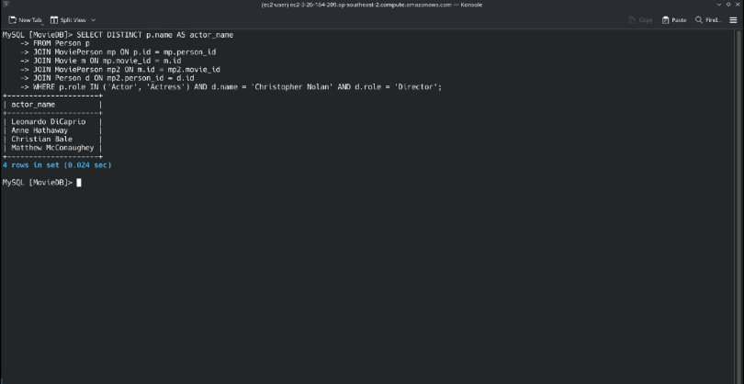
Figure 22. Q10 – Actors and actresses in Christopher Nolan’s movies. The query used DISTINCT to list four performers once each: Leonardo DiCaprio, Anne Hathaway, Christian Bale and Matthew McConaughey.

Final Output Verification -:
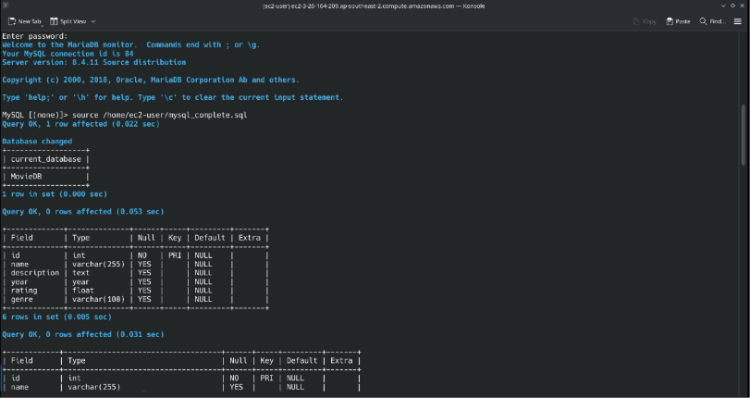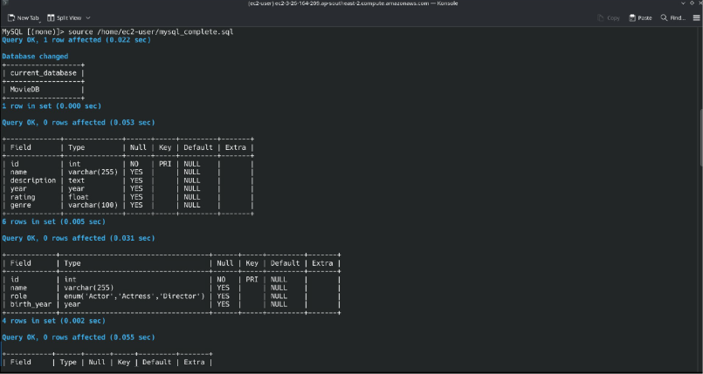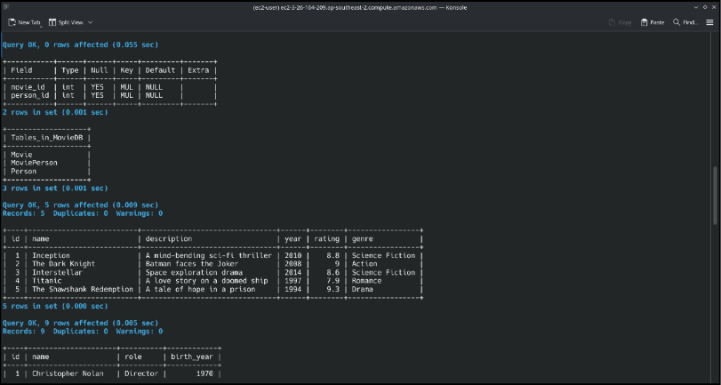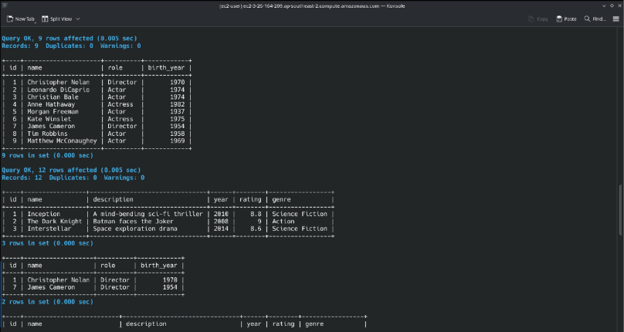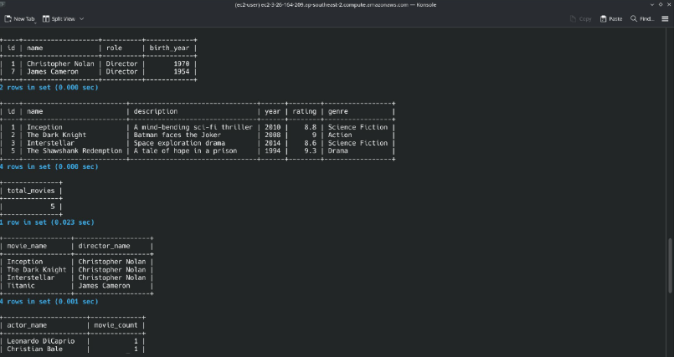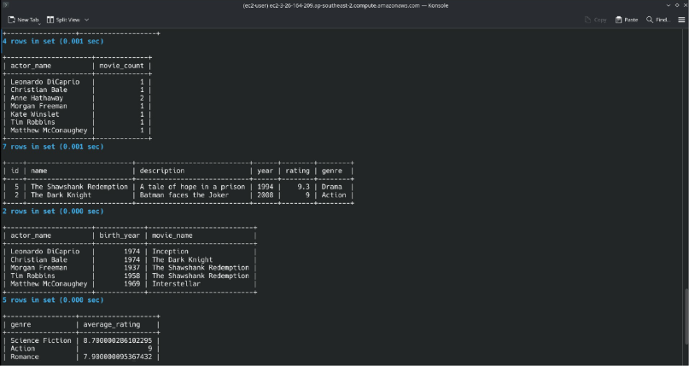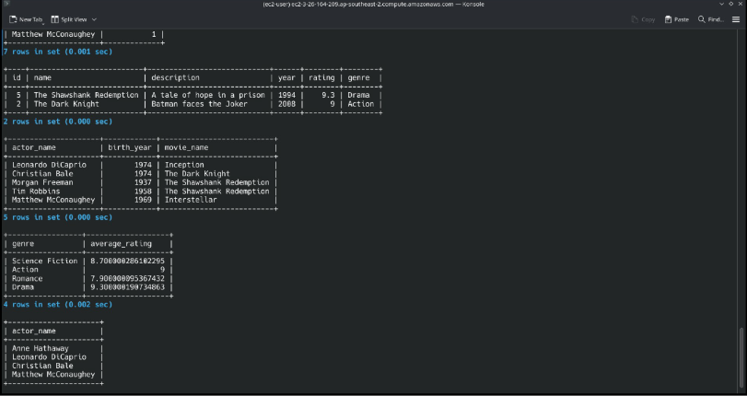
Figure 23. 7 Screenshots all together show execution of .sql file on Amazon RDS for MySQL showing the database setup, sample data insertion and results of all 10 queries.

My README.md File screenshots on how to run it (it is present in the zip file,can refer to it)
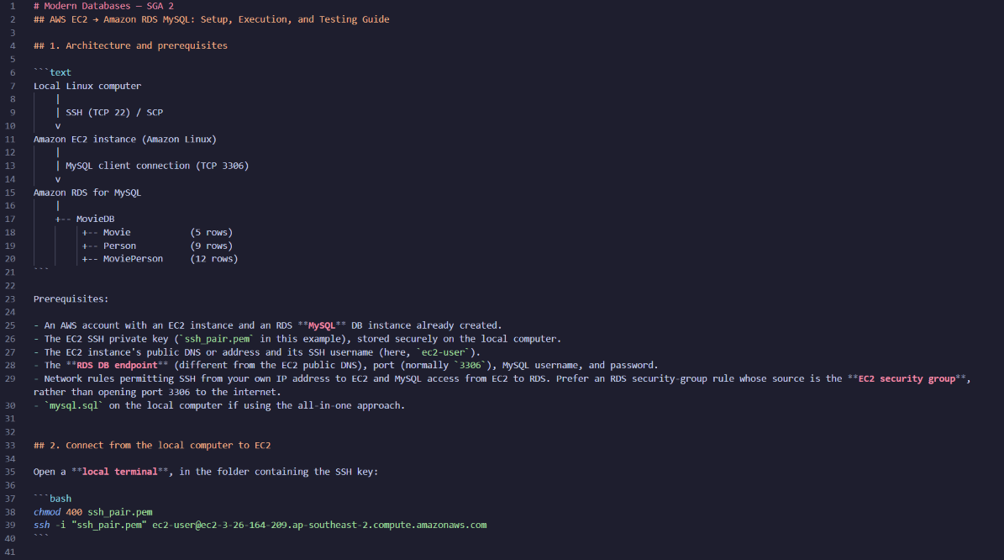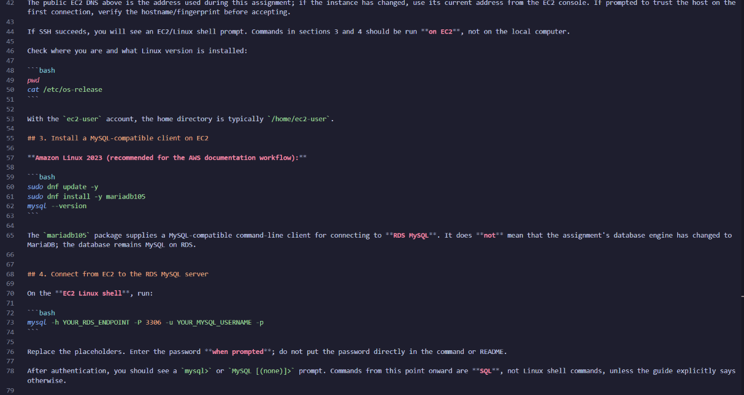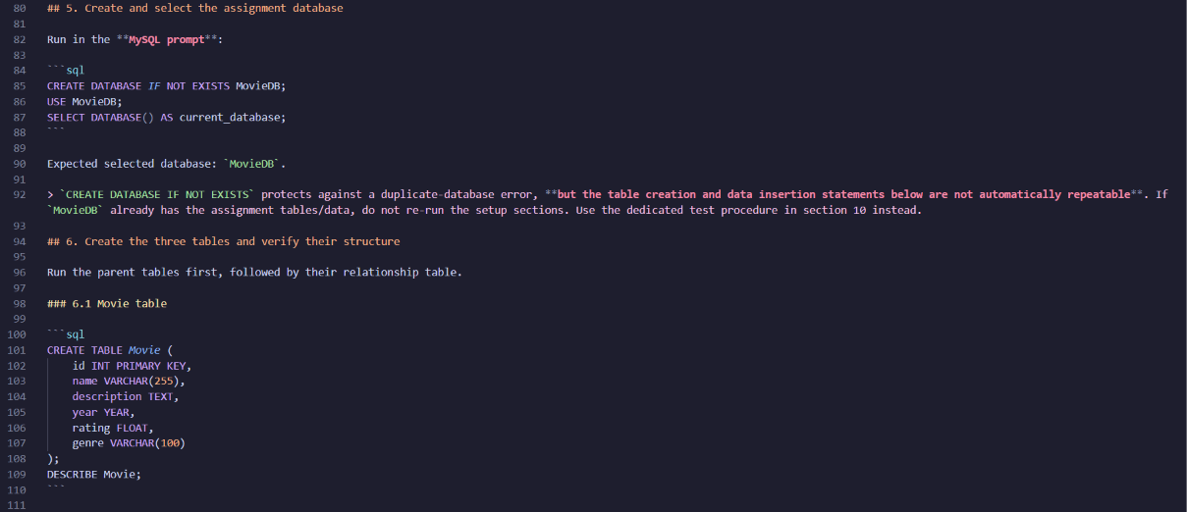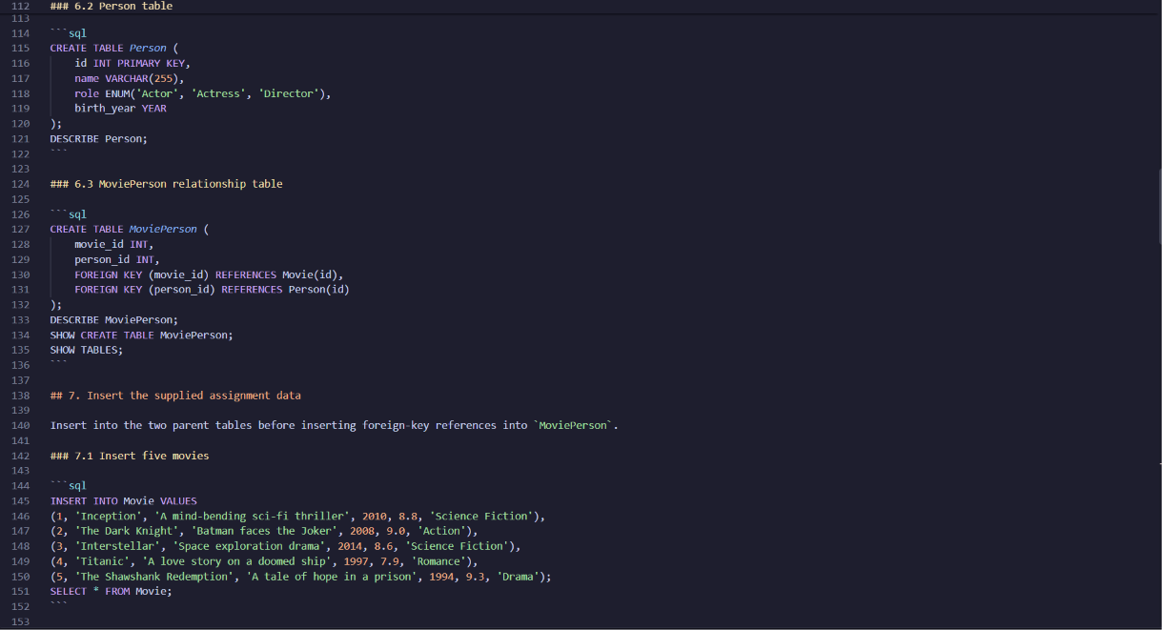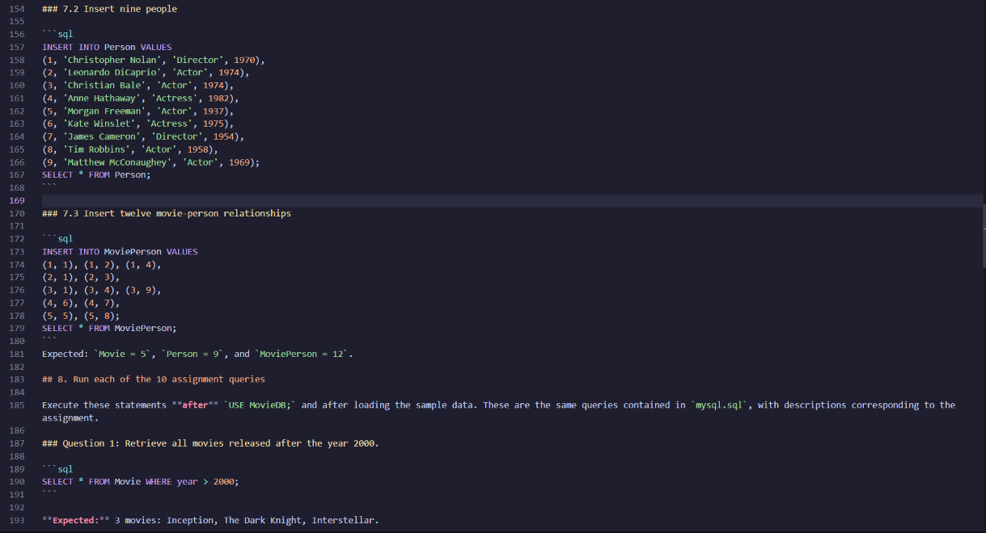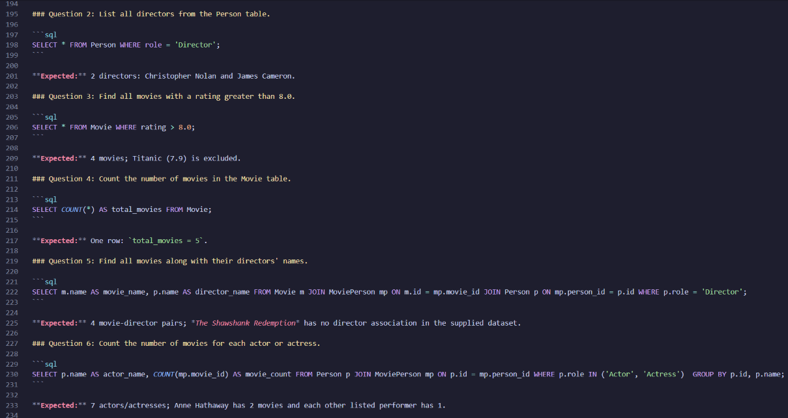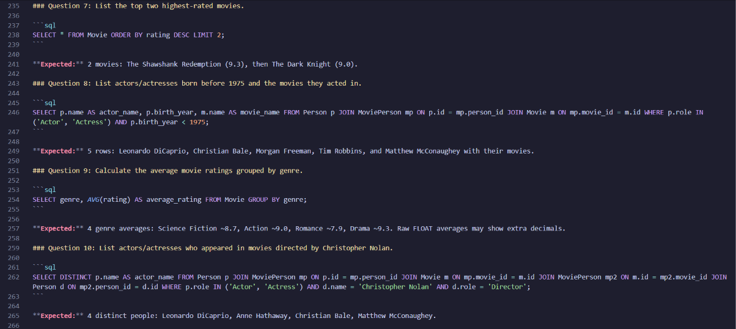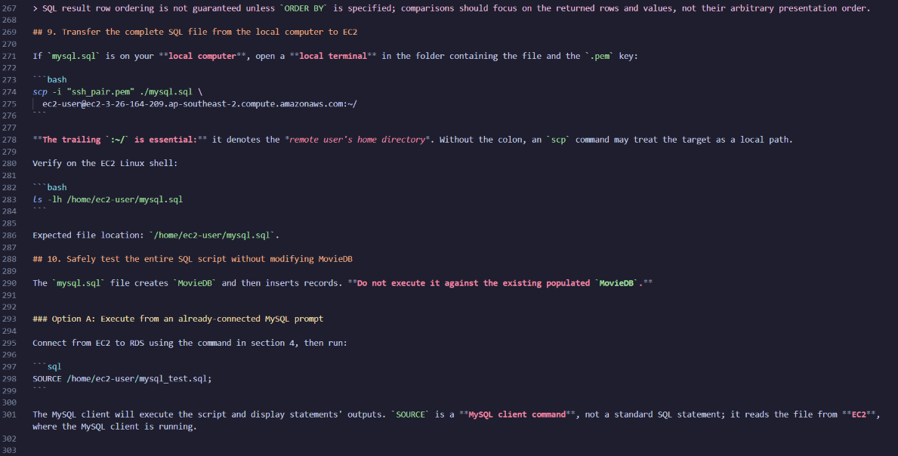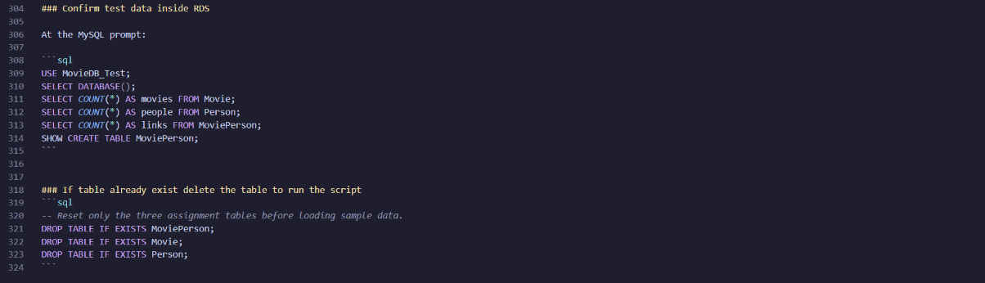
Figure 24. 9 README screenshots documenting the SSH connection to EC2, the connection to Amazon RDS for MySQL, the creation and population of MovieDB, and the execution of all ten assignment queries. The guide also explains how to transfer the SQL script to EC2 and test it in a separate database.
The screenshots show me running the script as mysql_complete.sql. I renamed it to mysql.sql for submission, and the README.md instructions use that filename. The SQL statements are the same, so please use mysql.sql from the submission ZIP when running the script.

