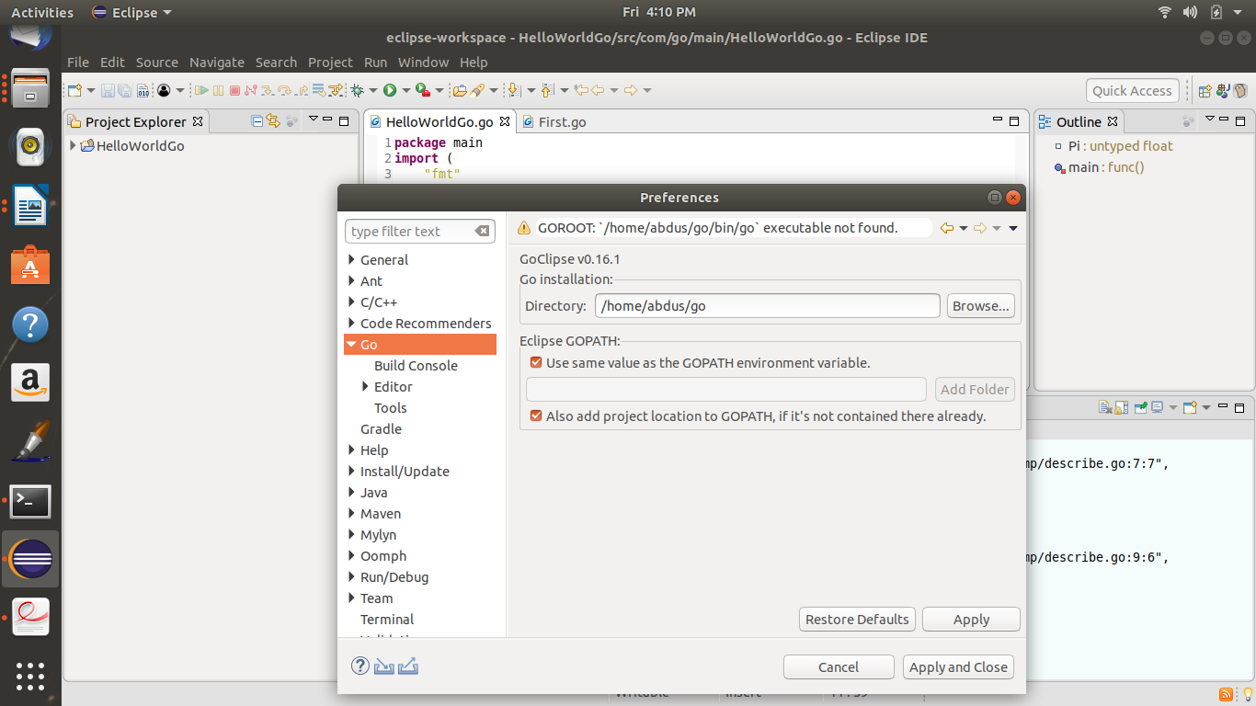
1.Setup the go language home directory in eclipse.
Go to Windows>Preference and set the below.

2.
Make sure you have the below files
/home/abdus/go/bin/gocode
/home/abdus/go/bin/guru
/home/abdus/go/bin/godef
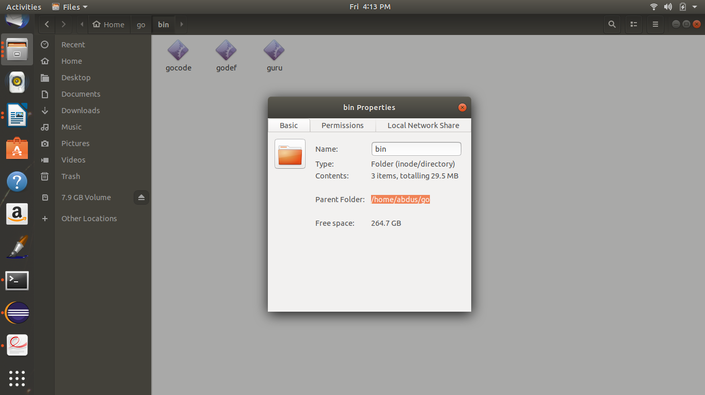

3.Set the path for gocode, guru and godef
