Sample Software Architecture Document

Mobile Banking 1.0

Bank of Tritech



SAD Revision History

Date | Version | Description | Author
2005-06-16 | 0.1 | Significant Use-Cases : the key requirements | Abdus Mondal  Architecture Team
2003-06-18 | 0.2 | Candidate architecture : the high level architecture of the system | Abdus Mondal  Architecture Team
2003-07-20 | 0.3 | Initial Deployment Model | Abdus Mondal  Architecture Team
2003-07-24 | 0.4 | Key abstractions : the key data elements used in the system | Abdus Mondal  Architecture Team
2003-08-29 | 0.5 | Analysis Model | Abdus Mondal  Architecture Team
2003-09-05 | 0.6 | Design Model | Abdus Mondal  Architecture Team
2004-09-11 | 0.7 | Concurrency mechanisms | Abdus Mondal  Architecture Team
????-??-?? | 0.8 |  | Abdus Mondal  Architecture Team

Table of Contents

1. Introduction 4
1.1 Purpose 4
1.2 Scope 5
1.3 Definitions, Acronyms and Abbreviations 5
1.4 References 5
1.5 Overview 5
2. Architectural Representation 6
3. Architectural Goals and Constraints 7
3.1 Technical Platform 7
3.2 Transaction 7
3.3 Security 7
3.4 Persistence 7
3.5 Reliability/Availability (failover) 7
3.6 Performance 8
3.7 Internationalization (i18n) 8
4. Use-Case View 8
4.1 Login Service 9
4.2 Transaction Service Use-Case 10
4.3 Use-Case Realizations 11
5. Logical View 11
5.1 Overview 11
5.2 Architecturally Significant Design Packages 15
6. Process View 17
7. Deployment View 20
7.1 Multiple Service Instances per Host Pattern 20
7.2 Service Instance per Host Pattern 20
7.3 Detail deployment view. 21
8. Implementation View 22
8.1 Overview 22
8.2 Layers 22
9. Data View 22
10. Size and Performance 23
11. Quality 23

Introduction
This document comes as a complement to develop a mobile banking solution for the Ban of Tritech Inc. It illustrates what can be the content of a Software Architecture Document (SAD) produced during the software design and architecture phase.
Each time an activity is completed, a specific section of the SAD is enriched accordingly.

Architectural activities | Software Architecture Document
Step 1 - Identify and prioritize significant Use-Cases | Section 4
Step 2 - Define the candidate architecture | Section 3, 5.1, 10, 11
Step 3 - Define the initial Deployment Model | Section 7
Step 4 - Identify key abstractions | Section 9
Step 5 - Create an Analysis Model | Section 5
Step 6 - Create the Design Model | Section 5
Step 7 - Document concurrency mechanisms | Section 6, 7
Step 8 - Create the Implementation Model | Section 8

Purpose
The Software Architecture Document (SAD) provides a comprehensive architectural overview of the Online Catering Service 1.0 offered by Yummy Inc. It presents a number of different architectural views to depict different aspects of the system. It is intended to capture and convey the significant architectural decisions which have been made on the system.

In order to depict the software as accurately as possible, the structure of this document is based on the “4+1” model view of architecture [KRU41].

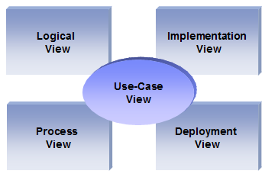
The “4+1” View Model allows various stakeholders to find what they need in the software architecture.

Scope
The scope of this SAD is to depict the architecture of the mobile banking solution aplicatin for Bank of Tritech created by the company ABC Inc.

Definitions, Acronyms and Abbreviations

UML: Unified Modeling Language
SAD: Software Architecture Document

References

[KRU41]: The “4+1” view model of software architecture, Philippe Kruchten, November 1995, http://www3.software.ibm.com/ibmdl/pub/software/rational/web/whitepapers/2003/Pbk4p1.pdf

[StarUML]: StarUML
http://staruml.io/

Overview

In order to fully document all the aspects of the architecture, the Software Architecture Document contains the following subsections.
Section 2: describes the use of each view
Section 3: describes the architectural constraints of the system
Section 4: describes the functional requirements with a significant impact on the architecture
Section 5: describes the most important use-case realization. Will contain the Analysis Model and the Design Model
Section 6: describes design’s concurrency aspects
Section 7: describes how the system will be deployed. Will contain the Deployment Model
Section 8: describes the layers and subsystems of the application
Section 9: describes any significant persistent element. Will contain the Data Model
Section 10: describes any performance issues and constraints
Section 11: describes any aspects related to the quality of service (QoS) attributes

Architectural Representation

This document details the architecture using the views defined in the “4+1” model [KRU41], but using the UML naming convention. The views used to document the Yummy Inc. application are:

Logical view
Audience: Designers.
Area: Functional Requirements: describes the design's object model. Also describes the most important use-case realizations.
Related Artifacts: Design model

Process view
Audience: Integrators.
Area: Non-functional requirements: describes the design's concurrency and synchronization aspects.
Related Artifacts: (no specific artifact).

Implementation view
Audience: Programmers.
Area: Software components: describes the layers and subsystems of the application.
Related Artifacts: Implementation model, components

Deployment view
Audience: Deployment managers.
Area: Topology: describes the mapping of the software onto the hardware and shows the system's distributed aspects.
Related Artifacts: Deployment model.

Use Case view
Audience: all the stakeholders of the system, including the end-users.
Area: describes the set of scenarios and/or use cases that represent some significant, central functionality of the system.
Related Artifacts : Use-Case Model, Use-Case documents

Data view (optional)
Audience: Data specialists, Database administrators
Area: Persistence: describes the architecturally significant persistent elements in the data model
Related Artifacts: Data model.

Architectural Goals and Constraints

This section describes the software requirements and objectives that have some significant impact on the architecture

Technical Platform

The ABC Inc online application will be deployed onto a mobile platform and a J2EE application server (Tomcat Server version 9, as it is already the application server use for internal applications).

Transaction

The ABC Inc online application is transactional, leveraging the technical platform capabilities. Transaction management model of the J2EE platform will be reused intensively.

Security

The system must be secured, so that a customer can make online payments.
The application must implement basic security behaviors:
- Authentication: Login using at least a user name and a password
- Authorization: according to their profile, online customer must be granted or not to perform some specific actions (gold customer, business partners, etc..)
For internet access, the following requirements are mandatory
- Confidentiality: sensitive data must be encrypted (credit card payments)
- Data integrity : Data sent across the network cannot be modified by a tier
- Auditing: Every sensitive action can be logged
- Non-repudiation : gives evidence a specific action occurred
Spring security model will be reused

Persistence

Data persistence will be addressed using a relational database.

Reliability/Availability (failover)

The availability of the system is a key requirement by nature, as it is a selling system. The candidate architecture must ensure failover capabilities. Reliability/Availability will be addressed through the J2EE platform
Targeted availability is 24/7: 24 hours a day, 7 days a week
The time left (8 hours) is reserved for any maintenance activities

Performance

The payment process (payment authorization and confirmation) must be under 10 seconds.

Internationalization (i18n)

The online catering service of ABC Inc must be able to deal with several languages (at least Hindi and English)
So the presentation layer must be able to support i18n.
Other layers must be generic enough to work with any internationalization context

Use-Case View

This section lists use cases or scenarios from the use-case model if they represent some significant, central functionality of the final system. The only use-case with a significant impact on the mobile banking architecture is the one related to online payment. It includes an IMPS payment feature as well as a call to external services (delivery and payment)

Some of the use case which could be implemented as a micro service
- Login Service
- Transaction Service
- Card Service
- Loan Service
- Account Service
- Shopping Service
- Alert Service
- IVR Service
- Admin Service
- Bill payment service

Login Service

A customer accesses the core banking application through the mobile application. Once customer is registered and authenticated with the existing sub system, every time user wan to access the core banking system the login service is used
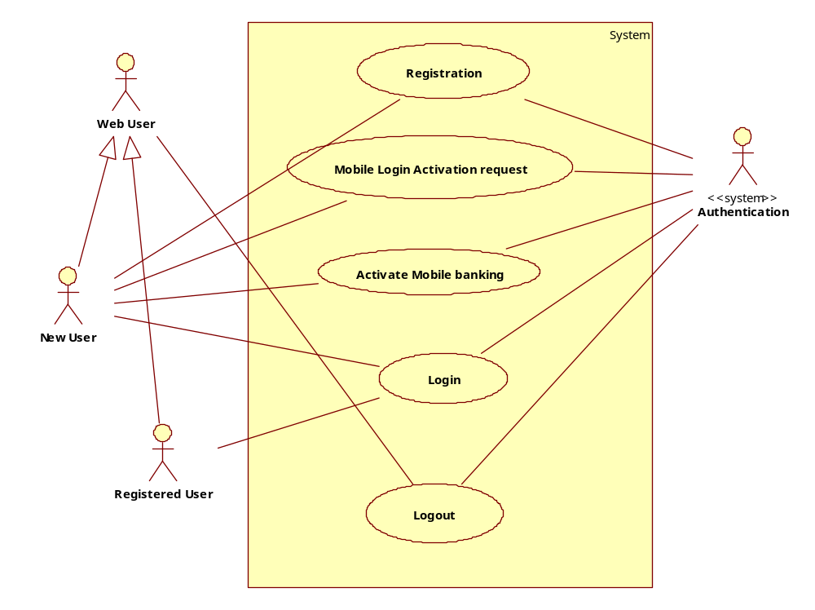

Registration
Brief Description: This use case allows a user to register for mobile banking for the existing core or internet banking. To registrar in the mobile banking system, user should have valid account with the bank.

Mobile Banking Login Activation
Brief Description: To get access to the mobile banking system user should activate their mobile no and follow the steps to get the access to mobile banking system.

Activate Mobile Banking access
Brief Description: Once user raise the request to get the access to the mobile banking, back send a message or email to activate the account. In this process there are some steps which user needs to follow.

Login
Brief Description: Once the user has installed the mobile banking app into their device, and user has internet data connection , user can login to the mobile banking system

Logout
Brief Description: To logout from the system, user t click the logout button in the mobile banking app. After logout, user should not be able to access the mobile banking system anymore.

Transaction Service Use-Case
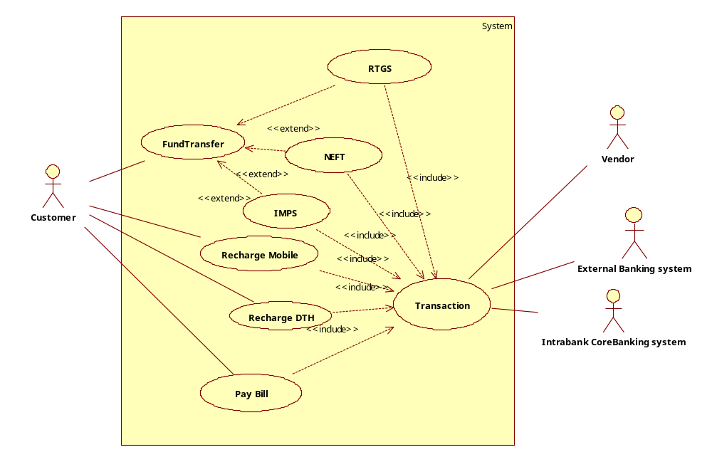

Fund Transfer
Brief Description: This shall do the fund transfer from user’s account to any destination account in any bank

RTGS Transfer
Brief Description: This is one type of transfer which could be transfer money within 30 min

NEFT Transfer
Brief Description: This in one type of transfer which could transfer money in a day

IMPS Transfer
Brief Description: This is one type of fund transfer which could transfer from one mobile to another mobile using mobile payment gateway

Recharge Mobile
Brief Description: This is a utility service provided in the mobile banking system. To pay the recharge charge the system use the fund transfer service

Recharge DTH
Brief Description: Similar to recharge mobile, user can recharge DTH using the mobile banking. So the recharge DTH use the Fund transfer service

Pay Bill
Brief Description: This use case is similar to the recharge DTH or Recharge Mobile.

Note: Similar to these Login Service and Fund Transfer Service we can draw the use cases for other services.

Use-Case Realizations
Refers to section 5.2 to see how design elements provide the functionalities identified in the significant use-cases.

Logical View
A description of the logical view of the architecture. Describes the most important classes, their organization in service packages and subsystems, and the organization of these subsystems into layers. Also describes the most important use-case realizations, for example, the dynamic aspects of the architecture. Class diagrams may be included to illustrate the relationships between architecturally significant classes, subsystems, packages and layers.
The logical view of the fund transfer system is comprised of the 3 main packages: User Interface, Business Services, and Business Objects.
The User Interface Package contains classes for each of the forms that the actors use to communicate with the System. Boundary classes exist to support login, maintaining of schedules, maintaining of professor info, avail the account service, Card Service, Loan Service, Account Service, Shopping Service, Alert Service, IVR Service, Admin Service, Bill payment service.
The Business Services Package contains control classes for interfacing with the different services and sub system, such as Card Service, Loan Service, Account Service, Shopping Service, Alert Service, IVR Service, Admin Service, Bill payment service
The Business Objects Package includes entity classes for the different service artifacts (i.e. Card Service, Loan Service, Account Service, Shopping Service, Alert Service, IVR Service, Admin Service, Bill payment service) and boundary classes for the interface with the sub system.

Overview

The Mobile Banking application is divided into layers based on the N-tier architecture
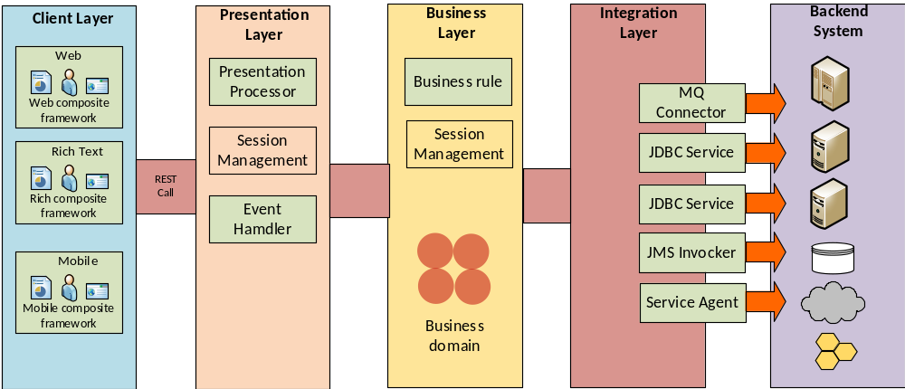

The layering model of the Mobile Banking application is based on a responsibility layering strategy that associates each layer with a particular responsibility.
This strategy has been chosen because it isolates various system responsibilities from one another, so that it improves both system development and maintenance.

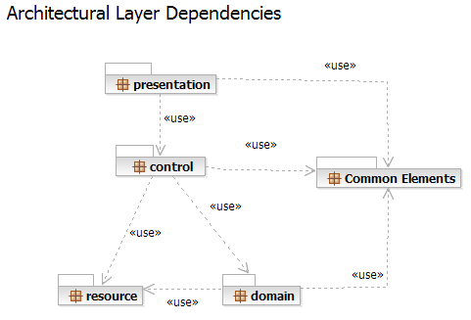

Each layer has specific responsibilities.
- The presentation layer deals with the presentation logic and the pages rendering
- The control layer manages the access to the domain layer
- The resource layer (integration layer) is responsible for the access to the enterprise information system (databases or other sources of information)
- The domain layer is related to the business logic and manages the accesses to the resource layer.
- The Common Elements layer gathers the common objects reused through all the layers

The Mobile Banking application version 1.0 is quite simple and only contains the basic features like registration and login, payment service, fund transfer service, security service, account service etc.
External services are reused fro the payment and the delivery functionalities.
Package and subsystem layer
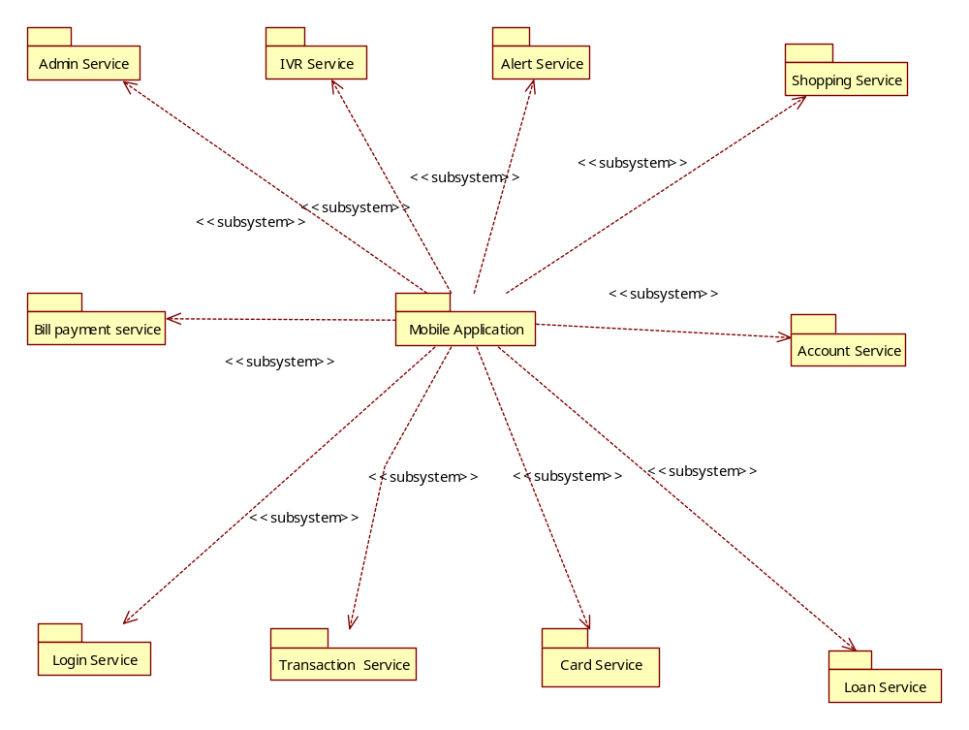

Package diagram
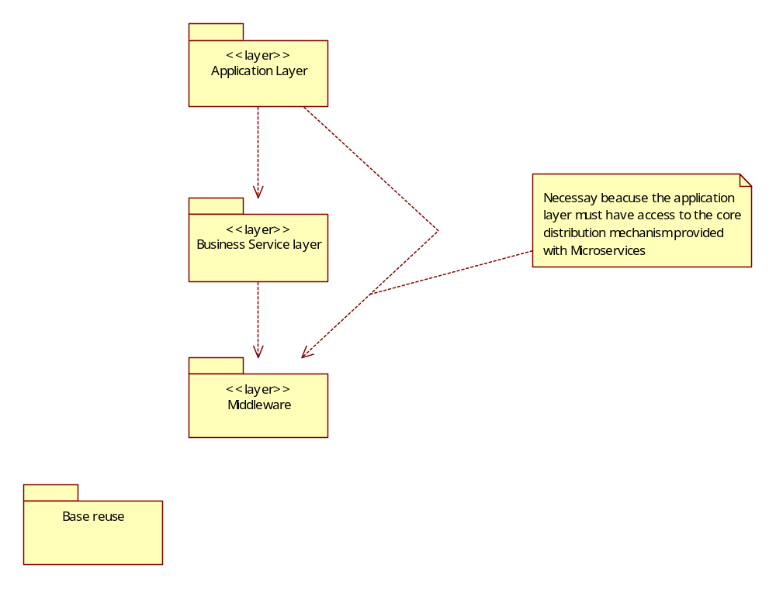
5.1.1 Application layer
This application layer has all the boundary classes that represent the application screens that the user sees. This layer depends upon the Process Objects layer; that straddles the separation of the client from mid-tier.
5.1.2 Business Services layer
The Business Services process layer has all the controller classes that represent the use case managers that drive the application behavior. This layer represents the client-to-mid-tier border. The Business Services layer depends upon the Process Objects layer; that straddles the separation of the client from mid-tier.
5.1.3 Middlewarelayer
The Middleware layer supports access to Relational DBMS and OODBMS.
5.1.4 Base Reuse
The Base Reuse package includes classes to support list functions and patterns.

Architecturally Significant Design Packages

Fund Transfer Service

This package is responsible for all the logic related to the online orders. It provides ordering features and the necessary components to access the external services (Payment and Delivery)

Analysis Model

Interaction and responsibilities diagram

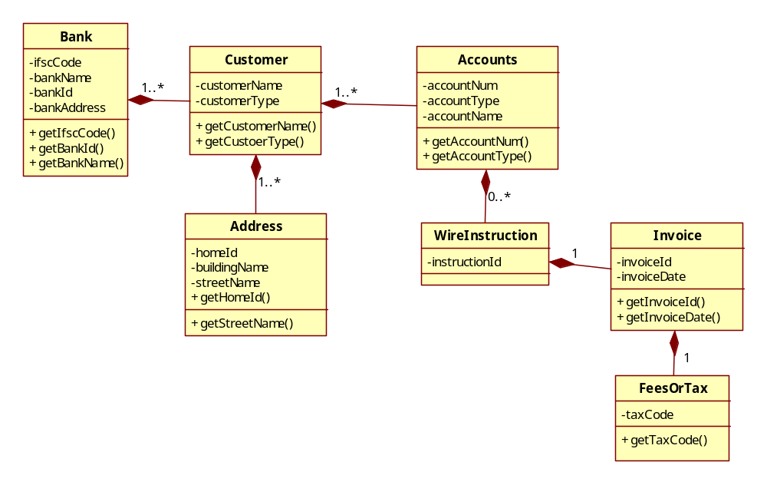

Basic Flow:

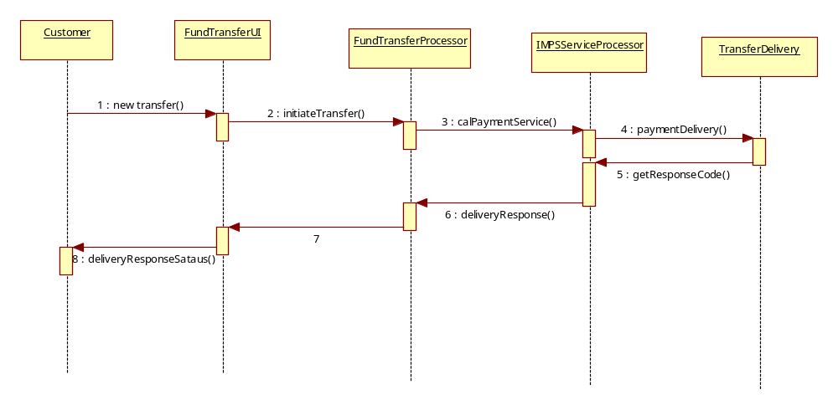

Design Model

Account Service
Contains all the logic related to the customer’s account service.
The Account Service is an external subsystem documented in its own Software Architecture Document

IVR Service
Contains all the logic related to the IVR System
The IVR Service is an external subsystem documented in its own Software Architecture Document.

Process View
A description of the process view of the architecture. Describes the tasks (processes and threads) involved in the system's execution, their interactions and configurations. Also describes the allocation of objects and classes to tasks.
The Process Model illustrates the fun transfer classes. Processes exist to support customer registration, loan payments, bill payments, and access to the external Shopping systems.

Below we are showing the processing involved in the fund transfer service.The J2EE model automatically handles threads which are instances of this process.
Participants:
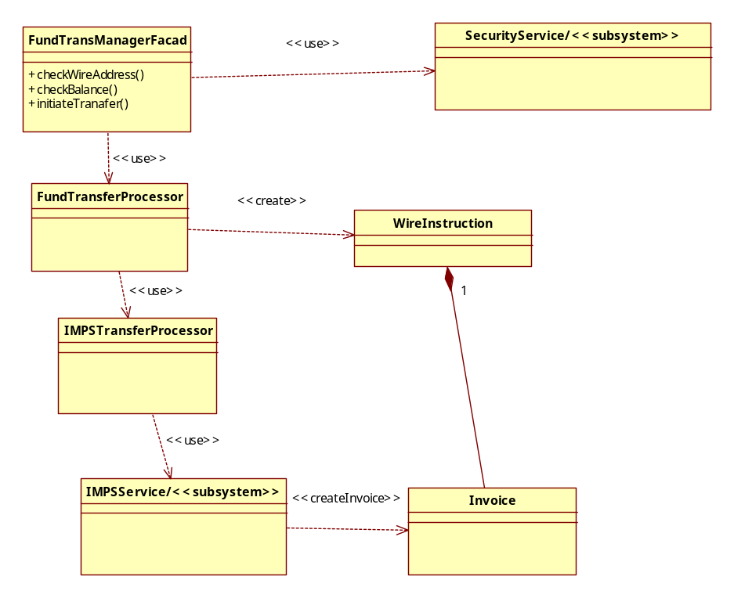

6.1.1 Fund TransferManagerFacad
This process manages access to the different types of fund transfer processors. It can be shared by multiple users doing the fund transfer.
Analysis Mechanisms:
- Legacy Interface
Requirements Traceability:
- Design Constraints: The system shall integrate with existing legacy system (core banking system).

6.1.2 FundTransferProcessor
This is the common Processor for all types of fund transfer.

6.1.3 SecurityServiceProcess
There is one instance of this process for each customer that is currently doing the fund transfer. It checks if the customer has the proper access privilege to transfer the funds.

6.1.4 IMPSTransferProcessor
This supports the use case allowing a customer to transfer funds using IMPS protocol, which is faster than NIFT.
This is Analysis Mechanisms:
- Distribution

6.1.5 IMPSService
Manages the IMPS Transfer processor functionality, including customer transfer processing and coordination with the business processes.
There is one instance of this process for each customer that is currently initiated the fund transfer.

6.1.6 WireInstruction
The main class for each initiated fund transfer. This is the instance per fund transfer.

6.1.7 Invoice
This process is the response of the each transaction which take place during the fund transfer.

Process Model to Design Model Dependencies
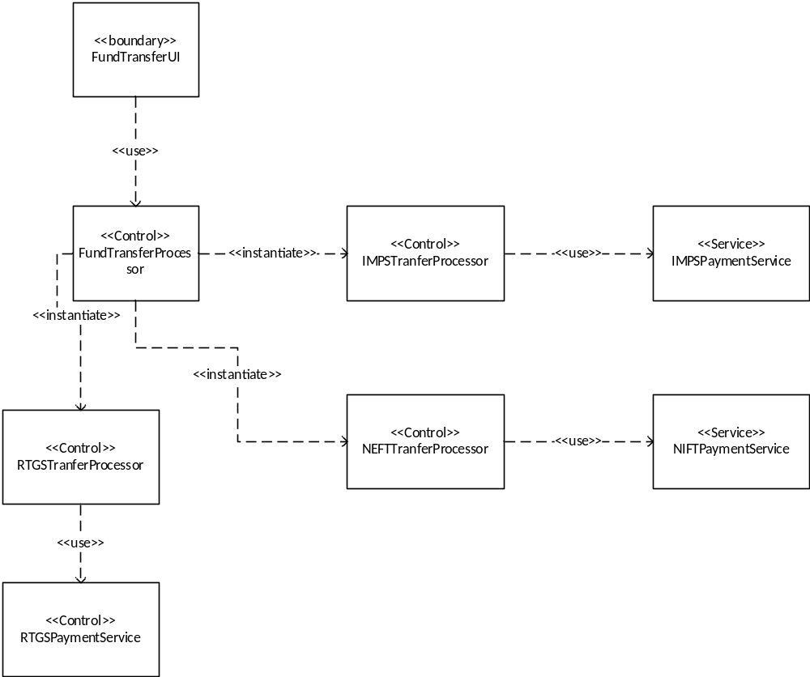

Deployment View
Global Overview

Multiple Service Instances per Host Pattern
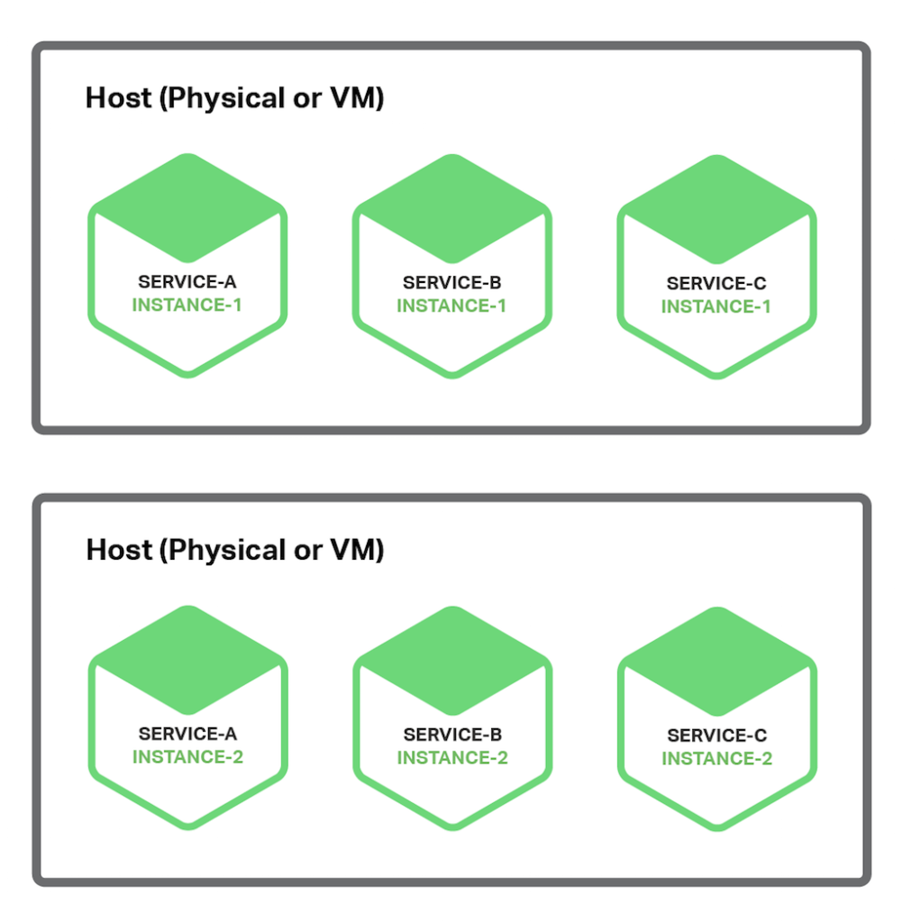

Service Instance per Host Pattern

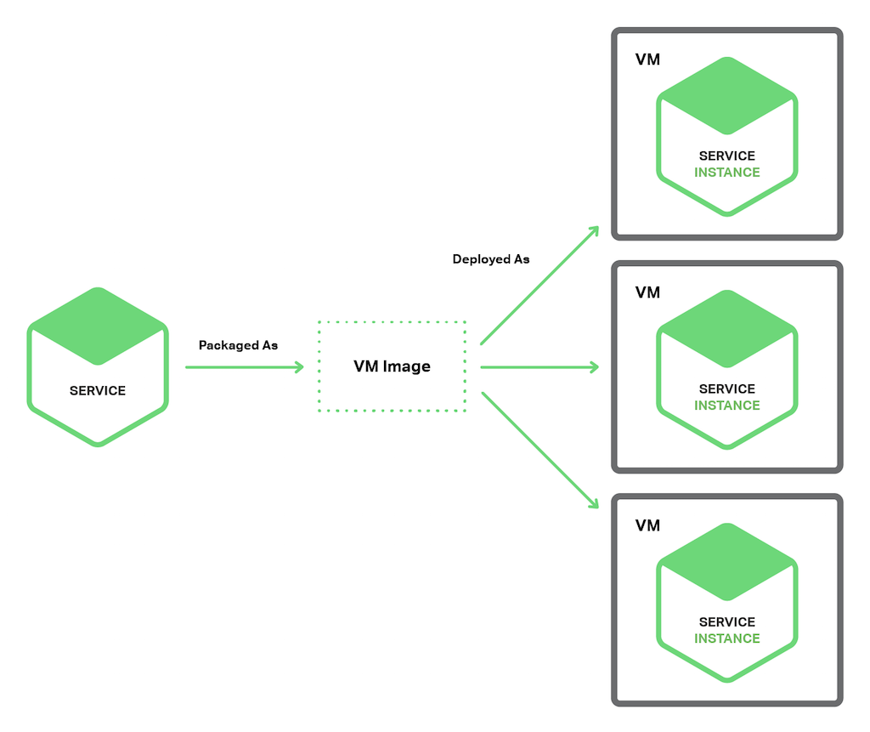

Detail deployment view.

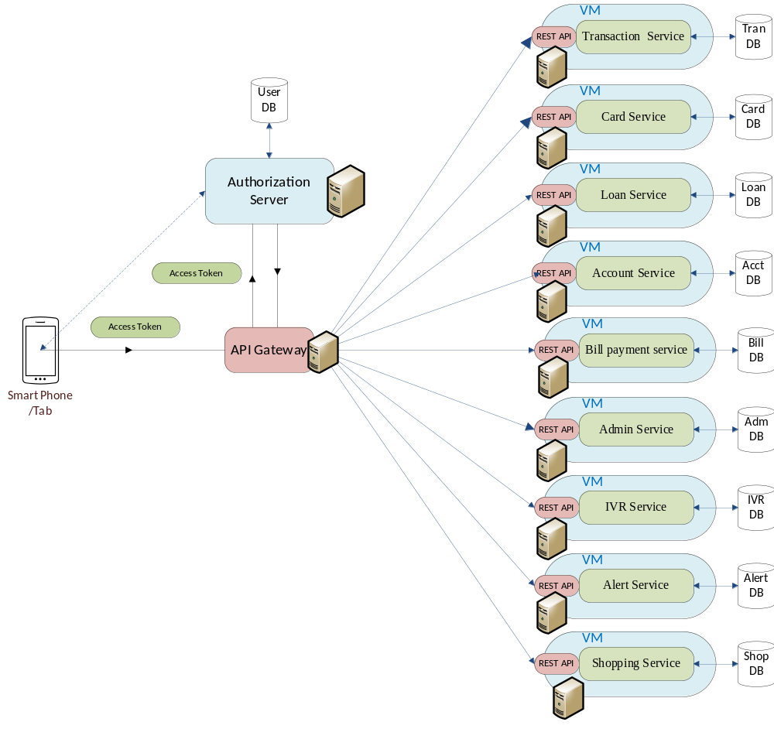

The services are deployed in separate VM. However, there are different options which we can think of , like single VM could host multiple services or each service is hosted in a single JVM. Each service is a microservice having it’s own database. Also the services are accessed by the REST call.

Implementation View

Overview

The Implementation view depicts the physical composition of the implementation in terms of Implementation Subsystems, and Implementation Elements (directories and files, including source code, data, and executable files).
Usually, the layers of the Implementation view do fit the layering defined in the Logical view

It is unnecessary to document the Implementation view in great details in this document. For further information, refer to the Online Catering Service 1.0 workspace in Rational Software Architect.

Layers

Presentation Layer
The Presentation layer contains all the components needed to allow interactions with an end-user. It encompasses the user interface

Control Layer
The Control layer contains all the components used to access the domain layer or directly the resource layer when this is appropriate.

Resource Layer
The Resource layer contains the components needed to enable communication between the business tier and the enterprise information systems (Database, external services, ERP, etc…)

Domain layer
The Domain layer contains all the components related to the business logic. It gathers all the subsystems that meet the needs of a particular business domain. It also contains the business object model.
.

Common Elements Layer
The Common Element layer contains the components re-used within several layers.

Data View

The key data elements related to the Mobile Banking system and their interactions are:
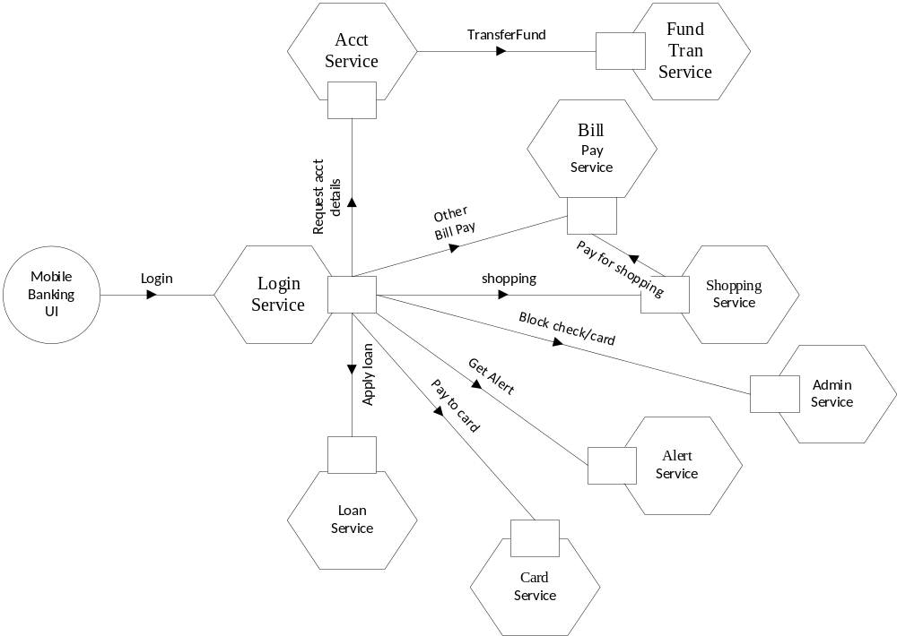

Size and Performance
The chosen software architecture supports the key sizing and timing requirements, as stipulated in the Supplementary Specification:
- The system shall support up to 2000 simultaneous users against the central database at any given time, and up to 500 simultaneous users against the local servers at any one time.
- The system shall provide access to the legacy core banking database with no more than a 10 second latency.
- The system must be able to complete 80% of all transactions within 2 minutes.
- The client portion shall require less than 20 MB disk space and 32 MB RAM.
The selected architecture supports the sizing and timing requirements through the implementation of a micro service architecture. The client portion is implemented as a mobile application and hosted in the customer’s mobile device having minimum hardware and data connection.

Quality

As far as the online catering application is concerned, the following quality goals have been identified:

Scalability:
- Description : System’s reaction when user demands increase.
- Solution:: As the system is designed as microservice architecture, it can be horizontally scalable at any point of time using Docker and elastic cloud infra structure.
Reliability, Availability:
- Description : Transparent failover mechanism, mean-time-between-failure
- Solution : : J2EE application server supports load balancing through clusters. Also the application can be easily scalable using Docker and elastic cloud infrastructure.
Portability:
- Description : Ability to be reused in another environment
- Solution : The system me be fully J2EE compliant and thus can be deploy onto any J2EE application server using Docker and various cloud infrastructure.
Security:
- Description : Authentication and authorization mechanisms
- Solution : J2EE native security mechanisms will be reused, to connect with the external vendor service such as mobile recharge, online shopping service SSL will be used. And for internal token based security authentication like OAuth will be used. For Authorization, a separate database will be maintained.

