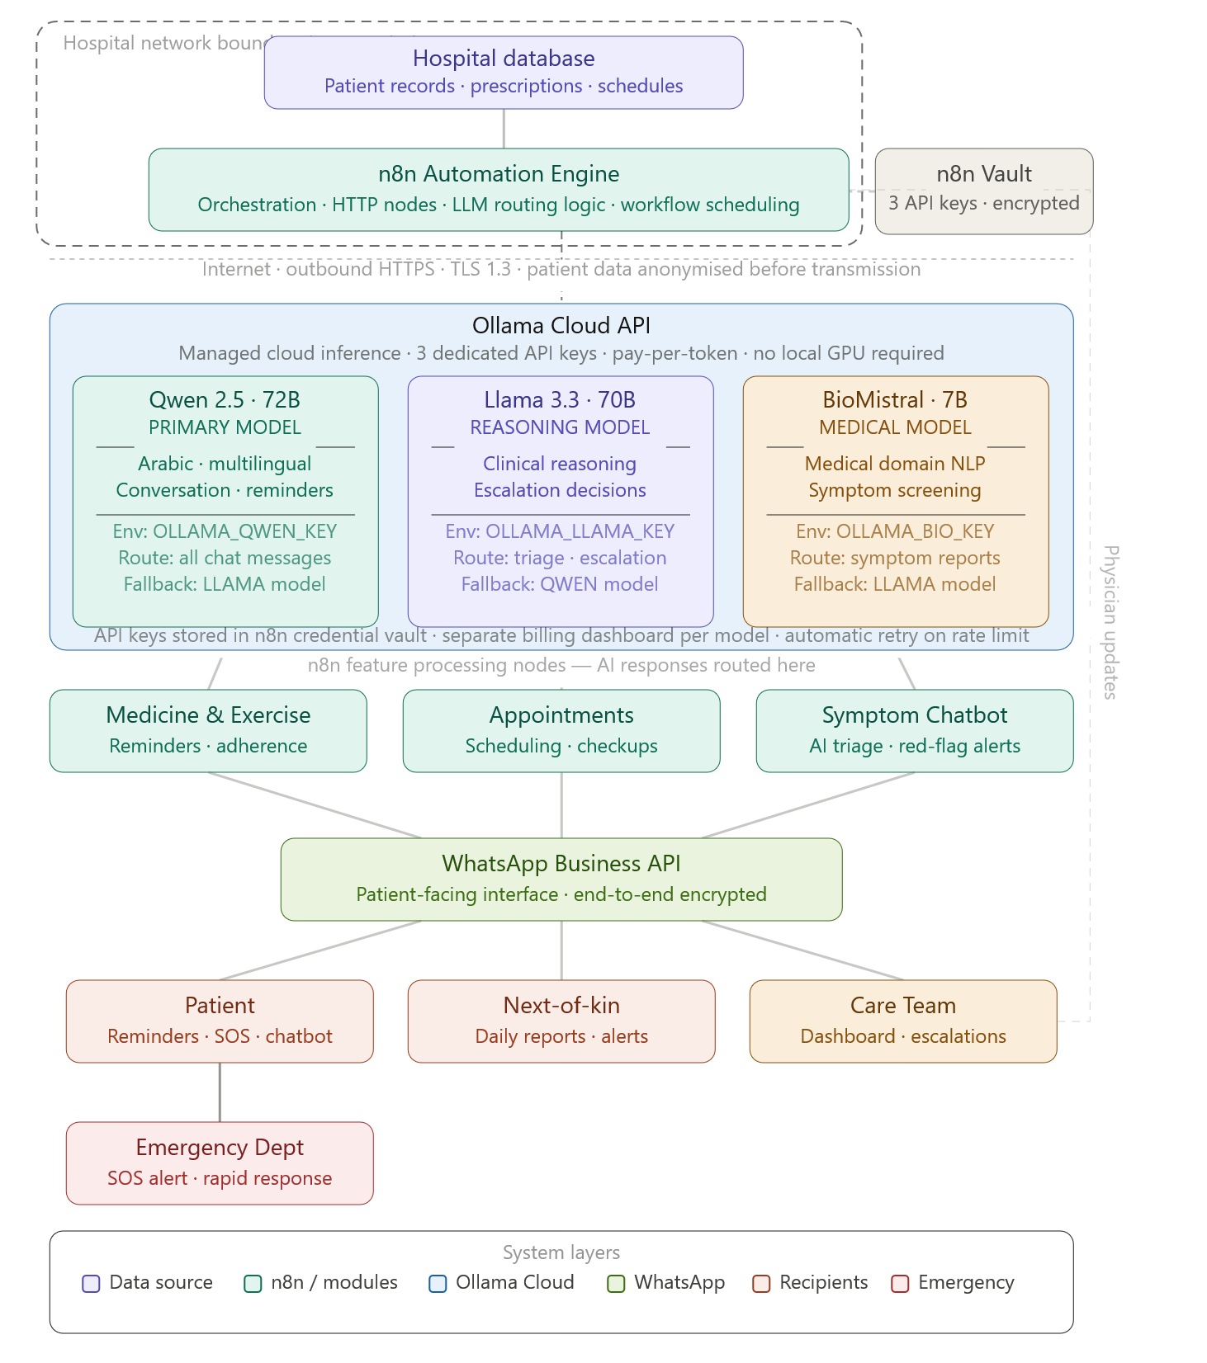
What changed in this architecture
The Ollama LLM layer now sits outside the hospital network boundary, connected via outbound HTTPS from n8n. Three important additions: the n8n Credential Vault (top right) stores all three API keys encrypted within your on-premise infrastructure, never in cloud config files. Each model box now shows its environment variable name, routing trigger, and fallback model in case of API failure. The feature modules are coloured teal to visually reinforce they are n8n workflow nodes, not separate servers.

Next Steps — Detailed Implementation Plan
Phase 1 — Accounts & API Access (Week 1–2)
Step 1: Register on Ollama Cloud Go to ollama.com and create an organisational account for the hospital. Choose the pay-per-token billing plan (no upfront commitment, ideal for piloting). Generate three separate API keys from the dashboard — one per model — and name them exactly: OLLAMA_QWEN_KEY, OLLAMA_LLAMA_KEY, OLLAMA_BIO_KEY. Request access to Qwen 2.5 72B, Llama 3.3 70B, and BioMistral 7B specifically — not all models are available on cloud by default and may require activation.
Step 2: Sign a Data Processing Agreement (DPA) with Ollama Before sending any patient data, your legal and compliance team must sign a DPA. Request Ollama's healthcare DPA template. If one is not available, negotiate a custom BAA (Business Associate Agreement). This is non-negotiable under Saudi PDPL and standard healthcare regulations. Until this is signed, only test with synthetic (fake) patient data.
Step 3: Apply for WhatsApp Business API Register through a verified WhatsApp Business Solution Provider (BSP) — recommended: Twilio, 360dialog, or Vonage. Hospital entities in Saudi Arabia typically take 7–14 days for Meta verification. You will need: a verified business phone number, a Facebook Business Manager account, and hospital trade licence documentation.

Phase 2 — n8n Setup & LLM Integration (Week 2–4)
Step 4: Deploy n8n on hospital server Install n8n on an on-premise server (a standard Ubuntu 22.04 server with 16GB RAM is sufficient for the orchestration layer alone — the heavy compute is now in Ollama Cloud). Use the Docker deployment method for easier maintenance. Configure n8n to use HTTPS with a valid SSL certificate.
Step 5: Store API keys in n8n Credential Vault In n8n, navigate to Settings → Credentials. Create three separate "HTTP Header Auth" credentials, one per Ollama model. Store as Bearer tokens. Never hardcode keys in workflow JSON — always reference credentials by name.
Step 6: Build the LLM routing logic in n8n Create a reusable sub-workflow called LLM Router. It accepts two inputs: task_type (conversation / escalation / symptom) and payload (the patient message + context). Using an IF/Switch node, it routes to the appropriate Ollama Cloud HTTP node. Each HTTP node is pre-configured with the model endpoint, the correct API key credential, and a standardised system prompt for that model's role.
Step 7: Build the data anonymisation middleware node Before any payload is sent to Ollama Cloud, insert a Code node in n8n that strips or hashes: patient full name → hashed ID, phone number → removed, physician name → removed, exact address → removed. The AI receives only: age range, gender, condition category, medication names, and the patient's message text. Real identifiers are never transmitted to the cloud.
Step 8: Configure the three system prompts Each model needs a precisely crafted system prompt loaded at the start of every API call. Draft these with your clinical team:
- Qwen prompt: warm, family-member tone, bilingual (Arabic/English), never diagnose, always encourage
- Llama prompt: structured clinical reasoning, decision criteria for escalation, output in JSON format for n8n parsing
- BioMistral prompt: medical symptom classification, risk stratification (low/medium/high), one-word severity output

Phase 3 — Hospital Database Integration (Week 3–5)
Step 9: Map the hospital database schema Work with your IT team to identify the exact tables and fields for: patient demographics, prescriptions (medicine name, dose, frequency, duration, timing instruction), appointments, lab schedules, and physician assignments. Document the API or database connection method n8n will use (REST API, direct SQL, or HL7 FHIR interface — whichever your HIS supports).
Step 10: Build the daily data pull workflow in n8n Create a scheduled n8n workflow (cron: 11:00 PM daily) that pulls the next day's patient schedule from the hospital database, transforms it into a structured JSON per patient, and stores it in n8n's internal data store ready for morning reminder execution.

Phase 4 — Patient Onboarding Flow (Week 4–6)
Step 11: Build the WhatsApp onboarding conversation Design and implement the first-contact conversation flow: welcome message → consent collection (explicit yes/no) → daily routine questionnaire (wake time, meal times, exercise window, sleep time). Store responses per patient. This is the flow that runs exactly once per patient when they are first enrolled.
Step 12: Build the routine reminder engine Using each patient's stored routine, compute the exact send times for each medicine reminder. Build the n8n trigger logic: for a medicine prescribed "30 minutes before breakfast", the reminder fires at (patient's breakfast time minus 30 minutes). Test with 5–10 synthetic patient profiles before live use.

Phase 5 — Testing & Pilot (Week 6–10)
Step 13: Internal staff pilot (2 weeks) Before enrolling real patients, run the complete system with 10–15 hospital staff volunteers acting as mock patients. Test every scenario: medicine reminders, exercise check-ins, appointment reminders, symptom chatbot, SOS trigger, next-of-kin notifications. Document every failure and fix.
Step 14: Controlled patient pilot (2 weeks) Enrol 20–30 consenting patients from a single ward or condition group (e.g., post-discharge diabetes patients). Monitor daily. Assign a dedicated coordinator to manually review every AI response for clinical appropriateness. Collect patient feedback weekly.
Step 15: Clinical review and model tuning After the pilot, your medical team reviews all escalation decisions made by Llama 3.3 70B and all symptom triage outputs from BioMistral 7B. For any errors, refine the system prompts. This is the most important quality gate before scale-up.

Phase 6 — Go-Live & Monitoring (Week 10 onwards)
Step 16: Set up cost and usage monitoring Each of the three Ollama Cloud billing dashboards should have spending alerts configured. Estimate: at pilot scale (30 patients, 10 messages/day each), expect roughly $15–40/day across all three models. At full hospital scale (2,000 patients), re-evaluate pricing tiers and consider negotiating a volume contract.
Step 17: Build the care team dashboard A simple web dashboard (can be built as an n8n webhook-powered interface or a connected tool like Grafana or Retool) showing: daily adherence rates per patient, escalation queue, unanswered SOS alerts, and model API health status.
Step 18: Establish the ongoing governance cycle Monthly: clinical team reviews AI escalation accuracy. Quarterly: system prompt refinement based on real conversation data. Annually: re-evaluate whether to migrate to local hardware (as your patient volume grows, on-premise inference will become more cost-effective than pay-per-token cloud).

Click any box in the architecture diagram to generate the specific n8n configuration for that component. I can also draft the system prompts for each model, the WhatsApp onboarding conversation script, or the data anonymisation code node — just say which you need first.

