Name: Khan Abdur Rahman Roll No.: 231814 Batch: A Class: BE CSE IoTCSBC
Practical No. 1:-
AIM:-
To build a Logistic Regression model to predict whether a person has diabetes and compare model performance before and after selecting the top five most important features.
THEORY:-
Feature selection is the process of selecting the most relevant input variables before training a machine learning model. Real-world datasets often contain irrelevant or less useful features that increase computational cost and may reduce prediction performance due to noise. By selecting only important features, the model becomes simpler, faster, and easier to interpret. Feature selection methods are broadly classified into filter, wrapper, and embedded methods. In this practical, the filter-based SelectKBest method with the ANOVA F-test (f_classif) is used to assign a statistical score to every feature and automatically select the five most important features.
Logistic Regression is a supervised machine learning algorithm used for binary classification problems where the output belongs to one of two classes. Although it contains the word regression, it is mainly a classification algorithm because it predicts the probability of belonging to a class using the sigmoid function. In this practical, the Pima Indians Diabetes dataset is divided into training and testing data. A Logistic Regression model is first trained using all available features and its accuracy is calculated. Afterwards, the top five features selected using SelectKBest are used to train another Logistic Regression model. Finally, both models are compared to determine whether feature selection can reduce model complexity while maintaining similar prediction accuracy.
TOOLS REQUIRED:-
- Python 3.x
- Pandas
- Scikit-learn
- Internet connection
- VS Code / Jupyter Notebook
STEPS / PROCEDURE:-
- Import required libraries.
- Load the dataset.
- Separate input and output.
- Split dataset into training and testing sets.
- Train Logistic Regression using all features.
- Calculate accuracy.
- Select top 5 features using SelectKBest.
- Train another Logistic Regression model using selected features.
- Compare both accuracies.
PROGRAM:-
import pandas as pd
from sklearn.model_selection import train_test_split
from sklearn.linear_model import LogisticRegression
from sklearn.metrics import accuracy_score
from sklearn.feature_selection import SelectKBest, f_classif
columns=['Pregnancies','Glucose','BloodPressure','SkinThickness','Insulin','BMI','DiabetesPedigreeFunction','Age','Outcome']
df=pd.read_csv("https://raw.githubusercontent.com/jbrownlee/Datasets/master/pima-indians-diabetes.data.csv",names=columns)
X=df.drop('Outcome',axis=1)
y=df['Outcome']
X_train,X_test,y_train,y_test=train_test_split(X,y,test_size=0.2,random_state=1)
model=LogisticRegression(max_iter=800)
model.fit(X_train,y_train)
y_pred=model.predict(X_test)
print("Accuracy with all features:",accuracy_score(y_test,y_pred))
selector=SelectKBest(score_func=f_classif,k=5)
X_new=selector.fit_transform(X,y)
selected_features=selector.get_support(indices=True)
print("Selected feature column indices:",selected_features)
print("Selected feature names:",[columns[i] for i in selected_features])
X_train_new,X_test_new,y_train_new,y_test_new=train_test_split(X_new,y,test_size=0.2,random_state=1)
model2=LogisticRegression(max_iter=200)
model2.fit(X_train_new,y_train_new)
y_pred_new=model2.predict(X_test_new)
print("Accuracy with selected features:",accuracy_score(y_test_new,y_pred_new))
OUTPUT:-
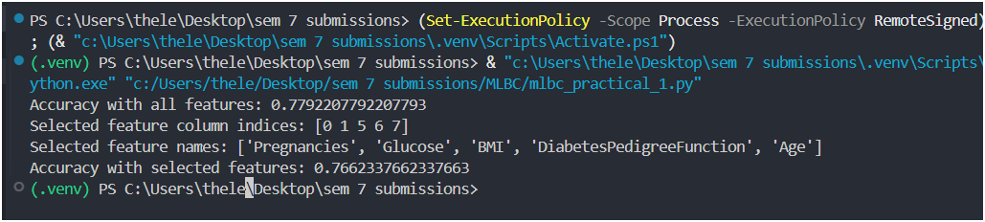
Fig. 1. Output In VS Code Terminal
Accuracy with all features: 0.7792207792207793
Selected feature column indices: [0 1 5 6 7]
Selected feature names: ['Pregnancies', 'Glucose', 'BMI', 'DiabetesPedigreeFunction', 'Age']
Accuracy with selected features: 0.7662337662337663
RESULT:-
The model successfully predicted diabetes using Logistic Regression. Feature selection reduced the number of input features from eight to five while maintaining nearly the same prediction accuracy.
CONCLUSION:-
The practical demonstrated the implementation of Logistic Regression for diabetes prediction and the application of SelectKBest feature selection. The model achieved 77.92% accuracy using all features and 76.62% accuracy using only the five selected features. The small reduction in accuracy indicates that the selected features retain most of the important information, making the model simpler, faster, and easier to interpret.

