Name: Khan Abdur Rahman Roll No.: 231814 Batch: A Class: BE CSE IoTCSBC
Practical No. 2:-
AIM:-
To implement Supervised Learning using Linear Regression algorithm.
THEORY:-
Supervised Learning: Supervised Learning is a machine learning technique in which a model learns from labelled data containing input variables and their corresponding target values. The model identifies the relationship between inputs and outputs during training and uses it to predict outputs for new data. It is mainly divided into Regression, which predicts continuous numerical values, and Classification, which predicts categories.
Linear Regression: Linear Regression is a supervised learning algorithm used to predict a continuous dependent variable from one or more independent variables. In Simple Linear Regression, the relationship between the input and output is represented by the equation y = mx + c, where y is the predicted value, x is the input variable, m is the slope and c is the intercept. The algorithm finds the best-fit line by minimizing the difference between actual and predicted values.
Working: The input and target data are provided to the model, and the fit() function trains the Linear Regression model by calculating the best slope and intercept. The trained model then uses the predict() function to generate predicted values. In this practical, the input values are 1, 2, 3, 4 and 5, while the target values are 2, 4, 6, 8 and 10. The model learns their linear relationship and generates the corresponding regression line.
Example: Linear Regression can be used to predict house prices based on house area. Here, house area is the independent variable and price is the dependent variable. The model learns from existing house data and predicts the price of a new house based on its area.
Advantages and Limitations: Linear Regression is simple, easy to implement, computationally efficient and useful for predicting continuous values. However, it assumes a linear relationship between variables, can be affected by outliers and may not perform well when the actual relationship is non-linear.
TOOLS REQUIRED:-
- Python 3.x
- Matplotlib
- Numpy
- Scikit-learn
- Internet connection
- VS Code / Jupyter Notebook / Google Collab
STEPS / PROCEDURE:-
- Import the required libraries.
- Define the input variable X and target variable y.
- Create a Linear Regression model.
- Train the model using the given data.
- Predict the target values using the trained model.
- Plot the actual data points.
- Plot the predicted values as the best-fit line.
- Add labels, title and legend.
- Display and observe the graph

PROGRAM:-
from sklearn.linear_model import LinearRegression
import matplotlib.pyplot as plt
X=[[1],[2],[3],[4],[5]]
y=[2,4,6,8,10]
model=LinearRegression()
model.fit(X,y)
y_pred=model.predict(X)
plt.scatter(X,y,color='blue',label='Actual Data')
plt.plot(X,y_pred,color='red',label='Best Fit Line')
plt.xlabel('X')
plt.ylabel('y')
plt.title('Simple Linear Regression')
plt.legend()
plt.show()
OUTPUT:-
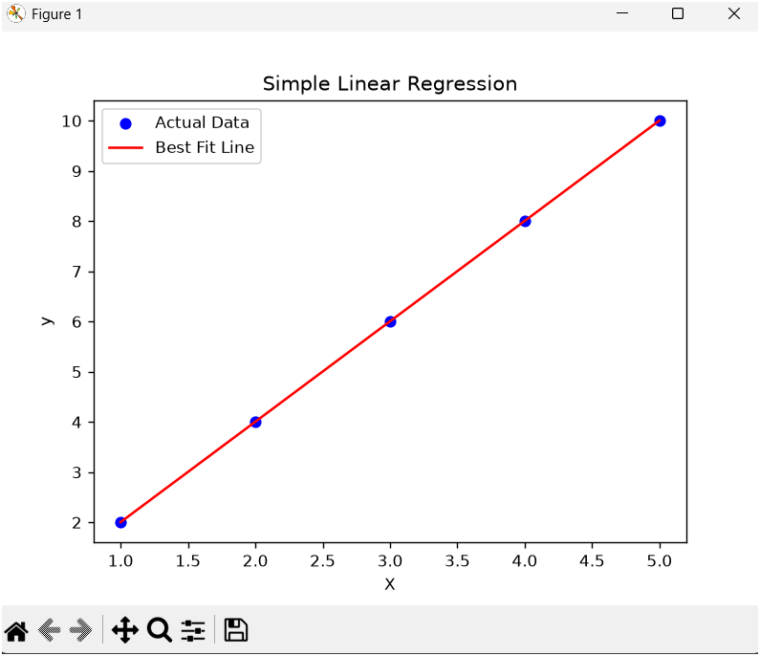
Fig. 1. Simple Linear Regression.
RESULT:-
The scatter plot displays the actual data points along with the best-fit regression line obtained using the Linear Regression algorithm. Since the given data has a perfect linear relationship, the regression line passes through all the data points.

CONCLUSION:-
The Linear Regression model was successfully implemented using Scikit-learn. The model learned the linear relationship between the input and output variables and generated a best-fit regression line. The predicted values closely matched the actual values, demonstrating that Linear Regression can effectively model a simple linear relationship between variables.

