Name: Khan Abdur Rahman Roll No.: 231814 Batch: A Class: BE CSE IoTCSBC
Practical No. 3:-
AIM:-
To implement Supervised Learning using Logistic regression algorithm
THEORY:-
Logistic Regression is a supervised machine learning classification algorithm used to predict the probability of a categorical outcome. Unlike Linear Regression, which predicts continuous values, Logistic Regression uses the sigmoid function to convert the output into a probability between 0 and 1. Based on a chosen threshold, the probability is converted into a class label. In this practical, the Logistic Regression model is trained using the Breast Cancer dataset available in Scikit-learn. The mean radius of the tumor is used as the input feature, while the target represents malignant or benign tumors. The trained model predicts the probability of a tumor being benign and the resulting sigmoid curve is plotted along with the actual data points.
Formula:
P(y=1|x) = 1 / (1 + e^-(β₀ + β₁x))
Where,
β₀ = Intercept
β₁ = Coefficient
x = Input feature
P(y=1|x) = Probability of the positive class
TOOLS REQUIRED:-
- Python 3.x
- Scikit-learn
- Numpy
- Matplotlib
- VS Code / Jupyter Notebook
STEPS / PROCEDURE:-
- Import NumPy, Matplotlib and Logistic Regression libraries.
- Load the Breast Cancer dataset using load_breast_cancer().
- Select the mean radius feature as the input variable X.
- Store the target labels in y.
- Create a Logistic Regression model.
- Train the model using X and y.
- Generate a smooth range of tumor-radius values.
- Calculate the probability of the tumor being benign using predict_proba().
- Plot the actual data points and Logistic Regression curve.
- Display the graph.
PROGRAM:-
import numpy as np
import matplotlib.pyplot as plt
from sklearn.linear_model import LogisticRegression
# import load_breast_cancer function from sklearn.datasets module
from sklearn.datasets import load_breast_cancer

# 1. Load the real dataset
# load_breast_cancer function creates dataset object and stores it in 'cancer'.
# It's a standard scikit-learn dataset object, it's organized as follows:-
# - .data: The main data (the features or X values).
# - .target: The "answer key" (the labels or y values).
cancer = load_breast_cancer()

# 2. Prepare the data
# From the cancer dataset, we access the features using '.data'.
# '[:, 0]' selects all rows but only from the first column ('mean radius').
# '.reshape(-1, 1)' then turns this data into a single vertical column, which is the required format for scikit-learn models.
# 1 means you want one column.
# -1 is a placeholder that tells NumPy to automatically calculate the number of rows needed.
X = cancer.data[:, 0].reshape(-1, 1)

# We access the list of labels (0 for malignant, 1 for benign) using '.target'.
y = cancer.target

# 3. Create and train the model
model = LogisticRegression()
model.fit(X, y)

# 4. Create a range of values to plot the logistic curve smoothly
# 'np.linspace()' is a NumPy function that creates an array of evenly spaced numbers.
# We create 300 points between the minimum and maximum tumor sizes found in our data.
# This creates a smooth set of points on which to plot our prediction line.
X_test = np.linspace(X.min(), X.max(), 300).reshape(-1, 1)

# Predict probabilities for the smooth range.
# 'model.predict_proba()' returns two columns of probabilities (for class 0 and class 1).
# The slice '[:, 1]' selects all rows (:) but only the second column (1),
# which contains the probabilities for class 1 (Benign).
y_prob = model.predict_proba(X_test)[:, 1]

# 5. Plot the results
plt.scatter(X, y, color='blue', label='Actual Data (0=Malignant, 1=Benign)', alpha=0.4)
plt.plot(X_test, y_prob, color='red', label='Logistic Regression Curve')
plt.xlabel('Mean Radius of Tumor')
plt.ylabel('Probability of Being Benign')
plt.title('Logistic Regression on Breast Cancer Data')
plt.legend()
plt.show()

OUTPUT:-
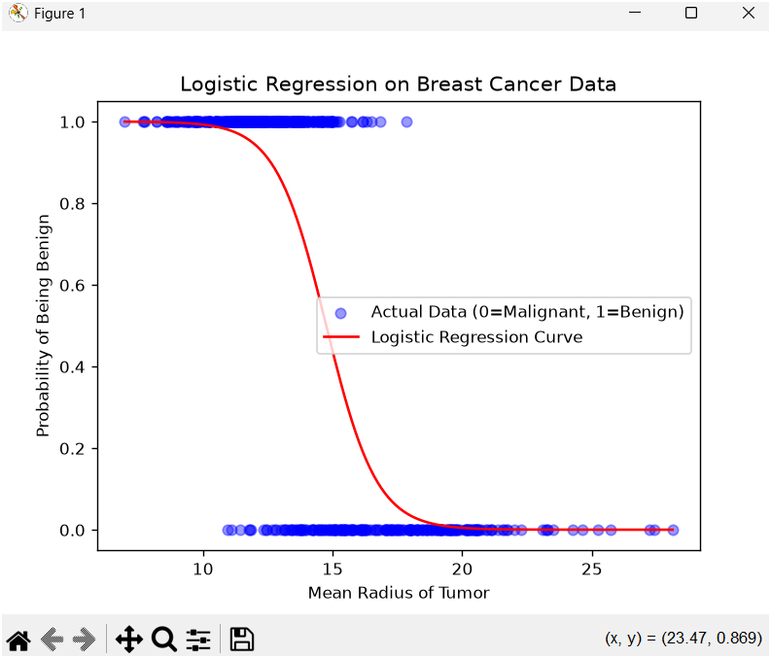
Fig. 1. Linear Regression on Breast Cancer DataSet
A graph is generated showing the actual breast cancer data points and the Logistic Regression sigmoid curve representing the probability of a tumor being benign based on its mean radius.
RESULT:-
The Logistic Regression model was successfully implemented on the Breast Cancer dataset. The model learned the relationship between tumor mean radius and the target class, and the probability of a tumor being benign was visualized using a Logistic Regression curve.
CONCLUSION:-
Thus, Logistic Regression was successfully implemented for binary classification using the Breast Cancer dataset. The sigmoid curve demonstrates how the probability of the tumor being benign changes with its mean radius.

