Name: Khan Abdur Rahman Roll No.: 231814 Batch: A Class: BE CSE IoTCSBC
Practical No. 4:-
AIM:-
To implement Principal Component Analysis (PCA).
THEORY:-
Principal Component Analysis (PCA) is an unsupervised machine learning technique used for dimensionality reduction. It transforms a dataset containing a large number of correlated features into a smaller number of new variables called principal components, while retaining as much information or variance from the original data as possible. The first principal component captures the maximum possible variance in the data, the second captures the maximum remaining variance while being perpendicular to the first, and so on. Before applying PCA, features are generally standardized so that variables with larger numerical scales do not dominate the analysis. PCA calculates the covariance structure of the data and determines eigenvectors and eigenvalues, where eigenvectors represent the directions of the principal components and eigenvalues represent the amount of variance captured by them. By selecting only the most important principal components, the dimensionality of the dataset can be reduced while preserving most of its useful information. PCA is widely used for data visualization, noise reduction, feature extraction, and improving computational efficiency of machine learning models. In this practical, PCA is applied to the Iris dataset, which contains four numerical features: sepal length, sepal width, petal length, and petal width. These four features are standardized and transformed into two principal components, which are then visualized using a scatter plot.
Dataset: Iris Dataset
Source: sklearn.datasets
Samples: 150
Features: 4 numerical features
Classes: 3 — Setosa, Versicolor, Virginica
The four original features are:
- Sepal Length
- Sepal Width
- Petal Length
- Petal Width
The PCA implementation reduces these 4 dimensions to 2 principal components.
TOOLS REQUIRED:-
- Python 3.x
- Scikit-learn
- Numpy
- Matplotlib
- VS Code / Jupyter Notebook
STEPS / PROCEDURE:-
- Import the required Python libraries.
- Load the Iris dataset from sklearn.datasets.
- Extract the four numerical features.
- Standardize the features using StandardScaler.
- Apply PCA and reduce the four features to two principal components.
- Transform the standardized data into the new two-dimensional space.
- Display the explained variance of each principal component.
- Plot the transformed data using a scatter plot.
- Observe how the three Iris classes are represented in the reduced feature space.

PROGRAM:-
import numpy as np
import matplotlib.pyplot as plt
from sklearn.datasets import load_iris
from sklearn.preprocessing import StandardScaler
from sklearn.decomposition import PCA

#Load the Iris dataset

iris = load_iris()
X = iris.data
y = iris.target

#Standardize the features

scaler = StandardScaler()
X_scaled = scaler.fit_transform(X)

#Apply PCA and reduce 4 features to 2 components

pca = PCA(n_components=2)
X_pca = pca.fit_transform(X_scaled)

#Display explained variance

print("Explained Variance Ratio:", pca.explained_variance_ratio_)
print("Total Variance Explained:", sum(pca.explained_variance_ratio_))

# Plot the principal components

plt.figure(figsize=(8,6))
for i, name in enumerate(iris.target_names):
plt.scatter(X_pca[y == i, 0], X_pca[y == i, 1], label=name)
plt.xlabel("Principal Component 1")
plt.ylabel("Principal Component 2")
plt.title("PCA of Iris Dataset")
plt.legend()
plt.grid(True)
plt.show()

OUTPUT:-
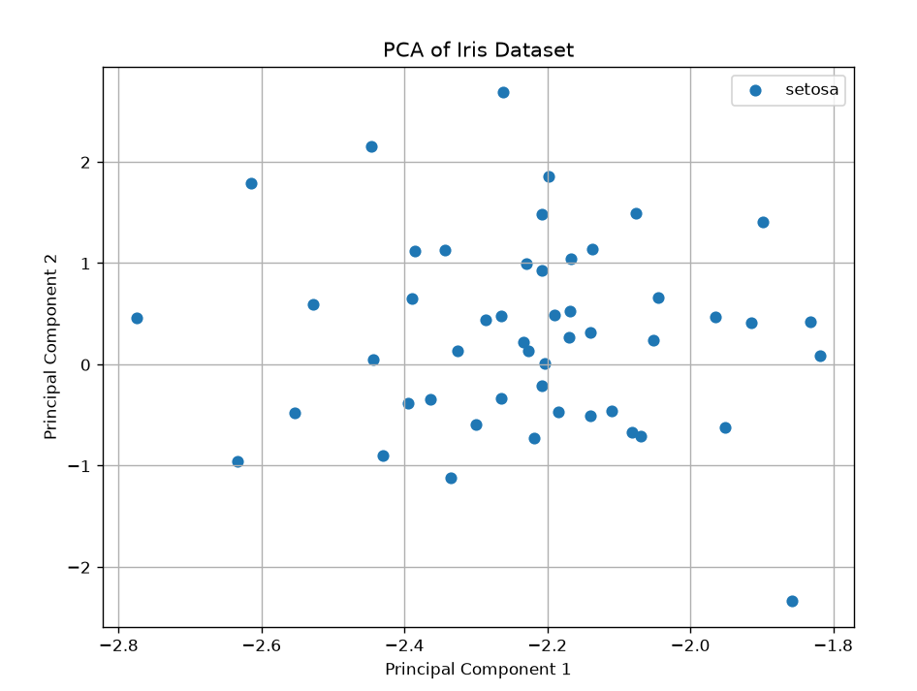
Fig. 1 PCA visualisation for iris dataset
The program displays the explained variance ratio of the two principal components and the total variance explained. A scatter plot is generated with Principal Component 1 on the X-axis and Principal Component 2 on the Y-axis. The three Iris classes are represented as separate groups in the graph.
Typical output is approximately:
Explained Variance Ratio: [0.7296, 0.2285]
Total Variance Explained: 0.9581
Thus, the two principal components preserve approximately 95.8% of the total variance of the original four features.
RESULT:-
PCA was successfully implemented on the Iris dataset. The original 4-dimensional feature space was reduced to 2 principal components, while preserving approximately 95.8% of the total variance. The PCA scatter plot was generated successfully, showing the distribution of the three Iris classes in the reduced feature space.
CONCLUSION:-
PCA was successfully implemented on the Iris dataset. The original four-dimensional dataset was reduced to two principal components while retaining approximately 95.8% of the total variance. The resulting visualization shows that PCA can effectively reduce dimensionality while preserving important patterns and differences between the classes.

