Name: Khan Abdur Rahman Roll No.: 231814 Batch: A Class: BE CSE IoTCSBC
Practical No. 5:-
AIM:-
To implement Decision Tree Algorithms.
THEORY:-
Decision Tree is a supervised machine learning algorithm used for classification and regression problems. It represents the decision-making process in the form of a tree structure consisting of a root node, internal nodes, branches, and leaf nodes. At each internal node, the dataset is divided based on a feature and a condition that provides the best separation of data. For classification, common splitting criteria are Gini Impurity and Entropy. Gini Impurity measures the probability of incorrect classification, while Entropy measures the uncertainty or impurity in the dataset. The tree continues splitting the data until a stopping condition is reached. The final leaf nodes represent the predicted classes. Decision Trees are easy to understand and interpret because their decisions can be visualized. However, a very deep tree may overfit the training data. Parameters such as maximum depth and minimum samples can be used to control overfitting. In this practical, the Iris dataset is used to train a Decision Tree Classifier, and its performance is evaluated using accuracy and a confusion matrix.
Dataset:
The Iris dataset from Scikit-learn is used. It contains 150 samples belonging to three classes: Setosa, Versicolor, and Virginica. Each sample contains four features: sepal length, sepal width, petal length, and petal width.
TOOLS REQUIRED:-
- Python 3.11.9
- VS Code / Jupyter Notebook
- NumPy
- Matplotlib
- Scikit-learn
STEPS / PROCEDURE:-
- Import the required libraries.
- Load the Iris dataset.
- Separate the input features and target labels.
- Divide the dataset into training and testing sets.
- Create a Decision Tree Classifier.
- Train the model using the training data.
- Predict the classes of the test data.
- Calculate the model accuracy.
- Display the confusion matrix.
- Visualize the Decision Tree.

PROGRAM:-
import numpy as np
import matplotlib.pyplot as plt
from sklearn.datasets import load_iris
from sklearn.model_selection import train_test_split
from sklearn.tree import DecisionTreeClassifier, plot_tree
from sklearn.metrics import accuracy_score, confusion_matrix, ConfusionMatrixDisplay

#1. Load the Iris dataset

iris = load_iris()
X = iris.data
y = iris.target

#2. Split the dataset into training and testing data

X_train, X_test, y_train, y_test = train_test_split(X, y, test_size=0.2, random_state=42)

#3. Create the Decision Tree model

model = DecisionTreeClassifier(criterion='gini', max_depth=3, random_state=42)

#4. Train the model

model.fit(X_train, y_train)

#5. Predict the test data

y_pred = model.predict(X_test)

#6. Calculate accuracy

accuracy = accuracy_score(y_test, y_pred)
print("Decision Tree Accuracy:", accuracy)

#7. Display confusion matrix

cm = confusion_matrix(y_test, y_pred)
print("\nConfusion Matrix:")
print(cm)

disp = ConfusionMatrixDisplay(confusion_matrix=cm, display_labels=iris.target_names)
disp.plot()
plt.title("Confusion Matrix")
plt.show()

#8. Visualize the Decision Tree

plt.figure(figsize=(12, 8))
plot_tree(model, feature_names=iris.feature_names, class_names=iris.target_names, filled=True)
plt.title("Decision Tree Classifier")
plt.show()

OUTPUT:-
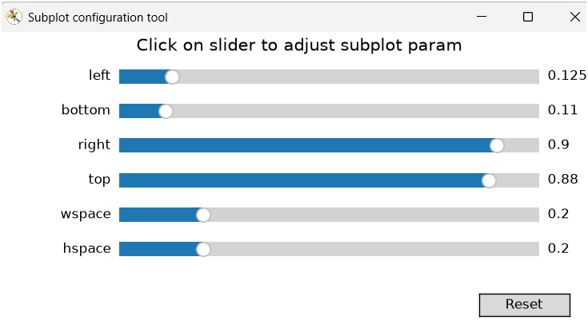
Fig. 1 Subplot configuration tool.
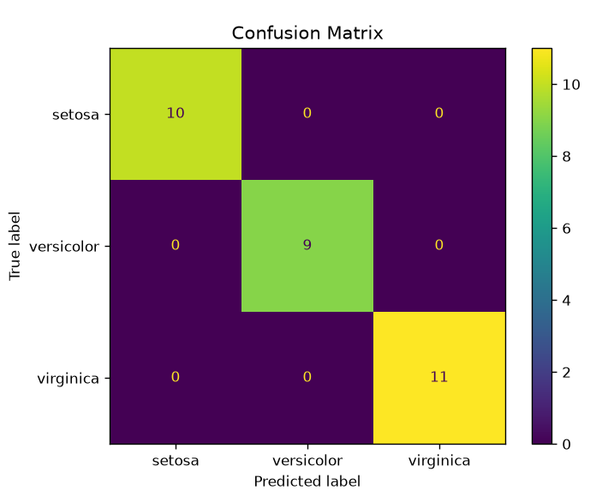
Fig. 2 Decision Tree Confusion Matrix
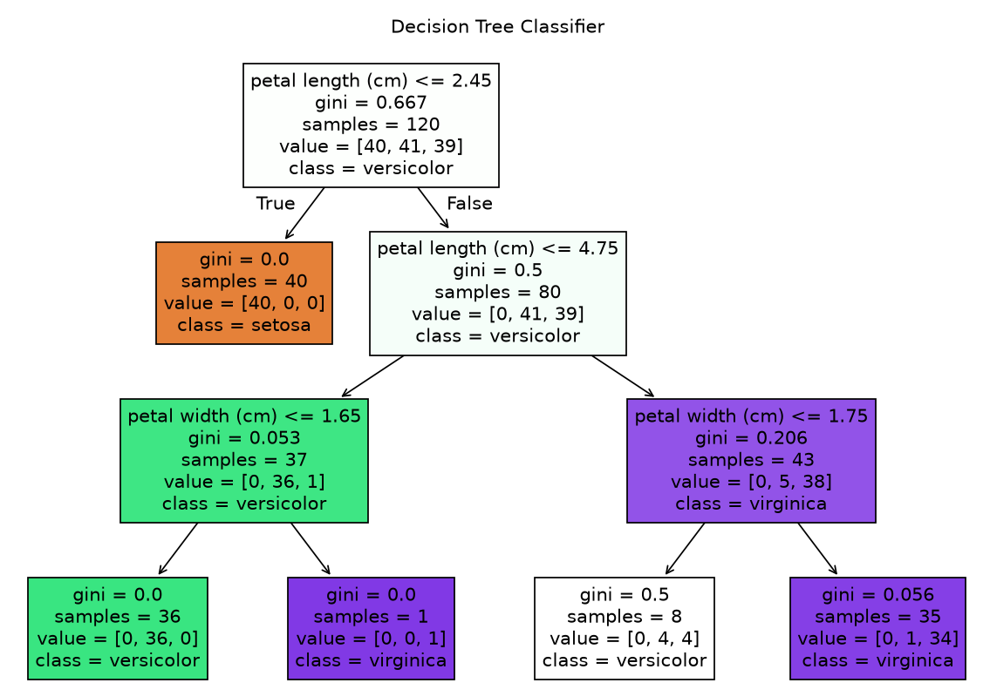
Fig. 3 Decision Tree Classifier
RESULT:-
The Decision Tree Classifier successfully classifies the Iris flower species. With the given train-test split and model parameters, the model is expected to achieve high accuracy on the test dataset.
CONCLUSION:-
The Decision Tree algorithm was successfully implemented using the Iris dataset. The model classified the different flower species based on their features and achieved good accuracy. The confusion matrix was used to evaluate the classification performance, while the tree visualization helped in understanding the decision-making process of the model. Thus, Decision Tree is an effective and interpretable supervised learning algorithm for classification.

