Name: Khan Abdur Rahman Roll No.: 231814 Batch: A Class: BE CSE IoTCSBC
Practical No. 6:-
AIM:-
To implement Graph Based Clustering and CART algorithm.
THEORY:-
Graph Based Clustering:
Graph based clustering is an unsupervised learning technique in which data points are represented as nodes of a graph and relationships between similar data points are represented by edges. The objective is to divide the graph into groups where points within the same group have greater similarity. Spectral Clustering is a popular graph based clustering technique. It constructs a similarity graph and uses the eigenvectors of the graph representation to obtain a suitable representation of the data. Clustering is then performed on this representation. Graph based clustering can identify complex cluster structures and is useful in applications such as image processing, social networks and pattern recognition.
CART Algorithm:
CART stands for Classification and Regression Trees. It is a supervised machine learning algorithm used for classification and regression. For classification, CART uses measures such as Gini impurity to select the best feature and threshold for splitting the data. The process continues recursively until the stopping conditions are reached. The final tree consists of decision nodes and leaf nodes. CART is easy to interpret and does not require feature scaling. However, a very deep tree can overfit the training data, so parameters such as maximum depth are used to control the model.
Dataset:
The Iris dataset is used for implementing Graph Based Clustering and CART algorithm. It contains 150 samples of Iris flowers belonging to three classes: Setosa, Versicolor and Virginica. Each sample contains four numerical features: sepal length, sepal width, petal length and petal width. The dataset is loaded directly from the Scikit-learn library using the load_iris() function.
TOOLS REQUIRED:-
- Python 3.11
- NumPy
- Matplotlib
- Scikit-learn
- VS Code / Jupyter Notebook
- Iris Dataset
STEPS / PROCEDURE:-
- Import the required Python libraries.
- Load the Iris dataset from Scikit-learn.
- Extract the input features and target classes.
- Apply Spectral Clustering to perform graph based clustering.
- Visualize the generated clusters using a scatter plot.
- Split the Iris dataset into training and testing sets.
- Create a CART Decision Tree Classifier using the Gini criterion.
- Train the CART model using the training data.
- Predict the classes of the test data.
- Calculate and display the classification accuracy.
- Visualize the generated CART decision tree.

PROGRAM:-
import numpy as np
import matplotlib.pyplot as plt
from sklearn.datasets import load_iris
from sklearn.cluster import SpectralClustering
from sklearn.model_selection import train_test_split
from sklearn.tree import DecisionTreeClassifier,plot_tree
from sklearn.metrics import accuracy_score
iris=load_iris()
X=iris.data
y=iris.target

#Graph Based Clustering

graph_cluster=SpectralClustering(n_clusters=3,affinity='nearest_neighbors',random_state=42)
cluster_labels=graph_cluster.fit_predict(X)
plt.figure(figsize=(7,5))
plt.scatter(X[:,0],X[:,1],c=cluster_labels,cmap='viridis',s=50)
plt.xlabel('Sepal Length')
plt.ylabel('Sepal Width')
plt.title('Graph Based Clustering using Spectral Clustering')
plt.show()

#CART Algorithm

X_train,X_test,y_train,y_test=train_test_split(X,y,test_size=0.2,random_state=42)
cart=DecisionTreeClassifier(criterion='gini',max_depth=3,random_state=42)
cart.fit(X_train,y_train)
y_pred=cart.predict(X_test)
accuracy=accuracy_score(y_test,y_pred)
print('CART Classification Accuracy:',accuracy)
plt.figure(figsize=(12,7))
plot_tree(cart,feature_names=iris.feature_names,class_names=iris.target_names,filled=True)
plt.title('CART Decision Tree')
plt.show()

OUTPUT:-
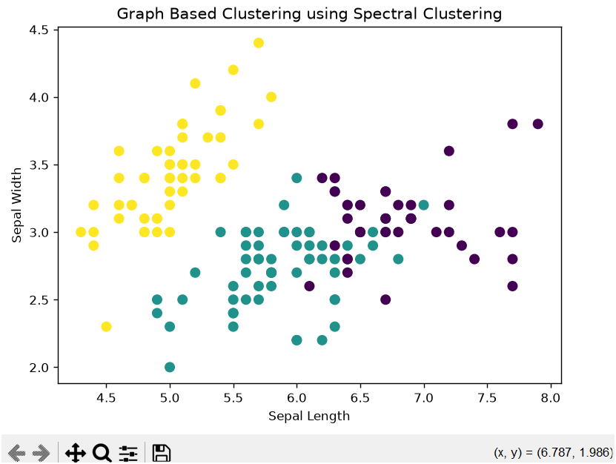
Fig. 1 Subplot configuration tool.
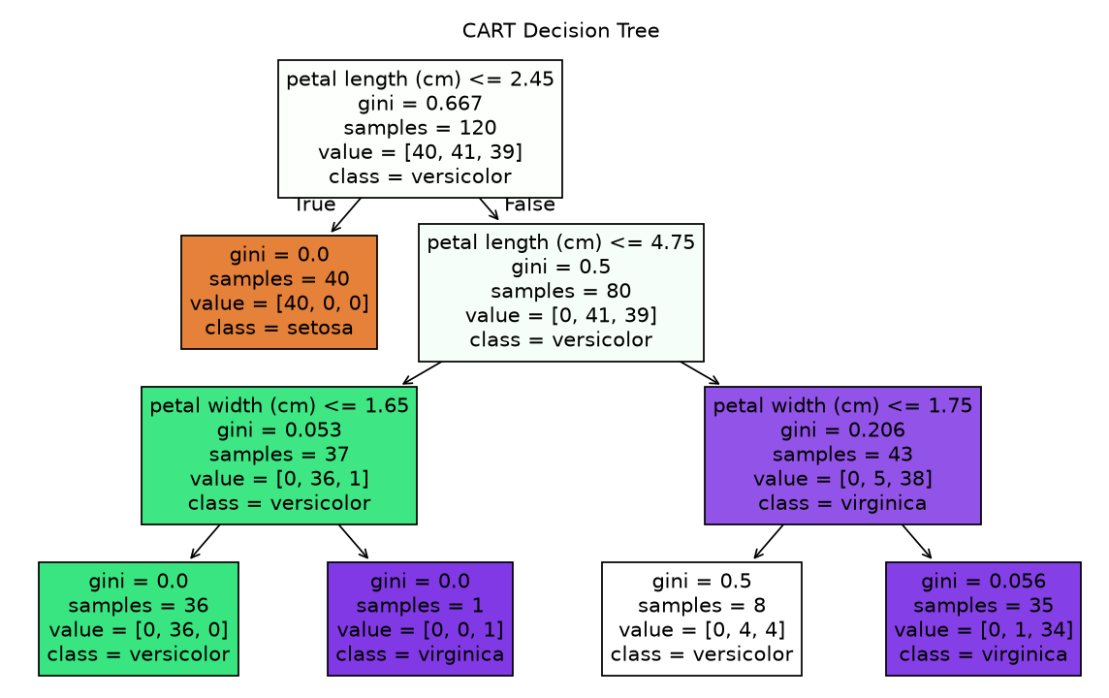
Fig. 2 Decision Tree Confusion Matrix
The first output displays the Iris data points grouped into three clusters using graph based clustering. The second output displays the classification accuracy of the CART model. The final output shows the decision tree with feature-based splitting rules used to classify the Iris flower classes.

RESULT:-
- Graph Based Clustering successfully divided the Iris dataset into three clusters using Spectral Clustering.
- The generated clusters were displayed using a scatter plot.
- The CART classifier was successfully trained using the Iris dataset.
- The classification accuracy was calculated and displayed.
- The CART decision tree was successfully visualized.

CONCLUSION:-
Thus, Graph Based Clustering and the CART algorithm were successfully implemented using Python and Scikit-learn. Spectral Clustering grouped similar data points into clusters, while CART classified the Iris samples using a decision tree based on Gini impurity.

