Name: Khan Abdur Rahman Roll No.: 231814 Batch: A Class: BE CSE IoTCSBC
Practical No. 7:-
AIM:-
To implement a Simple Neural Network using Backpropagation.
THEORY:-
A Neural Network is a machine learning model inspired by the working of biological neurons. It consists of interconnected layers of neurons through which input data passes to produce an output. A simple neural network generally contains an input layer, one or more hidden layers, and an output layer. Each connection between neurons has a numerical value called a weight, which determines the importance of that connection.
The neural network learns by adjusting these weights during the training process. In this practical, the XOR logical problem is used as the dataset. XOR produces an output of 1 when the two inputs are different and 0 when they are the same. The XOR problem is important because it cannot be solved correctly using a single linear neuron, so a hidden layer is required.
The learning process consists mainly of forward propagation and backward propagation. During forward propagation, the input values are multiplied by their corresponding weights and passed to the hidden layer. An activation function, such as the sigmoid function, converts the calculated value into a range between 0 and 1. The hidden-layer output is then passed to the output layer to generate the predicted result.
The sigmoid activation function is given by:
σ(x) = 1 / (1 + e⁻ˣ)
Its derivative is:
σ'(x) = σ(x)(1 − σ(x))
After obtaining the predicted output, the network calculates the error by comparing the predicted output with the actual output. In backpropagation, this error is propagated backward through the network. The gradients of the weights are calculated using the derivative of the activation function. The weights are then updated to reduce the error.
The basic weight-update concept is:
New Weight = Old Weight + Learning Rate × Gradient
The learning rate controls how much the weights are changed during each update. A small learning rate results in slower learning, while a very large learning rate can cause unstable learning. This process is repeated for many epochs until the neural network learns the relationship between the inputs and outputs.
Thus, backpropagation enables a neural network to automatically adjust its internal weights based on its errors and gradually improve its predictions.
TOOLS REQUIRED:-
- Python 3.x
- NumPy library
- VS Code / Jupyter Notebook / Google Colab
- Windows/Linux operating system

STEPS / PROCEDURE:-
- Import the NumPy library.
- Define the sigmoid activation function and its derivative.
- Create the XOR input and corresponding output dataset.
- Define the number of input, hidden, and output neurons.
- Initialize the weights with random values.
- Set the learning rate and number of training epochs.
- Perform forward propagation.
- Calculate the prediction error.
- Perform backpropagation to calculate gradients.
- Update the weights using the calculated gradients.
- Repeat the process for the specified number of epochs.
- Display the final predicted output.

PROGRAM:-
import numpy as np

# 1. Define the activation function
def sigmoid(x):
return 1 / (1 + np.exp(-x))

# Derivative of sigmoid function
def sigmoid_derivative(x):
return x * (1 - x)

# 2. Prepare XOR dataset
X = np.array([[0, 0],
[0, 1],
[1, 0],
[1, 1]])

y = np.array([[0],
[1],
[1],
[0]])

# 3. Initialize network parameters
np.random.seed(42)

input_neurons = 2
hidden_neurons = 4
output_neurons = 1

hidden_weights = np.random.uniform(size=(input_neurons, hidden_neurons))
output_weights = np.random.uniform(size=(hidden_neurons, output_neurons))

learning_rate = 0.1
epochs = 10000

# 4. Train the neural network
print("Initiating neural network training...")

for epoch in range(epochs):

# Forward propagation
hidden_layer_input = np.dot(X, hidden_weights)
hidden_layer_output = sigmoid(hidden_layer_input)

output_layer_input = np.dot(hidden_layer_output, output_weights)
predicted_output = sigmoid(output_layer_input)

# Backpropagation
error = y - predicted_output

output_gradient = error * sigmoid_derivative(predicted_output)

hidden_error = output_gradient.dot(output_weights.T)
hidden_gradient = hidden_error * sigmoid_derivative(hidden_layer_output)

# Update weights
output_weights += hidden_layer_output.T.dot(output_gradient) * learning_rate
hidden_weights += X.T.dot(hidden_gradient) * learning_rate

print("Training complete.")

# 5. Display final prediction
print("\nFinal predicted output:")

print(predicted_output.round(2))

# 6. Convert probabilities into binary predictions
binary_output = (predicted_output >= 0.5).astype(int)

print("\nBinary predicted output:")
print(binary_output)

print("\nActual output:")
print(y)

OUTPUT:
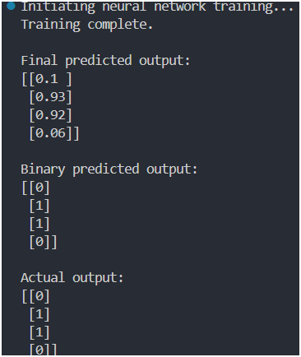
Fig. 1 Final output of the Neural Network using Backpropagation
RESULT:-
The Simple Neural Network was successfully implemented using the Backpropagation algorithm. The trained network learned the XOR relationship and produced predictions corresponding to the actual outputs.
CONCLUSION:-
The practical demonstrated how a neural network learns by forward propagation, error calculation, backpropagation, and weight updating. The XOR problem was successfully solved using a hidden layer, showing the ability of neural networks to learn non-linear relationships.

