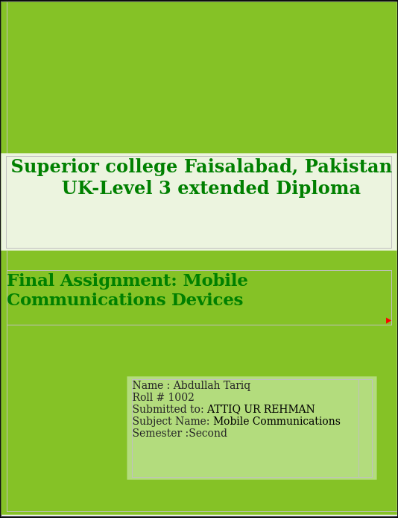 **Case Study Report – Mobile Communication Devices in Microsoft Corporation**

**1. Introduction**

Mobile communication devices are a critical component in revolutionizing business operations, collaboration, and productivity in the digital economy. As a major player in the global technology industry, Microsoft Corporation has adopted mobile communication technologies in product development as well as in its international organizational framework. This case study examines Microsoft's mobile communications transmission technologies, standards, and protocols, as well as legal and ethical issues. The case study also assesses the general advantages of these technologies to Microsoft and its workforce.

**The report aims at the following three main objectives:**

An examination of the transmission technologies applied in Microsoft's mobile communication system.

Definition and explanation of standards, protocols, and ethical considerations related to mobile device use.

An analysis of the organizational and individual-level advantages obtained from mobile communication technologies, such as instant messaging, unified messaging, and presence technology.

**2. Transmission Technologies Utilized by Microsoft**

(LO 2.1, 3.1)

Microsoft has incorporated multiple transmission technologies to facilitate mobile communications among its over 200,000 employees, partners, and vendors globally. These technologies ensure smooth connectivity, real-time collaboration, and secured data exchange.

**2.1 Cellular Network Technology**

Microsoft leverages the most advanced 4G LTE and 5G cellular networks to provide remote and mobile access to corporate resources. Staff members often use eSIM or SIM-connected smartphones, tablets, and laptops to connect with Microsoft Teams, Outlook, SharePoint, and OneDrive.

4G LTE provides high-speed upload/download capabilities and is globally supported.

5G, launched in various of Microsoft's smart campuses, offers ultra-low latency and high bandwidth. This is a requirement for high-definition video collaboration, real-time cloud access, and mixed-reality teamwork (particularly with HoloLens and Teams).

Use Case Example: Microsoft Surface Duo, a dual-screen smartphone, is 5G-optimized, allowing executives and developers to prototype mobile solutions in real-world environments all over the world.

**2.2 Wi-Fi Networks**

Microsoft campuses and offices are furnished with latest Wi-Fi 6 (802.11ax) technology, enabling:

Fast and reliable wireless internet between floors and remote access areas.

Thousands of devices to be supported for simultaneous connections.

Smart network segregation for visitors, employees, and IoT devices.

Wi-Fi is the transmission mode of choice in offices, utilized for access to cloud applications, video conferencing, and Microsoft Teams hybrid meetings.

**2.3 Bluetooth and BLE**

Bluetooth is essential in Microsoft Surface family devices such as keyboards, pens, headsets, and fitness wearables.

Bluetooth Low Energy (BLE) is utilized for battery-friendly connectivity to smartwatches and healthcare monitoring applications utilized in Microsoft wellness programs.

Microsoft HoloLens 2 also employs BLE for peripheral pairing during immersive AR collaboration sessions.

**2.4 Near Field Communication (NFC)**

NFC is in common usage for authentication, contactless payment, and device pairing:

Employees employ NFC-enabled ID badges to access secure locations in Microsoft buildings.

Surface devices connect in an instant to accessories or transfer data using NFC tap capabilities.

**2.5 GPS and Location-Based Services**

GPS is also built into Microsoft's mobile offerings like Cortana, Bing Maps, and Microsoft Authenticator:

Employed for tracking employees when they travel on business.

Supports geofencing of security policies (i.e., conditional access policies based on geography).

Useful in finding lost devices through Microsoft Endpoint Manager.

**2.6 Satellite and Remote Connectivity**

Microsoft. partners with the likes of Starlink and utilizes Azure Space to provide cloud services and mobile connectivity for. out-of-grid locations. This makes. mobile communication accessible even in off-grid. development or. testing. areas.

**3. Standards, Protocols, and Ethical Implications**

. (LO 2.2, 3.2)

**3.1 Mobile Communication Standards Utilized**

Microsoft adheres to international communication standards to maintain consistency, interoperability, and security across its global network.

| Standard | Purpose | Application |
| --- | --- | --- |
| **3GPP** | Defines cellular standards (4G, 5G) | Ensures mobile connectivity across devices |
| **IEEE 802.11** | Wi-Fi standards | Enables high-speed wireless internet in offices |
| **Bluetooth SIG** | Governs Bluetooth interoperability | Connects peripherals like pens, headsets, and wearables |
| **NFC Forum** | NFC device compliance | Used in Surface devices for secure pairing |
| **IETF/ITU** | IP-based communication protocols | Standardizes VoIP and secure messaging over Teams |

All these standards make Microsoft's mobile devices operate smoothly across different regions and adhere to network providers and device makers.

**3.2 Security and Communication Protocols**

**Microsoft has strict security protocols for mobile communication:**

**HTTPS/SSL/TLS:**

Provides secure communication between mobile applications and servers.

**VPN (Virtual Private Network):**

Any mobile device that accesses internal resources has to use Microsoft's internal VPN gateway.

**OAuth 2.0 and OpenID Connect:**

Used for managing identities in Microsoft 365 applications on mobile devices.

**Zero Trust Architecture:**

Mobile devices are never trusted by default. Access is determined by real-time risk assessment, location, and compliance state.

**Compliance Tool:**

Microsoft Defender for Endpoint checks mobile device compliance in real-time.

**3.3 Regulatory and Legal Implications**

As a multinational company, Microsoft adheres to:

**GDPR (General Data Protection Regulation)** – All mobile communications processing EU citizens' data adhere to stringent consent and privacy policy.

**HIPAA (for Microsoft Cloud for Healthcare) –** Provides secure transmission of patient information through mobile applications.

CCPA, FERPA, and ISO/IEC 27001 standards are also complied with.

**Ethical Implications:**

Microsoft prioritizes employee permission for device monitoring.

**BYOD (Bring Your Own Device)** policies are ethically considered to strike a balance between corporate security and individual privacy.

Real-time monitoring stops at threat detection and not at personal data intrusion.

**4. Advantages of Mobile Communication Devices in Microsoft**

(LO 2.3, 3.1)

**4.1 Organizational Advantages**

**Greater Flexibility:**

Mobile devices allow remote work, variable hours, and hybrid collaboration via Teams, OneDrive, and SharePoint.

**Instant Collaboration:**

Workers in different time zones work together instantly through mobile-accessible apps.

**Cost Efficiency:**

Minimized requirement of physical infrastructure and commuting.

Business Continuity:

Mobile communication provided Microsoft's business throughout the COVID-19 crisis with no downtime.

**Innovation:** Devices such as Surface Duo and HoloLens were designed and prototyped with real-time internal feedback gathered from mobile-first trials.

**4.2 Employee Productivity and Engagement**

Mobile access to Power BI, Planner, and Outlook enhance task visibility and performance.

Wellness and feedback apps enhance employee engagement and mental health.

Surface Pro and iPhones are Microsoft 365-optimized devices, providing employees with seamless access to productivity tools at all times.

**5. Social, Legal, and Health Implications**

(LO 3.2, 3.3)

**5.1 Social Implications**

Digital Inclusion: Microsoft's mobile-first strategies provide employees across geographies with access to corporate assets.

Work-Life Balance Challenges: The "always connected" mindset threatens employee burnout. Microsoft leverages MyAnalytics and Viva Insights to promote digital wellness.

BYOD and Diversity: BYOD programs enable flexibility and inclusivity, acknowledging cultural and economic variations in device ownership.

**5.2 Legal Considerations**

Data Sovereignty: Mobile device data needs to meet the law of the nation where the data is processed. Microsoft employs Azure region centers to ensure compliance.

Device Monitoring: Microsoft is transparent regarding monitoring of mobile devices and only imposes enterprise controls through Microsoft Intune with consent of the user.

Licensing and App Usage: Authorized apps alone are allowed to run on company network-connected mobile devices.

**5.3 Health Consequences**

Extended usage of mobile devices has brought to the fore issues relating to employee health:

**Eye Strain and Fatigue:** Ongoing screen exposure contributes to digital eye strain. Microsoft mitigates this with ergonomic policies and screen usage reminders.

**Posture and Musculoskeletal Disorders:** Mobile device usage tends to be associated with poor posture. Microsoft encourages correct device use ergonomics by offering internal training.

**EMF (Electromagnetic Fields) Exposure:** All devices utilized are FCC and EU certified for safe EMF exposure.

**Mental Health:** The lines between work and personal life may become blurred, raising stress levels. Microsoft Viva provides methods to disconnect, reflect, and enhance mental health.

**6. Conclusion**

This Microsoft case study illustrates the ways mobile communication devices are effortlessly integrated into one of the world's most creative and agile workplaces. With the use of advanced transmission technologies such as 5G, Wi-Fi 6, NFC, and Bluetooth, employees are enabled with rapid, secure, and mobile access to information. Microsoft stays compliant with global standards and stringent security measures, guaranteeing compliance and ethical operation in every market.

The advantages to Microsoft are considerable, such as enhanced productivity, better teamwork, and worldwide connectivity. Meanwhile, the corporation proactively deals with social, legal, and medical consequences by embracing open, participative, and accountable practices.

The ongoing development of mobile communication at Microsoft indicates not only technological advancements but also a strategic move towards an agile, robust, and human-centric workplace.

**References:**

1. Microsoft. (2024). Microsoft Digital Defense Report. [https://www.microsoft.com](https://www.microsoft.com/)
2. IEEE Standards Association. (2024). IEEE 802.11ax Specification. [https://standards.ieee.org](https://standards.ieee.org/)
3. European Commission. (2024). General Data Protection Regulation (GDPR). [https://gdpr.eu](https://gdpr.eu/)
4. Bluetooth SIG. (2024). Bluetooth Specifications. [https://www.bluetooth.com](https://www.bluetooth.com/)
5. Microsoft Learn. (2024). Zero Trust Architecture. [https://learn.microsoft.com](https://learn.microsoft.com/)
6. NFC Forum. (2024). About NFC. [https://nfc-forum.org](https://nfc-forum.org/)
7. ITU. (2024). Mobile Communication Protocols. [https://www.itu.int](https://www.itu.int/)