**User Instructions**

* Initially user will be prompted with the below message. Press Enter to continue into the program. Type “quit” and press Enter key to quit.



* After continuing to the program by pressing Enter key, Second screen will appear as below. Insert 1 and press enter to do the search, Insert 2 and press enter to find the fields that the user can do the search.

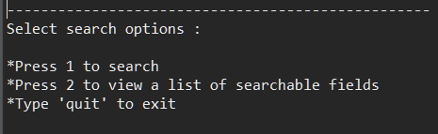

* If user continued to search option, then the below screen appears to insert the entity to do the search. Insert the number of any entity (1, 2, 3) and press enter to search that entity.



* Once the user selected entity to do the search, user have to type in the field of the entity to do the search (eg: name)



* Then user have to insert the value of the field to do the search in the following screen. (eg: Hensley)



* User will be presented with the search results as below

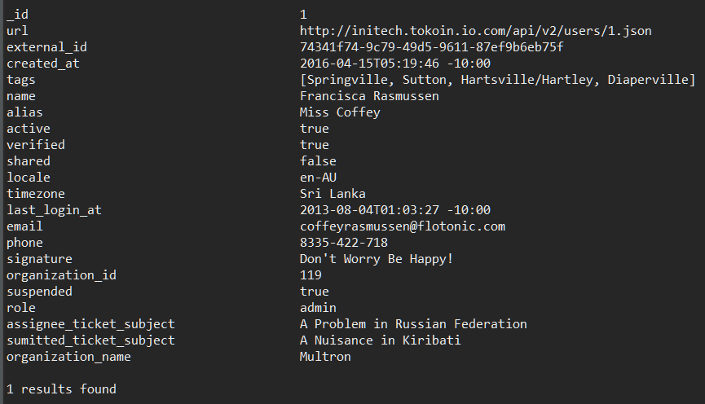

* In the second screen, user type “2” to go to below screen. Where user can list down fields of each entity. Type in the number of the entity and press enter to list down the fields.



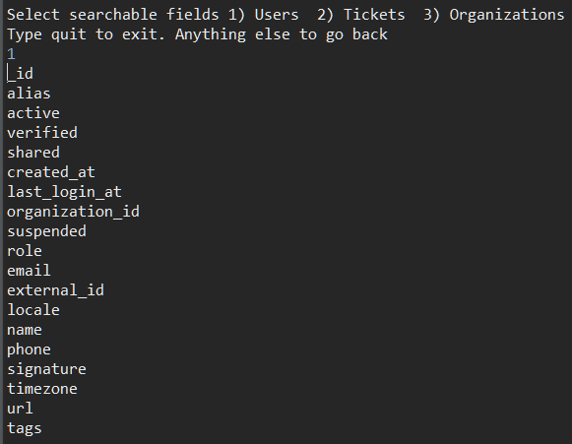

* Type quit and press enter in any screen to exit the program