A_evol

Abelether Germa

Abstract

Acknowledgements
CONTENTS

Abstract i
Acknowledgements ii
1 Introduction 4
2 Methodology 6
3 Research 7
4 Design 8
4.1 Concept Design 8
5 Implementation 9
6 Testing 10
7 Evaluation 11
8 Recommendations 12
9 Conclusion 13
List of Figures 14
References 15
Appendix A 16

Introduction

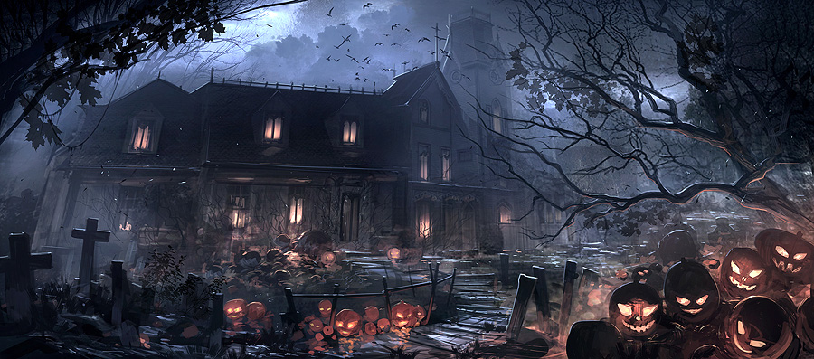
Figure 4.1-1 Halloween, Zhu, Feng (2013)
Note: If you refer to the image in your text use (see fig.1) or, if you choose to put your images in the appendices: (See appendix 1)
In your list of References
1. If you are referring to an online image
Fig. 1. Halloween Feng Zhu (2013)
At http://www.fengzhudesign.com/images/gallery_image_649.jpg
(Accessed on 25.10.13).

Order of Information:
Figure number: Fig.1
Artist's surname then given names
or initials (if unknown, replace with the title of the image):
Creation date if known: (2013)
Image title in italics (or artist if only that is known)
Medium in square brackets: [Digital Image]
At: URL: At http://www.fengzhudesign.com/images/gallery_image_649.jpg
(Accessed on date): (Accessed on 25.10.13)
2. If you are referring to a reproduction of an artwork you have scanned from a book:
In the list of illustrations the entry will look like:
Fig. 6. Schiele, Egon. (1914). Façade of a house [Oil painting] In: Comini, A Egon Schiele. Plate 43. London: Thames and Hudson.

Methodology

Research

Deoxyribonucleic acid (DNA) is the molecule that carries all of our genetic information. DNA has two strands that form a double helix, for this project both strands are not necessary as one is used for duplication of DNA in the process mitosis and meiosis.

DNA is made out of a nitrogen-containing nucleobase – either cytosine (C), guanine (G), adenine (A), and thymine (T).

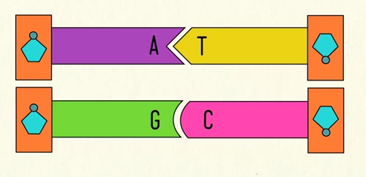
Figure 4.1-2: base pairing (CrashCourse, 2012)

A human cell contain forty-six DNA molecules which are called chromosomes

Combinations
DNA is read three letters at a time. Using the Formula: n to the power of r where n = 4 and where r = 3. Where the order is not important and repetition allowed, DNA can have 64 different combinations listed below.

[A,A,A],[A,A,T],[A,A,G],[A,A,C],[A,T,A],[A,T,T],[A,T,G],[A,T,C],[A,G,A],[A,G,T],
[A,G,G],[A,G,C],[A,C,A],[A,C,T],[A,C,G],[A,C,C],
[T,A,A],[T,A,T],[T,A,G],[T,A,C],[T,T,A],[T,T,T],[T,T,G],[T,T,C],[T,G,A],[T,G,T],
[T,G,G],[T,G,C],[T,C,A],[T,C,T],[T,C,G],[T,C,C],[G,A,A],[G,A,T],
[G,A,G],[G,A,C],[G,T,A],[G,T,T],[G,T,G],[G,T,C],[G,G,A],[G,G,T],[G,G,G],[G,G,C],[G,C,A],[G,C,T],[G,C,G],[G,C,C],
[C,A,A],[C,A,T],[C,A,G],[C,A,C],[C,T,A],[C,T,T],[C,T,G],[C,T,C],[C,G,A],[C,G,T],[C,G,G],[C,G,C],[C,C,A],[C,C,T],[C,C,G],[C,C,C]

Even though there are 64 different combinations, [A, T, G] has the same meaning as [T, A, C] therefore there is in fact 32 possible combinations. Because mitosis and duplication of DNA is not a problem when using a computer therefore we can make full use of

DNA
Chromosoms
Geans = protine
Amunio Acids
Codons

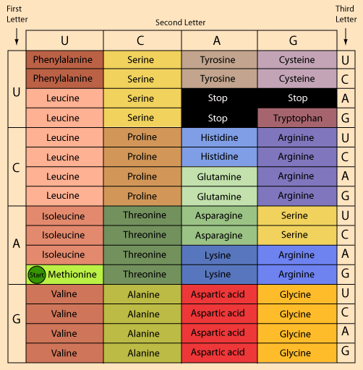

Helen said there is more than one combination of amino acids to make a specific protein.
As we can see from the above table, there is also

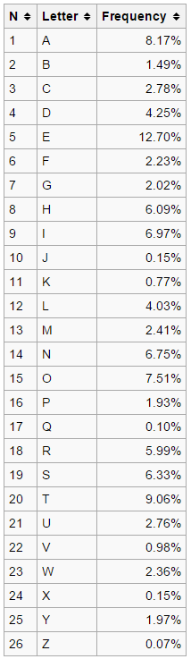
Leucine | 6 | E | 12.70
Valine | 4 | T | 9.06
Serine | 4 | A | 8.17
Proline | 4 | O | 7.51
Threonine | 4 | I | 6.97
Alanine | 4 | N | 6.75
Aspartic acid | 4 | S | 6.33
Arginine | 4 | H | 6.09
Glycine | 4 | R | 5.99
Isoleucine | 3 | D | 4.25
Phenylalanine | 2 | L | 4.03
Tyrosine | 2 | C | 2.78
Histidine | 2 | U | 2.76
Glutamine | 2 | M | 2.41
Asparagine | 2 | W | 2.36
Lysine | 2 | F | 2.23
Cysteine | 2 | G | 2.02
Serine | 2 | Y | 1.97
Arginine | 2 | P | 1.93
Tryptophan | 1 | B | 1.49
Stop | 3 | V | 0.95
Methionine | 1 | K | 0.77

 |  | Second Letter
 |  | T | C | A | G
First Letter | T | L | A | C | G | T | Third Letter
First Letter | T | L | A | C | G | C | Third Letter
First Letter | T | E | A | V | V | A | Third Letter
First Letter | T | E | A | V | B | G | Third Letter
First Letter | C | E | O | U | H | T | Third Letter
First Letter | C | E | O | U | H | C | Third Letter
First Letter | C | E | O | M | H | A | Third Letter
First Letter | C | E | O | M | H | G | Third Letter
First Letter | A | D | I | W | Y | T | Third Letter
First Letter | A | D | I | W | Y | C | Third Letter
First Letter | A | D | I | F | P | A | Third Letter
First Letter | A | K | I | F | P | G | Third Letter
First Letter | G | T | N | S | R | T | Third Letter
First Letter | G | T | N | S | R | C | Third Letter
First Letter | G | T | N | S | R | A | Third Letter
First Letter | G | T | N | S | R | G | Third Letter

Phenocopy, where an environmental factor induces an effect similar to a genetic mutation.

All humans have genes. Even though almost everyone’s genes is identical, only a small percentages of our gene is different yet that small percentage is enough to make each one of us unique. Genes interact with each other to create phenotypes. The slightest change in one gene can have a big effect on a phenotype or no effect at all. Our environment can also change which genes are used.

All humans know words. Even though almost everyone knows the basic words, the way we interpret them can be different. In addition, everyone knows different amount of words and the words we know are different depending on whom we know, where we grew up, how old we are, and what field of study we are interested in. Depending on the way we interpret the words we use the words differently compared to someone who knows the exact same words therefore being used differently. Our environment plays a big role on which words we choose to use also. From informal, formal, playful, flirty. We use different set of words and structure them differently.

Why 20 amino acid?
http://www.reasons.org/articles/why-these-20-amino-acids
They have a strong link.
Unlimited possibilities.
Can maintain 3D structures
Diverse
When looking at this attributes I can’t help think of the alphabet and how it I used to create words and tell a story. I thought of amino acids as alphabets and looked for a language that contained the least amount of alphabet. Rotokas language has the least amount alphabet but I was discurged from using it as the words would mean nothing to me or to anyone that will use this system. There for I have decided to use English.

To use the English alphabet, I first need to cut it down to 20 characters to represent the amino acids. To do this I got the list of the alphabet and the frequency of how many times they appare in words
https://en.wikipedia.org/wiki/English_alphabet

out of the 26 chrectores the cherctore JKQVX and Z were removed to as they have the lowest amount of frequency

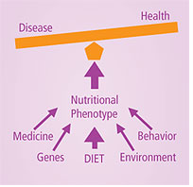

http://blogs.scientificamerican.com/a-blog-around-the-clock/files/2011/09/a2-genotype-phenotype.jpg

Design
This is the design section

Concept Design

Implementation

Testing

Evaluation

Recommendations

Conclusion

List of Figures

Figure 1 Zhu, Feng (2013) 5

References

Appendix A

