**SCHOOL OF COMPUTING**

**UNIVERSITY OF TEESSIDE**

**MIDDLESBROUGH**

**TS1 3BA**

**Artificial Evolution**

**BSc Computer Science**

**Abelether Germa**

**11 April 2016**

**Supervisor: Eudes Diemoz**

**Second Reader:**

# Abstract

Artificial Intelligence Research Project which aims to establish whether Darwin’s theory of natural selection can be used to solve algorithmic problems. Using the Agile Methodology, my first goal is building an environment to force the agents (something that perceive its environment through sensors and acts upon it) to evolve and test out whether they modify with each generation. I will be looking to see if they adapt to the environment just as animals do according to Darwin’s theory. I will be using Java to store agents DNA, Clojure to retrieve DNA, translate it into commands, and send it to NetLogo where agents interact with the set environment. Challenges agents will face includes getting to food first. This will require them not only to be fast but also sense food that is far. The agents that performed well will continue to live and also have offspring. The expected output is agents will evolve to sense food that is really far away and also are really fast. . All results will be stored to see how the agents evolved over time. I will also be looking at how this evolution process can be used to solve real life problems.

# Acknowledgements

**CONTENTS**

Abstract i

Acknowledgements ii

1 Introduction 5

2 Methodology 8

3 Cheese 9

4 Research 10

4.1 NetLogo 10

4.2 Java 10

4.3 Clojure 10

4.4 Integration 10

5 Design 11

5.1 Concept Design 11

5.2 Netlogo 11

5.3 Java 11

5.4 Clojure 11

5.5 Integration 11

6 Implementation 12

6.1 NetLogo 12

6.2 Java 12

6.3 Clojure 12

6.4 Integration 12

7 Testing 13

7.1 NetLogo 13

7.2 Java 13

7.3 Clojure 13

7.4 Integration 13

8 Evaluation 14

9 Recommendations 15

10 Conclusion 16

List of Figures 17

References 18

Appendix A 19

# Introduction

Make sure you remove the chevrons when you have entered correct data on cover page.

Alter headings as required

To insert additional headings: Select Page Layout tab > Breaks then in the Section Break area select Next Page.

To update your contents page: Right click on the contents table, select update, then update entire table.

To apply styles to headings:

Key in your heading then with your cursor on the heading text select the Home Tab, in the Styles section select either:

Heading 1,Main Heading

Heading 2, Second Heading

Heading 3, Third Heading

To insert Illustrations/Screenshots etc

Tool Bar>Insert>Picture Navigate to where your image is stored

Select the correct image and click Insert

To alter your image dimensions, select the image by clicking on it, you will see handles appear around it, the ribbon [top menu] will change and you will have the option to crop, resize etc.

Add a caption to your image, this will automatically provide a number and allow you to insert the list of figures into your document. This should be inserted at the back of your essay/dissertation but before your bibliography.

It should be in numerical order.

Click References>Insert caption

[Illustrations or images](javascript:void())

If you wish to include reproductions of artworks in your text you can either put them within the text or in your appendices.

In either position you would need to include the following information:

**In the text:**

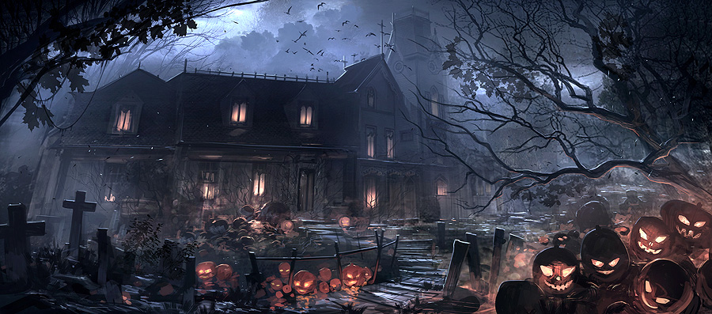

Figure Halloween, *Zhu, Feng* (2013)

Note: If you refer to the image in your text use (see fig.1) or, if you choose to put your images in the appendices: (See appendix 1)

**In your list of References**

1. If you are referring to an online image

Fig. 1.*Halloween* Feng Zhu (2013)

At http://www.fengzhudesign.com/images/gallery_image_649.jpg

(Accessed on 25.10.13).

Order of Information:

**Figure number:** Fig.1

**Artist's surname then given names   
or initials (if unknown, replace with the title of the image):**

**Creation date if known:** (2013)

**Image title in *italics*(or artist if only that is known)**

**Medium in square brackets:** [Digital Image]

**At: URL:** At http://www.fengzhudesign.com/images/gallery_image_649.jpg

**(Accessed on date):** (Accessed on 25.10.13)

2. If you are referring to a reproduction of an artwork you have scanned from a book:

In the list of illustrations the entry will look like:

Fig. 6. Schiele, Egon. (1914). *Façade of a house* [Oil painting] In: Comini, A *Egon Schiele.* Plate 43. London: Thames and Hudson.

# Methodology

# Cheese

# Research

## NetLogo

## Java

## Clojure

## Integration

## Choice of software development tools used

### Eclipse

### Netlogo

### Github

For this project, I have chosen to use GitHub for Version control. I have realised that I will be using the university computers as well as my laptop home. While working on previous projects I found version control is one of the baggiest problems when working on multiple computers. I often found myself having multiple version not know in which version I implemented a feature. By using Github, not only would I be able to work on one version using multiple computers, it would also be backed up and I would have constant access to it as long as I have an internet access.

I first used git hub for my Software architecture group work and became accustomed with the advantages and disadvantages of using GitHub. For my project to efficiently use GitHub I took it upon myself to do a tutorial so I am aware of all the features it has to offer and I can use them efficiently.

I have looked into version control software for Microsoft word for Git and looked at softwares such as Pandoc and

This is some changes for test

# Design

This is the design section

## Concept Design

## Netlogo

## Java

## Clojure

## Integration

# Implementation

## NetLogo

## Java

## Clojure

## Integration

# Testing

## NetLogo

## Java

## Clojure

## Integration

# Evaluation

# Recommendations

# Conclusion

# List of Figures

Figure 1 Zhu, Feng (2013) 5

# References

# Appendix A