A comparison of operator search and a planner

Abelether Germa
Teesside University
abel_germa@live.co.uk
Jess Bouge
Teesside University
n3078300@live.tees.ac.uk
Adam Postgate
Teesside University
n2095821@live.tees.ac.uk

Abstract
This paper presents a cross-platform AI application which consists of a back-end control system that uses operator search algorithm and planning algorithm devolved by S.C.Lynch. For the front-end we are using Netlogo and are using a wrapper in Clojure to send the commands. We argue that for our scenario the planner is much more suited and the operator should only be used in circumstance where the result is not immediately needed.

Keywords: Operator Search, Planner, Clojure, Netlogo

1. Introduction
This paper

2. Scenario

2.1 Initial Design

The aim of this design would be to build an object out of different shapes. The goal state would be for example; to have a green square with a blue triangle on the left and a red circle on the right. Using either Op-search or the planner to calculate and compare the fastest way to reach the goal state by moving the pusher and each block.

The different shapes will be located around the edges of the table. The object will be created in the center by the pusher. The pusher would only work in x-y directions. Once the product is complete it is then pushed over to the finished product area. The product will then disappear and the machine will be ready to produce another product.
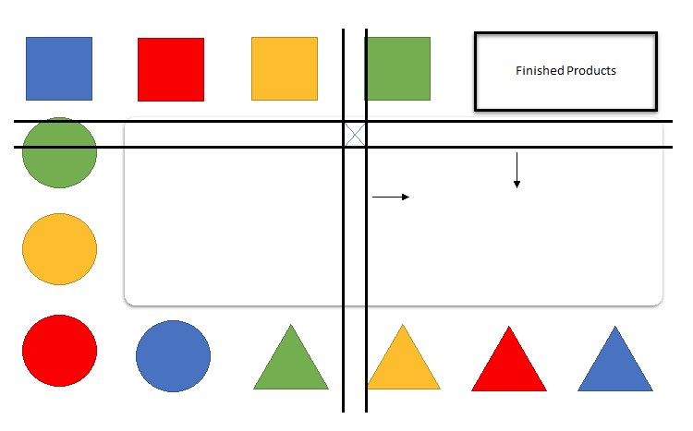

2.2 Final design
There would be 3 pushers in total; one on the top, one on the bottom and one on the left side of the table. They can all move left and right to different columns, between them they will be able to put any block on any part of the table as long as the block does not need to move left. The blocks you see on the diagram, are not actually created at the beginning but are only used for reference of where they will be created. Every time a block needs to be moved the algorithm will first check if the block exists, if it does it will move it from where it is but if the block does not exist it will go to the blocks creation place and create it, only then can it move the block. The creating place of a block cannot be moved, e.g. using the diagram as an example, the only place to create a blue box is on the top row at the 5th column, and this is therefore a fixed point.

By having an initial creation space, the block would not need to be created at setup. We have found that this method is much more efficient and true to our scenario because if the algorithm can create the blocks anywhere on the table, it would just create it at the goal state which means none of the arms would have the opportunity to push unless the block is already created and on the table. The way Netlogo is set up the arms pushes the first block in that column therefor if all the blocks are created at the beginning they are most likely going to get in the way which forces the Netlogo to be out of sync with the algorithm because the algorithm will assume the goal state has been reached where in Netlogo it has not, this can also create future problems if the algorithm is updating the state as it achieves goals.
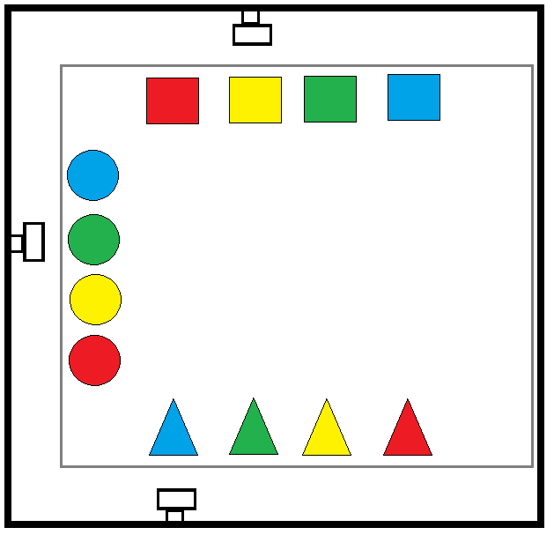

3. Netlogo
The front-end is created within Netlogo and is connected to the algorithm in Clojure using a wrapper. The scenario is similar to SHRDLU created by S.C.Lynch and the structure is adapted to fit our specific scenario.

3.1

(time (ops-search state '((at Tblue c3)(at Tblue y3)) ops :world world))

 | 3 x 3 | 4 x 4 | 5 x 5 | 6 x 6 | 7 x 7 | 8 x 8
1 | 616.547244 | 2179.537 | 2335.897 | 3744.325 | 13658.88 | 13260.83
2 | 662.254981 | 1798.898 | 2438.101 | 4167.984 | 6291.145 | 10167.19
3 | 650.232751 | 1667.062 | 3380.208 | 4243.747 | 7105.961 | 12952.47
4 | 629.979023 | 1353.625 | 2488.782 | 4225.622 | 10084.58 | 11370.33
5 | 607.529717 | 1457.625 | 2516.526 | 4832.807 | 6467.847 | 12473.16
6 | 621.792429 | 2711.422 | 2491.045 | 4112.513 | 8778.891 | 11213.65
7 | 612.641901 | 1905.882 | 2402.876 | 4324.081 | 7759.443 | 14815.44
8 | 615.012392 | 1380.902 | 2503.484 | 4270.808 | 8154.526 | 11213.16
9 | 663.842435 | 1591.612 | 2513.52 | 4098.848 | 7343.628 | 19357.18
10 | 615.57989 | 1746.565 | 2650.261 | 4134.795 | 6850.668 | 11342.31
Average | 629.541276 | 1779.313 | 2572.07 | 4215.553 | 8249.556 | 12816.57

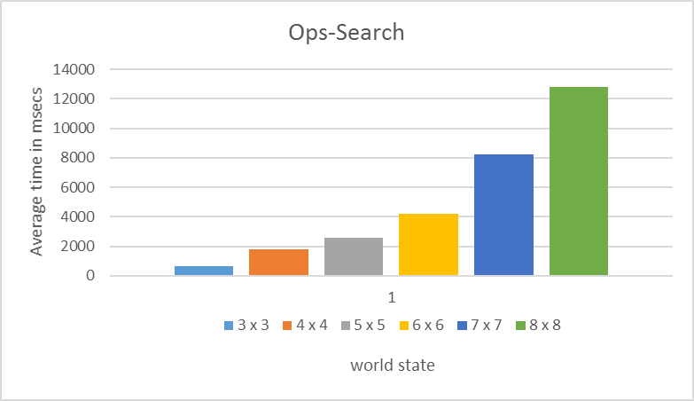

(n-test-opsearch random)
((at Tblue y3) (at Tblue c5) (at Sblue y8) (at Sblue c2) (at Cblue y6) (at Cblue c5) (at Tgreen y4) (at Tgreen c8) (at Sgreen y5) (at Sgreen c4) (at Cgreen y7) (at Cgreen c6))
StackOverflowError clojure.core/map/fn--4553 (core.clj:2616)
