**Understanding Spreadsheets Lessons**

[**Working with Spreadsheets**](https://www.free-online-training-courses.com/working-with-spreadsheets/)

Open, close a spreadsheet application. Open, close spreadsheets. To start Calc, click on the ‘Start’ button on your Windows machine. Click on ‘All Programs’ and then go to the ‘LibreOffice’ folder in the list of all programs which gets displayed. …[Take lesson](https://www.free-online-training-courses.com/working-with-spreadsheets/)

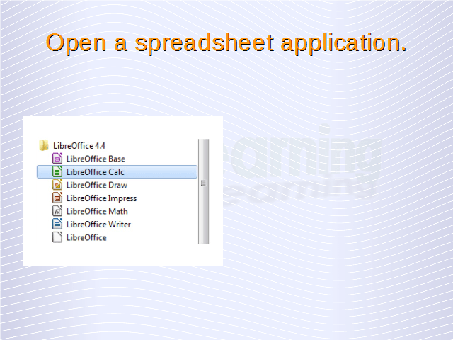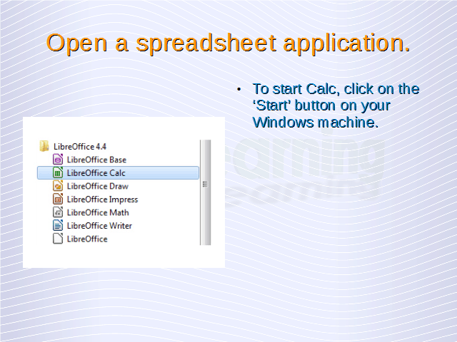

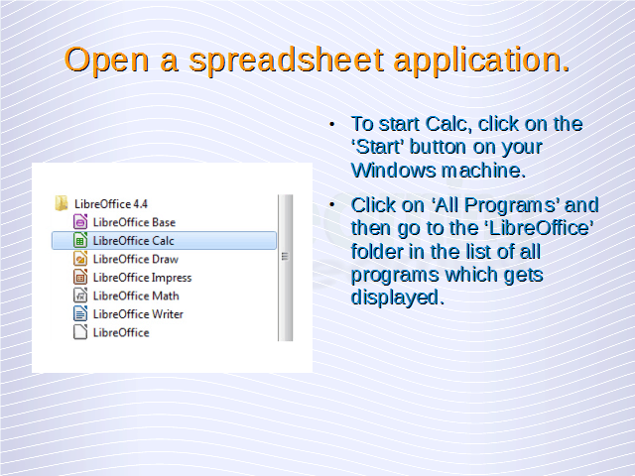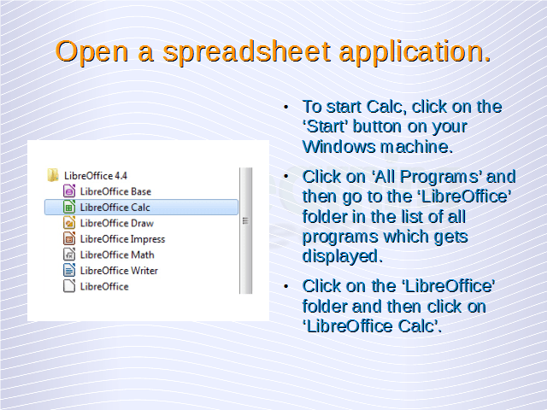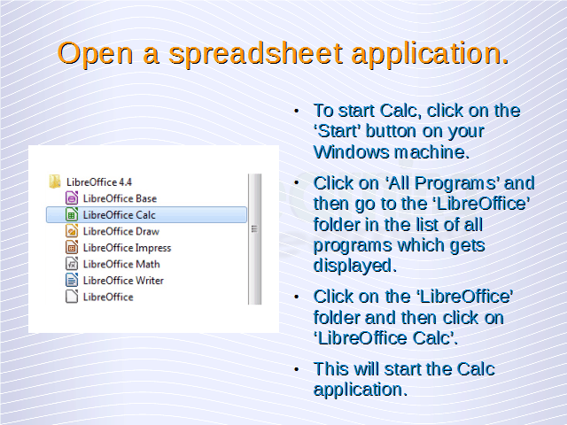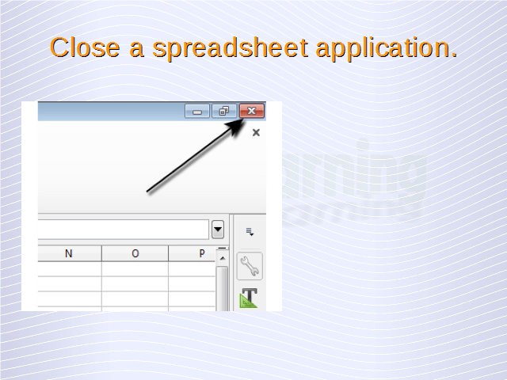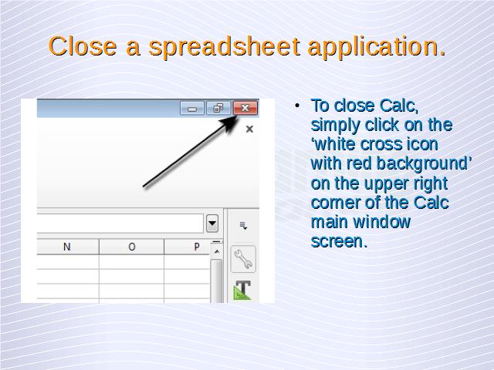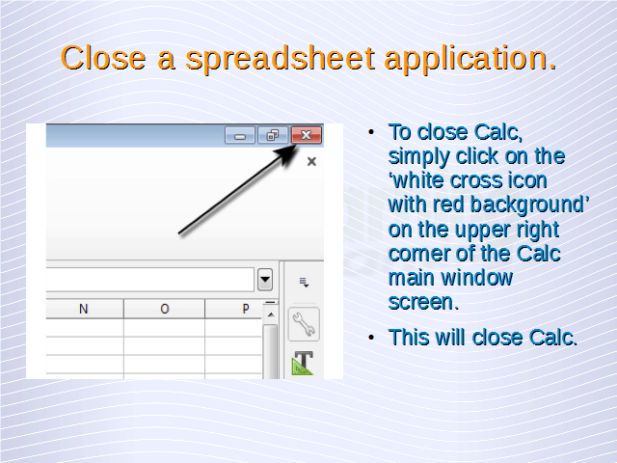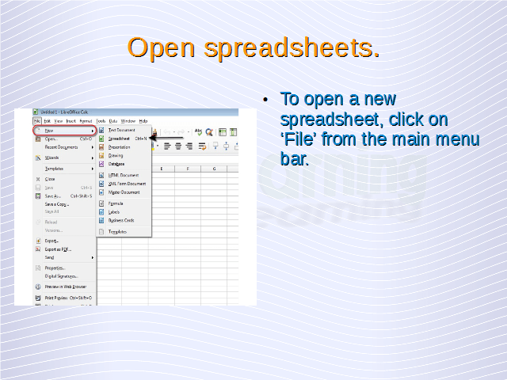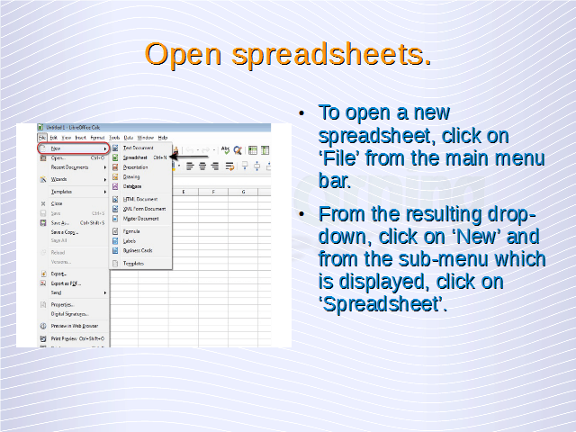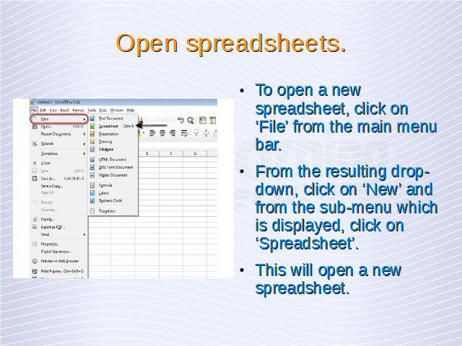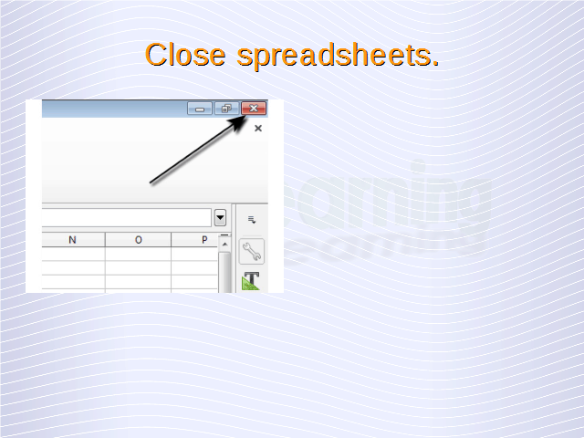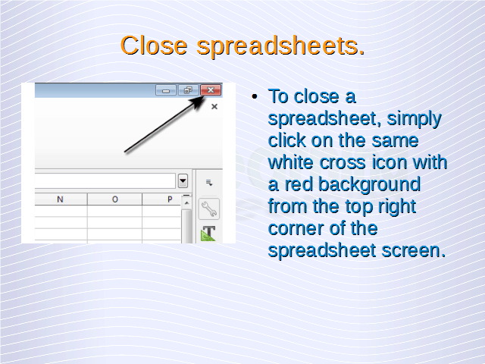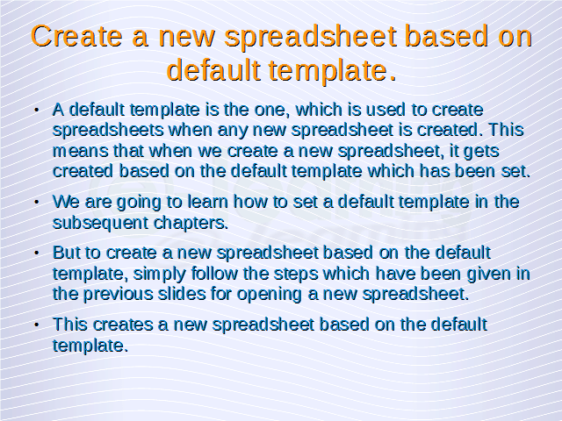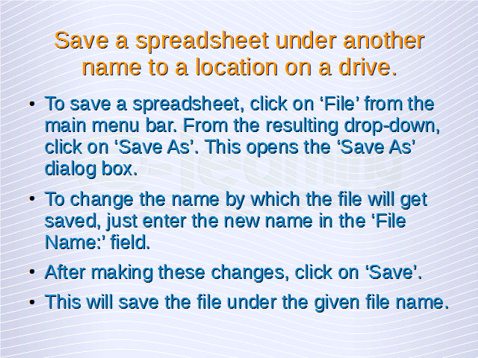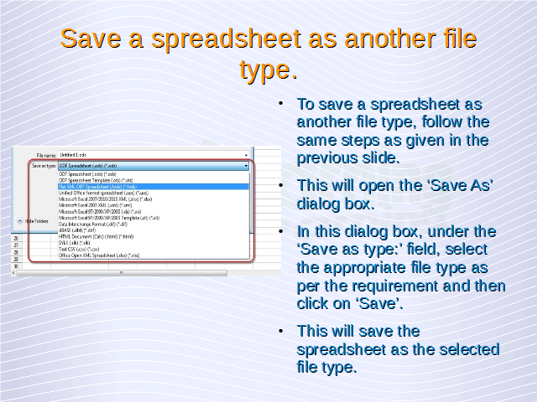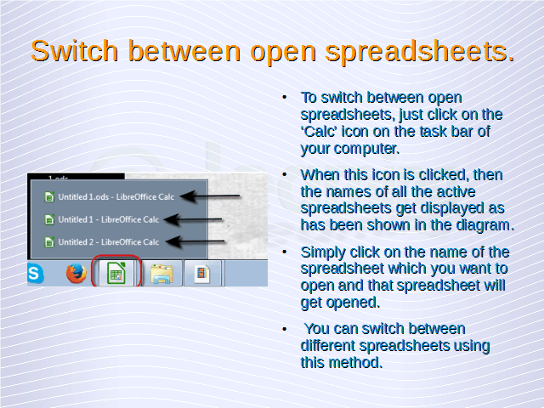

When Calc is started, the main window opens which has been shown below.

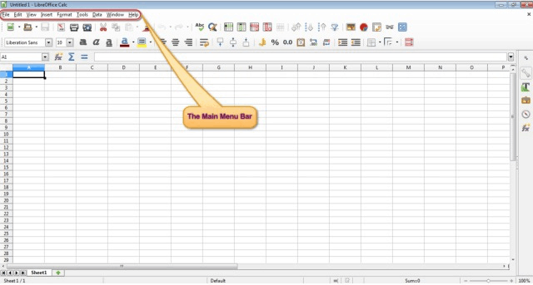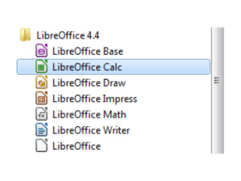

The highlighted portion shown in the above illustration is the ‘Main Menu Bar’. This is the most important menu bar in the Calc application and most of the operations in Calc can be performed from here. In this tutorial, we are going to use the main menu bar for performing a variety of different operations.  
To close Calc, simply click on the ‘white cross icon with red background’ on the upper right corner of the Calc main window screen. This will close Calc.

Once the application has been started, then a new spreadsheet can be opened. To open a new spreadsheet, click on ‘File’ from the main menu bar. From the resulting drop-down, click on ‘New’ and from the sub-menu which is displayed, click on ‘Spreadsheet’. This will open a new spreadsheet.

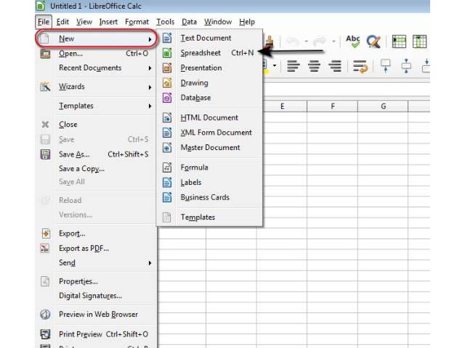

To close a spreadsheet, simply click on the same white cross icon with a red background from the top right corner of the spreadsheet screen.

## Create a new spreadsheet based on default template.

A default template is the one, which is used to create spreadsheets when any new spreadsheet is created. This means that when we create a new spreadsheet, it gets created based on the default template which has been set.

We are going to learn how to set a default template in the subsequent chapters. But to create a new spreadsheet based on the default template, simply follow the steps which have been given in the last section for opening a new spreadsheet. This creates a new spreadsheet based on the default template.

## Save a spreadsheet to a location on a drive. Save a spreadsheet under another name to a location on a drive.

Once the changes to a spreadsheet have been made, we need to save this spreadsheet to a location on our computer. To save a spreadsheet, click on ‘File’ from the main menu bar. From the resulting drop-down, click on ‘Save As’. This opens the ‘Save As’ dialog box.

In this dialog box, we can browse to the folder where we want to save the spreadsheet file and thus select the appropriate location. To change the name by which the file will get saved, just enter the new name in the ‘File Name:’ field. After making these changes, click on ‘Save’. This will save the file to the location which has been specified and under the given file name.

## Save a spreadsheet as another file type like: template, text file, software specific file extension, version number.

To save a spreadsheet as another file type, follow the same steps as given above. This will open the ‘Save As’ dialog box. In this dialog box, under the ‘Save as type:’ field, select the appropriate file type as per the requirement and then click on ‘Save’. This will save the spreadsheet as the selected file type.

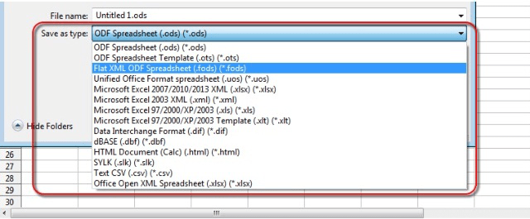

## Switch between open spreadsheets.

You can open multiple spreadsheets at a time in Calc. In such a case, to switch between these spreadsheets, just click on the ‘Calc’ icon on the task bar of your computer. This icon will always get displayed whenever you are running Calc on your machine.

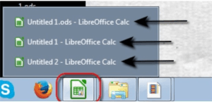

[**Enhancing Productivity**](https://www.free-online-training-courses.com/enhancing-productivity/)

Set basic options/preferences in the application: user name, default folder to open, save spreadsheets. To set the basic options in the Calc application, click on ‘Tools’ from the main menu bar. From the resulting drop-down, click on ‘Options’. This will …[Take lesson](https://www.free-online-training-courses.com/enhancing-productivity/)

[**Spreadsheet Cells**](https://www.free-online-training-courses.com/spreadsheet-cells/)

Insert, Select Understand that a cell in a worksheet should contain only one element of data, (for example, first name detail in one cell, surname detail in adjacent cell). Any cell in a worksheet should always contain only one element …[Take lesson](https://www.free-online-training-courses.com/spreadsheet-cells/)

[**Edit and Sort Spreadsheet Cells**](https://www.free-online-training-courses.com/edit-and-sort-spreadsheet-cells/)

Edit cell content, modify existing cell content. To edit or modify the content of a cell, double click on that cell. This will enable the editing for that cell. After this, delete the already present data in that cell using …[Take lesson](https://www.free-online-training-courses.com/edit-and-sort-spreadsheet-cells/)

[**Copy, Move, Delete Spreadsheet Cells**](https://www.free-online-training-courses.com/copy-move-delete-spreadsheet-cells/)

Copy the content of a cell, cell range within a worksheet, between worksheets, between open spreadsheets. To copy the content of a cell or a range of cells within a worksheet, between worksheets or even to another open spreadsheet, simply …[Take lesson](https://www.free-online-training-courses.com/copy-move-delete-spreadsheet-cells/)

[**Managing Worksheets**](https://www.free-online-training-courses.com/managing-worksheets/)

Rows and Columns Select a row, range of adjacent rows, and range of non-adjacent rows. To select a row, simply click on the row header for that row. It should just be a single click and not a double click. …[Take lesson](https://www.free-online-training-courses.com/managing-worksheets/)

[**Worksheets**](https://www.free-online-training-courses.com/worksheets/)

Switch between worksheets. To switch between different open worksheets, we just need to click on the appropriate sheet name from the bottom of the Calc window, as has been shown in the below given illustration. When we click on a …[Take lesson](https://www.free-online-training-courses.com/worksheets/)

[**Formulas and Functions**](https://www.free-online-training-courses.com/formulas-and-functions/)

Arithmetic Formulas Recognize good practice in formula creation: refer to cell references rather than type numbers into formulas. We have been entering either text or numbers into the cells till now, but in case the data in a cell is …[Take lesson](https://www.free-online-training-courses.com/formulas-and-functions/)

[**Functions**](https://www.free-online-training-courses.com/functions/)

Use sum, average, minimum, maximum, count, counta, round functions. Functions help us in analyzing and referencing data. To use functions in a worksheet, first of all we need some data on which the functions are to be applied. Any function …[Take lesson](https://www.free-online-training-courses.com/functions/)

[**The IF Function**](https://www.free-online-training-courses.com/the-if-function/)

Use the logical function if (yielding one of two specific values) with comparison operator: =, >, <. To use the logical function ‘IF’, we need to follow the same steps as before to reach the ‘Function Wizard’. In the ‘Function …[Take lesson](https://www.free-online-training-courses.com/the-if-function/)

[**Formatting**](https://www.free-online-training-courses.com/formatting/)

Numbers/Dates Format cells to display numbers to a specific number of decimal places, to display numbers with, without a separator to indicate thousands. It is possible in Calc to format cells to display any input in some particular styles. To …[Take lesson](https://www.free-online-training-courses.com/formatting/)

[**Change Spreadsheet Cell Content Appearance**](https://www.free-online-training-courses.com/change-spreadsheet-cell-content-appearance/)

Change cell content appearance: font sizes, font types. In the same ‘Format Cells’ dialog box, under the ‘Font’ tab, we have the ‘Font’ and ‘Size’ drop-down lists. The ‘Font’ drop-down list gives the different font types and ‘Size’ gives the …[Take lesson](https://www.free-online-training-courses.com/change-spreadsheet-cell-content-appearance/)

[**Spreadsheet Formats – Alignment and Border Effects**](https://www.free-online-training-courses.com/spreadsheet-formats-alignment-and-border-effects/)

Apply text wrapping to contents within a cell, cell range. To apply text wrapping to contents within a cell or a cell range, first select the cell or the cell range and then right click anywhere on the entire range. …[Take lesson](https://www.free-online-training-courses.com/spreadsheet-formats-alignment-and-border-effects/)

[**Create Spreadsheet Charts**](https://www.free-online-training-courses.com/create-spreadsheet-charts/)

Create different types of charts from spreadsheet data: column chart, bar chart, line chart, pie chart. In Calc, we can represent our data with the help of different graphical representations like column chart, bar chart, line chart, or pie chart. …[Take lesson](https://www.free-online-training-courses.com/create-spreadsheet-charts/)

[**Edit Spreadsheet Chart Title**](https://www.free-online-training-courses.com/edit-spreadsheet-chart-title/)

When a chart is created, then in the ‘Chart Wizard’, under the ‘Chart Elements’ tab, we have the option to add a ‘Title’ for the chart. Appropriate title can be added in this tab during the creation of the chart. …[Take lesson](https://www.free-online-training-courses.com/edit-spreadsheet-chart-title/)

[**Changing The Spreadsheet Chart**](https://www.free-online-training-courses.com/changing-the-spreadsheet-chart/)

Change the column, bar, line, pie slice colors in the chart. To change the column, bar, line, or pie slice color in a chart, simply double-click on the respective element for which you want to change the color. If it …[Take lesson](https://www.free-online-training-courses.com/changing-the-spreadsheet-chart/)

[**Prepare Outputs**](https://www.free-online-training-courses.com/prepare-outputs/)

Setup Change worksheet margins: top, bottom, left, right. In order to change the worksheet margins, click on the ‘Format’ button from the main menu bar. Click on ‘Page…’ button from the resulting drop-down. This gives the ‘Page Style’ dialog box. …[Take lesson](https://www.free-online-training-courses.com/prepare-outputs/)

[**Check and Print**](https://www.free-online-training-courses.com/check-and-print/)

Check and correct spreadsheet calculations and text. In order to check the spreadsheet calculations, we need to check the sheet for the error codes. These error codes have already been discussed. If error codes are present, this means that some …[Take lesson](https://www.free-online-training-courses.com/check-and-print/)

[**Preview a worksheet**](https://www.free-online-training-courses.com/preview-a-worksheet/)

To preview a worksheet, click on ‘File’ from the main menu bar and from the resulting drop-down menu, click on ‘Print Preview’. This will open the preview display of the worksheet as has been shown below. To close the preview, …[Take lesson](https://www.free-online-training-courses.com/preview-a-worksheet/)