*CS148 Summer 2016 HW2 - OpenGL*

**Introduction**

In this assignment, we will practice some of the basics of OpenGL.

**Setup**

We will be using the GLUT / freeglut library for our OpenGL code. If you are on Windows, you can find a freeglut 3.0.0 package for Visual Studio (MSVC) at <http://www.transmissionzero.co.uk/software/freeglut-devel/> . On OS X, GLUT should be installed by default. Finally, if you are on Linux and don’t have GLUT already installed, you should be able to install it by running *sudo apt-get install freeglut3-dev* or *sudo yum install freeglut-devel* in a terminal. We have written the included *Makefile* so that the homework should compile with it on Linux or OS X. For Windows, you will need to create a project in Visual Studio rather than using the *Makefile.*

*We note that the Ubuntu VM provided for the course already has the necessary library installed.*

***WARNING:*** Your code must successfully compile on the provided Ubuntu VM, regardless of the operating system on which you write your code. A penalty may be applied if we cannot get your code to run.

If you have any questions about setting up GLUT / freeglut on your machine, please ask them on Piazza or in office hours. Please make sure you try compiling the starter code ASAP so that there are no last-minute problems with getting your environment setup correctly.

**The Main Assignment**

Now that everything is up and running, let’s get to the main part of the assignment.

For this homework, you will be using your newfound OpenGL skills from class, as well as your artistic creativity, to create several 3D scenes with OpenGL.

The first part of the assignment is to write code to reproduce each of the following three images:

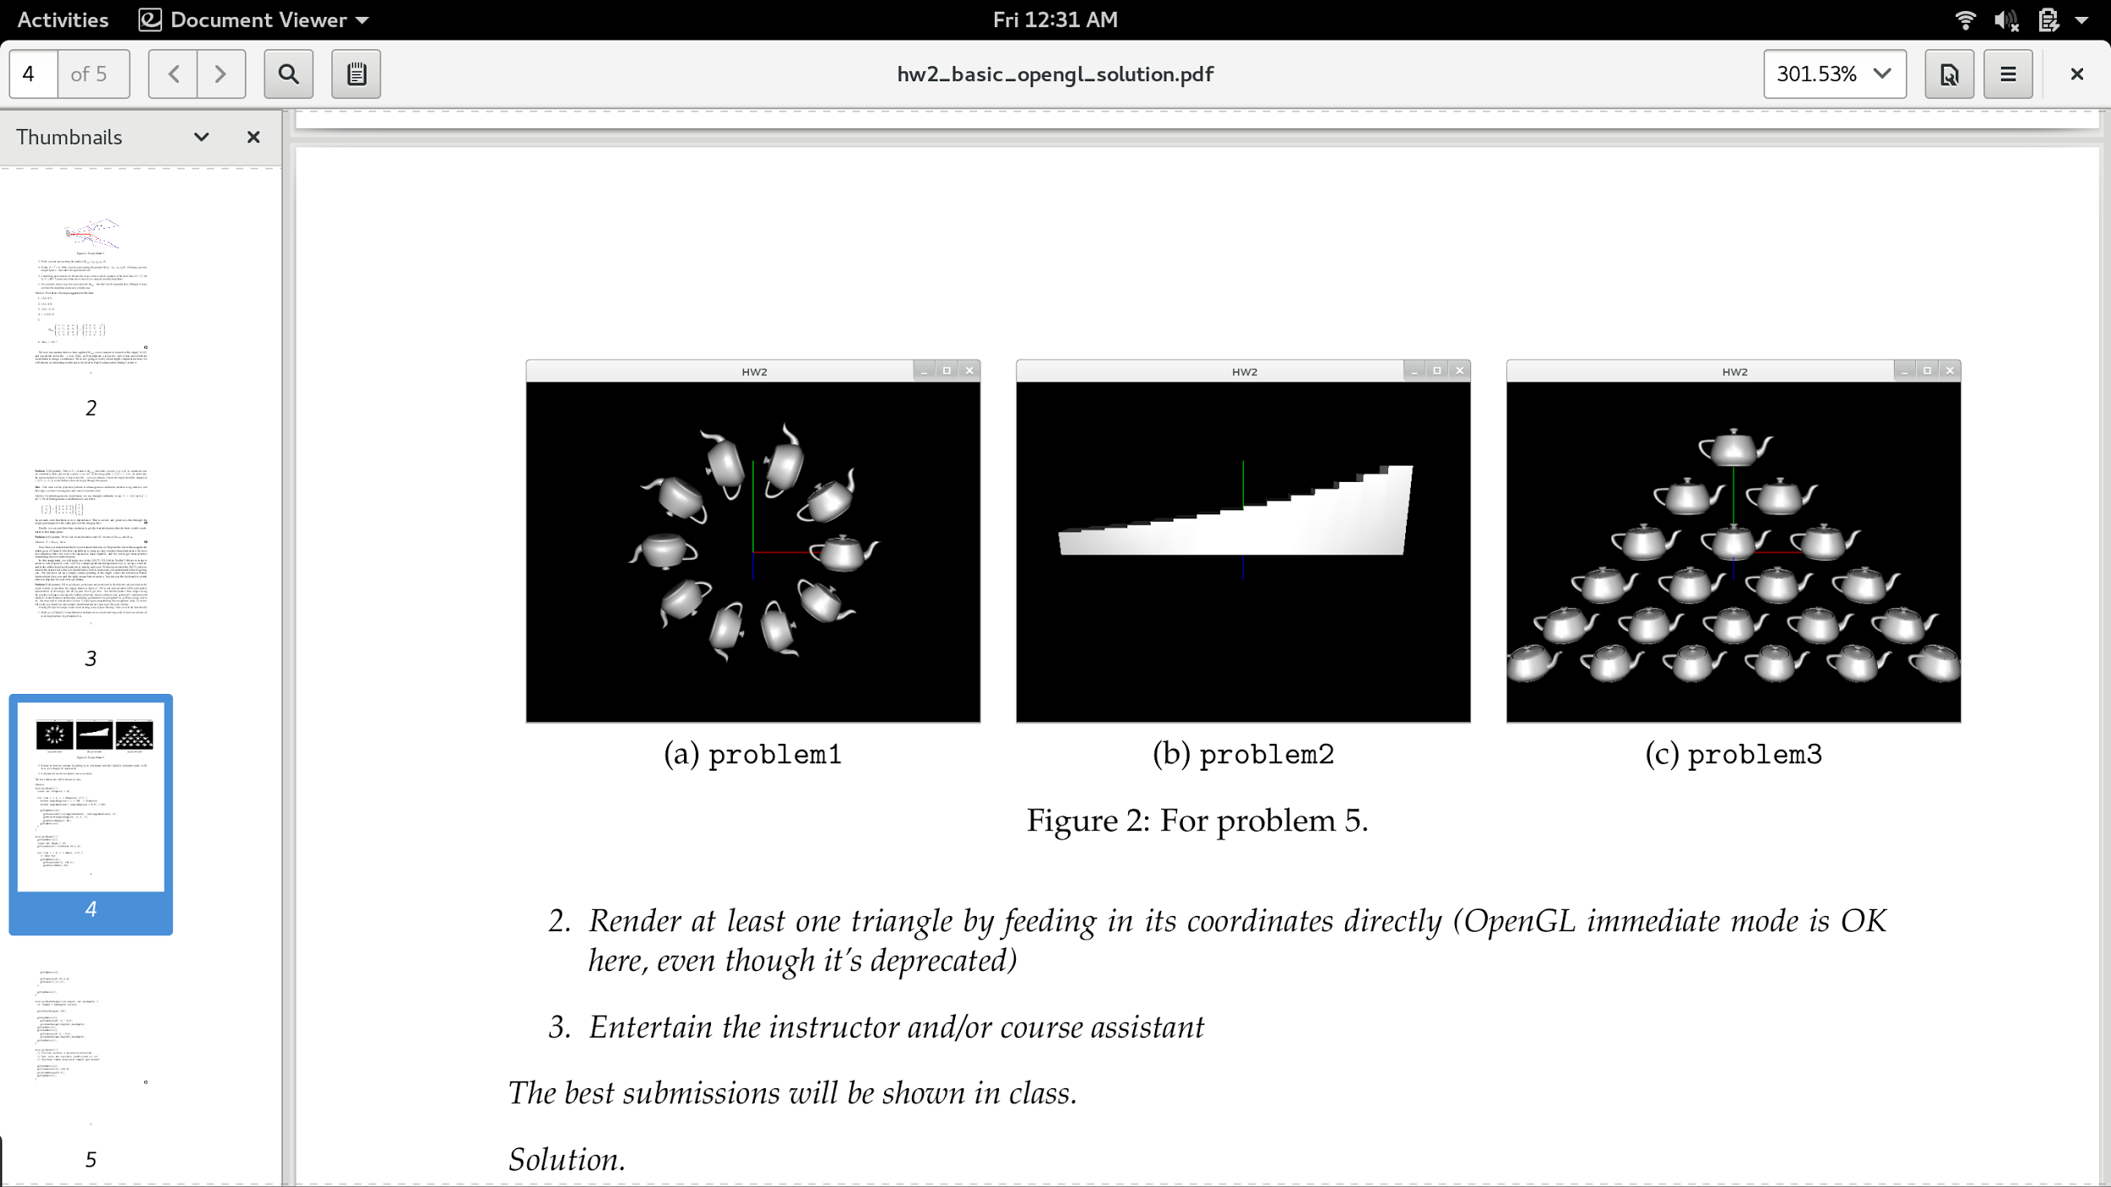

The second part of the assignment is to create, using similar techniques, a scene of your own imagination.

All the code for this homework lives in *main.cpp*; you need to fill in the functions *problem1*, *problem2*, *problem3*, and *problem4*. You can switch between the different examples while the program is running by pressing the 1, 2, … keys. Hence you don’t need to recompile in order to run different examples. Additionally, you can quit the program at any time by pressing ‘q’, ‘Q’, or the Escape key.

**Tips and Requirements**

For each of the three reproductions, you should be able to create the image using only *glutSolidTeapot*, *glutSolidCube*, and OpenGL’s transformation mechanisms like *glPushMatrix*, *glPopMatrix*, *glTranslatef*, etc. Note that you should not need any custom geometry, just the teapot and cube, to reproduce the images.

Your reproductions do not need to match exactly. However, please try to make them match the examples as closely as possible. We used nice numbers in the reference solutions, so if you find yourself using strange fractions etc. to reproduce the examples, you may be trying too hard!

For the open-ended image/scene, we require the following to make sure your image is interesting:

1. Make use of OpenGL’s transformation mechanisms in a nontrivial way, with at least one instance of nested applications of *glPushMatrix* (i.e., a *glPushMatrix* within another *glPushMatrix*).
2. Render at least one triangle by feeding in its coordinates directly (OpenGL immediate mode is okay here, even though it’s deprecated)

As an example, you could attempt to create a (very rough approximation of) an articulated hand:

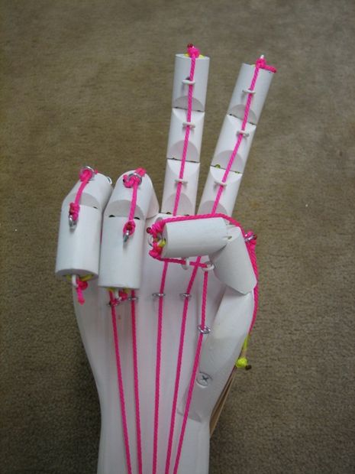

Otherwise, this piece of the assignment is intentionally left open for your creativity. We will show our favorite submissions in class!

**Deliverables**

*Submit all deliverables to the course staff’s gmail address. Note: submitting everything together as a .zip file is easiest for your graders.*

* Code for generating each of your four images (*main.cpp*)
* Screenshots (preferably .png) for each of your four images
* Any feedback you may have about this assignment

**Reminder**

Please recall and follow the university’s and the department’s honor codes. Please also recall and follow the collaboration and late day policies set forth for the course. If you are ever unsure, please ask first!