*CS148 Summer 2016 HW3 - Shaders*

**Introduction**

In this assignment, we will dive a little more deeply into OpenGL by implementing the Phong shader model.

**Setup**

Since this homework assignment is more complicated than the last, you will need a few libraries installed on your system: GLUT (which you should have already installed for HW2), GLEW, GLFW, and GLM.

*On Ubuntu/Debian,* first run *sudo add-apt-repository ppa:keithw/glfw3* in order to add a repository containing the GLFW3 library.

*On Ubuntu and other Linux variants*, these libraries can be installed with a one-liner at the terminal: *sudo apt-get install libglew-dev libglfw3-dev libglm-dev* . (Note: on some Linux variants, the package names might end in *devel* rather than *dev*; check your distribution’s package database to find the correct package.)

*On OS X*:

GLEW: If you have Homebrew installed, you can run *brew install glew*, or if you have Macports, you can run *sudo port install glew +universal* and *sudo port install libsdl +universal* .

GLFW: If you have Homebrew installed, you can run *brew install glfw3* . With Macports, you can run *sudo port install glfw* .

GLM: If you have Homebrew installed, you can run *brew install glm* . With Macports, you can run *sudo port install glm* .

*On Windows:*

You can download GLEW from <https://sourceforge.net/projects/glew/files/glew/1.13.0/> (select the download that ends in *win32*.zip) and GLFW from <http://www.glfw.org/download.html> (you will most likley want the 64-bit Windows binaries). The header-only (no compilation necessary) GLM library can be downloaded from <https://github.com/g-truc/glm/releases> . In your Visual Studio project, you will need to add the appropriate include directories and library directories for each of these libraries. Some help with this can be found at <http://www.41post.com/5178/programming/opengl-configuring-glfw-and-glew-in-visual-cplusplus-express> .

**Compiling and Running the Code**

For Linux and OS X, we have included aMakefile that will automatically compile the homework, assuming you have the correct libraries installed. Just run *make* in a terminal. The program that is generated is named *hw3*.

On Windows, you can use Visual Studio in the usual way to compile and run your program.

Note that the files needed for compilation include *main.cpp*, *Camera.h*, and *Shader.h*. Your vertex and fragment shader files are loaded by OpenGL at runtime; you do not need to compile them with the other files.

Note that the program takes no command line arguments etc. - you can just compile and run.

**Note**

We have provided ample starter code. Among the features we’ve included, you can pan and shift the camera. Moving the mouse will rotate the camera (note: on some machines, the code might be very sensitive to the mouse movement). Using the W+A+S+D keys will shift the camera. You can press the Escape key to quit the program.

**The Main Assignment**

The goal of this assignment is to implement the Phong shading model. We will do this by shading a simple cube, whose geometry is constructed in *main.cpp*.

You will write the vertex and fragment shaders for the Phong model; stubs for the shaders are provided in *phong.vs* and *phong.frag*, respectively. If you implement everything correctly, you should be able to reproduce an image like the following:

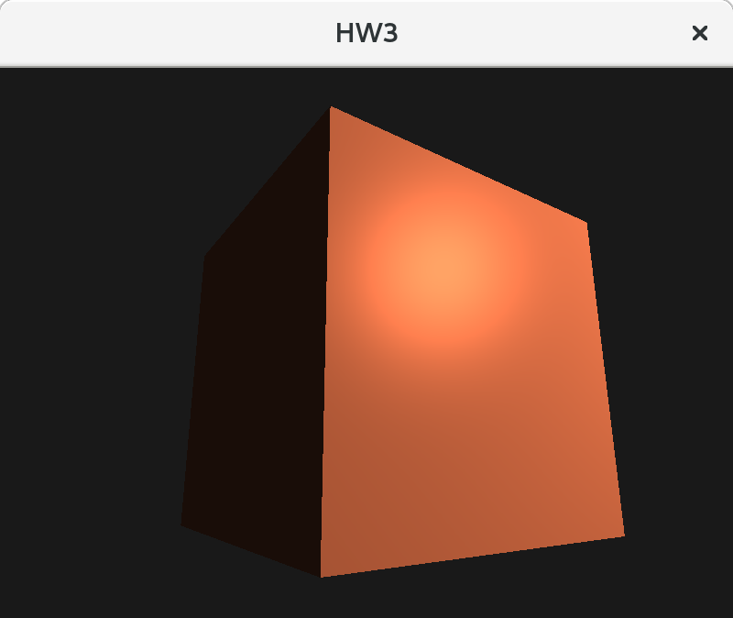

**Tips**

Initially, you will get a black screen. We recommend that you first attempt to get a solid red (or other color) cube visible. Once you have that, then you can proceed to build up your Phong model, and you can debug as you progress.

**Deliverables**

*Submit all deliverables to the course staff’s gmail address. Note: submitting everything together as a .zip file is easiest for your graders.*

* Code for your shaders (*phong.vs and phong.frag*)
* A screenshot (preferably .png) of your result
* Any feedback you may have about this assignment

**Reminder**

Please recall and follow the university’s and the department’s honor codes. Please also recall and follow the collaboration and late day policies set forth for the course. If you are ever unsure, please ask first!