*CS148 Summer 2016 HW4 – Ray Tracing*

**Introduction**

In this homework, you will be adding some features to a barebones ray tracer using techniques we have discussed in lecture. Unlike our other assignments, we will be leaving nearly all of the software engineering, implementation, and structuring decisions to you.

**Note**

We have tested the starter code on the VM and the Myth machines. For the VM you will need to install **libpng**; see below for instructions.

**Compiling (On the VM or Unix based system)**

Make sure your system is setup properly first (see **Setup Instruction** below). Run make from the terminal in the same directory as the “Makefile” This should compile an executable “hw4”. Running it the first time, without any modifications, will produce a PNG image “test.png” which should display three spheres shaded in gray as follows:

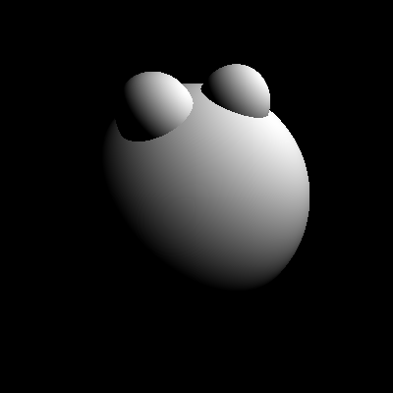

**Deliverables**

*Submit all deliverables to the course staff’s gmail address. Note: submitting everything together as a .zip file is easiest for your graders.*

* Written assignment answer file: **writeup.pdf**
* All the source files – including our starter code and your modifications. Make sure to run “make clean” before you zip the folder up.
* **Images produced in each problem** of the homework separately. Name them in a reasonable manner so it’s easy for us to tell which is which.
* Any feedback you may have about this assignment

**Setup Instruction**

**NOTE: Please make sure your code compiles and works on the VM more than anything else because that’s where we will grade you. Though we provide instructions for other platforms but those are really for your convenience. Keep in mind that each platform/IDE is different and you need to figure out the details of how to set it up on your machine if you want to develop outside the VM – here we are trying to help you as much as we can.**

**VM (or other Linux/Ubuntu)**

Install libpng12-dev on the VM (or if you are using your own Ubuntu based linux system) by running the following on the terminal

sudo apt-get install libpng12-dev

**Mac/OSX**

Assuming you already have Homebrew installed in your Mac, install libpng with the following

brew install libpng

**Windows**

We have attempted to include a Visual Studio solution that will work for you out-of-the box. It is only claimed to work with Visual Studio 2015, on a 64-bit machine (x64), with the build profile Debug with x64, on Windows 10. Other environments, other build profiles, etc. will **not** be supported, and you will have to use the VM or fix Visual Studio issues on your own or with your classmates. However, if you are running on the aforementioned platform, we can provide a limited amount of Windows support, as the project should theoretically compile and run out of the box. Remember, at the end of the day, your project must successfully compile and run on the VM.

**Reminder**

Please recall and follow the university’s and the department’s honor codes. Please also recall and follow the collaboration and late day policies set forth for the course. If you are ever unsure, please ask first!