Figures

Figure 1: Competition Networks by Year – before any pruning

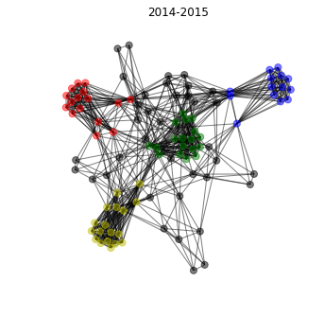
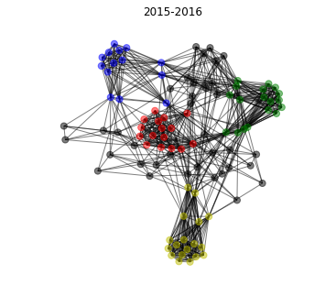
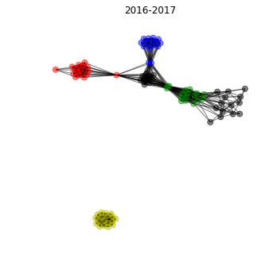
Legend for all competition networks:
Greek Basketball League - blue
Spanish Liga ACB – green
Italian Lega Basket Seri A – red
French LNB Pro A – yellow
Other - gray

Note: This is teams vs teams, which different than players vs teams, but that competition network is so large its hard to visualize well. Therefore, this is a simplified representation.

Figure 2: Competition Networks by Year - Teams with no club play data removed

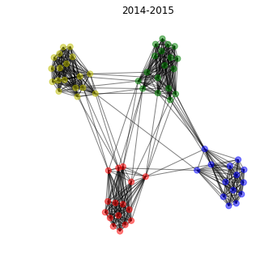
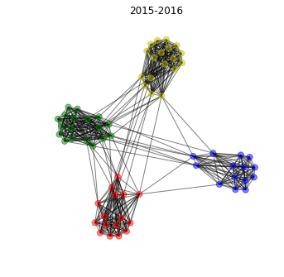
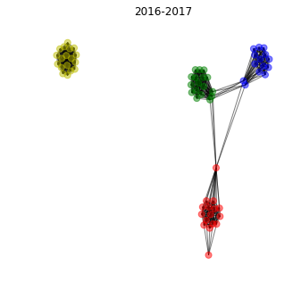

Figure 3: 2016-2017 Competition Network - French teams removed
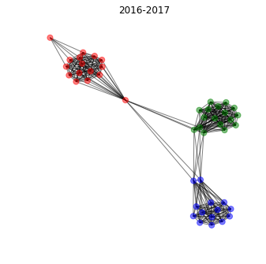

Figure 4: Sportsref Source webpage table
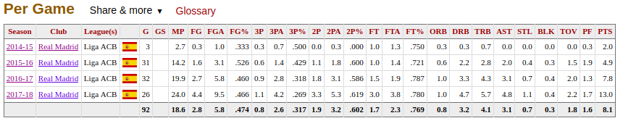
Source:
https://www.basketball-reference.com/euro/players/luka-doncic-1-club.html#per_gameCLU0::none

Figure 5: Python call and resulting DataFrame
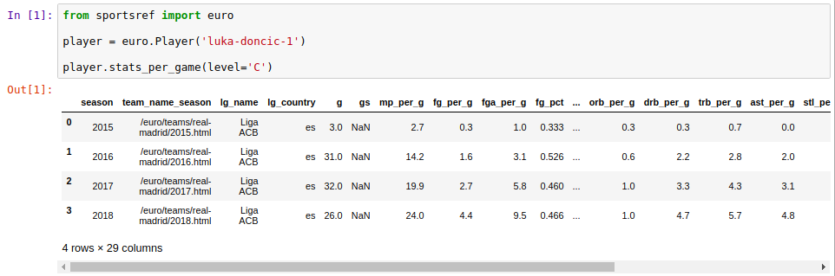

Figure 6: Boxscore example
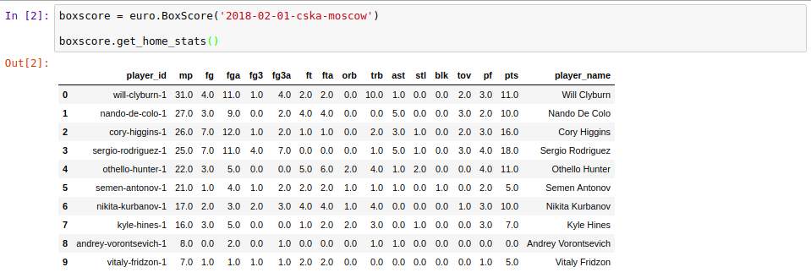
Source:
https://www.basketball-reference.com/euro/boxscores/2018-02-01-cska-moscow.html

Figure 7: Cleaned Dataset preview
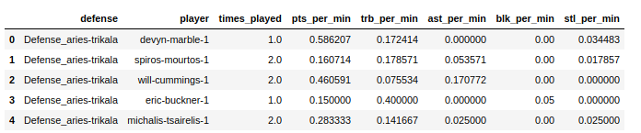

Figure 6

