Global Networking:

Standardizing International Basketball Statistics with a Network-Based Approach

Alex Beard

Advised by:

Michael J. Tomas III
Barbara Arel

Abstract
Do when done – just a short summary

Introduction
The table below shows Jimmer Fredette’s statistics from the 2014-2015 season, his last playing a significant amount of games in the NBA, and the 2016-2017 season, his first season playing in China after a brief stint on the Knicks (source 1, 2, 3).

Year | Team | MPG | FG% | PPG | RPG | APG
2014-2015 | New Orleans | 10.2 | 38.0 | 3.6 | 0.8 | 1.2
2016-2017 | Shanghai Dongfang | 40.5 | 47.4 | 37.6 | 8.2 | 4.2

How did Fredette’s statistics improve so much? Did he develop that much in the 18 months in between? Did his five minutes in two games in New York (where he now has the franchise record for effective FG% after hitting his only shot and going 4/5 from the line – source 3) inspire him to become a different player entirely? Unlikely.
What’s really at play here is the difference in strength of schedule. Differences in strength of schedule are sometimes mentioned in the NBA, but the difference in skill level isn’t that large (no matter what some tanking teams might make you think), and regardless – each team plays roughly the same schedule (source 4). European basketball is quite different, for two reasons – the greater disparity in competition than the NBA (cite a source somehow? → change to say because schedules are so diff and diff leagues… be less commital), and the structure of the schedule (which will be discussed in greater detail in the Data Methodology section.
These differences make it difficult to take European statistics at face value. It would be extremely easy to compare statistics between players if they had all played every one of the 88 other teams in the league. To approximate this, I attempted to predict the player vs team matchup results that didn’t happen in a given year, which could then, when every player has played the “same” schedule, allows standardized statistics to be calculated.

Literature Review
Previous papers have talked about itnernational play. For example… <author> in <paper>…
No headers – flow together with transitional sentences
Keep somewhat chronological?
(name, year)
Example: Jones and Johnson (2017) talked about…
If author’s name used as part of sentence, do like above
if not, in parantheses is (authors, year)
MoneyRoundball? The Drafting of International Players by National Basketball Association Teams (Source 5)
This article is relevant because it illustrates the ultimate goal of this work, which is to look into the performance of international players. Their input is draft position, but in future work using standardizing international statistics, they could either be placed as a comparison to draft position (which one predicts NBA performance better), or as an input, with draft position as an output, to essentially test the accuracy of the standardized statistics, assuming that the draft positions are with perfect information (which is obviously not true, but they might be close enough to provide a decent approximation).

Deep Dives: Measuring Level of Competition Around the World (Source 6)
This is similar analysis, except comparing leagues to leagues, instead of players to players (so a slightly less granular version). It does this by optimizing the different relative competition scores to minimize the disagreement, then standardizing them to a z-score (mean of 0, standard deviation of 1). This is actually something I tried to do, but on a player-game level, but I found it intractable (see Appendix 1?)

Projecting International Prospects, Parts 1-3 (Sources 7-9)
This series talks a lot about the challenges of strength of schedule, and about the differences between statistics in different leagues. For example, with his league-wise adjustments, he adjusts (for example) the French league being pass-happier). An extremely relevant quote that’s really why I tried to use a separate network-based approach for each statistic:
“Strength of competition does not necessarily impact all skill-sets in the same way, and different leagues may inflate one statistic while deflating another. These factors mean that information is lost in any simple SOS adjustment.”
The next step that I take is not assuming that within leagues, the inflation/deflation for each statistic is the same. If there are significant differences between defenses within a league, that’s something my model should capture.

WHY doing it with networks
TRANSITION INTO NON_INTERNATIONAL…
My paper will extend international analysis by...
Bayesian Inference of Natural Rankings in Incomplete Competition Networks
This peer-reviewed paper is looking at a slightly different problem (inferring the ranks of nodes in a competition network, rather than the specific adjustments), but the general idea is definitely the closest to mine. As I described in my introduction, we start out with an incomplete network, because not every player has played every team. This paper outlines the general concept I’m using, which is to infer the missing edges, resulting in a completely connected network, which can then be analyzed much more easily, as can be seen in Figure 1b. The main differences are what is trying to be predicted in the end (as mentioned), the fact that my competition network is a bipartite graph (players do not play other players specifically, they play defenses), and, of course, the specific application: While their main application is college football, mine is international basketball.

Data Methodology
There are four international leagues that I have data for: The Greek Basketball League, the Spanish Liga ACB, the Italian Lega Basket Serie A, and the French LNB Pro A. Each of these four leagues is the highest level of competition in their respective countries.
In addition to games within leagues (which is usually referred to as club play), I have data for EuroCup and EuroLeague, which are tournaments where the participants are teams in different leagues.

In international competition, EuroLeague is regarded as the top-tier tournament, and EuroCup as the second-tier. These tournament games are extremely important, because they allow players in different leagues to be compared, by providing connections, as can be seen in the network graph with and without EuroCup and EuroLeague data:

Put this mainly above lit review as leadin to international articles
Small amount of recap before explaining graphs below

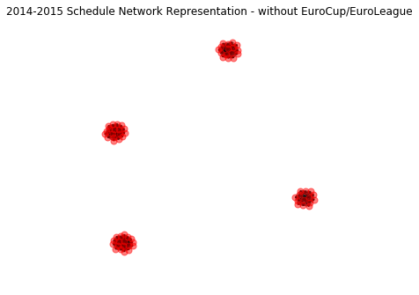
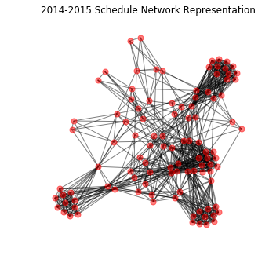

Will try to make graph positions consistent so its even easier to see – or color nodes by league
In the graph on the right with full data, you can still see the same four clusters, but there are many connections between them.

Put this FIRST in this section
X players, Y teams, by year (plot? Or table)

All of this data is scraped from Basketball Reference. Matt Goldberg wrote a python scraping library for the NBA and NFL (source 11). I forked it, and added international basketball support (source 12).
(Show example of webpage, and resulting table from python call:)
https://www.basketball-reference.com/euro/players/luka-doncic-1-club.html
Above is example of raw table scraped

Most of the international analysis I’ve seen, including the articles in the Literature Review (BE MORE SPECIFIC), use mainly season-level statistics, because for a long time, that’s all that was available. However, Basketball Reference has game-level data available from the 2014-2015 season on:
Show GAME boxscore dataframe and link to basketball reference page

By going through the the full schedule for each league, and pulling out each boxscore and concatenating it, (done in file X), we obtain a list of each player’s performances against each defense:
Show dataframe

This allows a weighted bipartite netwsork to be constructed, where the two disjoint groups of nodes are players and defenses, and the edge weights are the resulting statistic for that matchup. For example, this was the table of the matchup….this would be the resulting bipartite graph…
First half of http://localhost:8888/notebook/basketball/IndependentStudy/examples/toy_example_basics.ipynb

The five stats I used were points, total rebounds (offensive + defensive), assists, steals, and blocks, all adjusted to be per minute. NEED TO THINK MORE ABOUT WORDING OF REASONING
Therefore, for each year, and statistic, I have a separate network.

Is this a good split between data methodology/results?

SCRAPING FIRST – THEN SHOW NETWORK GRAPHS AND EXPLAIN WHY SOME LEFT OUT

Triangles
2nd half of http://localhost:8888/notebooks/basketball/IndependentStudy/examples/toy_example_basics.ipynb

Then, larger example to show all triangles that can be generated for a given edge to be predicted:
First half of http://localhost:8888/notebooks/basketball/IndependentStudy/examples/toy_example_prediction.ipynb

Triangle Selection/Ordering Methods
middle third of http://localhost:8888/notebooks/basketball/IndependentStudy/examples/toy_example_prediction.ipynb

Models
Show how one model works (example, linear regression) – draw features/response picture?
Variation of last third of
http://localhost:8888/notebooks/basketball/IndependentStudy/examples/toy_example_prediction.ipynb

Mention how stats are being standardized

Results

show results with accuracy (compared to null model)

TABLES?
Talk about how tables look
This is best sm, best model… overall
Show stats being standardized (plot? Histogram?)

Conclusion
Discuss takeaways from results – mainly accuracy of prediction
Standardize statistics

Possible Extensions

Graph of player old stats vs new stats (colored by league)
Cite arel/tomas first paper
Write about ideas for future research

