Figures

Figure 1: Competition Networks by Year – before any pruning

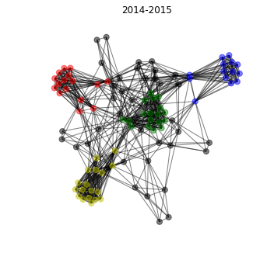
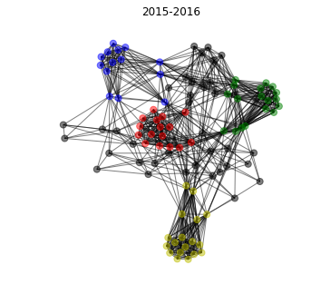
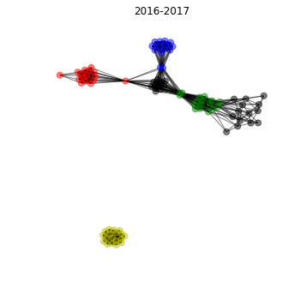
Legend for all competition networks:
Greek Basketball League - blue
Spanish Liga ACB – green
Italian Lega Basket Seri A – red
French LNB Pro A – yellow
Other - gray

Note: This is teams vs teams, which different than players vs teams, but that competition network is so large its hard to visualize well. Therefore, this is a simplified representation.

Figure 2: Competition Networks by Year - Teams with no club play data removed

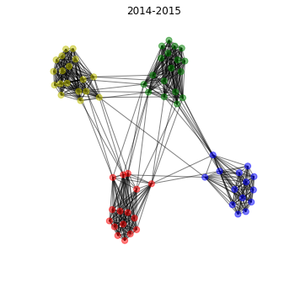
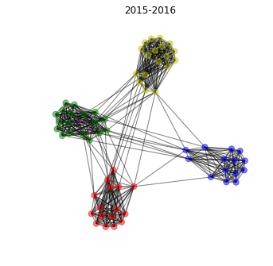
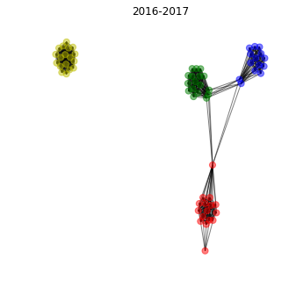

Figure 3: 2016-2017 Competition Network - French teams removed
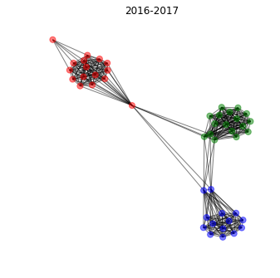

Figure 4: Sportsref Source webpage table
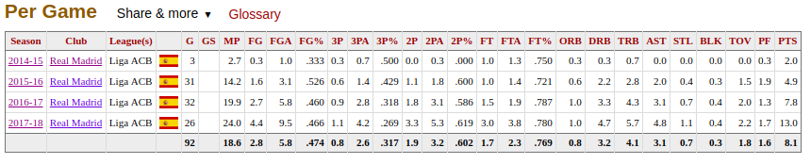
Source:
https://www.basketball-reference.com/euro/players/luka-doncic-1-club.html#per_gameCLU0::none

Figure 5: Python call and resulting DataFrame
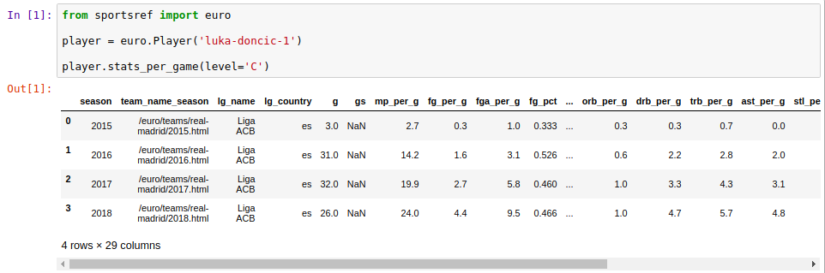

Figure 6: Boxscore example
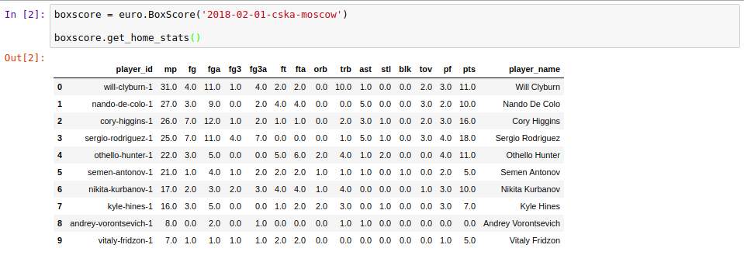
Source:
https://www.basketball-reference.com/euro/boxscores/2018-02-01-cska-moscow.html

Figure 7: Cleaned Dataset preview
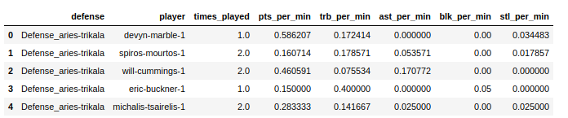

Figure 8: Example Dataset 1
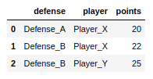

Figure 9: Resulting Network from Dataset 1

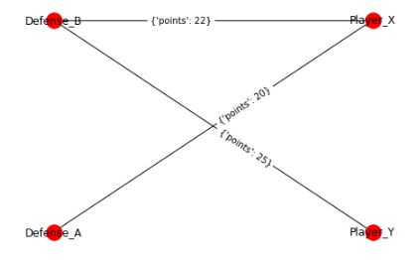

Figure 10: Example Dataset 1 Triangle Component
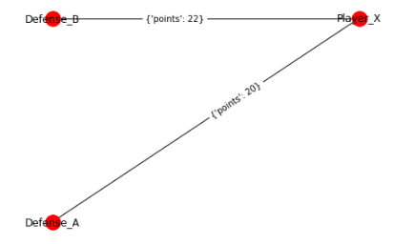

Figure 11: Example Dataset 2 and resulting Network-Based

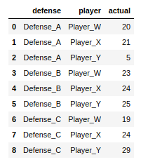
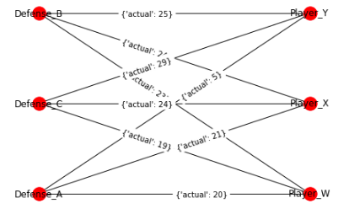

Figure 12: Jagged Matrix (without any Triangle Selection/Ordering)

Figure 13: Matrix Structure - 5 buckets, mean

Note: CX denotes Chunk X

Figure 14: Linear Regression Example (using example Dataset 2)

Feature Matrix corresponding output (actual performances)
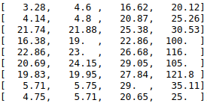

Resulting prediction from trained model
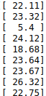
*Model is trained with above features/output
Resulting intercept of line:
[ 13.58]
Resulting feature weights:
[-2.1 , 0.94, 0.47, 0.16]

*In practice, training data and test data are split – see Cross-Validation section
Figure 15: Random Forest Regressor Example
*Using same training data as Figure 14
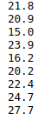
Resulting prediction from trained model:

Figure 16: Residuals vs Actual across iterations – 2 examples

